Paramount Pursuits
HubSpot to Zoho One Migration & Custom CRM Build-Out
A Case Study in Data Migration, Workflow Automation, and Business Intelligence

1. Client Overview
Paramount Pursuits, LLC is an entrepreneur education and economic development consulting organization (operating since 2016) that delivers business coaching, mentorship, and workshop programs to small businesses, nonprofits, and aspiring entrepreneurs. Their program portfolio includes Launch, Thrive, Ascend, Pathways, Open for Business (OFB), Shell LiveWire Pennsylvania, Food Justice Fund, and Tech2Elevate, delivered in partnership with corporate and government funders.
Because Paramount runs multiple concurrent, funder-specific programs — each with its own client intake process, consultant assignments, and reporting obligations — their operations depend on clean, unified client data and reliable session-level reporting across every program.

2. The Challenge
Paramount Pursuits was operating out of HubSpot, which was not built to handle the organization's core reporting need: program-specific session notes tied to individual consultants, clients, and funders, rolled up into KPI dashboards that funders require for compliance and renewal reporting.
Specific pain points included:
- Fragmented client records across Contacts, Leads, and Funders with no unified 360° view.
- No structured session-note data model — consultant visit notes, time spent, and outcomes were not captured in a reportable format.
- Manual webinar attendee tracking with no link back to CRM contact records.
- Attachments and signed documents (including PandaDoc proposals/agreements and historical email attachments) scattered and not tied to contact records.
- No self-service reporting for program managers or funders — reporting was manual and after-the-fact.
The objective was a full migration to Zoho One, re-architected around Paramount's actual operating model, not a lift-and-shift of the HubSpot schema.

3. Solution Architecture
The solution was built across five connected Zoho applications, orchestrated so that data entered once (via a form or the CRM) automatically propagates everywhere it's needed: HubSpot/PandaDoc APIs feed Zoho CRM; Zoho Forms feed Zoho Flow, which synchronizes Zoho Creator and Zoho CRM; and both CRM and Creator data feed Zoho Analytics dashboards.

3.1 Data Migration — HubSpot → Zoho CRM
Using the HubSpot API and PandaDoc API, contacts, leads, deals/companies, email attachments, PandaDoc documents, and webinar registrants were extracted, transformed, and loaded into Zoho CRM:
Source Object | Destination in Zoho CRM | Notes
Contacts | Clients module | Custom fields added: Contact Type, Program status, Business/Organization Name
Leads | Leads module | Standard conversion mapping preserved
Deals/Companies | Funders module | Custom module built to track funding partners
Email attachments | Attachments related list | Re-linked to correct Client record
PandaDoc documents | Attachments / custom fields | Sync tracked via PandaDoc Documents Synced / PandaDoc Not Found fields
Webinar registrants | Webinar Attendees related list | Linked to BigMarker webinar activity

Each Client record in Zoho CRM (Figure 1) surfaces a unified activity view: Emails, Attachments, Open/Closed Activities, Invited Meetings, Webinar Attendees, and program applications (Business Assessment, OFB Assessment, Thrive cohorts) — replacing what had been siloed HubSpot properties and manual spreadsheets.
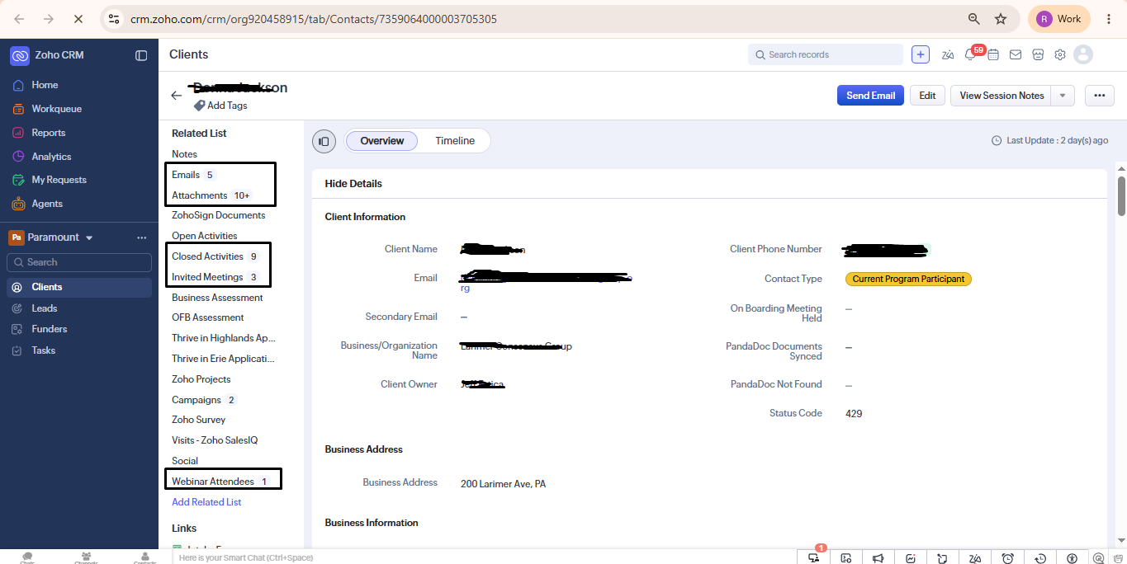
Figure 1 — Zoho CRM Client record: unified activity view (Emails, Attachments, Closed Activities, Invited Meetings, Webinar Attendees).
Custom status fields were added directly to the Client record to support funder reporting without leaving the CRM, e.g. Contact Type (Current Program Participant / Program Graduate / At Risk Client / Removed from Program), On Boarding Meeting Held, and PandaDoc Documents Synced.

3.2 Session Notes Data Model
The core technical build was a multi-program Session Notes system, since Paramount's consultants run session types that differ structurally by funder (Food Justice Fund, Open for Business, Tech2Elevate Digital Coach) but must all roll up to the same Client record and the same KPI dashboards.
Design decisions:
- A single Zoho Creator application (SessionNotes) acts as the system of record, with program-specific subforms (tabs) — Paramount Session Notes, Tech2Elevate Digital Coach, and Open for Business — each capturing the fields relevant to that program (session type, engagement date/time, meeting type, billable time, client highs/lows, “Big Win” narrative).
- Each Session Note record is linked back to the originating Client record in Zoho CRM and rendered inline as a related list, so consultants and program managers see full session history without switching systems.
- Data capture happens through program-specific Zoho Forms with required-field validation, dropdown-driven Consultant Company Name, and structured Client/Business fields — eliminating free-text inconsistency at the point of entry.
- Every session note stores: Consultant Name, Client Name, Business/Organization, Session Type, Session Date, Time Spent (minutes), and a narrative “Big Win”/outcome field — the minimum structured fields needed for both consultant performance reporting and funder KPI reporting.
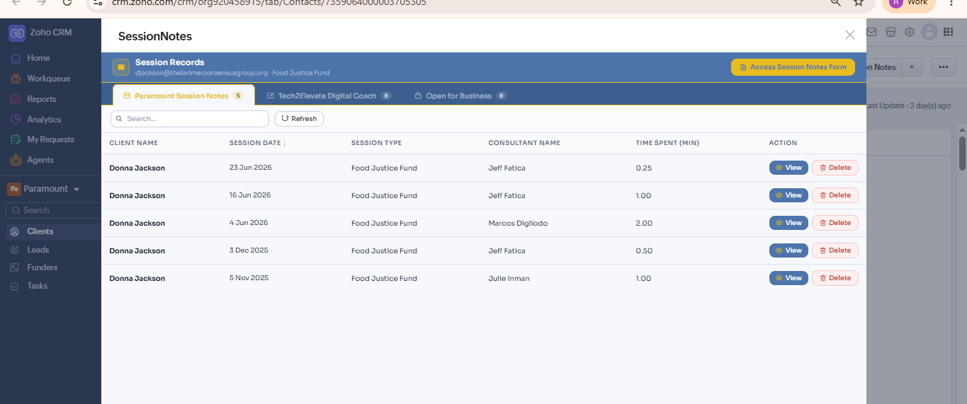
Figure 2 — Session history for a client (Donna Jackson / Food Justice Fund) rendered as a related list inside the CRM record, pulled live from Zoho Creator.
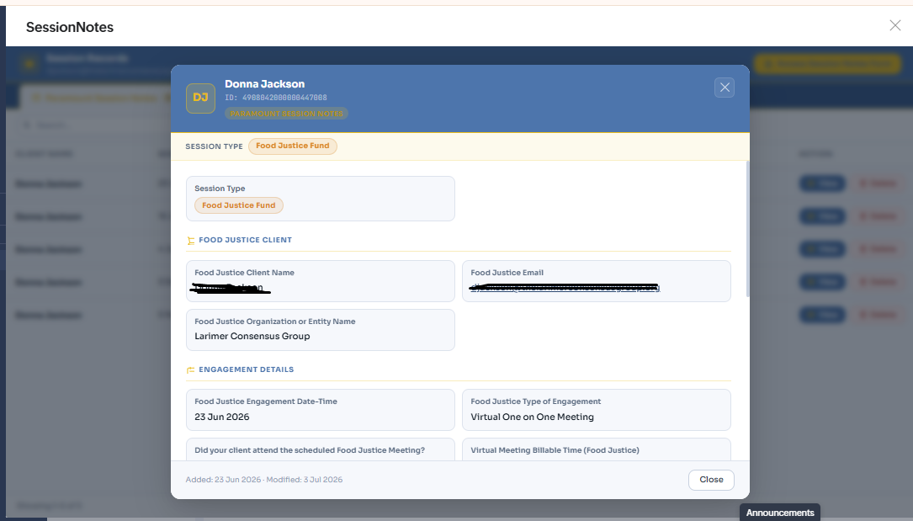
Figure 3 — Session Note detail view: program-specific subform (Food Justice Fund) with engagement date, meeting type, and billable time captured against the linked client.
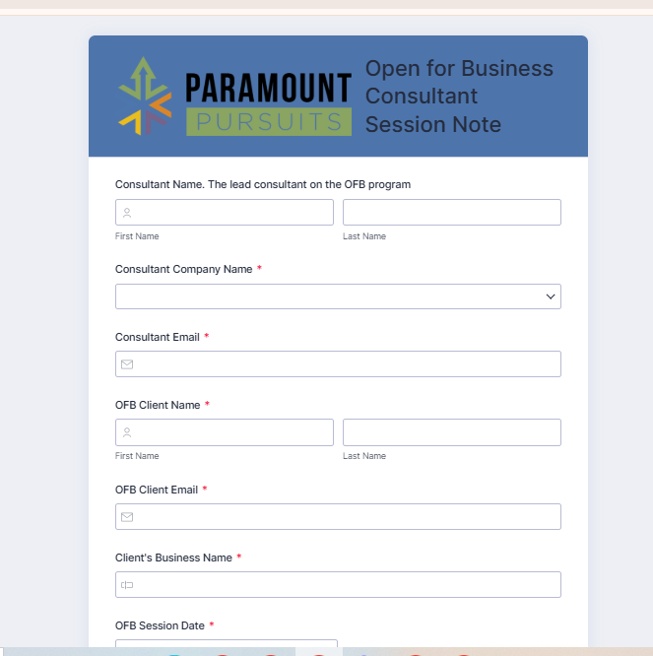
Figure 4 — Open for Business Consultant Session Note intake form (Zoho Forms), with required-field validation and structured client/business capture at the point of entry.

3.3 Automation Layer — Zoho Flow
Three production Zoho Flow automations (workspace: Session Notes Synchronization) form the integration backbone between Forms, Creator, and CRM:
Flow | Function | Status
Create Session Report Meeting and Sync in Creator | Fires on new session note submission → creates the meeting record and syncs the session note into Zoho Creator | ON — 76 executions, 0 failures
Sync Open for Business | Pushes OFB-program session notes from Creator into the corresponding Client record in CRM | ON
Sync Tech2Elevate Digital Coach | Pushes Tech2Elevate coaching session data from Creator into CRM | ON

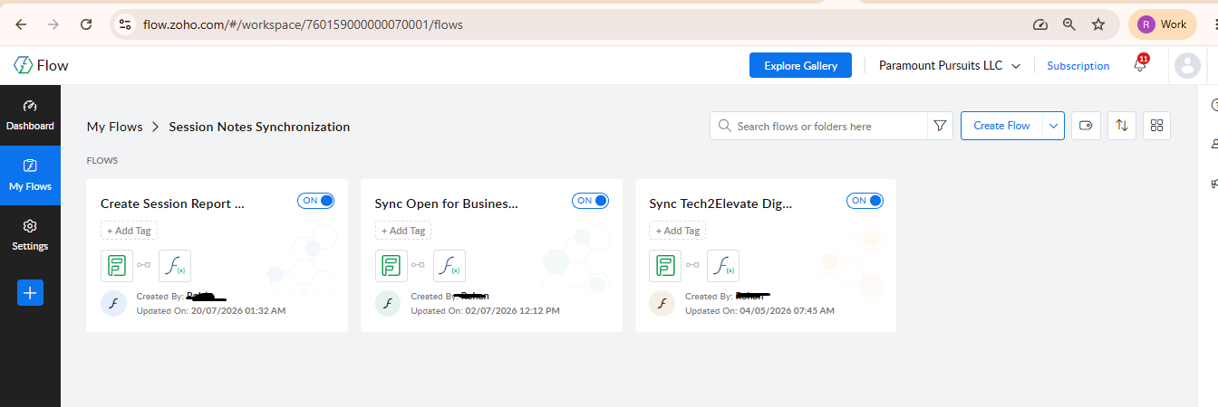
Figure 5 — “Session Notes Synchronization” Zoho Flow workspace: three active flows connecting Forms, Creator, and CRM.
Each flow uses a custom function (syncSessionNoteWithCRMMeeting) to match the incoming session note to the correct existing Client record (rather than creating duplicates), then writes back a linked Meeting/Activity record and updates the CRM related list in real time.
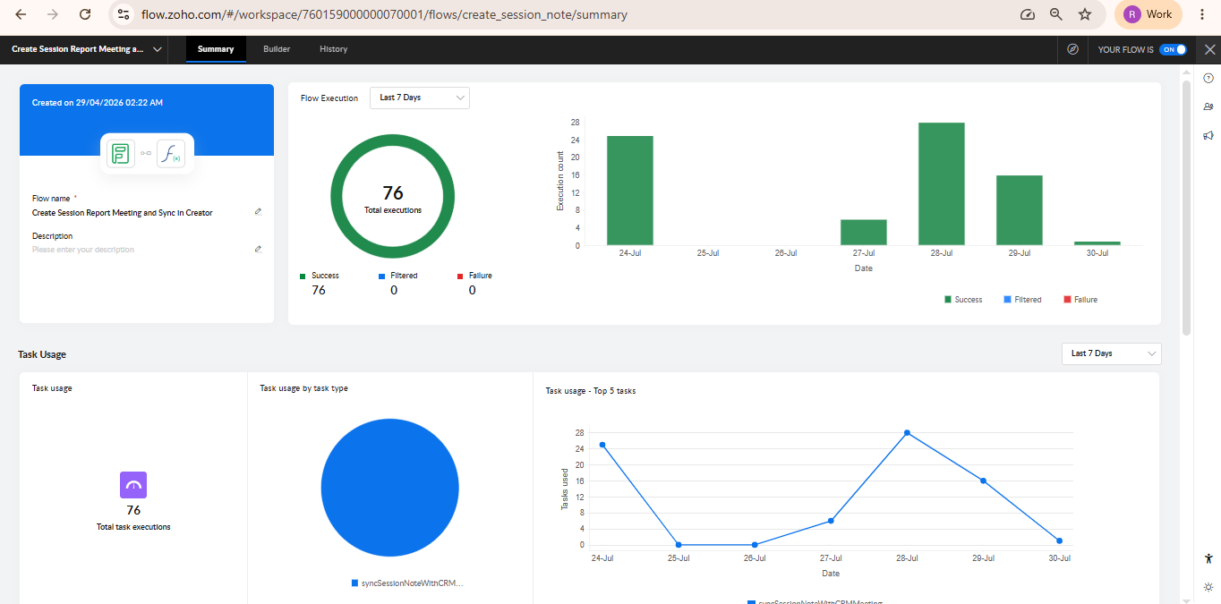
Figure 6 — Flow execution summary: 76 total executions over a 7-day window, 100% success rate, zero filtered or failed runs — validating that the sync logic reliably resolves client matches across programs.

3.4 Reporting & Business Intelligence — Zoho Analytics
All Session Notes and Client data feed into Zoho Analytics, where three dashboard sets were built to serve different audiences.
Program KPI Dashboard
Tabbed by OFB Monthly Data, FJF Monthly Data, and OFB Program Data, with scorecards for OFB Consulting Hours, Mentor Hours, Outside Consulting Hours, Assessments Completed, and Approved/Denied/Total Applications, plus a drill-down pie chart of application decision status.
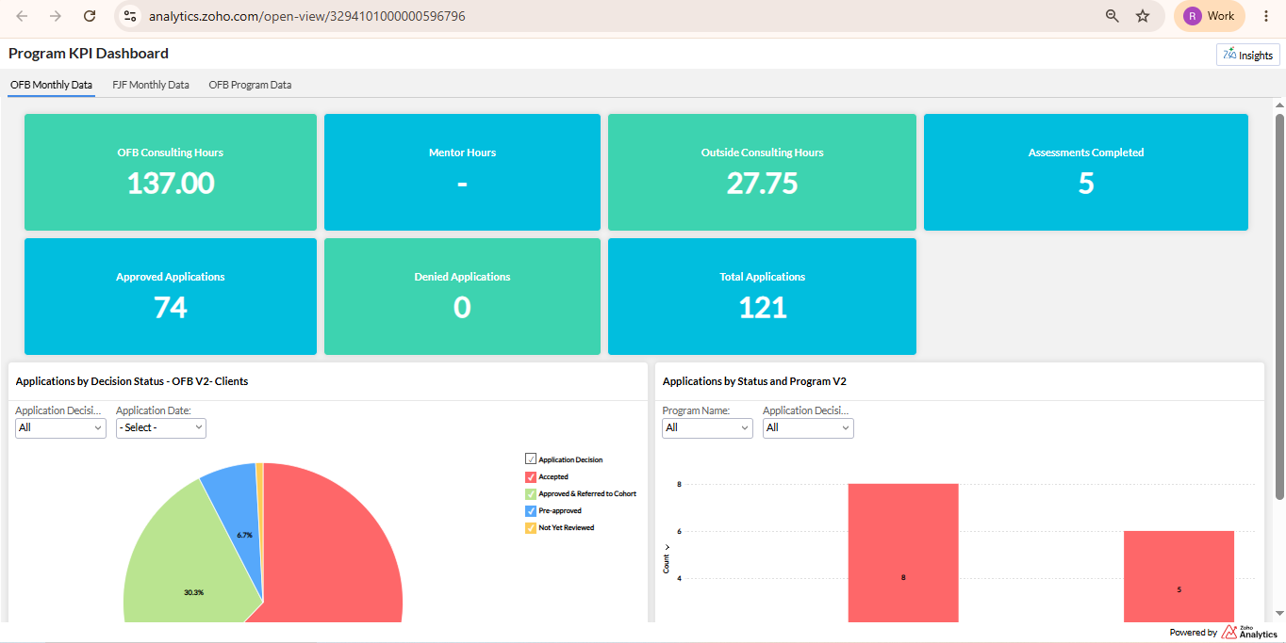
Figure 7 — Program KPI Dashboard (OFB Monthly Data): consulting/mentor hours, assessments completed, and application decision status.
A stacked bar chart of client counts by program (Food Justice Fund, Open for Business, Shell LiveWire PA, Thrive in Erie, etc.) segmented by Contact Type lets a program manager see at a glance how many clients per program are “Current Program Participant” vs. “At Risk Client,” alongside an overall client-status distribution used for funder-facing retention/outcomes reporting.
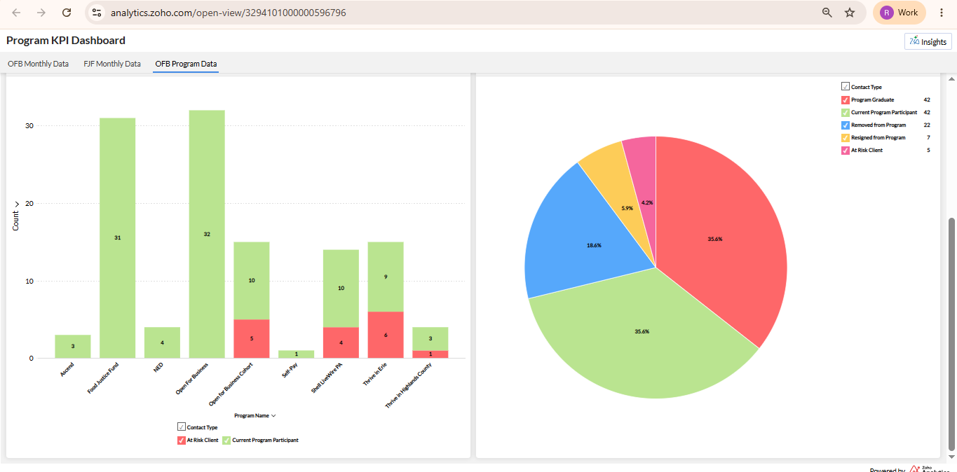
Figure 8 — Program KPI Dashboard (OFB Program Data): client counts by program segmented by status, and overall program outcome distribution (Graduate / Current / Removed / Resigned / At Risk).
“Big Wins” Report
A filterable, exportable table (Session Date, Coach Name, Client, Business Name, Program, Big Wins narrative, Hours Billed, Session Notes) that lets program staff pull qualitative outcome evidence per funder without touching the underlying CRM/Creator records.
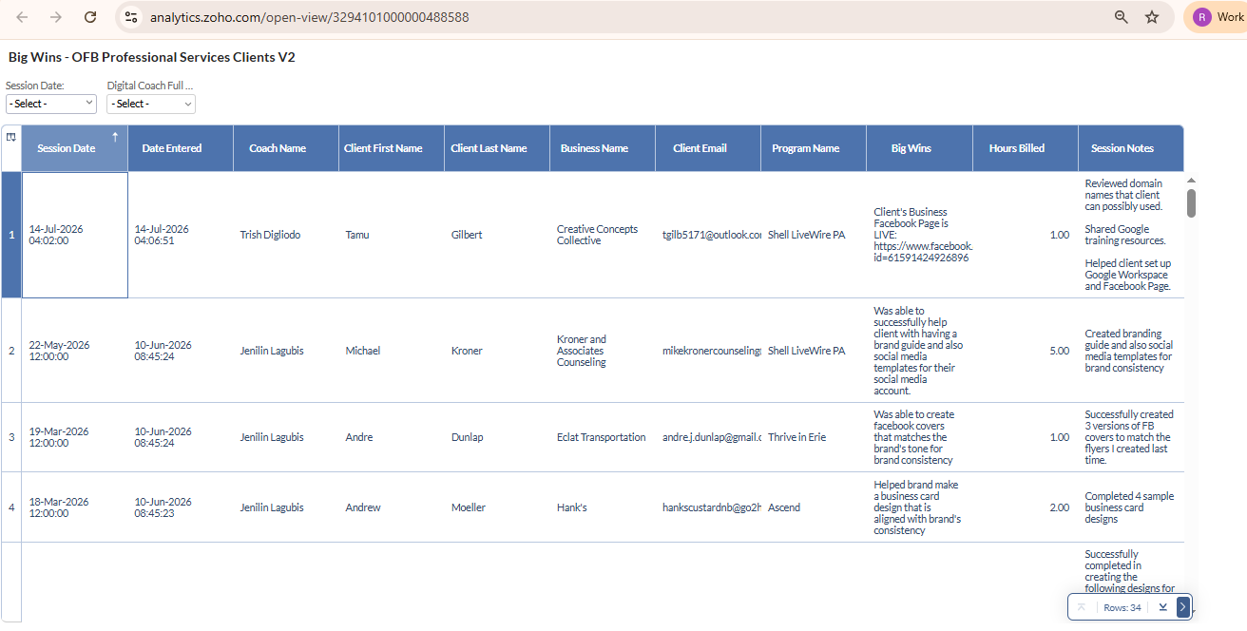
Figure 9 — “Big Wins” report across OFB Professional Services clients, combining hours billed with narrative outcome data for funder evidence.
Shell LiveWire Mentor Meeting Attendance
A funder-specific attendance report with live filters by Session Date and Client Name, and footer aggregate functions (SUM of Time Spent, COUNT of sessions) for quick funder reporting on mentor engagement hours.
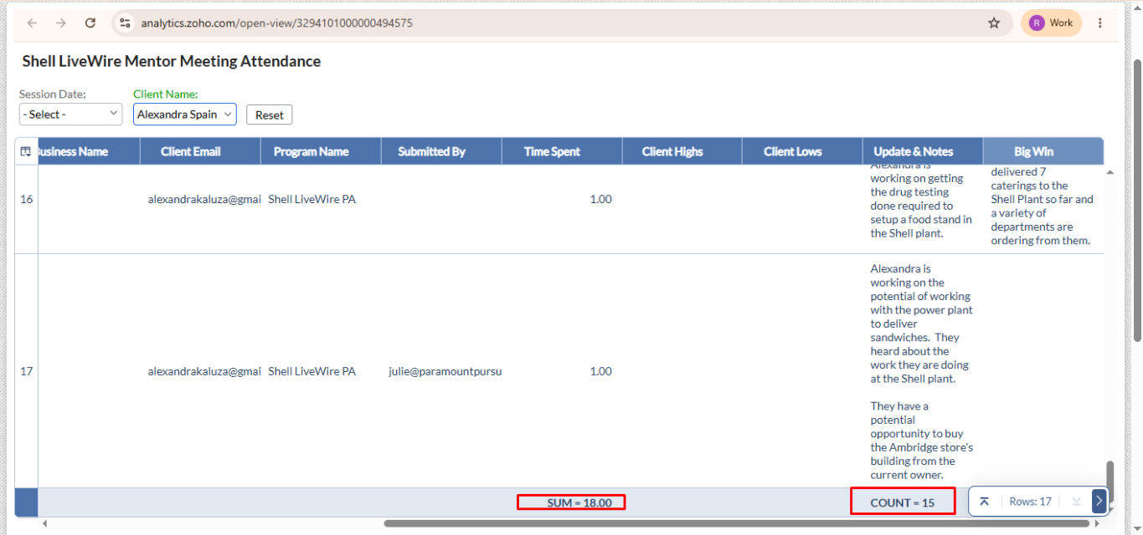
Figure 10 — Shell LiveWire Mentor Meeting Attendance report with filters and live SUM/COUNT aggregates for funder engagement-hour reporting.

4. Technical Stack Summary
Layer | Tool | Purpose
Data source (legacy) | HubSpot API | Contact/Lead/Deal extraction
Document source | PandaDoc API | Signed document/attachment extraction
System of record | Zoho CRM | Clients, Leads, Funders, Activities, Attachments
Structured intake | Zoho Forms | Program-specific session note capture, direct Form-to-CRM
Session data store | Zoho Creator | Multi-program Session Notes application
Integration/automation | Zoho Flow | Form → Creator → CRM synchronization, meeting creation
Reporting | Zoho Analytics | KPI dashboards, funder reports, attendance tracking

5. Results & Impact
- Zero data loss migration: Contacts, Leads, Session Notes, Webinar data, Form submissions, and PandaDoc attachments migrated from HubSpot with full historical continuity.
- 76 successful, zero-failure Flow executions in the most recent reporting window, confirming the automation layer reliably keeps Creator and CRM in sync across three concurrent programs.
- Unified 360° client view in Zoho CRM: consultants and program managers no longer switch between systems to see session history, attachments, and program status.
- Self-service funder reporting: Shell LiveWire, Food Justice Fund, and OFB dashboards let program staff generate compliance-ready reports on demand instead of manual compilation.
- Structured outcome capture: qualitative “Big Win” data — previously inconsistent free text — is now captured, filterable, and reportable across every consultant and program.
- Multi-program scalability: the subform/tab architecture in Creator means a new funder program can be added without rebuilding the entire session-notes system.

6. Conclusion
By re-architecting Paramount Pursuits' operations around Zoho CRM, Creator, Flow, and Analytics rather than replicating the HubSpot schema, the migration turned a manual, spreadsheet-dependent reporting process into an automated, real-time system of record — giving program managers, consultants, and funders a single source of truth for client engagement and program outcomes across every Paramount Pursuits program.

