**Name: PARMESH YADAV**

**Roll No: 2020319**

MTH-371 SPA

ASSIGNMENT 2

**QUESTION – 1**

**Simulating a Discrete Time Markov Chain.**

1. Simulate 5 times a 50 step Markov Chain.

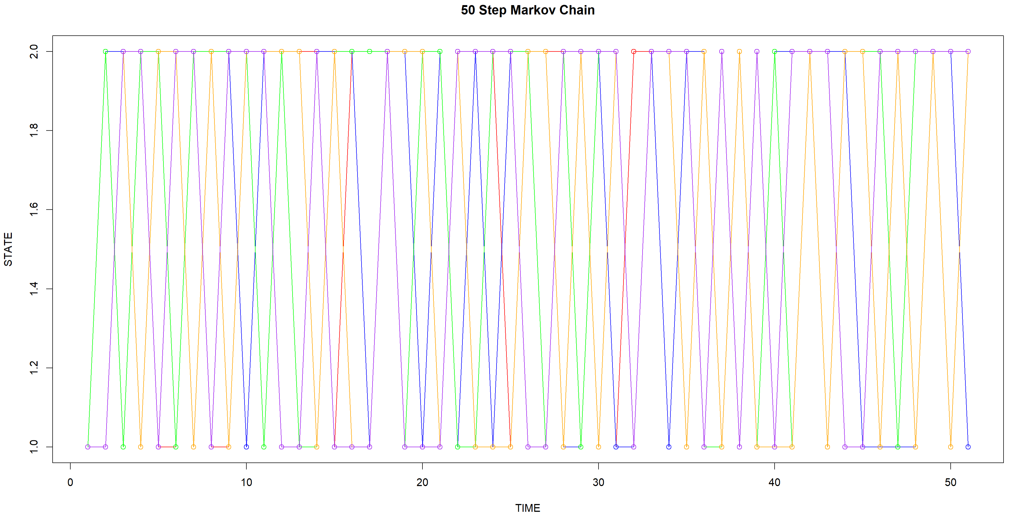

The above results were obtained by simulating a Markov Chain 5 times along 50 steps with State Space S = {1,2} with Transition Matrix P = [0.3,0.7,

0.5,0.5].

Calculate P10, P20 and P50 for P = [0.3,0.7,

0.5,0.5].

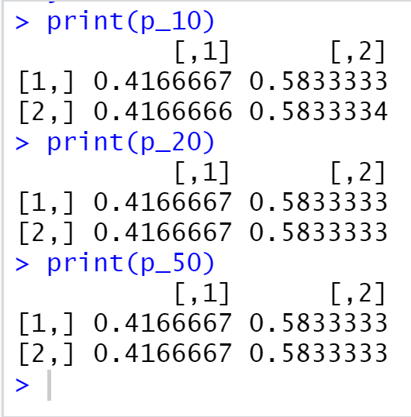

As we can see in the output, we get the same values for P10, P20 and P50. This is known as the Stationary Distribution of Markov chain. Since this Markov chain is clearly irreducible and aperiodic, hence, the Stationary Distribution will be equal to the Limiting Distribution.

**QUESTION – 2**

**Gambler’s Ruin Problem [1-D Random Walk].**

2 Gambler’s A and B start with 5$.

P = 0.8 🡺Probability of Winning of A

1-p = 0.2 🡺 Probability of Winning of A 🡺 Probability of A losing

Plotting the movement of Gambler - A w.r.t Time.

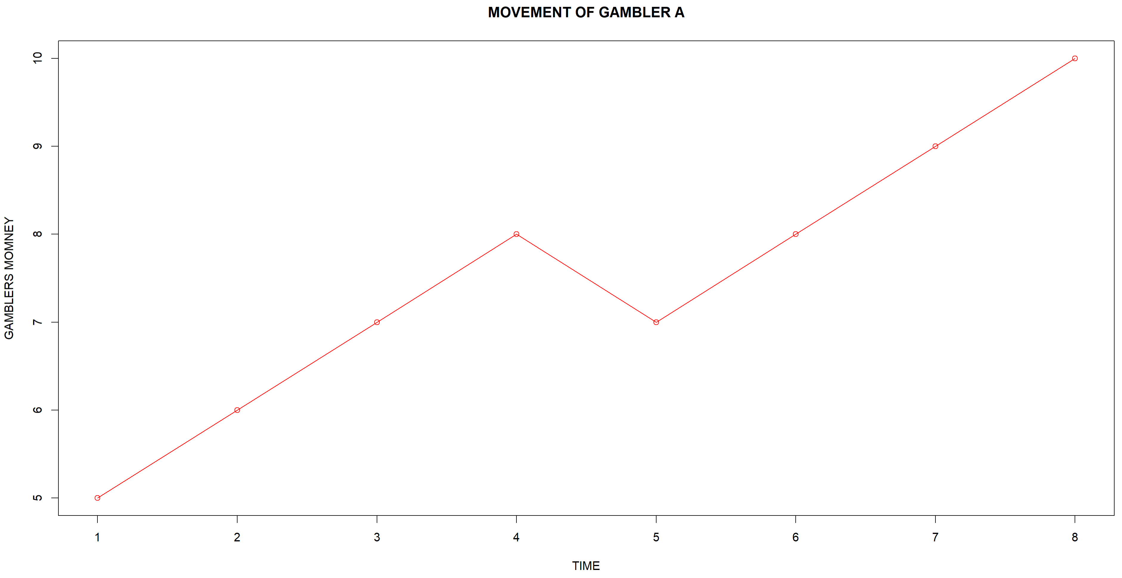

According to the question, the max and min amount of money a player can win or lose in 10$ and 0$ respectively. This gives us the boundaries of the Random Walk. Therefore, we can see in the above simulation that A wins the game by reaching 10$ in 8 units of time.