**A**



**Summer Internship Report On**

**"Cloud Computing & Web Frameworks"**

(IT346 – Summer Internship - I)

**Prepared by**

Parmesh Bhatt (21IT009)

**Under the Supervision of**

Assistant Professor Dhaval Patel

**Submitted to**

Charotar University of Science & Technology (CHARUSAT) for the Partial Fulfillment of the Requirements for the Degree of Bachelor of Technology (B.Tech.)

for Semester 5

**Submitted at**

**Accredited with Grade A+ by NAAC Accredited with Grade A by KCG**

**SMT. KUNDANBEN DINSHA PATEL DEPARTMENT OF INFORMATION TECHNOLOGY**

**Chandubhai S. Patel Institute of Technology (CSPIT) Faculty of Technology & Engineering (FTE), CHARUSAT At: Changa,Dist: Anand, Pin: 388421.**

**July,2023**



**Accredited with Grade A+ by NAAC**

**Accredited with Grade A by KCG**

**CERTIFICATE**

This is to certify that the report entitled “**Cloud Computing & Web Frameworks**” is a bonafide work carried out by **Parmesh Bhatt(21IT009)** under the guidance and supervision of **Assistant Professor Dhaval Patel** & **Mr. Samarth N Magdallawala** for the subject **Summer Internship – I (IT346)** of 5th Semester of Bachelor of Technology in **Department of Information** at Chandubhai S. Patel Institute of Technology (CSPIT), Faculty of Technology & Engineering (FTE) – CHARUSAT, Gujarat.

To the best of my knowledge and belief, this work embodies the work of candidate himself, has duly been completed, and fulfills the requirement of the ordinance relating to the B.Tech. Degree of the University and is up to the standard in respect of content, presentation and language for being referred by the examiner(s).

Under the supervision of,

|  |  |
| --- | --- |
| **Dhaval Patel** Assistant Professor  Smt. Kundanben Dinsha Patel Department of Information Technology  CSPIT, FTE, CHARUSAT, Changa, Gujarat |  |
| **Dr. Parth Shah**  Head of Department(IT)  CHARUSAT, Changa, Gujarat | **Samart N**  Krtya Technologies Pvt.Ltd |

**Chandubhai S. Patel Institute of Technology (CSPIT) Faculty of Technology & Engineering (FTE), CHARUSAT** At:Changa, Ta. Petlad, Dist. Anand, Pin: 388421. Gujarat.

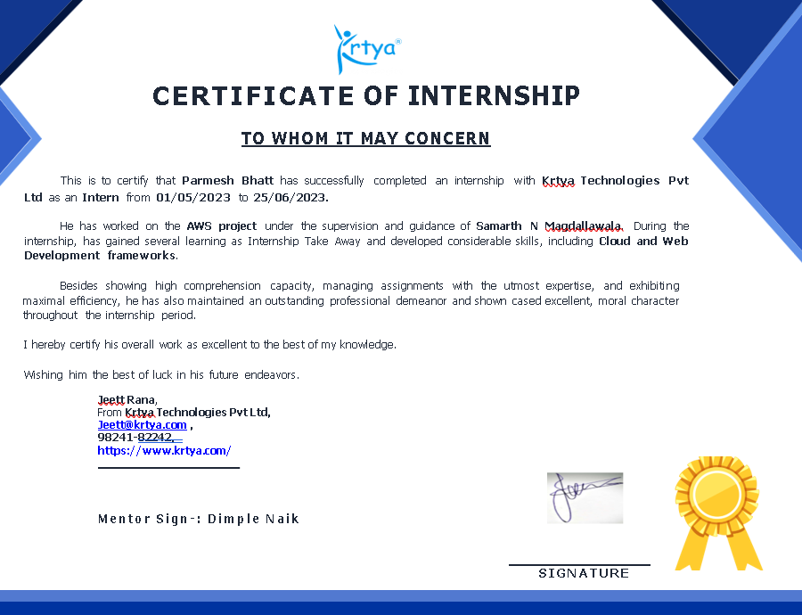

**ACKNOWLEDGEMENT**

.   
I am writing to express my sincere gratitude and acknowledgment for the invaluable learning experience and support I received during my internship at Krtya Software. I am immensely grateful for the opportunity to be a part of the AWS Project and contribute to the organization's goals.

Throughout my internship tenure, I have had the privilege of working with a team of dedicated professionals who generously shared their knowledge and expertise. I am particularly grateful to my supervisor, **Samarth N Magdallawala** and **Dimpleben Naik**, for their guidance, mentorship, and constructive feedback, which played a pivotal role in my personal and professional growth.

During my time at Krtya Software, I had the chance to engage in diverse projects and tasks, allowing me to gain hands-on experience and develop essential skills relevant to my academic and career aspirations. The exposure to real-world challenges and the collaborative environment fostered an enriching learning experience that I will carry with me throughout my professional journey.

Lastly, I want to express my gratitude to the entire organization for creating an inclusive and supportive work environment, where interns like me could flourish and make a meaningful contribution. A big thank you goes to the faculties at Chandubhai S. Patel Institute of Science and Technology, Changa. Their support made this internship possible and successful.

Thanks,

Parmesh Bhatt (21IT009)

Chandubhai.S.Patel Institute of Technology

**ABSTRACT**

Cloud Computing is always dream for me to learn about it. This summer, I had a chance to work on the project of AWS-cloud. I got the chance to work with the cloud team during the internship. I got selected as a Cloud and web developer intern at Krtya Software Pvt Ltd. During the period of internship, I learned about what is cloud computing and how it is working in real life. I also learn about React and Bootstrap during the internship because I had a few projects to do using React and Bootstrap.

I learned about different AWS services like AWS EC2, AWS RDS, AWS EBS, AWS EFS, AWS S3, AWS Lambda, and many more. There are many Cloud providers are there in the market. But I like AWS because It is easy to use, flexible, and cost-effective. AWS is also more secure than others.

I learned about many AWS services which I don't know before the internship. Starting with the EC2 instances which is the virtual machine that provides lots of benefits over the implementation of the actual machine. There is also the EC2 instances auto-scaling which automatically increase the number of EC2 instance when the number of users increases. There is one service called AWS EKS means Amazon Elastic Kubernetes Service, which provides Kubernetes containerization to deploy our websites. The main benefits of this kind of service are that the users don't need to set up the OS and hypervisor for all computers. There are many more services like AWS RDS which is Amazon Relational Database Service and another one is AWS DynamoDB which is AWS NoSQL database service and also is serverless service and another serverless service which is AWS Lambda. The storage service is S3-Simple Storage Service to store our data in the cloud, and there are many services like IAM, AWS EBS, and AWS EFS. I learn about this project and also learn about React as well as Bootstrap.

In React, I learned about the difference between stateless and stateful components. I learned about React is the most effective JS library to build the UI using Bootstrap. I also learned about the component life cycle methods in React which is only supported in the class components of React. But in the functional component, there are hooks to handle the state. Also, we can handle the routing in React and there are many more things in React that one developer can do with Bootstrap. Using Bootstrap, we can also include CSS in the responsive web design in the UI. Because Responsive Web Design is one of the toughest challenges for UI/UX designers.

Overall, the internship journey was amazing and lots of new things learn from my seniors as well as my community juniors. I came to know about React, Bootstrap, and the importance of Networking in the tech industry and now I am applying that thing in real life.

**Table of Contents**

Acknowledgment i

Abstract ii

Description of company/organization… vii

# Chapter 1 Introduction 1

* 1. Purpose of Internship 1
  2. What is Cloud Computing 1
  3. Importance of Cloud Computing 1
  4. Scope 1
  5. Disadvantage of Cloud Computing 1
  6. Alternatives and Future of Cloud 1

# Chapter 2 World of AWS 3

* 1. Introduction to AWS 3
  2. Learning How AWS Works? 3
  3. AWS Global Infrastructure 3
  4. AWS Services 4
  5. AWS Billing Model 6
  6. Pros and Cons of AWS 6

# Chapter 3 Developing Projects and Contributions 26

* 1. TextUtils.com 26
  2. Sourcefolio 38

3.3 ProjectsHut 42

# Chapter 4 Conclusion 44

**DESCRIPTION OF COMPANY**

**Krtya Technologies Pvt Lmt.**

Krtya Software is a Private Limited Company located in Surat, Gujarat. Krtya Software primarily focuses on providing IT outsourcing services with the flavor of trust and worthiness, helping us to grow more and more and set ourselves a benchmark in the market and also on the mission to deliver outstanding IT services to our customers & support them to provide them correct solution & guidance.

Support for all the queries of developers and also that the end users have is provided by Krtya. The basic needs of all our end users like fast loading, browser compatibility, and interactivity are provided by this Software development company. Incorporated in the year 2008, we provide Software Development Outsourcing services like Web Development, Website Design and Development, Product Development, Application Development and Maintenance, Development, SharePoint. Our other services are Cloud Technology Services, .NET Outsourcing Service Providers, Microsoft SharePoint Services, Open-Source Software, and many more. Krtya Software is specialized in providing .NET Outsourcing Services at the domestic as well as international level and is now expanding in other services too.

**Website**: [Krtya Software](https://krtya.com/)

**Email**: [Mail](mailto:jariwbh@krtya.com)

**Location**:

Krtya Technologies Pvt Ltd     
A1 - 01/02, Milestone Habitat, Kailash Nagar, Sagrampura  
Surat - 395002  
India.

21IT009 Introduction

**CHAPTER 1**

**Introduction**

* 1. **Purpose of Internship**
* Internships are of utmost importance in an engineering student's life as they provide practical experience, skill development, and networking opportunities. Through internships, students gain hands-on exposure to real-world engineering projects, enhancing their technical and soft skills. Additionally, they get insights into various industries and career paths, while also building valuable connections with professionals that can benefit their future careers. Internships bolster resumes, boost confidence, and act as a pathway to potential job opportunities. Moreover, students stay abreast of industry advancements, making them well-prepared for the transition from academia to the professional world.
* The internship was based on Cloud and Web frameworks. From this internship, I learned about the AWS services and how every website is required to deploy on the cloud because without deploying on the cloud every website is a static website. I also learn a little bit about React and Bootstrap and using this I also contributed to many open-source projects.
* Internships serve as a crucial bridge between academic learning and professional experience, offering students opportunities to develop and enhance their skills while exploring various career paths and industries.
  1. **What is Cloud Computing**
* Cloud computing refers to the delivery of computing services over the internet, providing on-demand access to a shared pool of computing resources, such as servers, storage, databases, networking, software, and analytics. Instead of owning and maintaining physical hardware and infrastructure, users can access these resources through a cloud service provider on a pay-as-you-go basis.
* There are mainly four types of deployment models defined by the NIST.

1. Public Clouds
2. Private Clouds
3. Community Clouds
4. Hybrid Clouds

* Also, There are three types of service models are there.

1. IaaS **–** Infrastructure as a Service
2. SaaS - Software as a Service
3. PaaS - Platform as a Service
   1. **Importance of Cloud Computing**

* Cloud computing is of immense importance in today's digital landscape due to its numerous benefits and transformative impact on various industries. Here are some key reasons why cloud computing is crucial:

CSPIT Smt. Kundanben Dinsha Patel Department of InformationTechnology

21IT009 Introduction

1. **Cost Savings**: Cloud computing eliminates the need for upfront investments in hardware, infrastructure, and maintenance costs. Users can access resources on a pay-as-you-go model, reducing capital expenses and enabling cost-effective scaling based on actual usage.
2. **Scalability and Flexibility**: Cloud services offer dynamic scalability, allowing businesses to rapidly adjust their computing resources to accommodate fluctuating demands. This flexibility enables efficient handling of both high and low workloads, ensuring optimal performance and resource utilization.
3. **Accessibility and Collaboration**: Cloud computing enables remote access to data and applications from anywhere with an internet connection. This accessibility promotes collaboration among geographically dispersed teams, enhancing productivity and efficiency.
4. **Data Backup and Recovery**: Cloud providers offer robust data backup and disaster recovery services, reducing the risk of data loss and ensuring business continuity in case of emergencies or hardware failures.
5. **Security**: Reputable cloud providers invest heavily in security measures, employing encryption, access controls, and monitoring to protect data and applications from unauthorized access and cyber threats.

**1.4 Scope**

* The scope of cloud computing is vast and continues to expand as technology evolves and businesses embrace digital transformation. Some key aspects that highlight the scope of cloud computing are as follows:

1. **Business Adoption**: Cloud computing is becoming the mainstream choice for businesses of all sizes and industries. As more organizations realize the benefits of cost savings, scalability, and accessibility, the adoption of cloud services is expected to increase.
2. **Hybrid and Multi-Cloud Environments**: Many enterprises are adopting hybrid and multi-cloud strategies to leverage the strengths of different cloud providers and maintain control over sensitive data. This trend will continue to evolve as businesses seek to optimize their infrastructure and operations.
3. **Edge Computing**: The proliferation of edge devices, IoT (Internet of Things) devices, and the need for low-latency applications is driving the integration of cloud computing with edge computing. This allows processing and data storage to occur closer to the source, improving performance and reducing bandwidth requirements.
4. **AI and Big Data**: Cloud computing provides the computational power required for processing large-scale data and running complex artificial intelligence and machine learning algorithms. As AI and big data applications grow, so will the demand for cloud resources to support these workloads.
5. **Serverless Computing**: Serverless architectures, where developers focus on writing code without managing the underlying infrastructure, are gaining popularity. This serverless approach is expected to become more prevalent as cloud providers expand their serverless offerings.

**1.5 Disadvantages of Cloud Computing**

* While cloud computing offers numerous benefits, it also comes with certain disadvantages and challenges that organizations should be aware of:

1. **Security and Privacy Concerns**: One of the primary concerns with cloud computing is the security of data stored on remote servers. Organizations may worry about unauthorized access, data breaches, and the potential for data loss. Additionally, data privacy regulations vary globally, and entrusting sensitive data to a third-party provider may raise compliance issues.

CSPIT Smt. Kundanben Dinsha Patel Department of Information Technology

21IT009 Introduction

1. **Downtime and Reliability**: Cloud service providers strive for high availability, but no system is entirely immune to outages or downtime. Reliability issues can impact business operations and cause disruptions in services, leading to potential loss of productivity and revenue.
2. **Internet Dependency**: Cloud computing heavily relies on internet connectivity. If there are internet disruptions or slow connections, users may experience reduced access to cloud resources, affecting their ability to work efficiently.
3. **Data Transfer and Bandwidth Costs**: Migrating large volumes of data to the cloud or continuously transferring significant amounts of data can incur substantial bandwidth costs for businesses.
4. **Data Location and Jurisdiction**: The physical location of cloud servers may raise concerns about data sovereignty and jurisdictional issues. Some countries have specific regulations on data storage, and using cloud services that store data overseas may not align with those regulations.

**1.6 Alternatives and Future of Cloud**

* Alternatives to Cloud Computing:

1. **On-Premises Infrastructure**: Instead of relying on cloud services, organizations can maintain their own data centers and physical servers on-site. This approach offers complete control over data and infrastructure but requires significant upfront investment and ongoing maintenance costs.
2. **Edge Computing**: Edge computing involves processing and storing data closer to the source or end-users, reducing the need for centralized cloud data centers. It is particularly useful for applications requiring low latency and real-time processing, such as IoT devices.
3. **Hybrid Cloud**: A hybrid cloud model combines both public cloud services and private on-premises infrastructure. It allows organizations to take advantage of the benefits of cloud computing while keeping sensitive data and critical workloads within their own controlled environment.
4. **Multi-Cloud**: Adopting a multi-cloud strategy involves using services from multiple cloud providers. This approach can help organizations avoid vendor lock-in, optimize costs, and leverage specialized services from different providers.

* Future of Cloud Computing:

1. **Quantum Cloud Computing**: As quantum computing technology advances, it may open up new possibilities for cloud computing by providing exponential processing power for certain types of tasks.
2. **Serverless Computing**: The future of cloud computing is likely to see further growth in serverless architectures. Serverless platforms abstract away infrastructure management, allowing developers to focus solely on writing code.
3. **AI and Machine Learning Integration**: Cloud providers are likely to offer more advanced AI and machine learning services, making it easier for organizations to leverage these technologies for their applications.
4. **Cloud-Native Applications**: As organizations increasingly embrace cloud-native development approaches, more applications will be designed explicitly to leverage the benefits of cloud services, resulting in enhanced performance and scalability.

CSPIT Smt. Kundanben Dinsha Patel Department of Information Technology

**CHAPTER 2**

**World of AWS**

**2.1 Introduction to AWS**

* Amazon Web Services (AWS) is a comprehensive and widely used cloud computing platform provided by Amazon, the world's leading online retailer. Launched in 2006, AWS has rapidly grown to become a dominant force in the cloud computing industry, offering a vast array of services that cater to businesses, individuals, and government organizations.
* AWS provides a scalable and flexible infrastructure that allows users to access computing resources over the internet on a pay-as-you-go basis. It encompasses a wide range of services, including computing power, storage options, databases, analytics, machine learning, Internet of Things (IoT), security, and more.
* By leveraging AWS services, organizations can build and deploy sophisticated applications, store and process vast amounts of data, run websites and mobile apps, and utilize AI and machine learning to gain valuable insights from their data. AWS's global network of data centers ensures high availability and low latency, enabling users to access their resources from anywhere in the world.
* AWS has played a pivotal role in the digital transformation of businesses, allowing them to innovate, scale, and reduce costs by offloading the complexities of managing infrastructure. Its extensive and ever-expanding service catalog continues to shape the future of cloud computing, empowering businesses of all sizes to embrace the benefits of cloud technology and drive innovation in their respective industries.

**2.2 How AWS Works?**

* Amazon Web Services (AWS) is a leading cloud computing platform offered by Amazon, delivering a vast array of services and solutions to businesses and individuals globally. Operating on a pay-as-you-go model, AWS allows users to access scalable computing power, storage options, databases, analytics, and machine learning resources. Its extensive global network of data centers ensures high availability and low-latency access to resources. With a comprehensive service catalog, security measures, and management tools, AWS empowers organizations to innovate, scale, and reduce costs while leveraging cloud technology to drive digital transformation and achieve business objectives.
* Amazon Web Services (AWS) operates on a distributed, global infrastructure, consisting of data centers located in multiple geographic regions worldwide. Each region is further divided into isolated data centers called Availability Zones, which provide redundancy and high availability. Customers can choose the AWS region closest to their end-users to minimize latency and improve performance. AWS offers a broad range of cloud services, including computing, storage, databases, networking, security, machine learning, and more. Users can access these services through the AWS Management Console, command-line interface, or APIs.

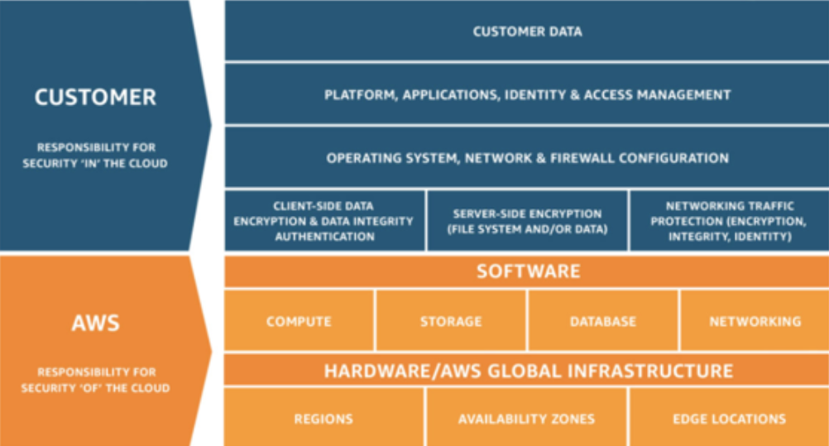

Figure .1

**2.3 AWS Global Infrastructure**

* AWS Global Infrastructure is a vast network of data centers strategically located across the world to provide low-latency access, high availability, and fault tolerance for AWS services. As of the last update, AWS had numerous regions worldwide, each consisting of multiple Availability Zones (AZs) within the same geographic area. The AWS Cloud spans 102 Availability Zones within 32 geographic regions around the world, with announced plans for 12 more Availability Zones and 4 more AWS Regions in Canada, Malaysia, New Zealand, and Thailand.
* **Regions**: AWS Regions are geographical locations that host a collection of data centers. Each region is designed to be completely isolated from other regions to ensure data resilience and compliance with data sovereignty regulations. As of my last update, AWS offered multiple regions in various continents, such as North America, South America, Europe, Asia Pacific, and the Middle East.
* **Availability Zones (AZs)**: Each AWS Region comprises two or more Availability Zones. AZs are distinct data centers within a region, located a few miles apart to minimize the risk of simultaneous failures due to natural disasters or other disruptions. AZs are interconnected with high-bandwidth, low-latency connections, providing high availability for services hosted within a region.
* **Edge Locations**: In addition to Regions and Availability Zones, AWS has a network of Edge Locations. These Edge Locations act as content delivery endpoints for the AWS CloudFront content delivery network (CDN) service. They are located in major cities around the world and serve cached content to end-users, reducing latency and improving the performance of web applications and media distribution.
* **Global Accelerator**: AWS Global Accelerator is a service that improves the availability and performance of applications by using the AWS global network. It routes user traffic through the AWS network to the closest AWS Edge Location, reducing the number of internet hops and improving the response time for end-users.

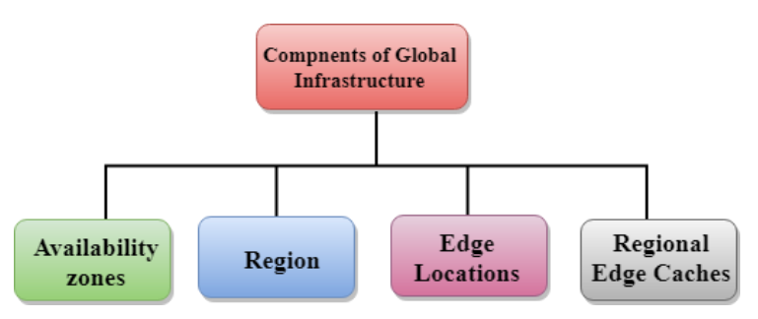

Figure .1

* AWS Global Infrastructure provides the backbone for the extensive range of cloud services and solutions offered by AWS. With its global network of data centers, AWS enables customers to deploy applications and services with high performance, scalability, and reliability, supporting a wide range of industries and use cases. As AWS continues to expand its global presence and introduce new services and features, it remains at the forefront of cloud computing, driving innovation and empowering businesses worldwide.

**2.4 AWS Services**

* Amazon Web Services (AWS) offers a vast array of cloud computing services across various categories. These services cater to different needs and use cases, allowing organizations to build, deploy, and manage applications and infrastructure in the cloud. Here are some key AWS services:

1. Computing Services:

* **Amazon Elastic Compute Cloud (Amazon EC2)**: Virtual servers that provide resizable compute capacity in the cloud.
* **AWS Lambda**: Serverless compute service that allows running code without managing servers.

1. Storage Services:

* **Amazon Simple Storage Service (Amazon S3):** Scalable object storage for data storage and retrieval.
* **Amazon Elastic Block Store (Amazon EBS)**: Persistent block storage volumes for EC2 instances.
* **Amazon Glacier**: Low-cost archival storage for long-term data retention.

1. Database Services:

* **Amazon Relational Database Service (Amazon RDS):** Managed relational database service for MySQL, PostgreSQL, Oracle, SQL Server, and others.
* **Amazon DynamoDB**: Fully managed NoSQL database service.
* **Amazon Redshift:** Managed data warehouse service for big data analytics.

1. Networking Services:

* **Amazon Virtual Private Cloud (Amazon VPC):** Isolated virtual network for resources deployment.
* **AWS Direct Connect**: Dedicated network connection between on-premises and AWS.
* **Amazon Route 53**: Domain Name System (DNS) web service for domain registration and routing.

1. Security, Identity, and Compliance Services:

* **AWS Identity and Access Management (IAM):** Identity management and access control service.
* **AWS Key Management Service (KMS):** Managed service for creating and controlling encryption keys.
* **AWS Config**: Service for assessing and monitoring resource configurations.

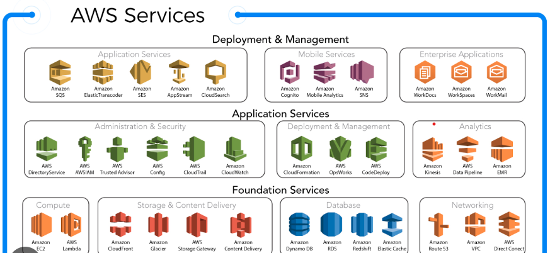

Figure .1

**2.5 AWS Billing Model**

* AWS follows a pay-as-you-go pricing model, which means customers are billed based on their actual usage of AWS services and resources. This model offers flexibility and cost-effectiveness, as customers only pay for the resources they consume without any upfront costs or long-term commitments.

1. **Usage-Based Pricing**: AWS services are typically priced based on the resources used, such as compute instances, storage usage, data transfer, and other service-specific metrics. Customers are billed based on the quantity and type of resources they provision and utilize.
2. **On-Demand Instances**: Amazon EC2 instances, the virtual servers in AWS, are available on an on-demand basis. Customers can launch instances and pay for the compute capacity by the hour or by the second, depending on the instance type.
3. **Pricing Tiers**: Some AWS services offer pricing tiers, where the cost per unit decreases as the usage volume increases. For example, Amazon S3 storage has different pricing levels based on the amount of data stored.
4. **Data Transfer Costs**: Data transfer into and out of AWS, as well as between different AWS regions or Availability Zones, may incur additional costs, depending on the volume of data transferred.
5. **Free Tier**: AWS offers a free tier that allows new customers to explore and try out a limited set of AWS services with no charge for a specified period. This allows users to get hands-on experience with AWS at no cost.
6. **Consolidated Billing**: For organizations with multiple AWS accounts, AWS offers consolidated billing, enabling them to view and manage billing across all accounts from a single master account.
7. **Cost Explorer**: AWS provides the Cost Explorer tool to help customers visualize, understand, and analyze their AWS costs. It allows users to view cost and usage data, set cost allocation tags, and create custom cost reports.

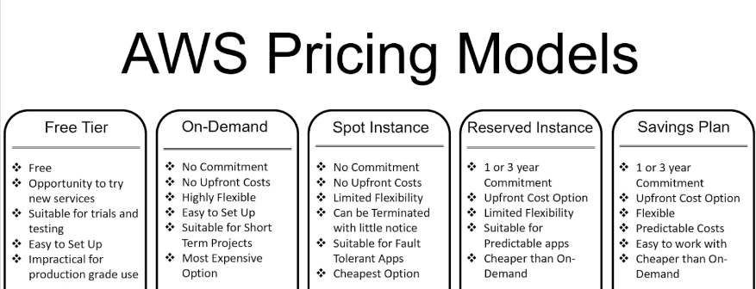

Figure .1

**2.6 Pros and Cons of AWS**

* Pros of AWS:

1. **Comprehensive Service Catalog**: AWS offers an extensive range of cloud services, providing customers with a one-stop solution for all their computing needs, from computing power and storage to analytics, machine learning, and IoT services.
2. **Scalability and Flexibility**: AWS allows users to scale their resources up or down based on demand, providing the flexibility to handle varying workloads efficiently. This scalability is particularly beneficial for businesses experiencing rapid growth or fluctuating usage patterns.
3. **Global Infrastructure**: AWS operates in multiple geographic regions with numerous Availability Zones, providing low-latency access and high availability for users worldwide. This global infrastructure ensures excellent performance and redundancy for mission-critical applications.
4. **Cost-Effectiveness**: The pay-as-you-go pricing model of AWS allows users to pay only for the resources they consume, avoiding the need for upfront capital investment and reducing wastage of unused resources.
5. **Security and Compliance**: AWS prioritizes security, implementing advanced encryption, access controls, and compliance measures to protect customer data and applications. AWS adheres to numerous industry certifications and compliance standards.

* Cons of AWS:

1. **Learning Curve**: The vastness of AWS's service catalog can be overwhelming for new users, requiring time and effort to learn and understand the different services and their optimal use cases.
2. **Complexity**: Configuring and managing AWS resources can be complex, especially for organizations with large-scale deployments. Proper governance and resource management are essential to avoid potential cost overruns and security risks.
3. **Data Transfer Costs**: Moving large volumes of data into and out of AWS or between different regions can incur additional data transfer costs, which may need to be carefully considered in the overall budget.
4. **Vendor Lock-In**: Migrating applications and data from AWS to other cloud providers or on-premises infrastructure can be challenging and may lead to vendor lock-in.
5. **Downtime Risk**: While AWS makes significant efforts to maintain high availability, no system is entirely immune to outages or downtime. Businesses should have contingency plans in place to handle disruptions if they occur.

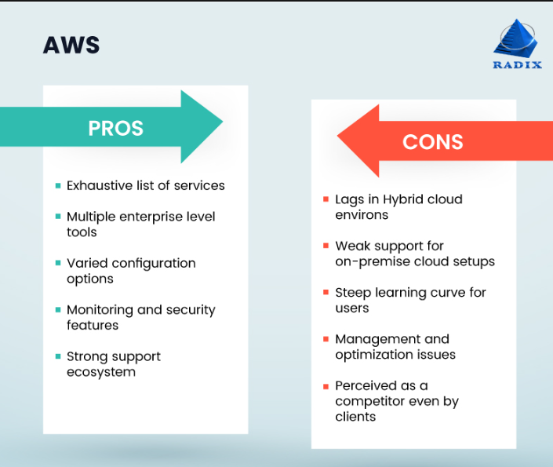

Figure .1

**CHAPTER 3**

**Developing Project and Contributions**

* 1. **TextUtils.com**

About Project:

* TextUtils is a website module for one company’s project which include that If any user comes and want to check how many numbers of character the sentence have then the user can able to do that also they can convert it into lowercase if it is in Uppercase or reverse also they can do and include many more features.

Tech Stack:

* **Front-end:** React, Bootstrap
* **Deploy:** AWS
  1. **SourceFolio**

About Project:

* SourceFolio is an open-source project that develops for developer and student who wants to build their portfolio without any cost. Because now in days, having a portfolio is the most important thing for any student as well as a developer. Using this, developers or students are easily able to build their portfolios.
* I am also contributing to this project as a fresher because during the period of internship, I have also learned about React and Bootstrap.

Tech Stack:

* **Front-end**: React.
* **Deploy**: Vercel
* They just need to go to the source-folio official link and need to fill out this form.

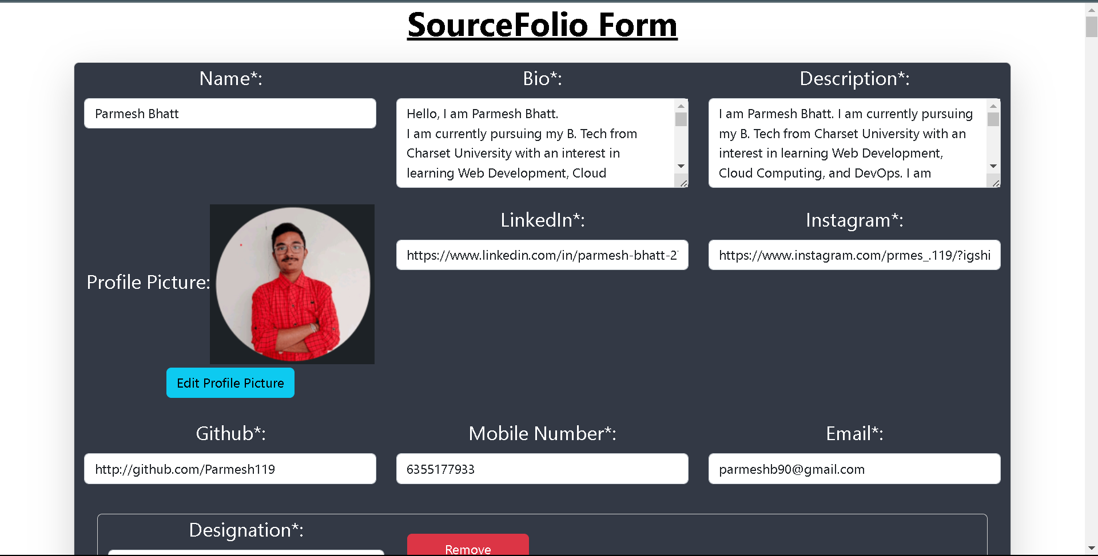

Image 1.1

* After Filling out the form the profile looks like this. This is not the complete profile because I am working on many parts of the profile because this sourcefolio project has missing many things.

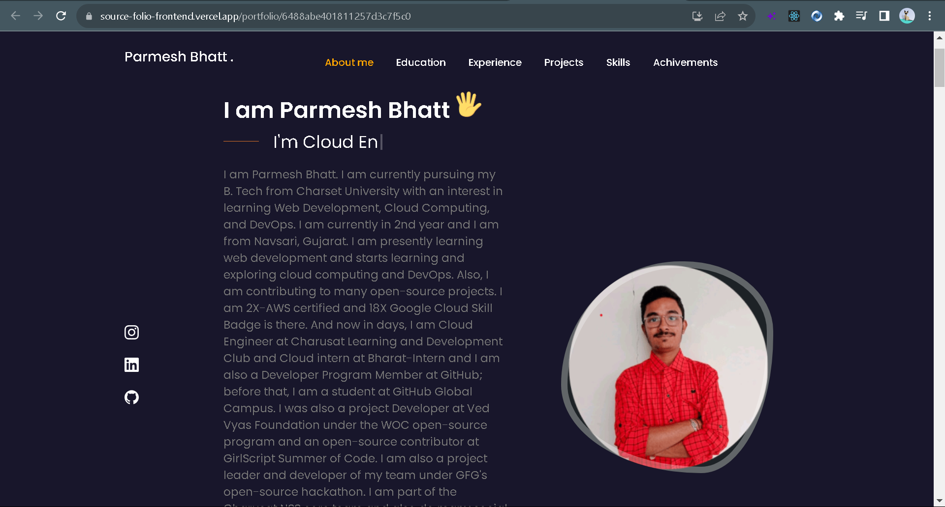

Image 1,2

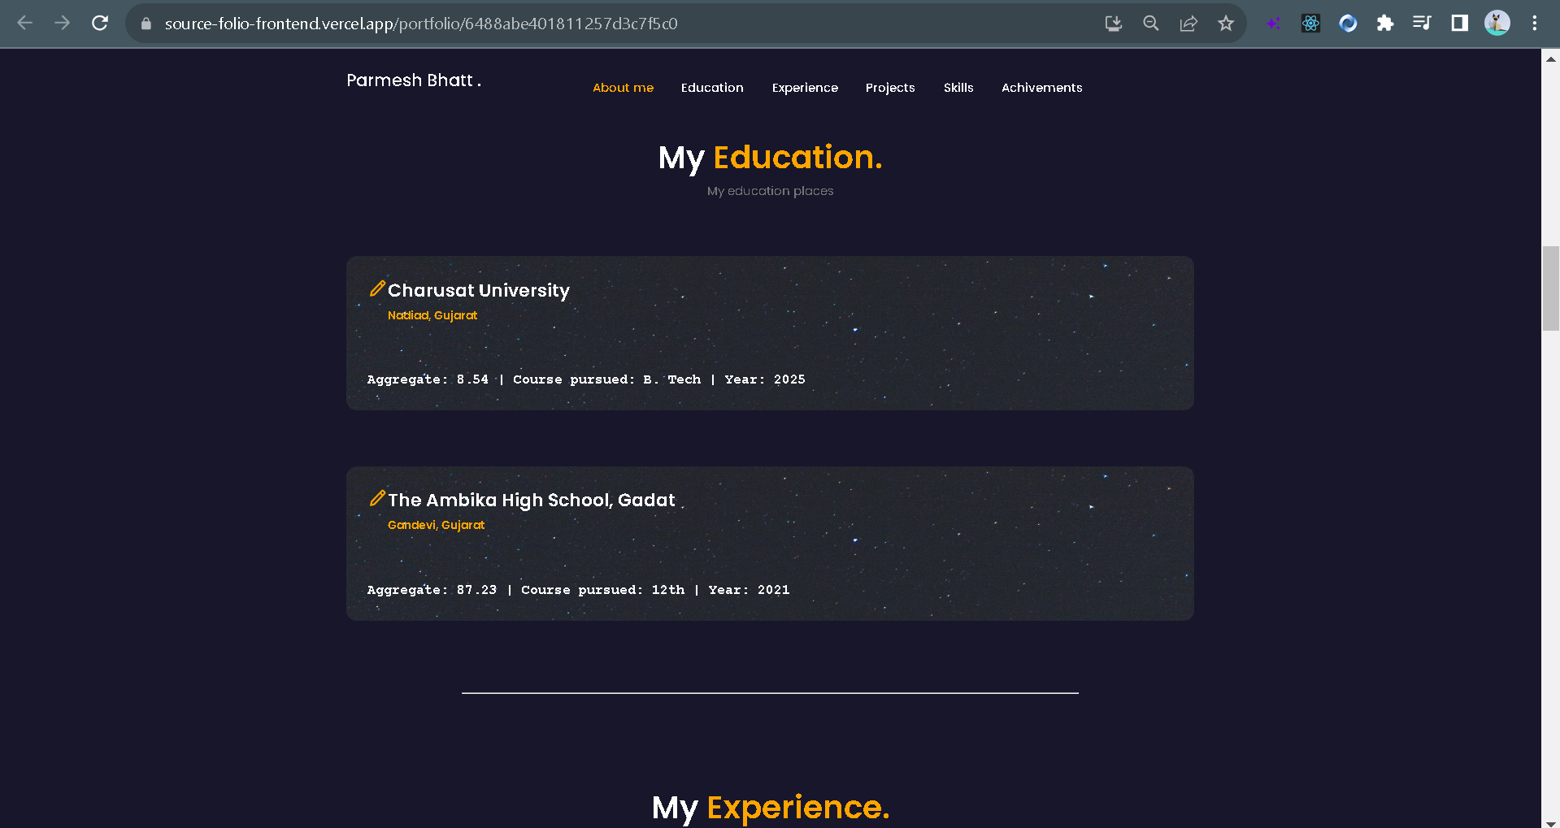

Image .3

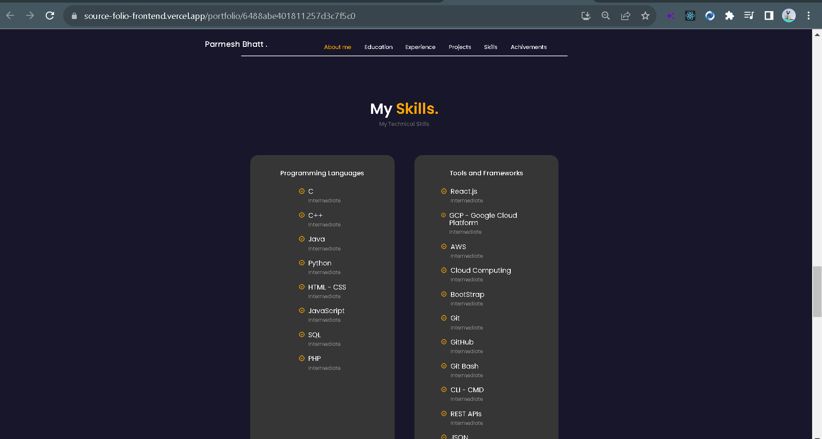

Image 1.4

* 1. **ProjectsHut**:

About Project:

* Projectshut is an open-source web app that enables users to freely publish their projects and create user profiles within the platform. I have successfully created many pull requests and those requests are successfully merged also. This is not the complete website because I am working on many parts of the profile because thisproject has missing many things.
* Home page:

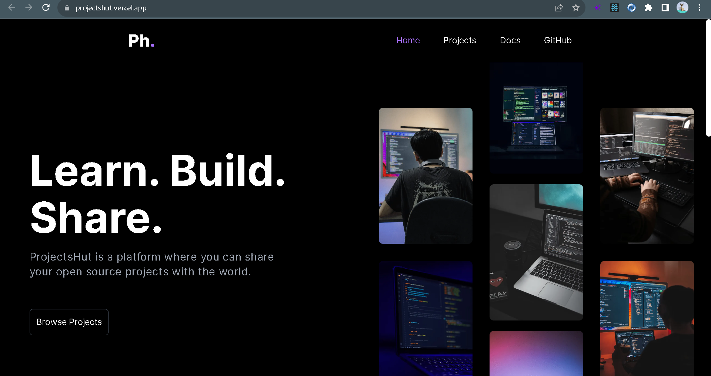

Image 1.5

* All project:

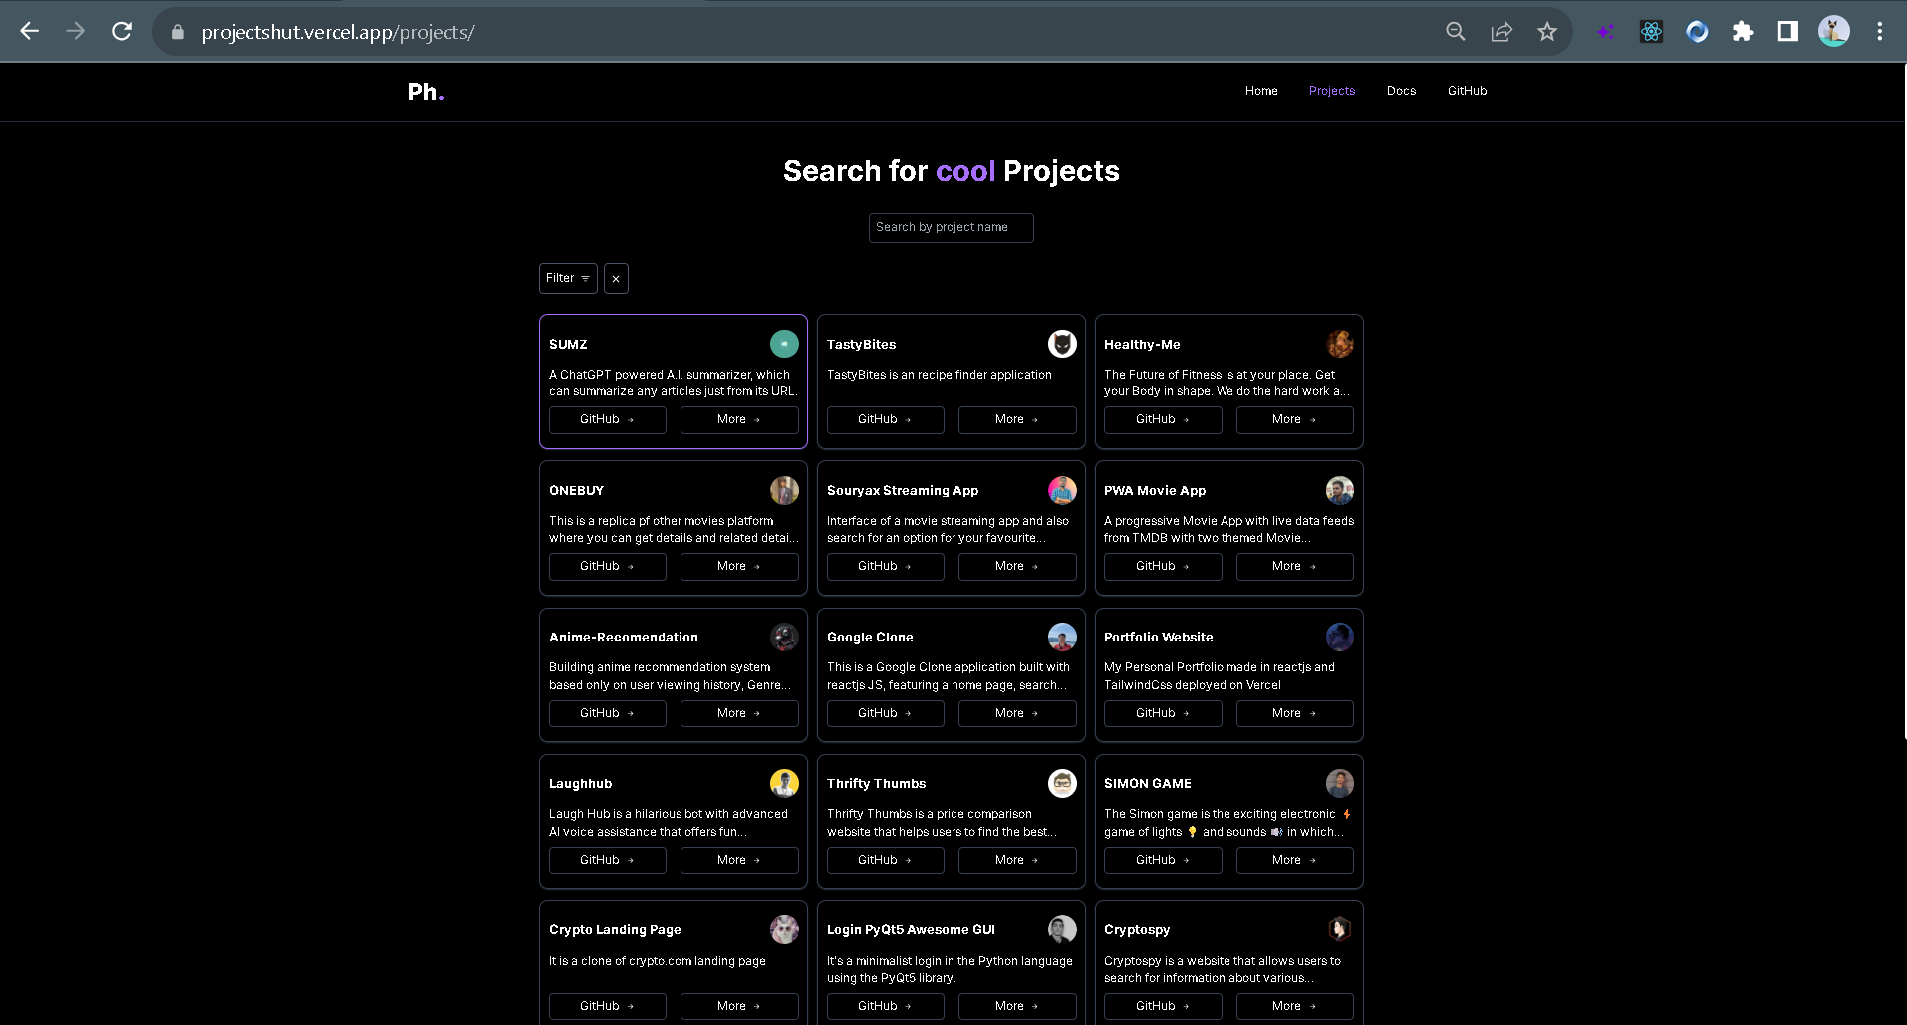

Image 1.6

**CHAPTER 4**

**Conclusion**

* Overall, the internship journey was amazing and lots of new things learn from my seniors as well as my community juniors. I missed those days right now in the hostel life. I came to know about React, Bootstrap, and the importance of Networking yourself. And also came to know about having a family and being with the family. From my internship experience, I would like to advise my junior and not especially to juniors, It is for everyone that If you want to learn something from the tech industry. So, only you need to do is "Be patient, and just be in the tech, be with the tech..." and you will automatically learn about it.
* From my internship experience, I came to know about this 👇

