- Tcpdump

This command lists out all the packets passing through the top interface (wlp3s0 here) until interrrupted (or constricted using the -c flag as shown). Each line displays the details of each packet, like the time it is sent/received, the source and destination address and length.

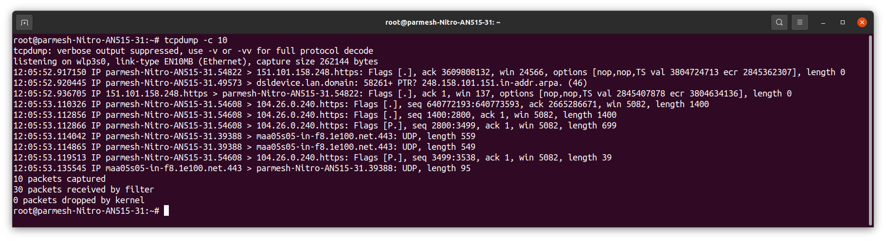

- Ifconfig

This command shows all the active interfaces on the system. It also shows us other details about them (like type and address) and the traffic passing through them.

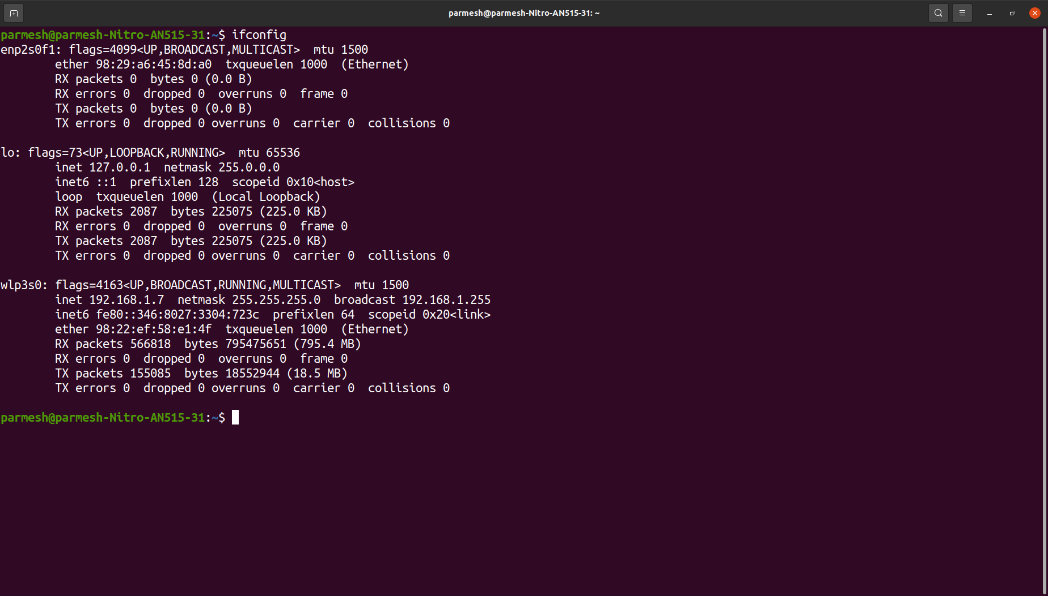

- dig

This command gives us info about the dns of www.google.com, which is a host that is present on the internet (indicated by the IN tag in the ANSWER SECTION), and has an IPv4 of 142.250.67.36 (from the last column in the ANSWER SECTION).

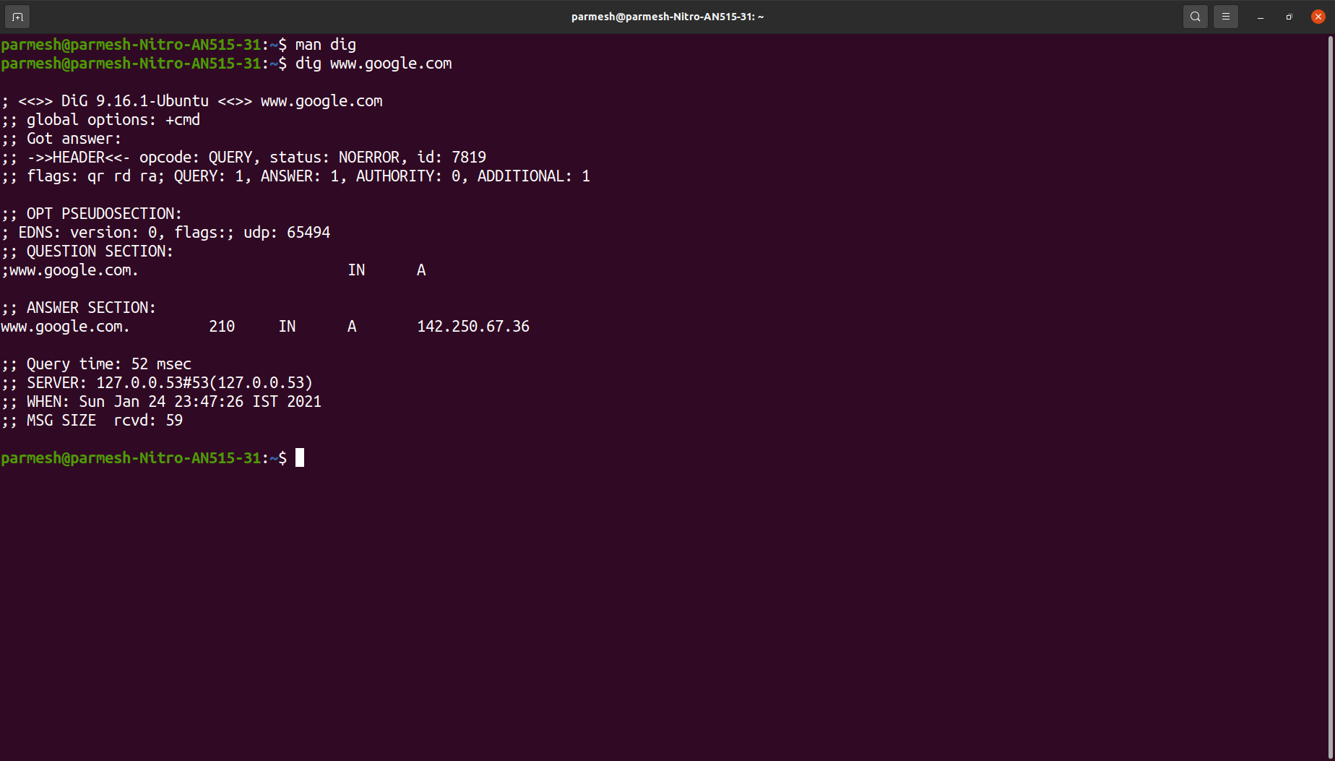

- arp

This command will display the contents of the ARP cache table. Here the cache table has only one entry, and th command shows the name of the host (its address when using the -n flag), its hardware address and the interface it is using.
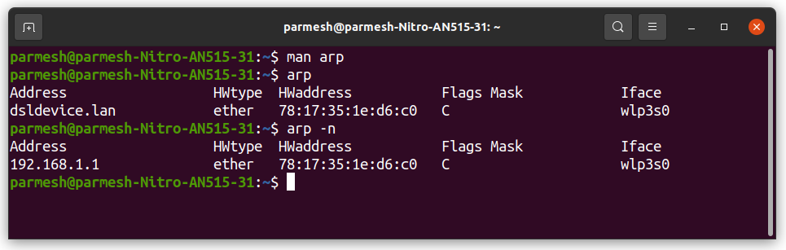

- netstat

This command displays the information of the networking subsystems, like the open sockets, network conections and interfaces. Each row is a new entry and contains details about the corresponding entity.

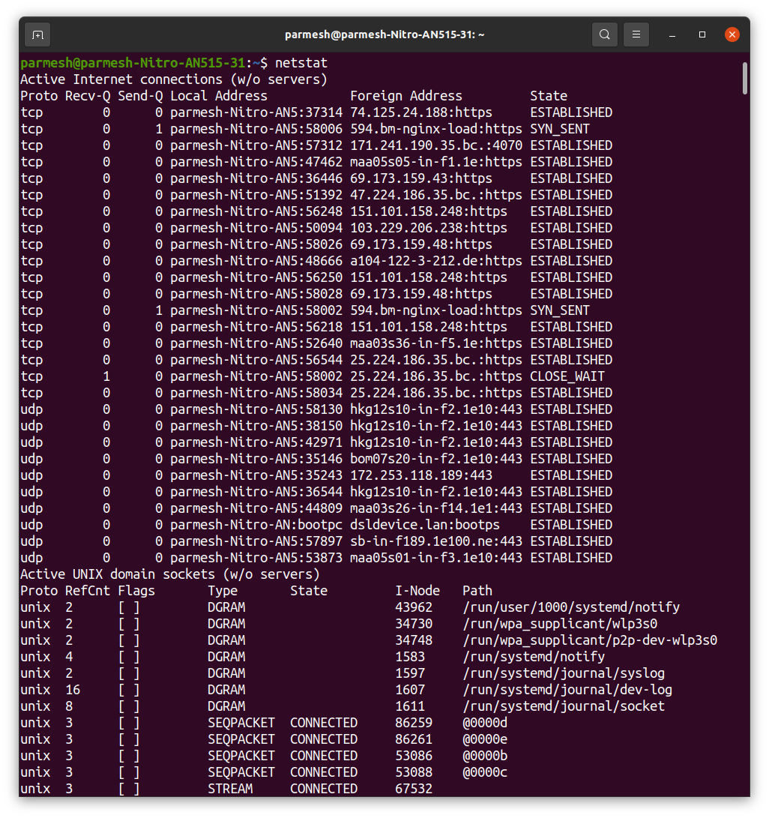
- telnet

- traceroute
This command traces the route to a particular host (www.google.com here). It lists out line by line the addresses that are communicated with before finally reaching the desired address (172.217.26.228).

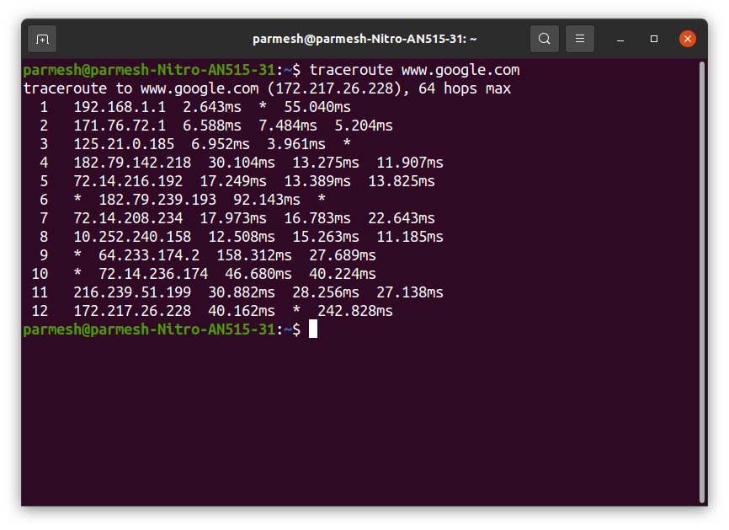

- ping

Using this command www.google.com (IP 142.250.67.196) receives and returns 10 packets of data, each of size 64 bytes (shown in the first column of each row). Each row shows the time delay from sending to receiving the packet (in milliseconds). The bottom row shows aggregate statistics and details of the packets transacted.

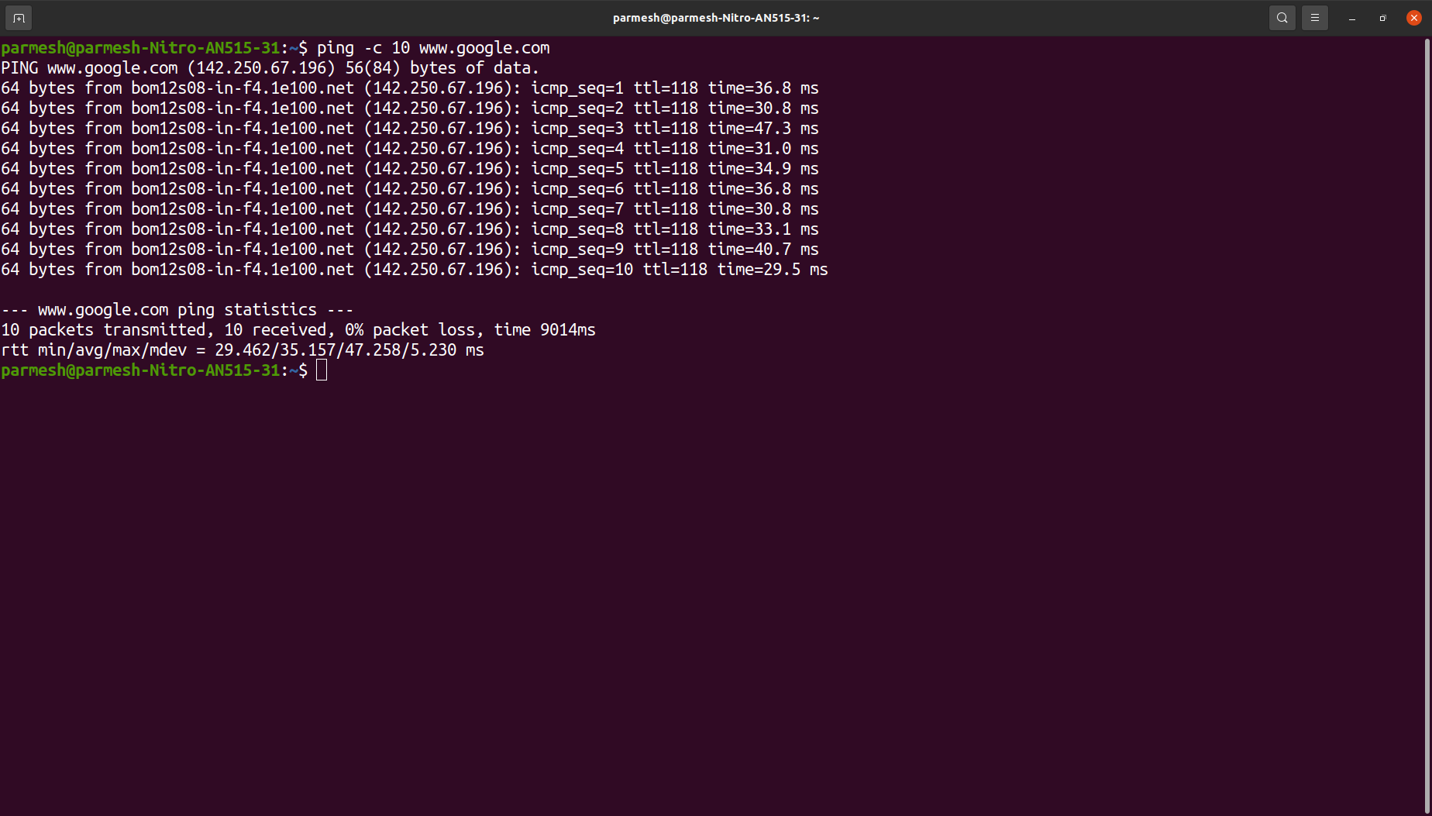

- top

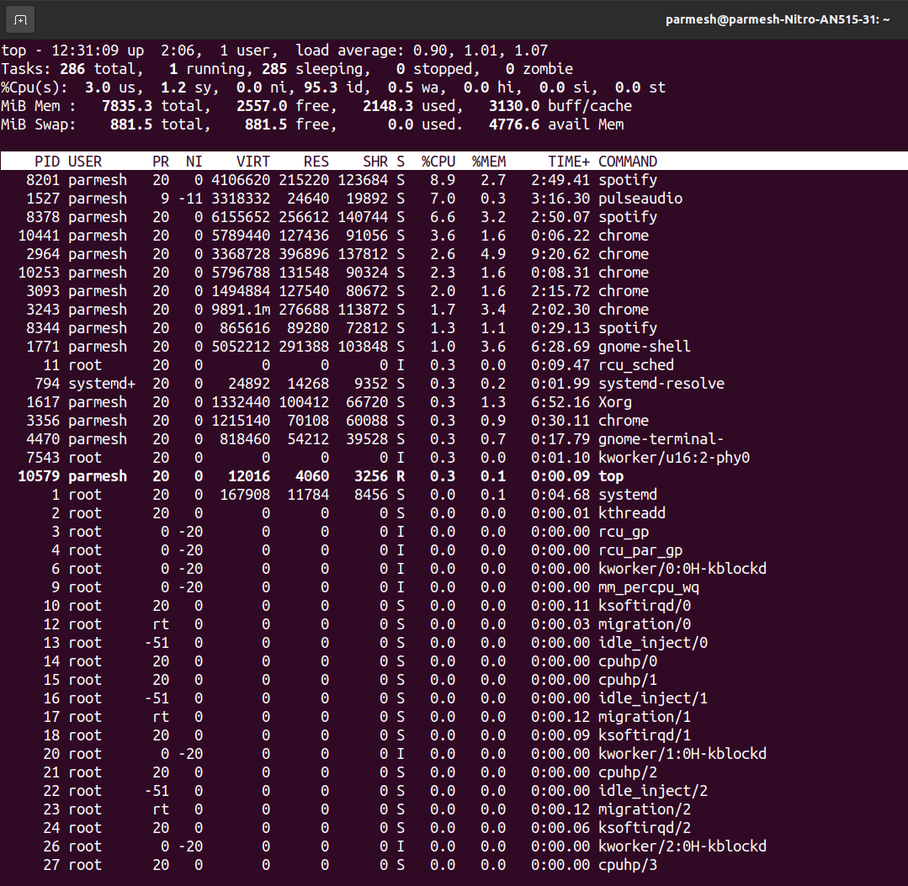

This command shows the state of the computer with respect to the resources being used by active processes. It also lists out some porcesses and their resource consumption details. This system is a single user process, hence USER is either ‘root’ or ‘parmesh’ for most processes.
- wall

- uptime

- nslookup

