Lab 2
Parmesh Mathur 2018A7PS0133G

- See the statistics of TCP and UDP ports on Linux machine

The netstat command enables us to see the statictics (-s flag) of the TCP (-t flag) and UDP (-u flag). The statistics displayed include number of conections opened, failed attempts etc. It also shows information on other TCP/UDP based protocols in the output (e.g. UdpLite, TcpExt ).

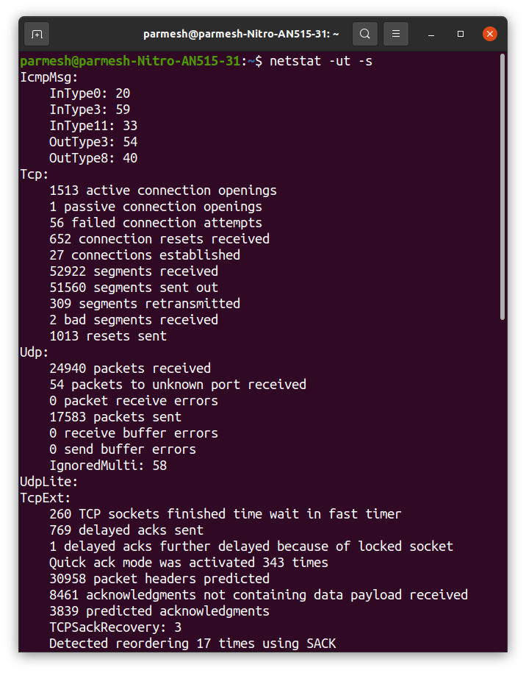

- Enlist the listeing ports on your machine

The netstat command is used to list the ports using the -l flag to filter out only the listening ports (shown in the State column of the outputs). As shown, the output is split into two separate lists, one which shoes ports conected to the internet, and another for UNIX domain sockets.
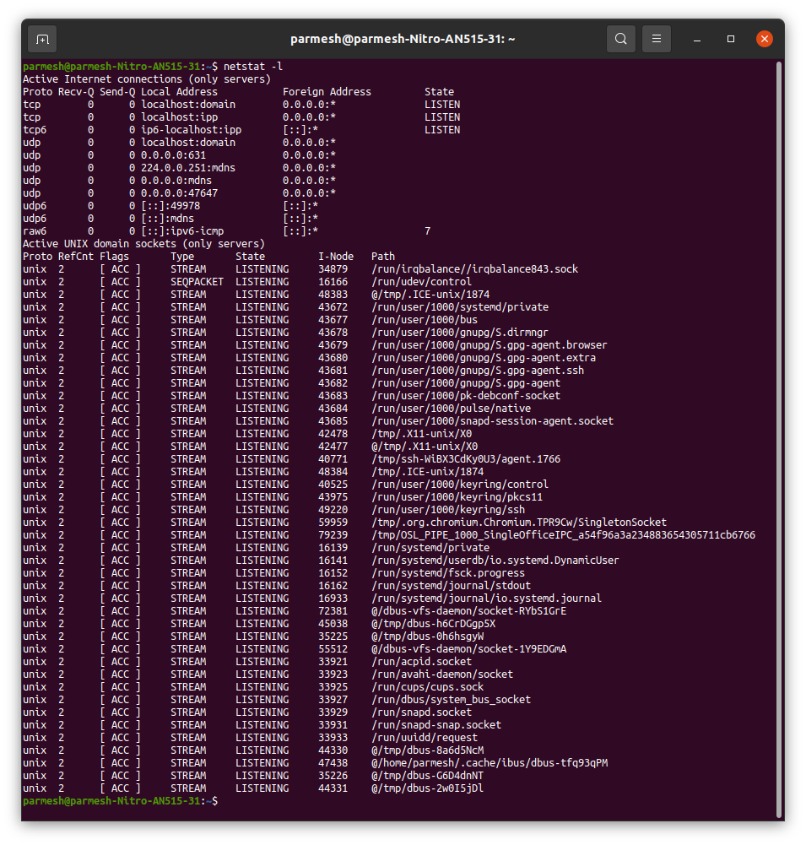

- See the mail exchange (MX) record for www.gmail.com

The -query=mx option of nslookup is used to obtain the mail exchange records for any domain (specified in the command itself as shown). This command lists out the SMTP servers that handle the traffic for the domain.

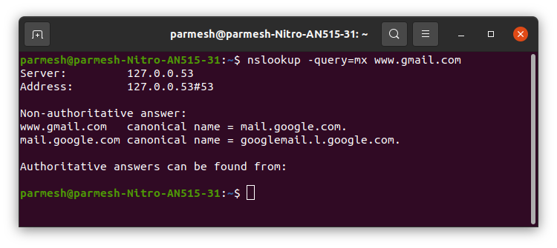
The command doesn’t work for www.gmail.com, but works for gmail.com, listing out the required server names.

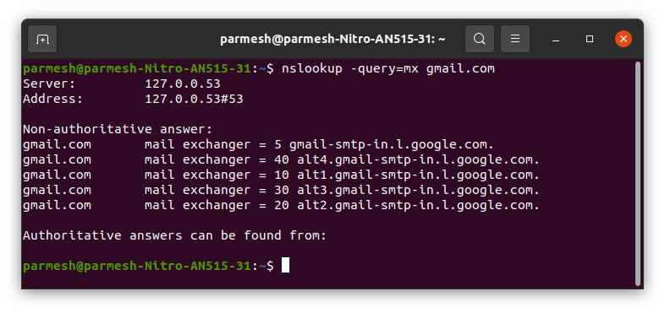

- Display the all network interfaces on your machine

The ifconfig command is used, which lists all the interfaces on the machine using the -a flag, and other statistics entailed by each of interface.
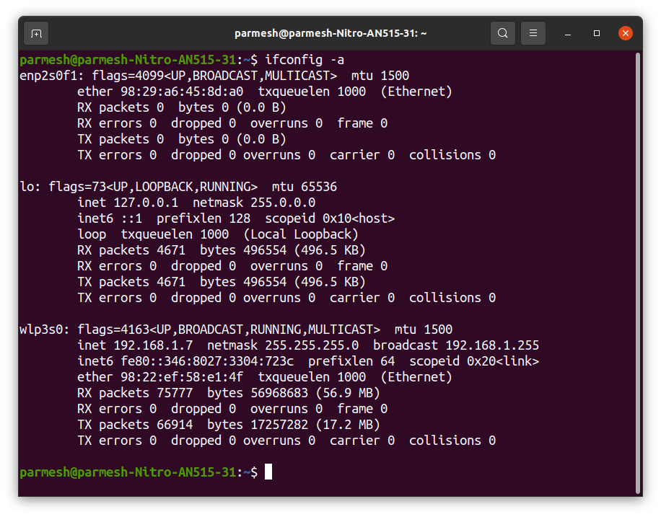

- A list of intermediate routers to reach 8.8.8.8 from your machine, with latency

The traceroute command is used to look up the intermediate addresses that are accessed to reach a particular host (passwd as an argument with the command). The latency for each step is individually in each row, in the latter 3 columns, which show the time for 3 separate packets.

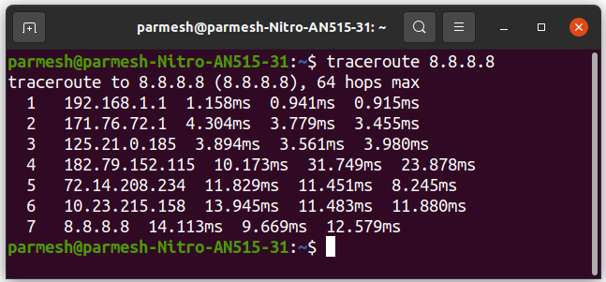

- Send 10 echo requests to 8.8.8.8 server from your machine

We use the ping command with the -c flag to limit the number of requests to 10. This command sends ICMP echo requests to the address passed in the argument.
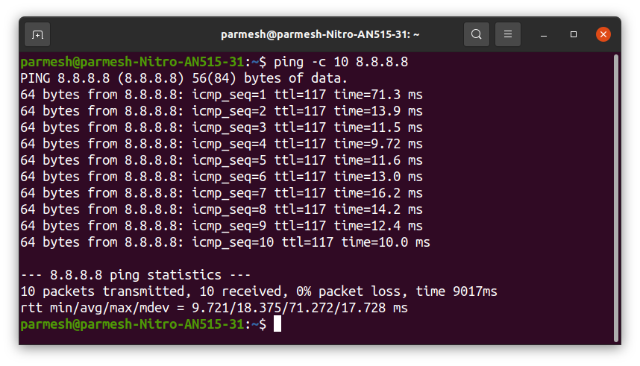

- Get the IP address of www.bits-pilani.ac.in domain

The nslookup command can be used to return the IP address for any domain. The site is hosted on two different servers and hence two different IP addresses are shown (under the Non-authoritative answer).

