Lab 3
Parmesh Mathur 2018A7PS0133G

- Customizing Wireshark

Wireshark can be customized to suit our own needs. General customization in Wireshark includes adding, removing, hiding or editing details of columns in the viewing space.

Here, the No., Protocol and Length columns have been hidden. We have added columns for the Source and Destination ports, and those for HTTP hosts and HTTPS server names of packets (entries for which are empty in most cases as not all packets have HTTP either attribute).

The Time column has been changed to show in UTC.

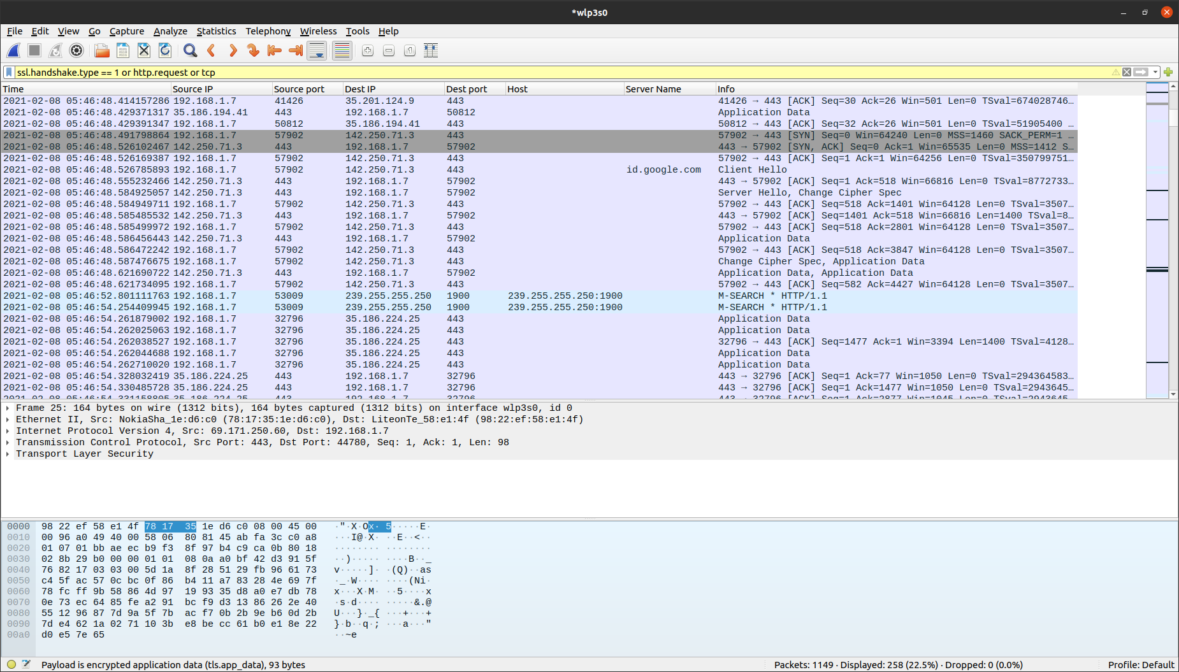

Note: A filter has been used here to shorten the output list. This was done to show frames with hosts and server names in one window of output of the application itself.

- Wireshark dump analysis

  - Identify the HTTP request packets.

The http.request filter is used to list out HTTP request packets.

As shown in the information column, HTTP requests entail actions like GET (among others like PUT, WRITE). It is also noticeable that the Source IP for these requests do not vary a lot as these packets originate in the system itself.

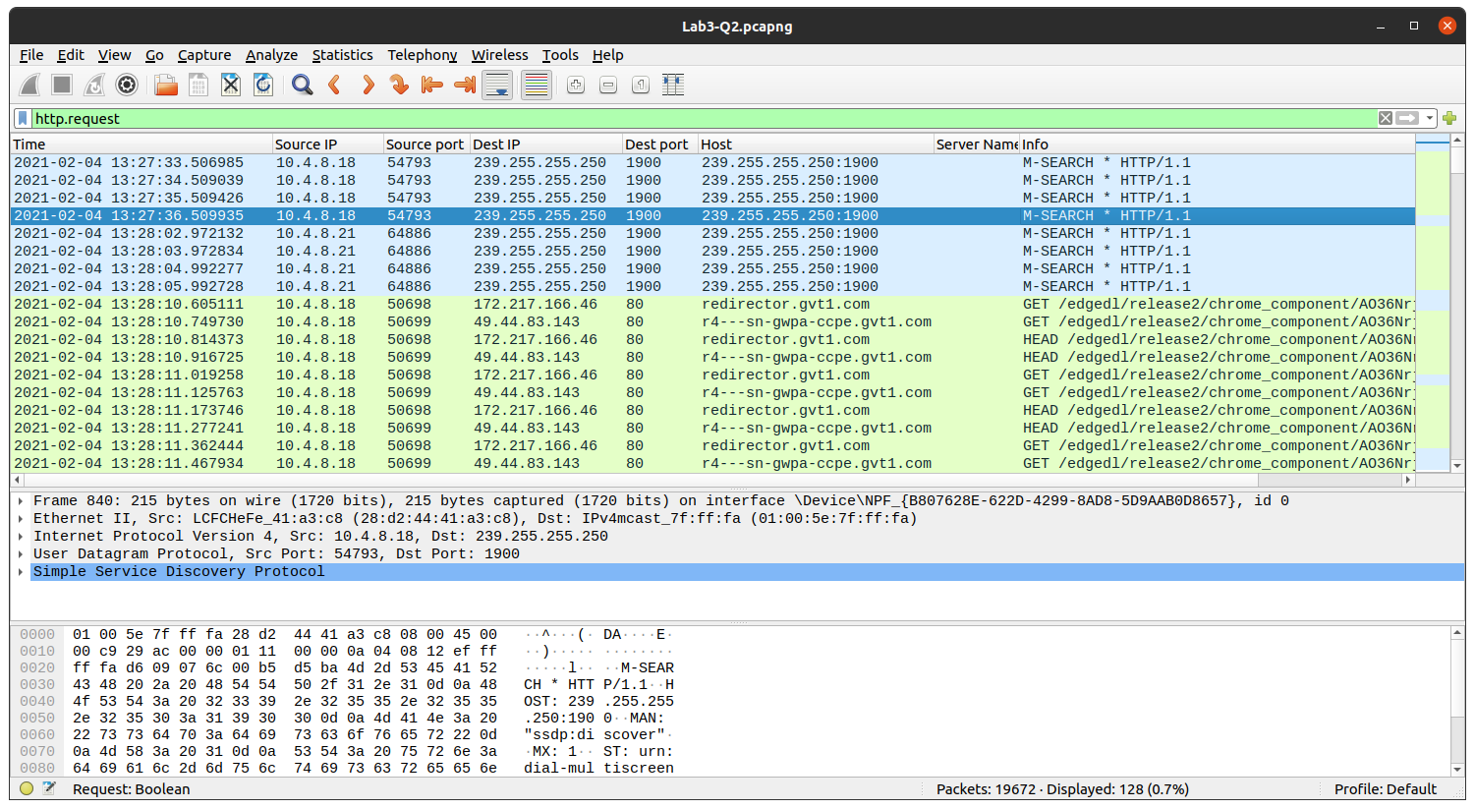

  - Identify the HTTP response packets.

The http.response filter is used to identify HTTP response packets.

As is visible, a majority of these responses are in the form of acknowledgement messages (e.g. OK, Found), while some might be of the form of denial/rejection of requests. As shown, the Destination IP of these packets are the same, indicating they are addressed to a particular address (the particular system, in this case).

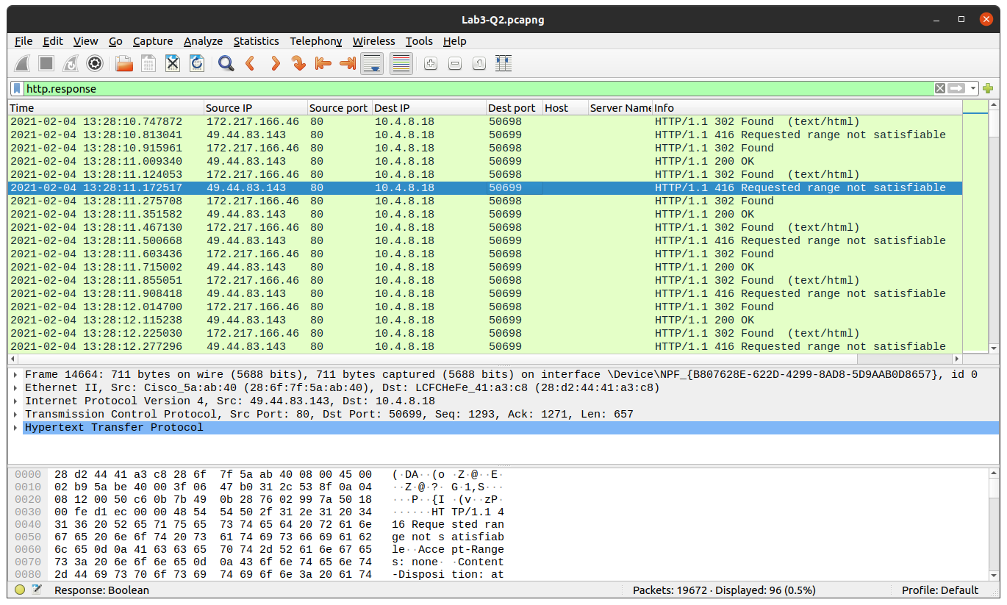

  - Display the statistics of the TCP and UDP packets

The filter used is tcp || udp, which is a logical or of the tcp and the udp filters.

To collect the staistics for these packets, we use the Statistics menu in Wireshark. From here some statistics to display are Throughput (from TCP Stream Graphs) and UDP Multicast Stream.

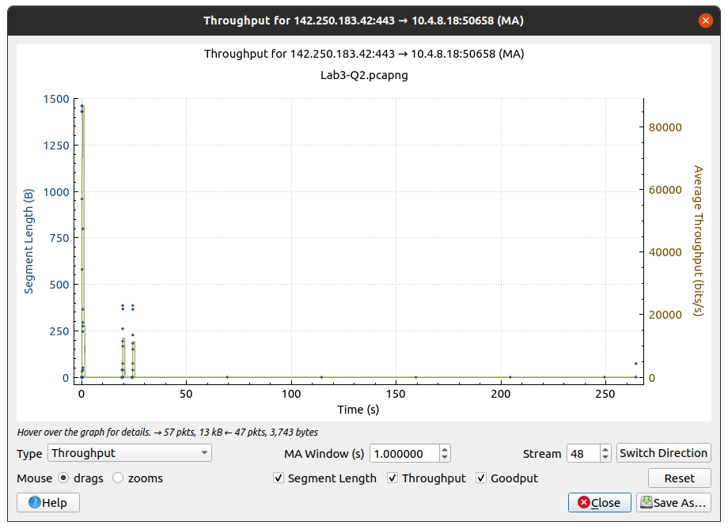
The Throughput Graph available in the TCP Stream Graphs option

P.T.O.
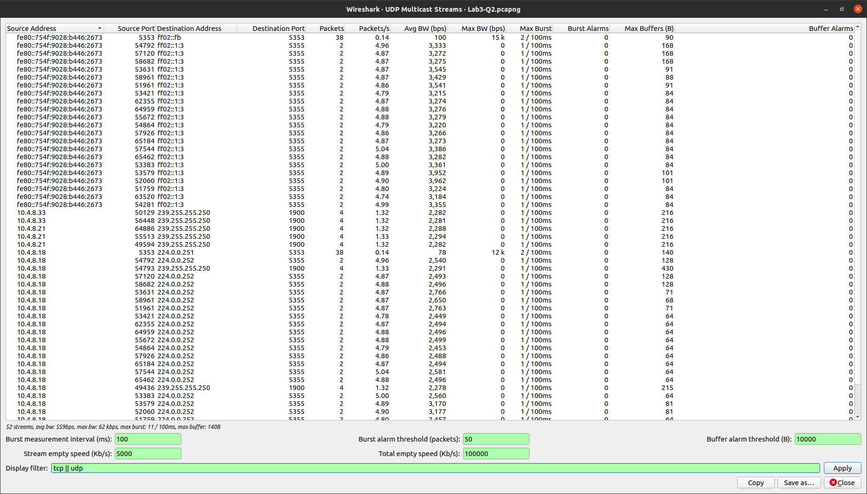

The UDP Multicast Streams statistics

  - List out the TCP packets whose syn. and ack. flags are on

The filter used here (tcp.flags.ack==1 && tcp.flags.syn==1) is a logical and of two separate filters (tcp.flags.ack==1) and (tcp.flags.syn==1).

As is visible, the Info column shows both [SYN, ACK]; signifying a connection being initiated, and the packet has been received succesfully, respectively.

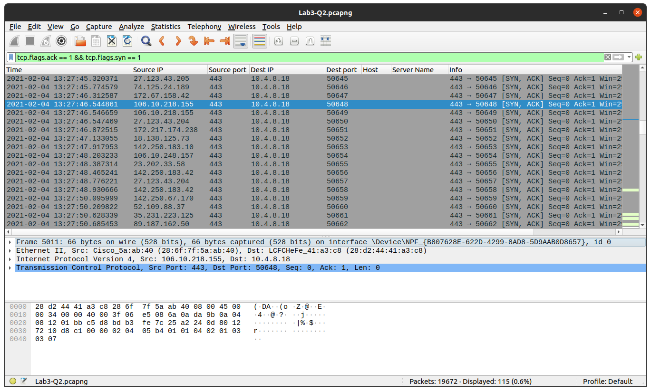

  - List out the TCP and UDP packets where destination port = 80

The filter used here, tcp.dstport == 80 || udp.dstport == 80, is also a logical combination of two separate filters.

As expected, the column for the Dest port shows number 80 for all the packets. This is also visible in the Info clumn, which displays both the Source and Destination port number.

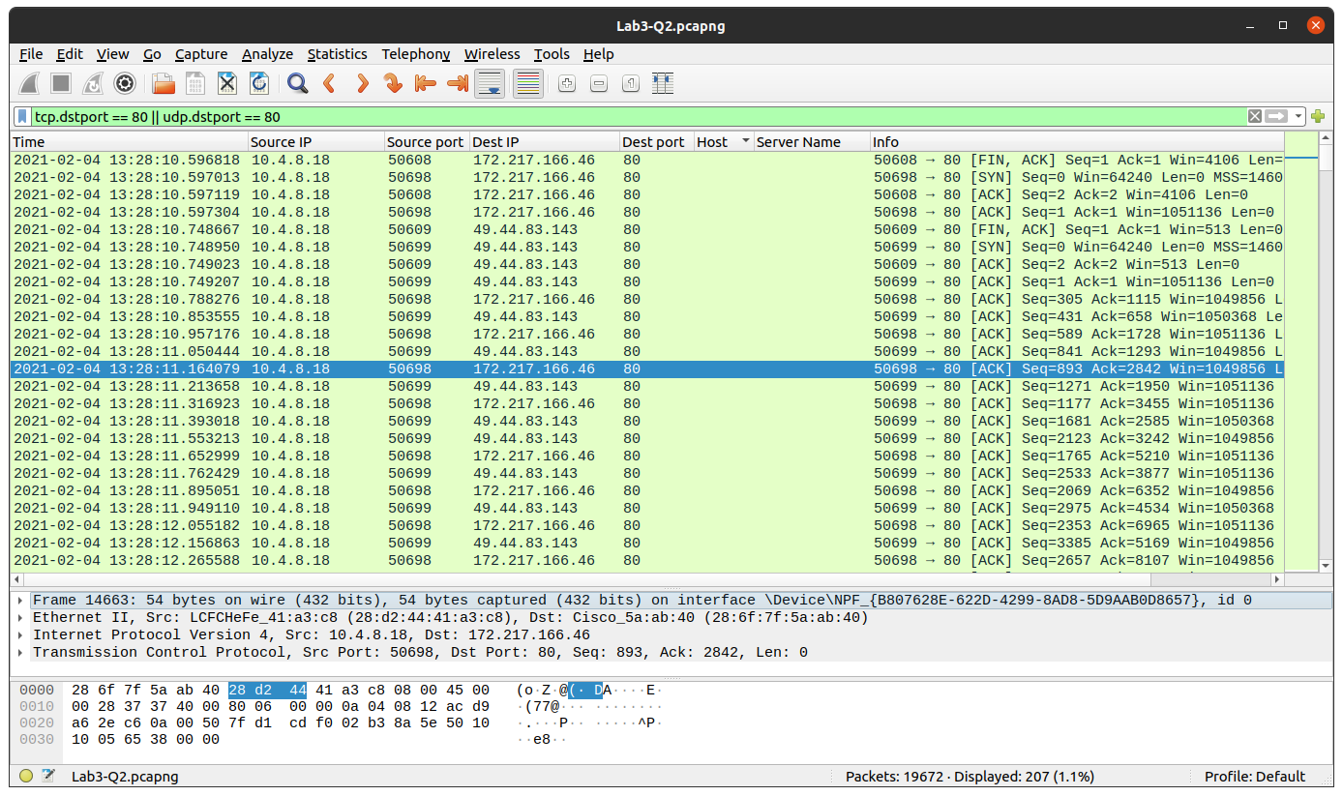

  - List out the ARP packets

The arp filter is used here, to list out packets following the Address Resolution Protocol.

The Info column shows more information about the communication taking place with each packet.

