Lab 5
Parmesh Mathur 2018A7PS0133G

When the server is not running client does not connect to it.
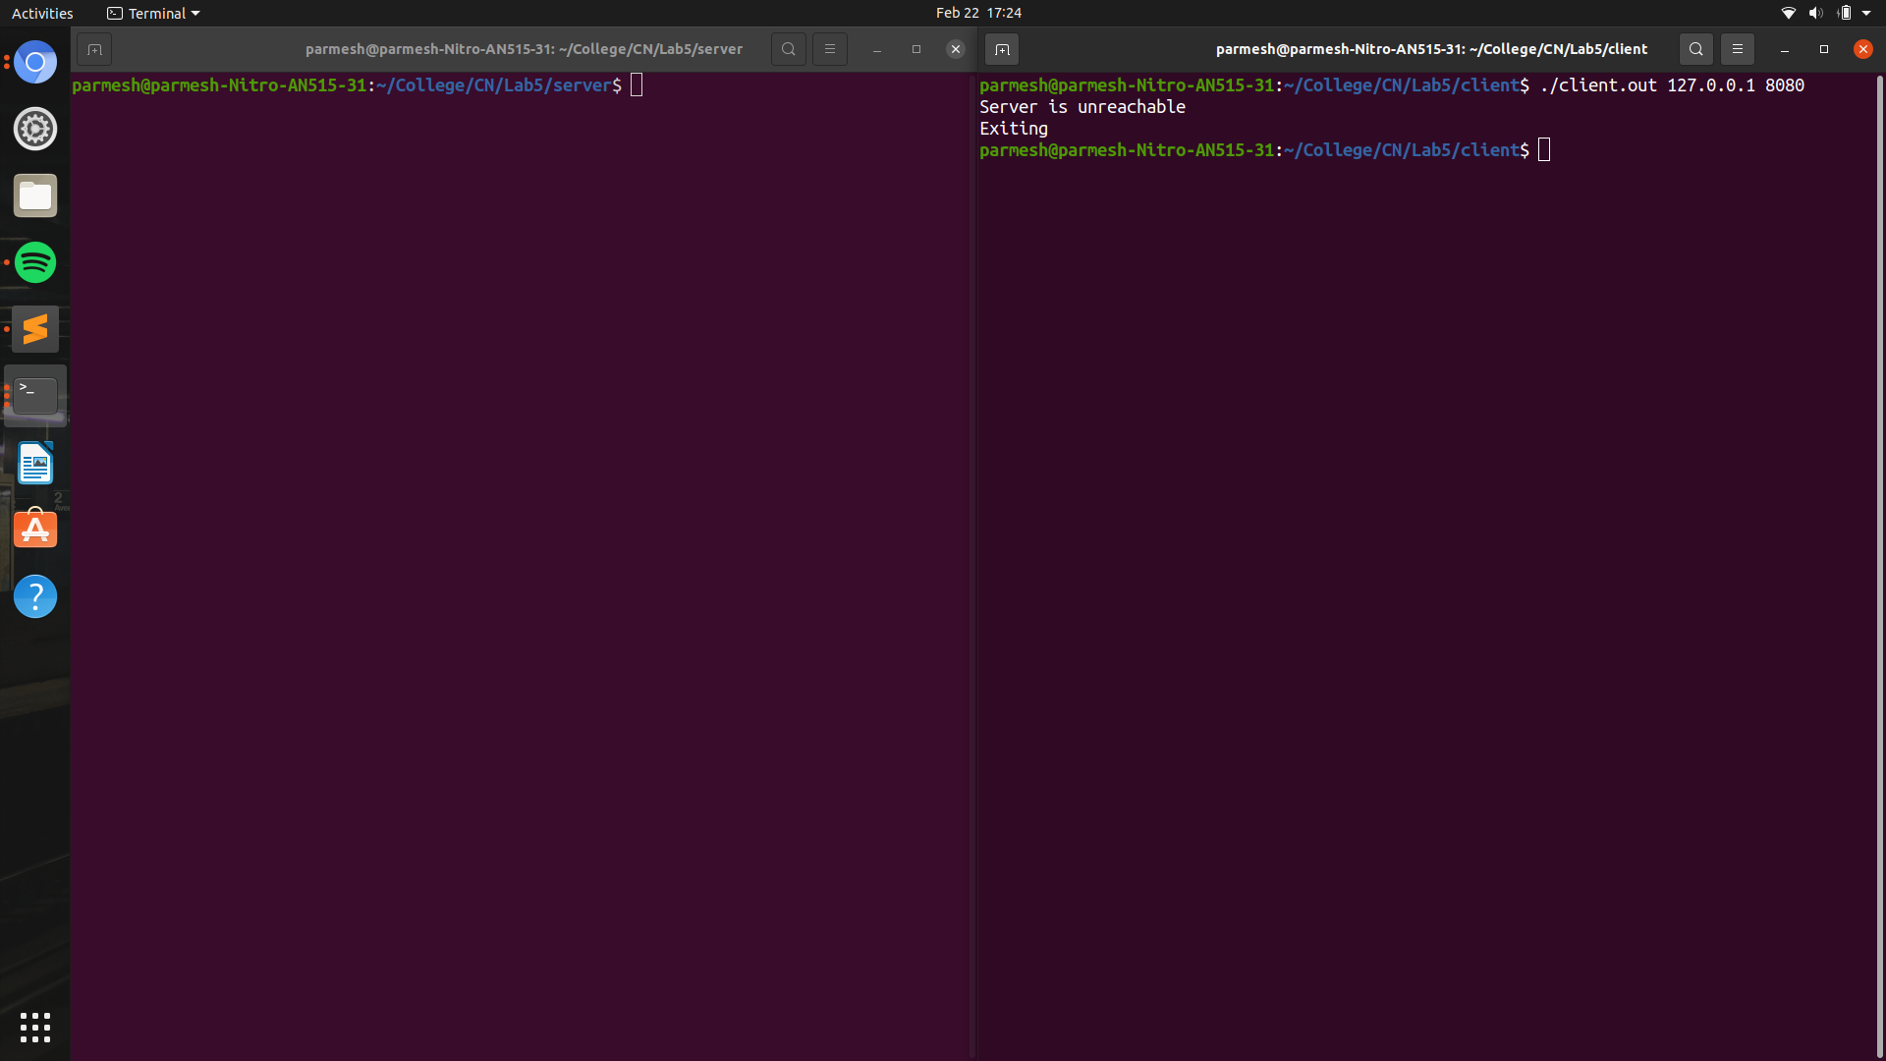

P.T.O.

When the client asks for particular file (or multiple files), ther server responds to it (them, one by one). It copies 10 bytes (or fewer, depending on how many bytes the original file contains) and return the message.
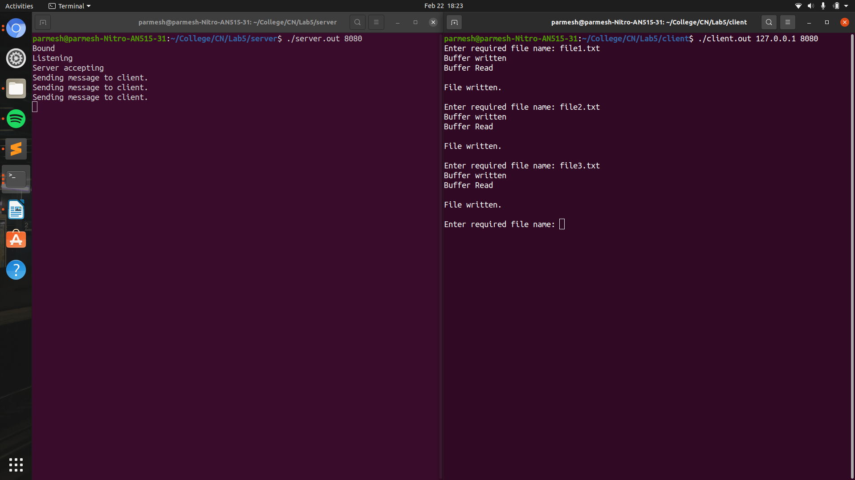

P.T.O.

When the client requests a file that does not exist in the server directory, it returns an empty message
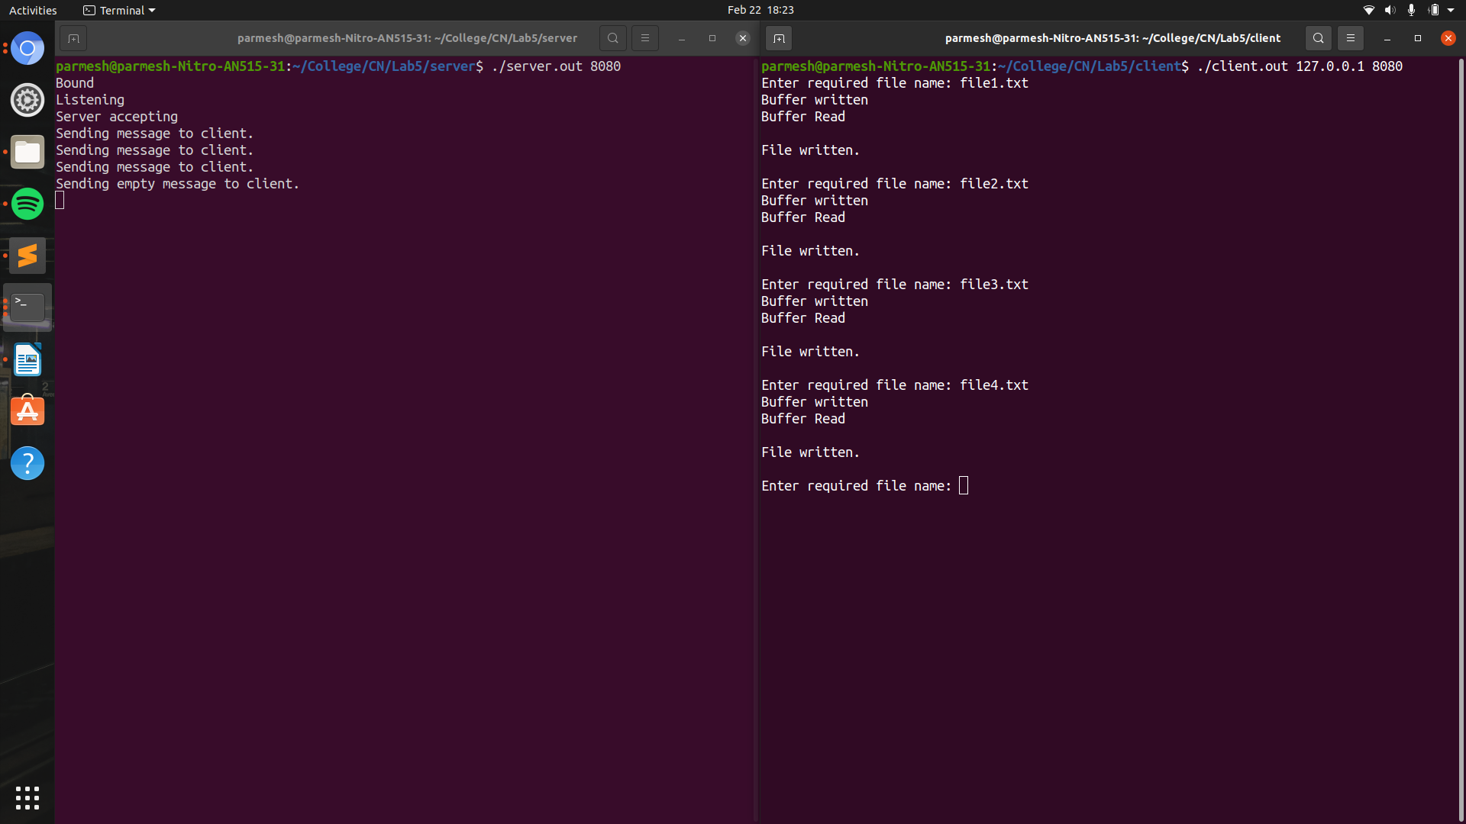

P.T.O.

After the programs have been run, the requested files’ copies have been made in the client directory.
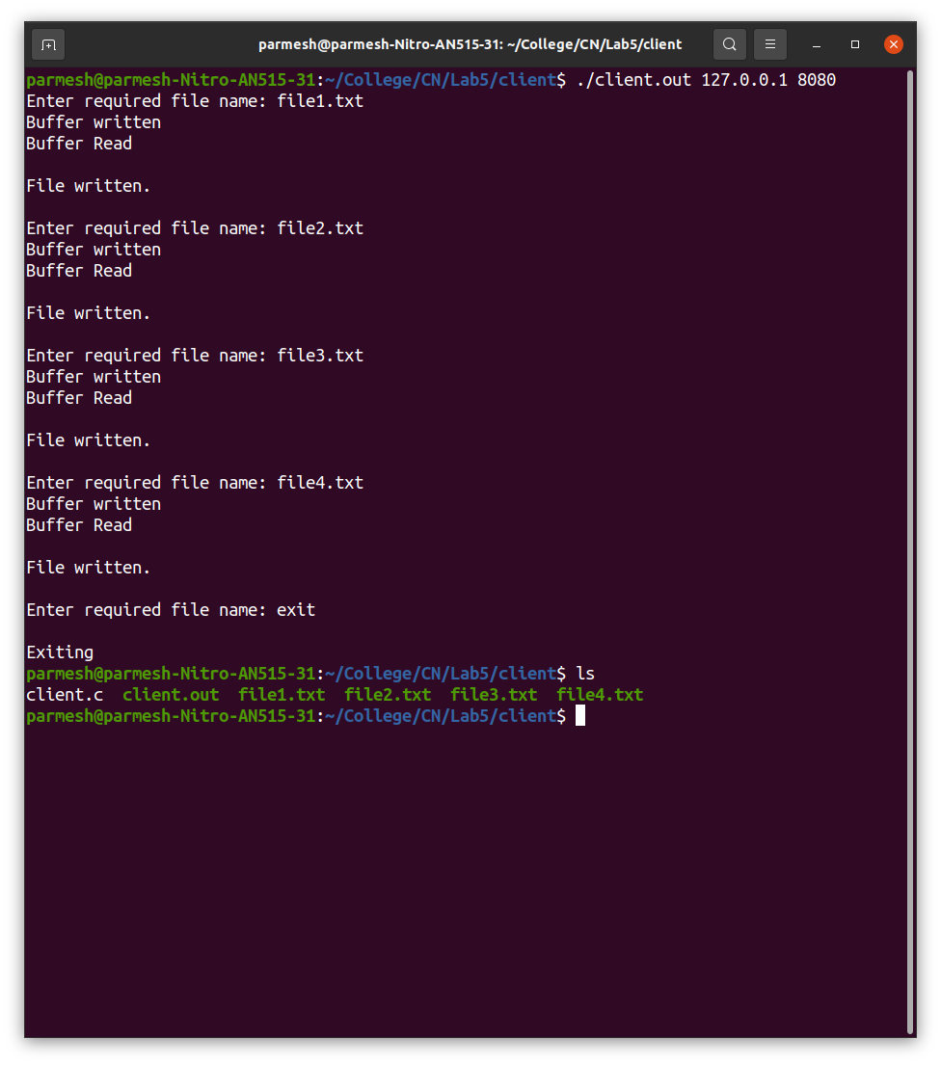

Please refer to README for intstruction to run the processes.

