Lab 6
Parmesh Mathur 2018A7PS0133G

1. The server accepts the port number it should bind to as a command line argument.

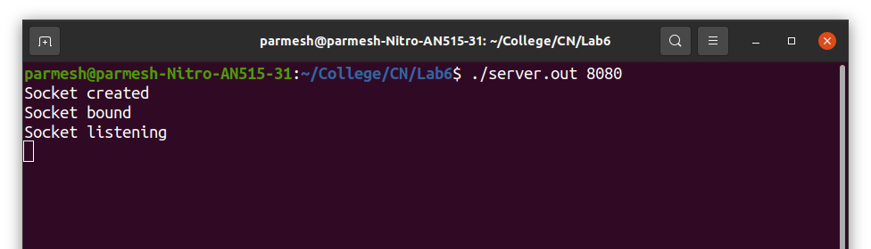

2. The client accepts the IP address and port number (in that particular order) where it will find the server.

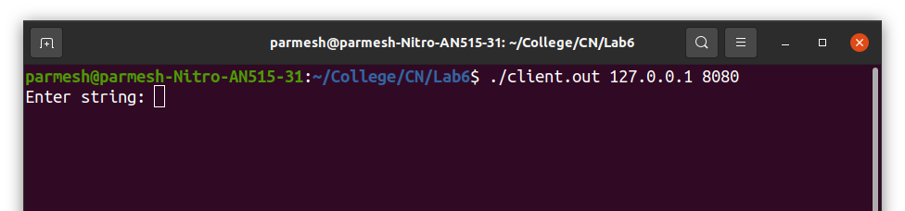

P.T.O.

3. After connecting to the server, the client reads a line from standard input (user) and sends it to the client.

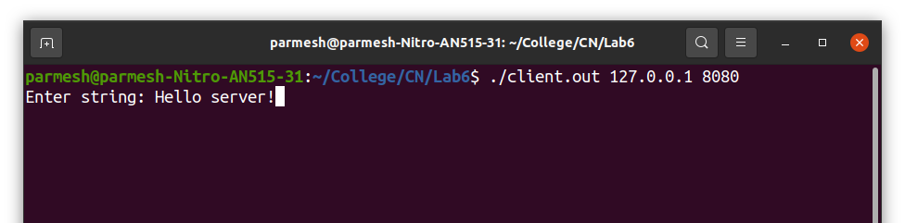

4. The server prints the received line from the client in reverse order.

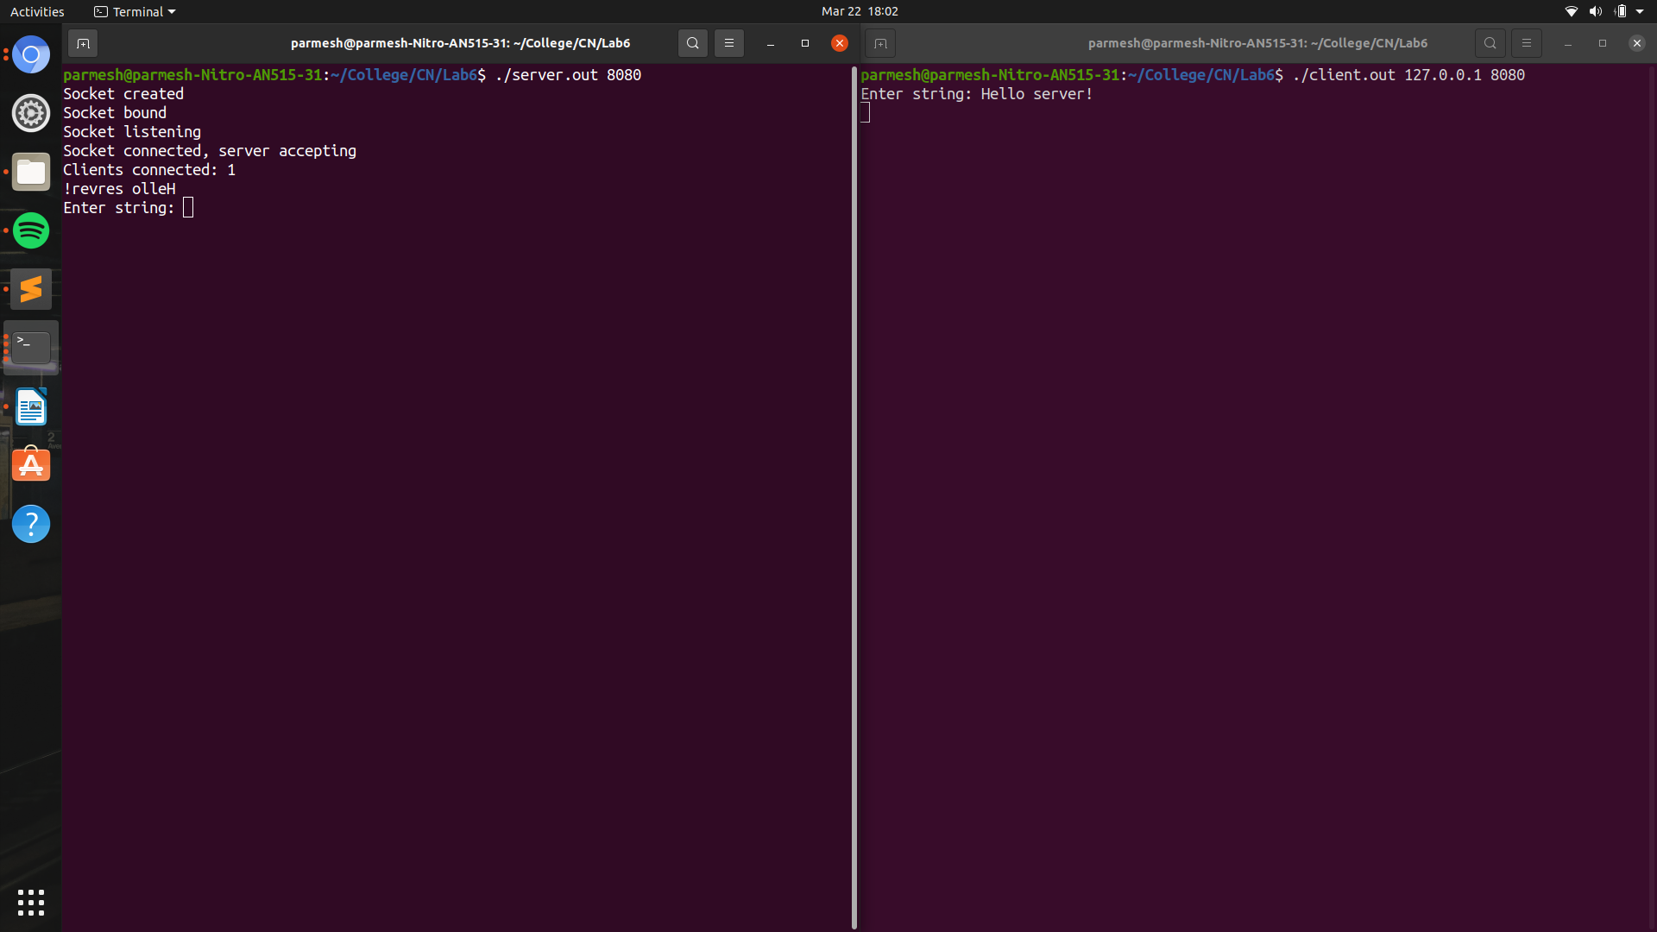

It reads a line from standard input (user) and sends it to the client.

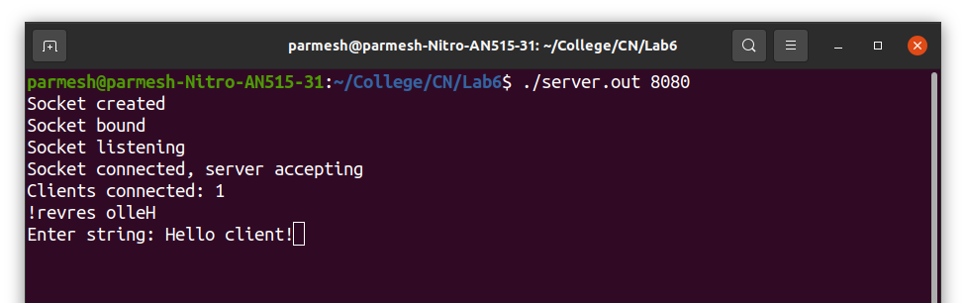

5. The client prints the received line in reverse order and is ready to accept a new line from the user.

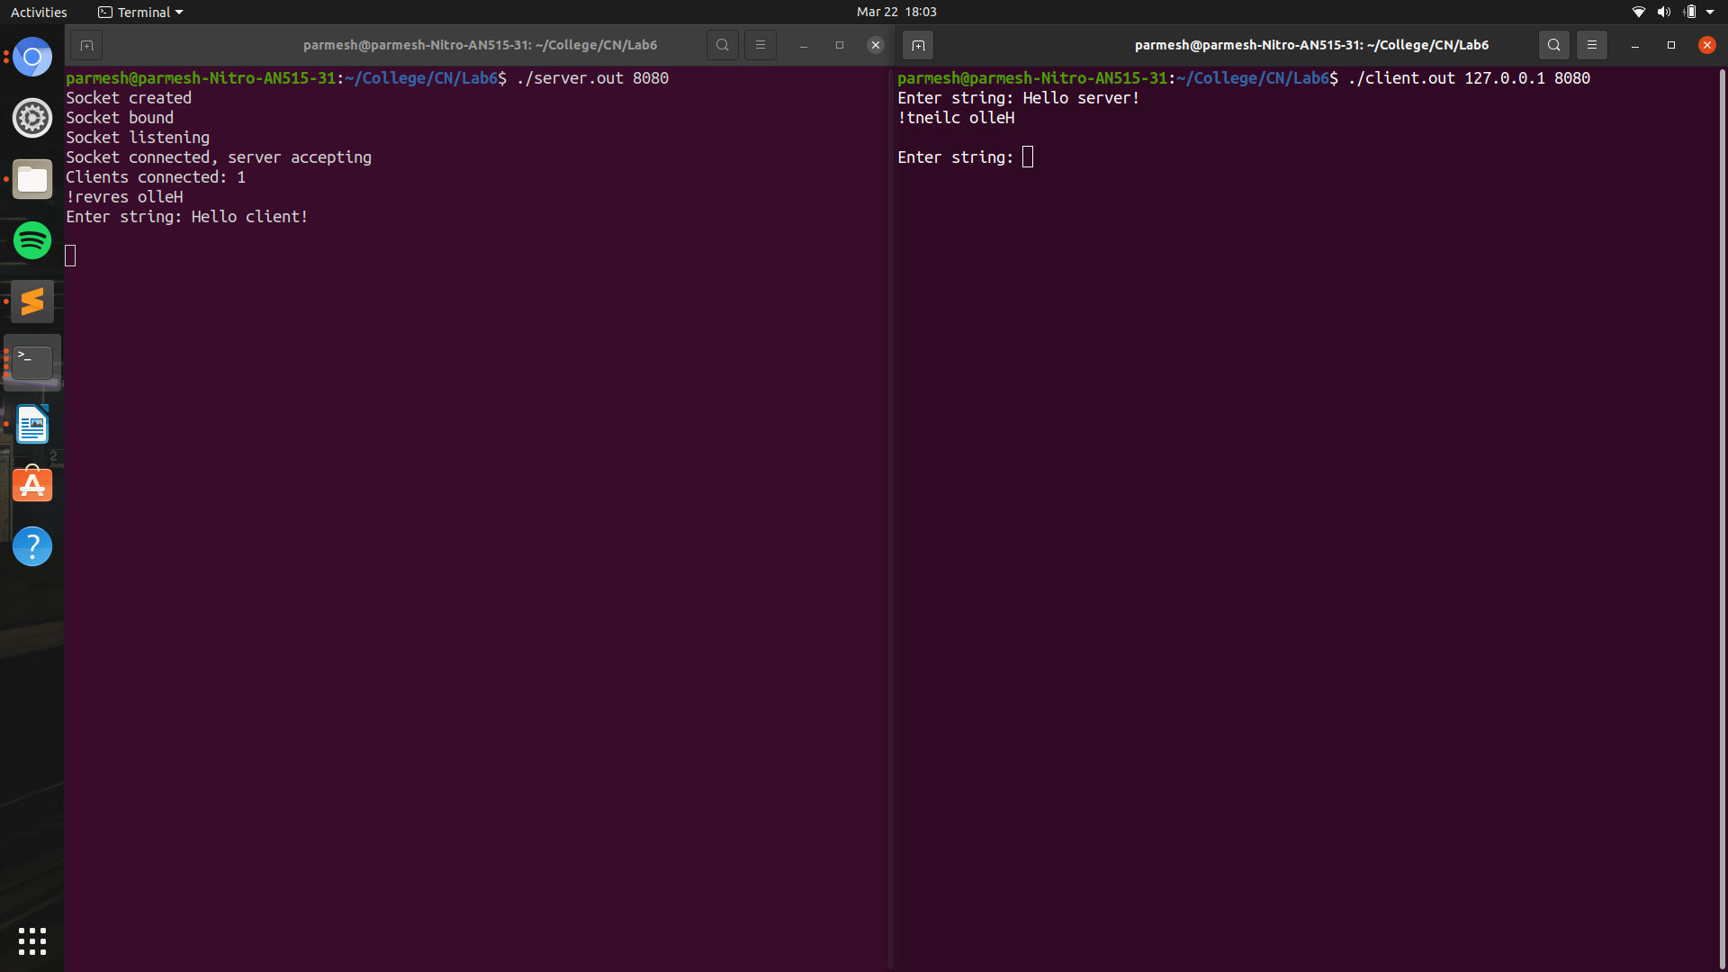

6. The client exits if the user types in “exit”.

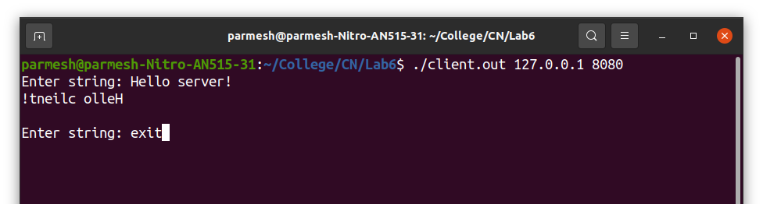

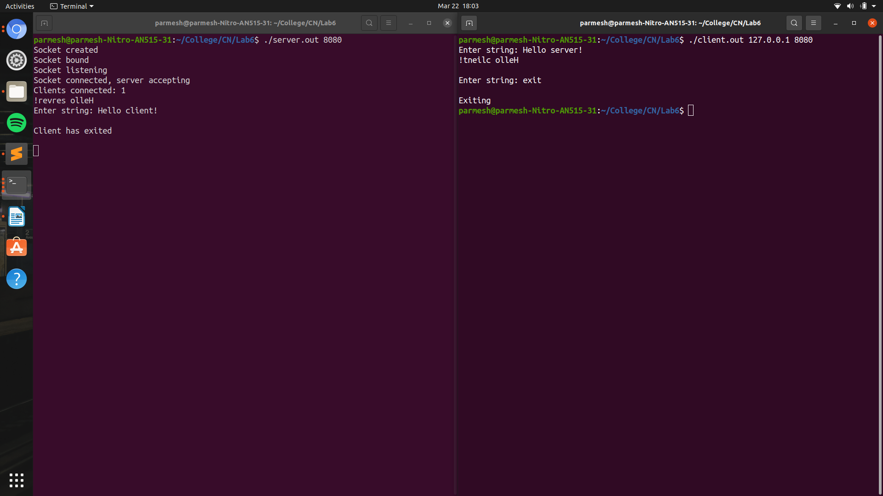

7. The server can accept upto four clients at a time.

1 Client

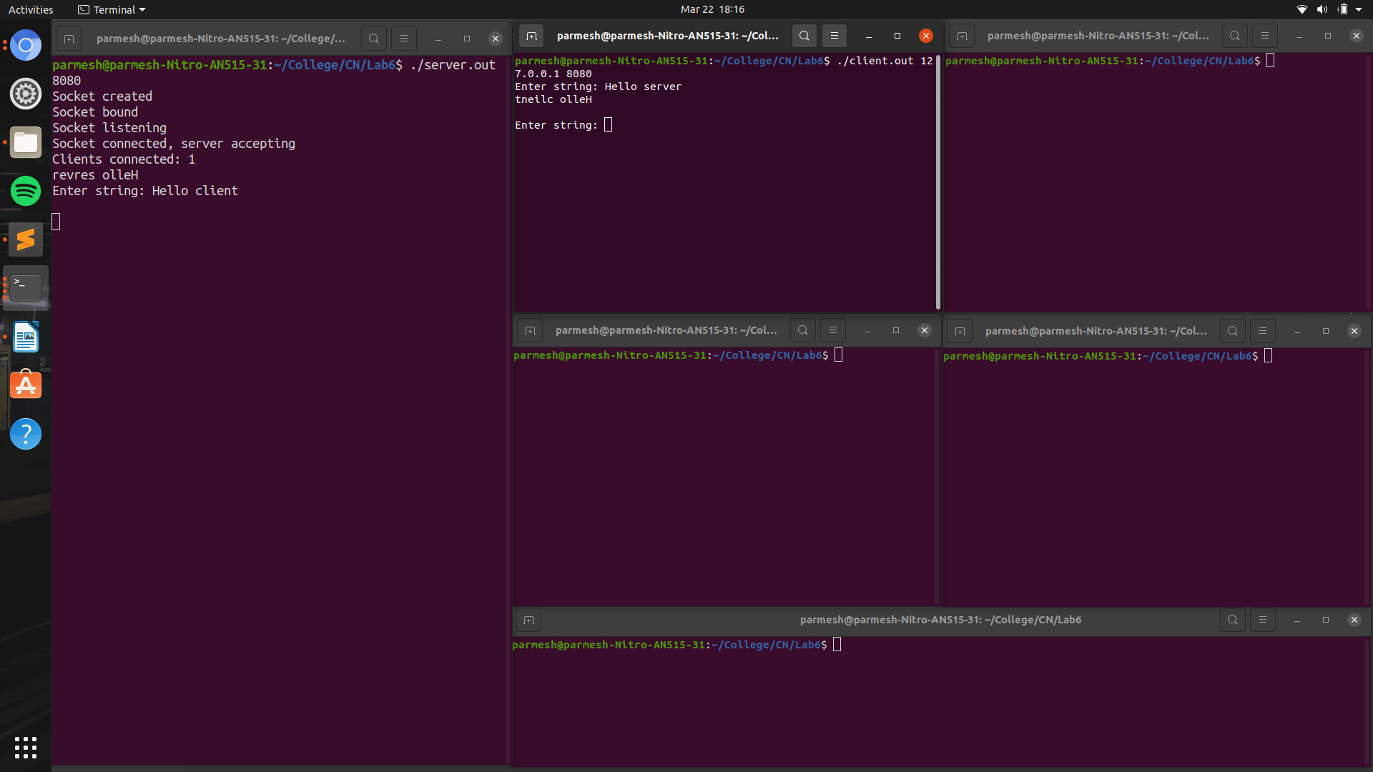

2 Clients

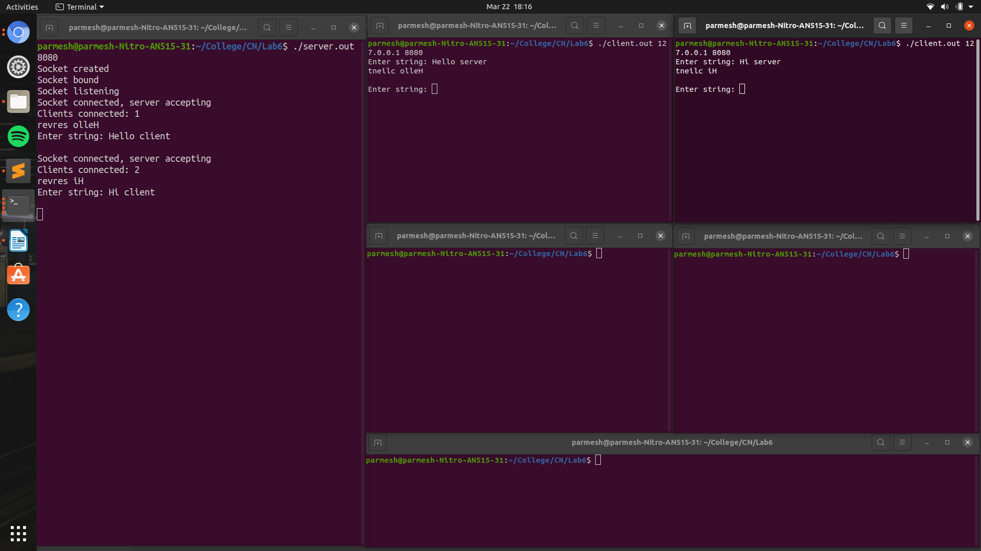

3 Clients

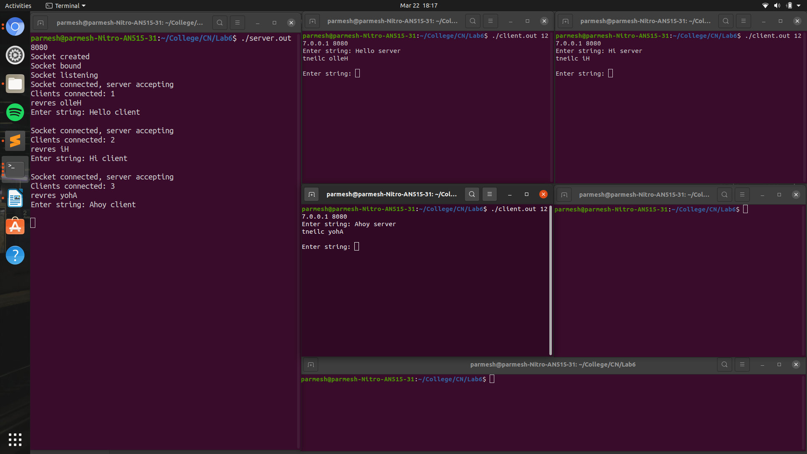

4 Clients

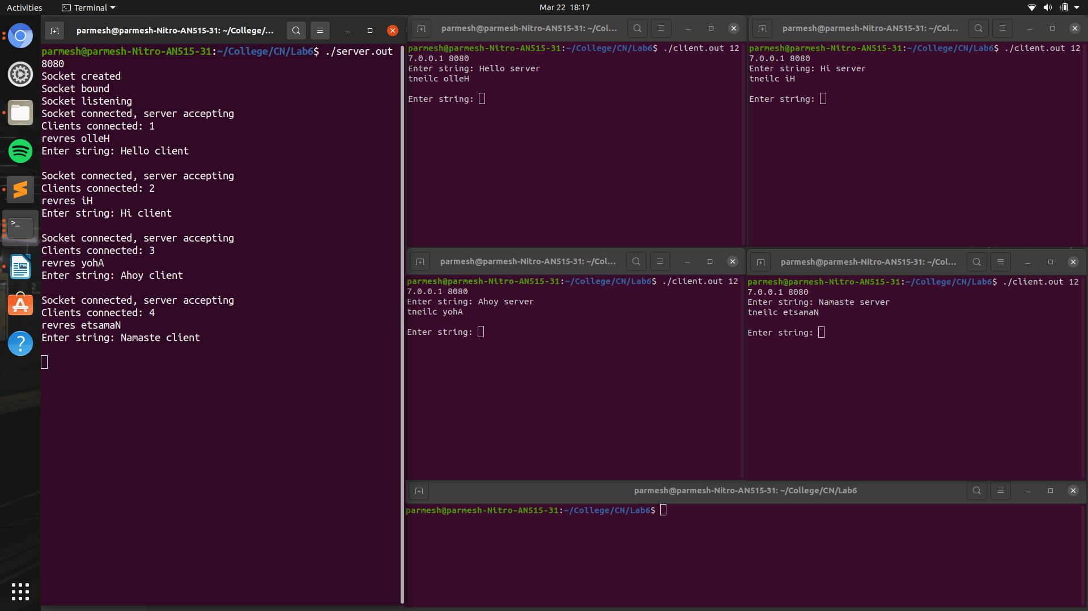

Any client above the limit is rejected.

5th client is rejected.

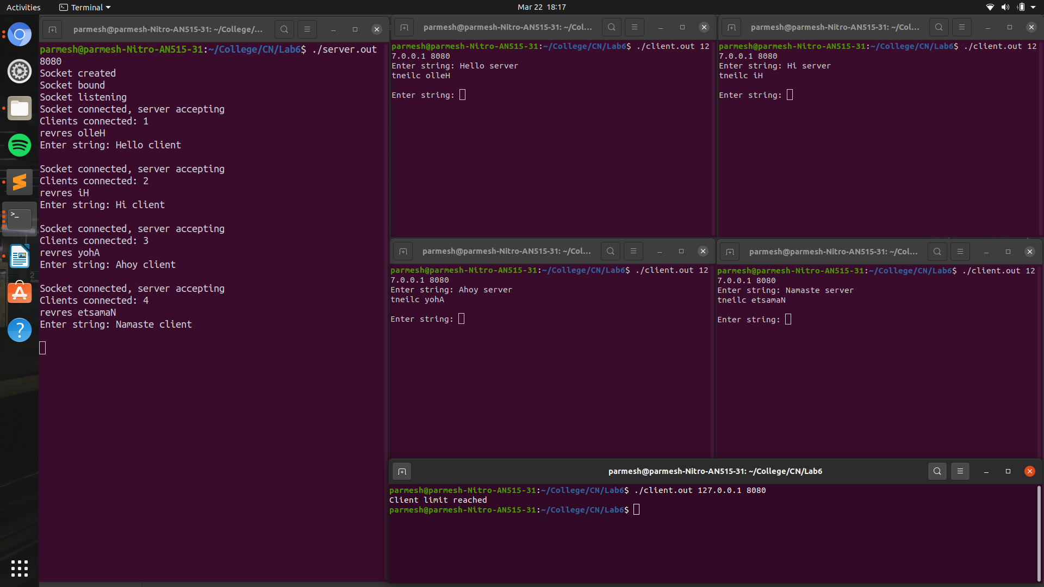

P.T.O.
As long as the number of clients is lesser than the limit, the summer accepts new clients. For example when a client exits, another can join.

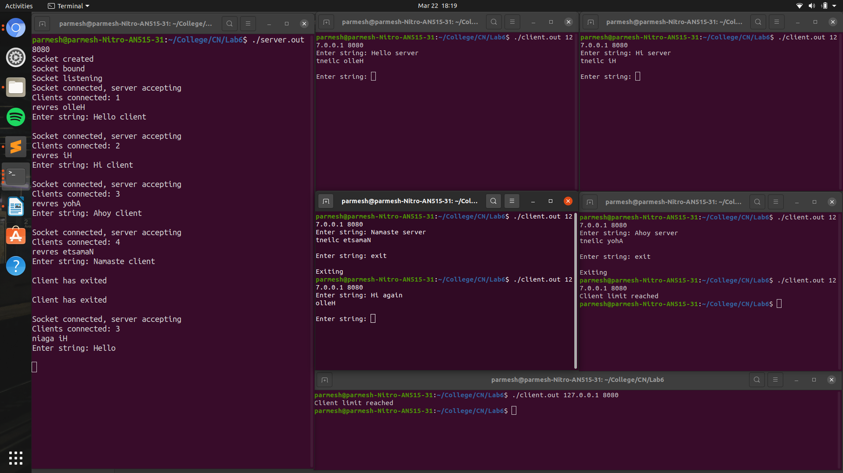

For example when a client exits (in the above case 2 clients exit), another can join.

P.T.O.

If another client sends a message to the server before it can reply to the previous client, the lines messages from the server are sent to the clients in which they contacted the server.

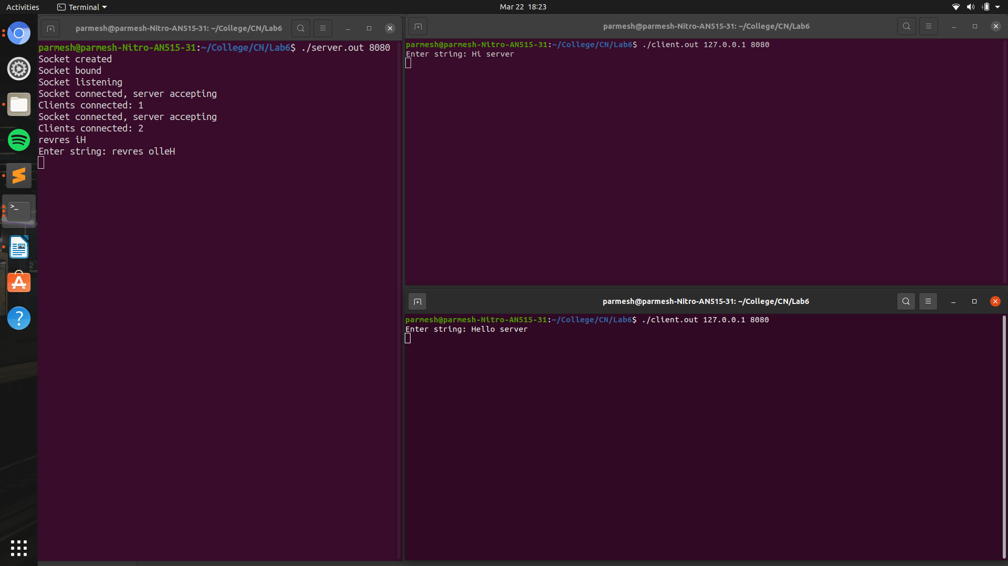

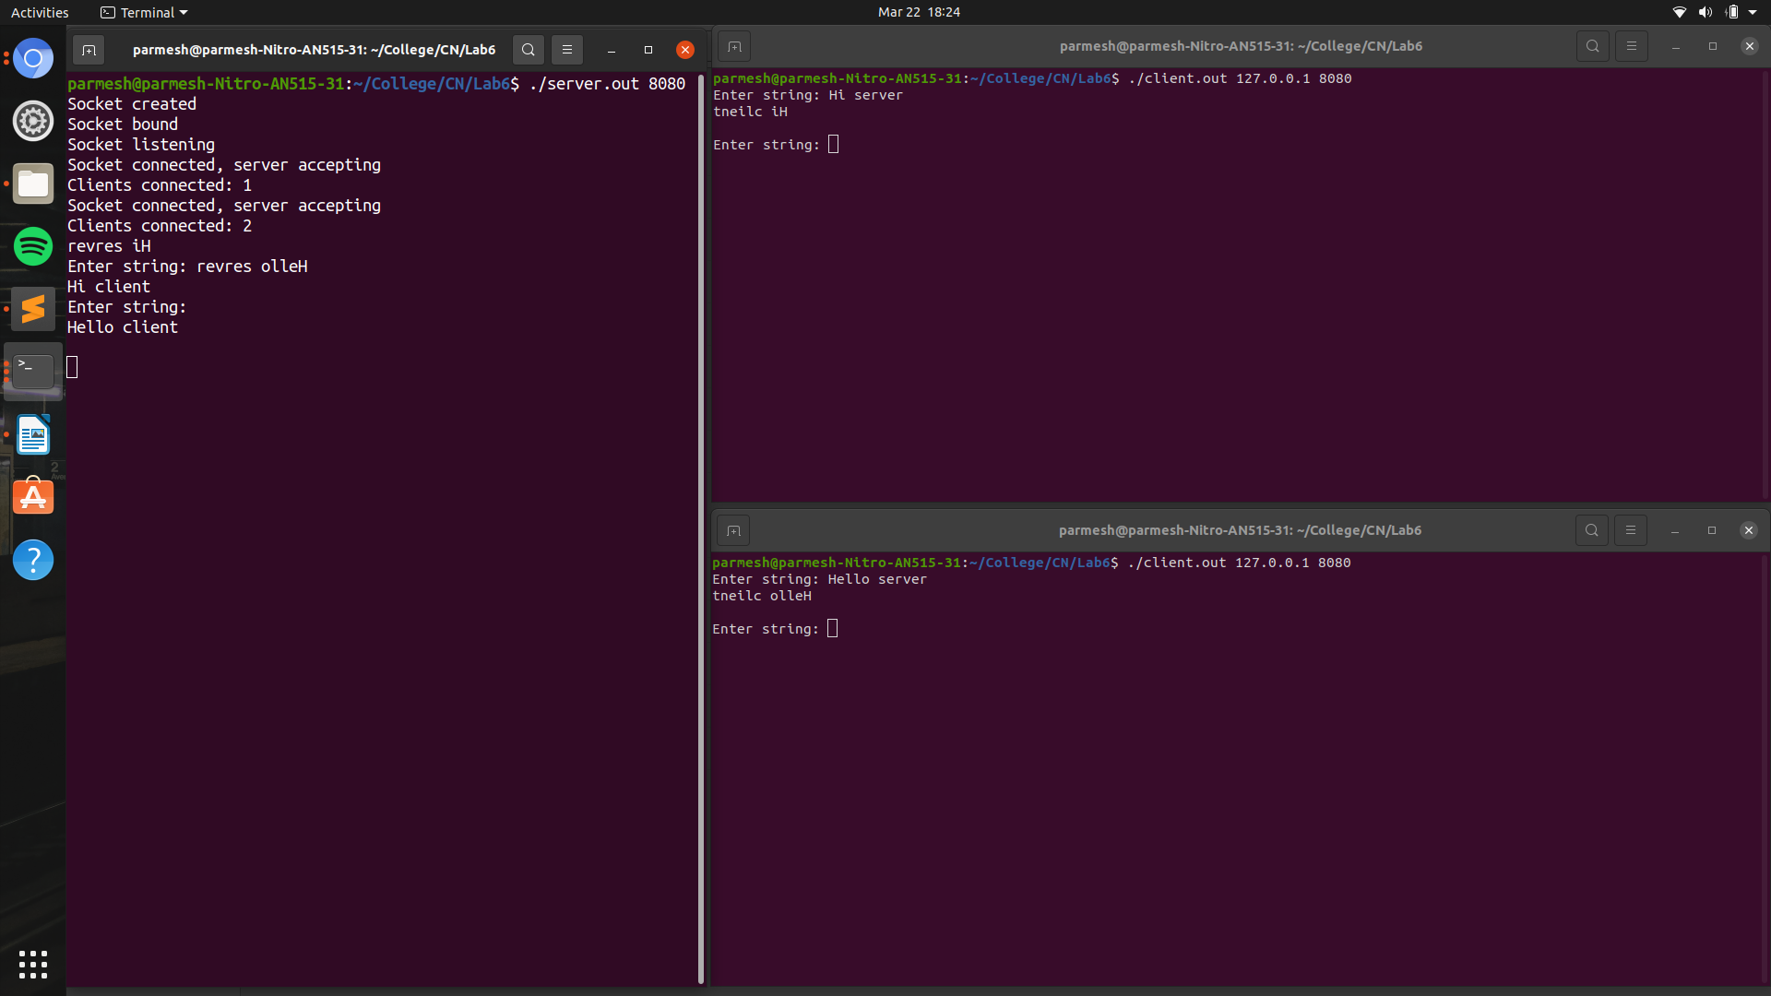

When the user types “exit” in the server’s standard input on its turn to enter a sting, that particular connection with that client is terminated and that client exits.

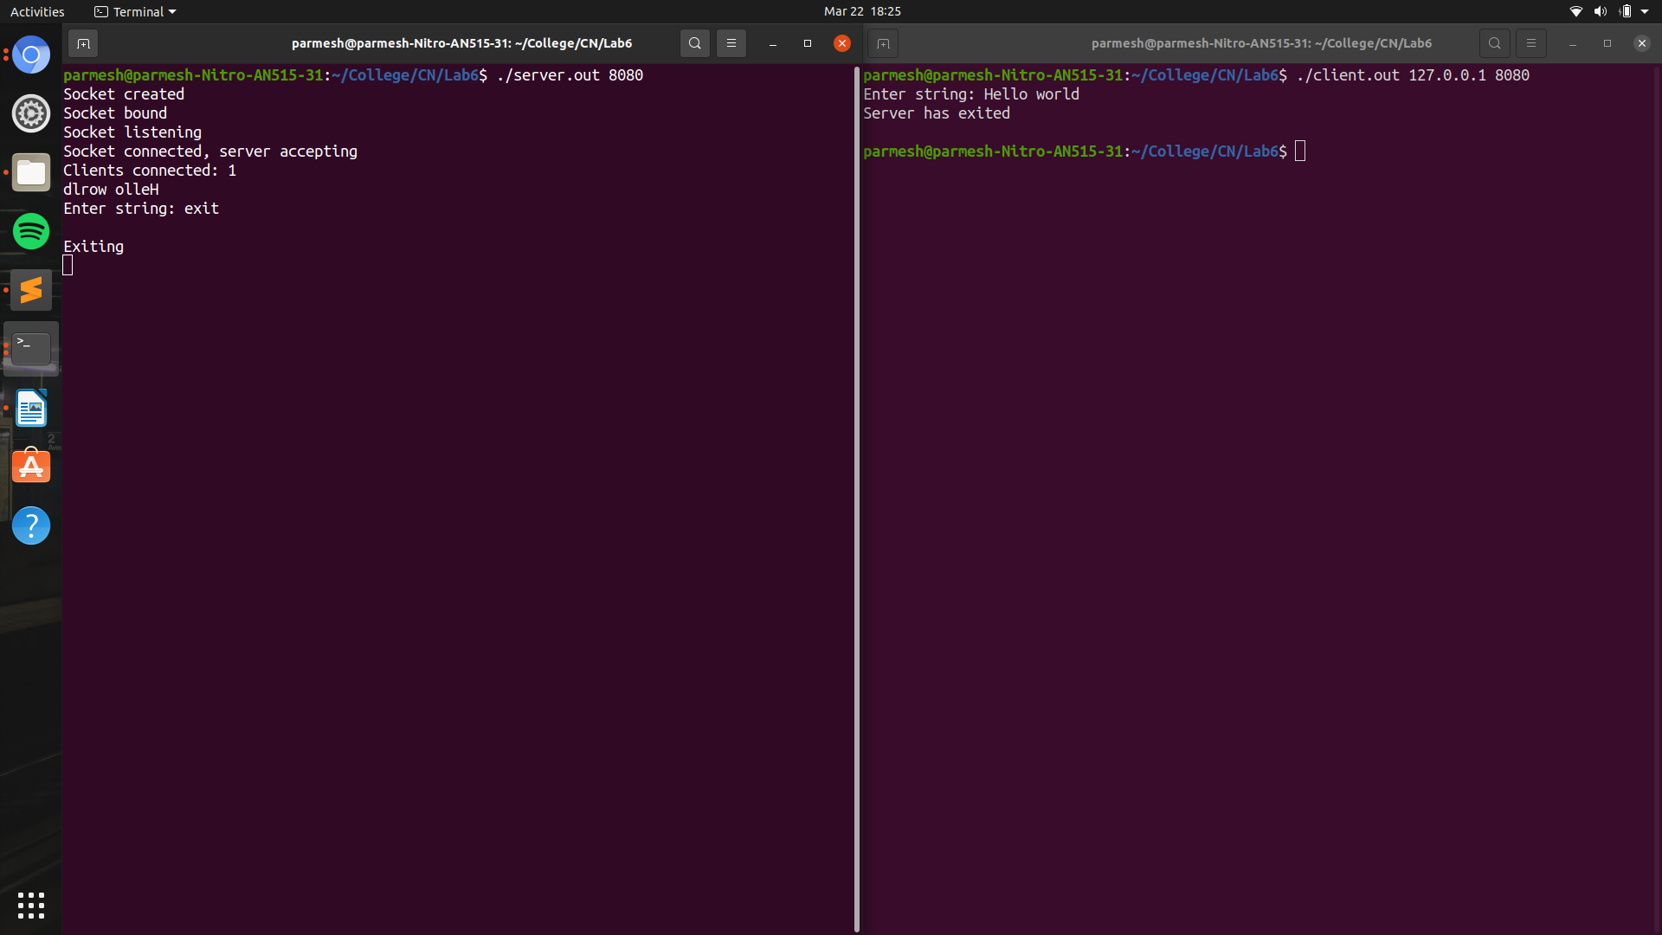

Refer to the README file for instructions on how to run the code.

