Smart Agriculture
(Crop recommendation based on soil condition)

Geddapu Dileep
School of Computer Science and Engineering
LPU,Phagwara
Visakhapatnam,India
dileepgeddapu07@gmail.com
Sayantan Jana
School of Computer Science and Engineering
LPU,Phagwara
Meerut,India
sayantanjana2707@gmail.com
Parmvir Singh Parihar
School of Computer Science and Engineering
LPU,Phagwara
Banga,India
parmparihar13@gmail.com
Krishna Kapoor
School of Computer Science and Engineering
LPU,Phagwara
Jalandhar,India
krishnakappor02@gmail.com
Abstract—Agricultural decision making at the field level often overlooks two critical indicators: air dryness and soil salinity. These factors, expressed as Vapor Pressure Deficit (VPD) and Electrical Conductivity at 25 °C (EC@25 °C), strongly influence crop performance, irrigation needs, and nutrient uptake[1–3], [11–12]. Existing IoT-based solutions typically depend on cloud connectivity and provide opaque recommendations, limiting their usability in rural areas [6–7], [21]with poor networks. Low-cost devices often fail to compute VPD accurately or ignore temperature-compensated EC, leading to unreliable advice[11–12].
This work presents an offline, explainable crop recommendation system built on an ESP32 microcontroller. The device captures temperature, relative humidity, soil moisture, and EC readings, computes VPD and EC@25 °C, normalizes features, and applies season-aware scoring to rank the top three crops. Each recommendation includes clear, human-readable reasons, and the system learns from farmer selections through a lightweight feedback mechanism. Data is logged locally in CSV format for traceability. By combining affordability, transparency, and independence from cloud services, the proposed solution aims to deliver practical, trustworthy guidance directly at the farm gate, supporting smallholder farmers in making informed crop choices.
Keywords—Crop recommendation; ESP32; VPD; EC@25 °C; Explainable AI; On-device ML; IoT; SPIFFS; TinyML

Introduction
Agriculture remains the backbone of food security, yet crop selection at the farm level often relies on intuition rather than scientific indicators. Choosing the right crop for prevailing conditions is critical because it influences yield, water use efficiency, and overall input costs. Traditionally, farmers have depended on experience or generalized advisories, which rarely account for dynamic environmental factors such as air dryness and soil salinity. These two parameters—Vapor Pressure Deficit (VPD) and Electrical Conductivity (EC) play a decisive role in plant health. VPD reflects the drying power of air and directly affects transpiration and irrigation needs[1–3], while EC indicates salinity levels that can restrict water uptake and nutrient absorption[11–12].
Modern IoT-based solutions and mobile applications attempt to bridge this gap, but most require continuous internet connectivity and often operate as black boxes, offering recommendations without clear reasoning. This lack of transparency reduces trust and adoption, especially in rural areas with limited connectivity. Furthermore, many low-cost devices fail to compute VPD accurately or ignore temperature-compensated EC values, leading to misleading results.
The proposed system addresses these challenges by providing an offline, explainable crop recommendation tool built on an ESP32 microcontroller. It integrates sensors for temperature, humidity, soil moisture, and EC, computes VPD and EC@25 °C, and uses season-aware scoring to suggest the top three crops with clear, human-readable reasons. By combining affordability, transparency, and adaptability, this solution aims to empower farmers with actionable insights directly at the field edge.

Problem Statement
Crop selection is a critical decision that directly impacts yield, irrigation planning, and resource efficiency. However, most smallholder farmers rely on intuition or generalized advisories that fail to consider real-time environmental conditions. Two key indicators—Vapor Pressure Deficit (VPD) and Electrical Conductivity at 25 °C (EC@25 °C)—are essential for assessing plant water stress and soil salinity, yet they are rarely measured by low-cost tools. VPD influences transpiration and irrigation needs, while EC determines salinity levels that affect nutrient uptake. Ignoring these parameters can lead to poor crop choices and reduced productivity.
Existing IoT-based solutions often depend on cloud connectivity and provide opaque recommendations, making them unsuitable for rural areas with limited internet access. Low-cost devices typically omit VPD or compute raw EC without temperature compensation, resulting in inaccurate assessments. A practical solution must be offline, affordable, and explainable, delivering clear, human-readable recommendations and adapting to farmer preferences.

Literature Review
Several studies have explored IoT-based crop recommendation and environmental sensing, but most fail to combine critical agronomic indicators with offline, explainable decision-making. RFID-based agricultural monitoring systems [1] offer convenience but do not analyze dynamic environmental factors. NPK-driven crop recommendation tools [2] provide nutrient-based suggestions but ignore VPD and salinity, limiting accuracy. VPD-aware irrigation systems [3] improve water scheduling but lack crop ranking or farmer feedback mechanisms.
Cloud-centric decision support systems [4], [5] achieve high predictive accuracy using machine learning models but require continuous connectivity and subscription costs, making them impractical for rural fields. Explainable AI frameworks such as AgroXAI [6] introduce interpretability through LIME and SHAP, yet these methods demand computational resources unsuitable for microcontrollers. TinyML deployments on ESP32 [7] demonstrate feasibility for edge inference but rarely include transparent reasoning or season-aware scoring.
Unlike these approaches, the proposed system integrates VPD, EC@25 °C, season awareness, and on-device explainable recommendations with adaptive learning in a fully offline ESP32 platform—while maintaining cost-effectiveness through low-cost hardware and minimal infrastructure requirements.

objectives
The primary objectives of this project are:
- Sensor Integration: Measure temperature, relative humidity, soil moisture, and electrical conductivity; compute derived indicators such as Vapor Pressure Deficit (VPD) and EC@25 °C for accurate agronomic assessment[1–3], [11–12].
- Feature Normalization and Season Detection: Normalize environmental parameters and identify agricultural season (Rabi, Zaid, Kharif) using NTP or compile-time fallback[21].
- Explainable Crop Recommendation: Implement a scoring algorithm that ranks the top three crops based on sensed conditions and provides clear, human-readable reasons for each recommendation[4],[8].
- Feedback Learning: Incorporate a lightweight personalization mechanism that adjusts crop ranking through bias reinforcement and decay based on farmer selections.
- Local Data Logging: Store all field snapshots and user choices in SPIFFS as CSV files (/choices.csv and /prefs.csv) for traceability and future tuning.
- Cost-Effective Design: Ensure the system remains affordable and replicable using ESP32 and low-cost sensors, without reliance on cloud connectivity[5],[7].

Methodology
The proposed system employs a structured pipeline combining sensing, feature engineering, explainable scoring, and adaptive learning. This section details the hardware-software workflow, mathematical modeling, and data handling.

- Block Diagram of the proposed model :
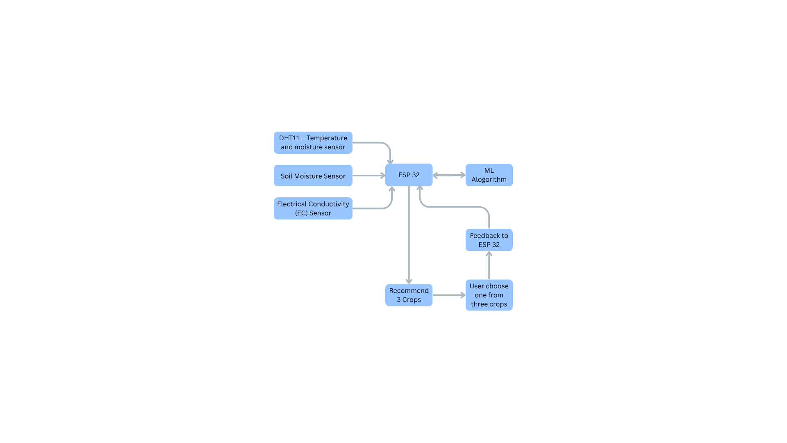

Fig. System architecture showing sensor inputs, ESP32 processing, ML-based scoring, and feedback loop for crop recommendation.

B. System Architecture
The architecture consists of three layers:
- Sensing Layer: DHT11 for temperature and RH, analog soil moisture probe, and EC electrodes connected via a 10 kΩ divider.
- Processing Layer: ESP32 microcontroller performs feature computation, normalization, scoring, and feedback learning.
- Output Layer: Serial console displays Top-3 crops with reasons; user selects via buttons.

C. Data Acquisition and Averaging
Sensors capture temperature, humidity, soil moisture, and EC readings. Each parameter is sampled multiple times over a 60-second window to reduce noise. Median filtering is applied to analog inputs to eliminate spikes. This averaging ensures stable feature values for accurate scoring and prevents transient fluctuations from influencing crop recommendations. Additionally, the system monitors sensor health and rejects implausible readings (e.g., RH <10% or >100%) to maintain reliability.

D.Feature Derivation
VPD (k Pa) :
Saturation vapor pressure:
es(T) = 0.6108 × exp((17.27 × T) / (T + 237.3))
VPD calculation:
VPD = es(T) × (1 - RH / 100)
EC@25 °C:
Raw EC is temperature-compensated using a correction factor (α ≈ 2.2% per °C) and mapped to dS/m via linear calibration constants.
Soil Moisture:
Two-point calibration (AIR vs WATER) converts ADC counts to percentage.

E. Normalization and Season Detection
After averaging, features are normalized to a 0–1 scale: T/50, RH/100, VPD/4, Moisture/100, EC/4. Normalization ensures uniform weight distribution across parameters.
Season detection uses NTP time for precise month mapping that plays a vital role in crop recommendation.

F. Explainable Scoring Algorithm
Each crop profile defines ideal ranges for temperature, humidity, VPD, soil moisture, and EC tolerance. For every feature, a band score is calculated:
Score = 1.0 if the value is within the ideal range.
Score decreases linearly as the value moves outside the range.
The final crop score is computed using weighted aggregation:
Score = (0.22 × Temp Score) + (0.18 × RH Score) + (0.22 × VPD Score) + (0.28 × Moisture Score) + (0.10 × EC Score)
A season factor is applied:
In-season crops: factor = 1.0
Off-season crops: factor = 0.55
Human-readable reasons are generated for each feature, such as “Soil too dry,” “Air too humid,” or “Salinity within limit,” to maintain transparency.

G. Feedback Learning
When a farmer selects a crop, its bias is reinforced (+0.10) while others decay (-0.02), clamped to ±0.5. This adaptive mechanism personalizes recommendations without overriding agronomic logic. Bias updates are logged in /prefs.csv, enabling traceability and iterative tuning. Over time, this learning improves relevance while maintaining transparency.

H. Data Logging
All snapshots and preferences are stored in SPIFFS:
- /choices.csv: Timestamp, averaged features, season, Top-3 crops, chosen crop.
- /prefs.csv: Crop name, bias value.
This ensures traceability and supports future tuning.
- Flowchart
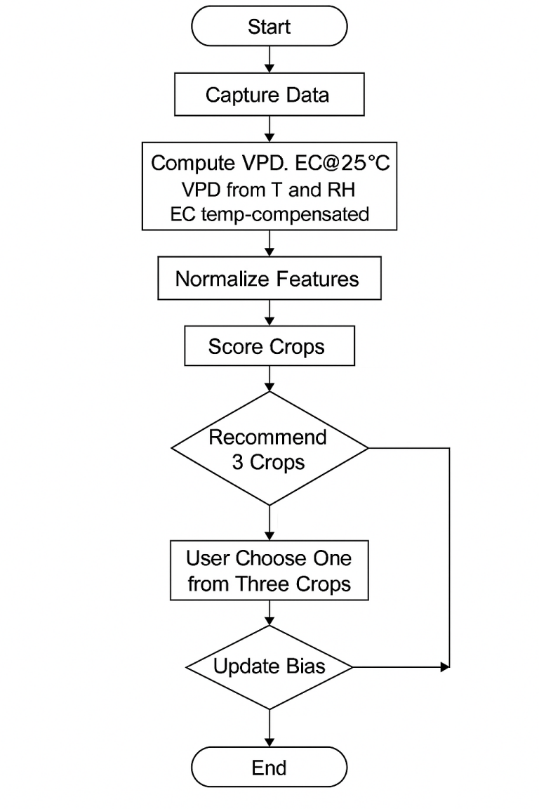

VI. HARDWARE AND IMPLEMENTATION
A breadboard prototype integrates ESP32, three push-buttons, DHT11, a resistive soil moisture sensor, and EC electrodes in a soil cup. Analog pins use 11 dB attenuation; EC duty cycle is limited to reduce polarization. Output is printed to the serial console; an OLED/LCD can be added later.
A .Table I. Bill of Materials and GPIO mapping for the ESP32-based crop recommendation system
Component | Specification / Description | GPIO Pin / Notes
Microcontroller | ESP32 DevKit (Wi-Fi, 12-bit ADC, SPIFFS) | —
Temperature & RH Sensor | DHT11 (upgrade: DHT22/SHT31) | GPIO4 (Digital Input)
Soil Moisture Sensor | Analog resistive probe (future: capacitive) | GPIO34 (ADC1, 11 dB attenuation)
EC Sensor | Stainless steel electrodes + 10 kΩ divider | GPIO35 (Analog Input)
Capture Button | Momentary switch | GPIO18 (INPUT_PULLUP)
Choice Buttons | 3 push-buttons for crop selection | GPIO21, GPIO22, GPIO23 (INPUT_PULLUP)
Power Supply | USB 5 V (future: battery + deep sleep) | —
Storage | SPIFFS partition (~1.5 MB for logs) | —
Additional | Breadboard, jumper wires, optional LED | —
- Circuit Simulation Diagram
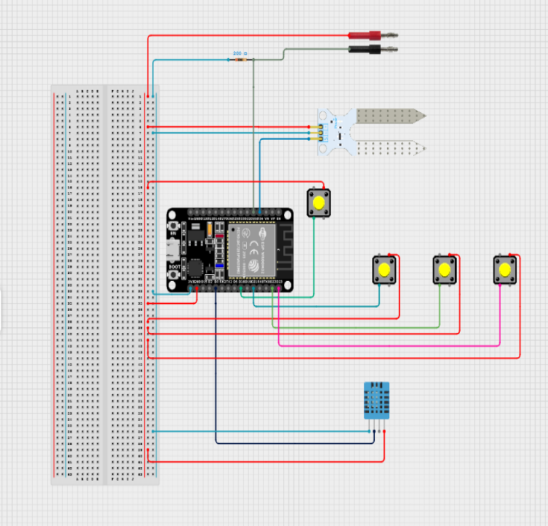
- Prototype Image
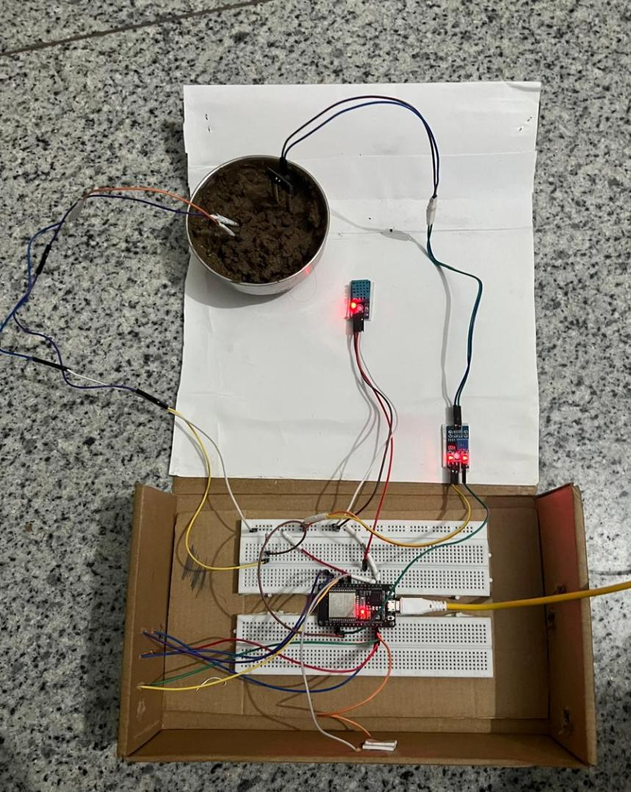

VII. Results and Observations
A. Representative Snapshot (Rabi Season)
After a 60-second averaging cycle, the device recorded:
- Temperature: 17.4 °C
- Relative Humidity: 74.1 %
- VPD: 0.515 kPa
- Soil Moisture: 46.3 %
- EC@25 °C: 0.664 dS/m
- Season: Rabi

Top-3 Recommended Crops:
- Wheat – Score ≈ 0.969
Reasons: Soil moisture ideal; Air too humid; Salinity within limit; Temperature ideal; Humidity ideal.
- Chickpea – Score ≈ 0.837
Reasons: Soil moisture ideal; Air too humid; Salinity within limit; Temperature ideal; Humidity ideal.
- Mustard – Score ≈ 0.777
Reasons: Soil moisture ideal; Air too humid; Salinity within limit; Temperature ideal; Humidity ideal.

Feedback:
When the user selected Chickpea, its bias was reinforced (+0.10), while others decayed (-0.02).
B. Device Output
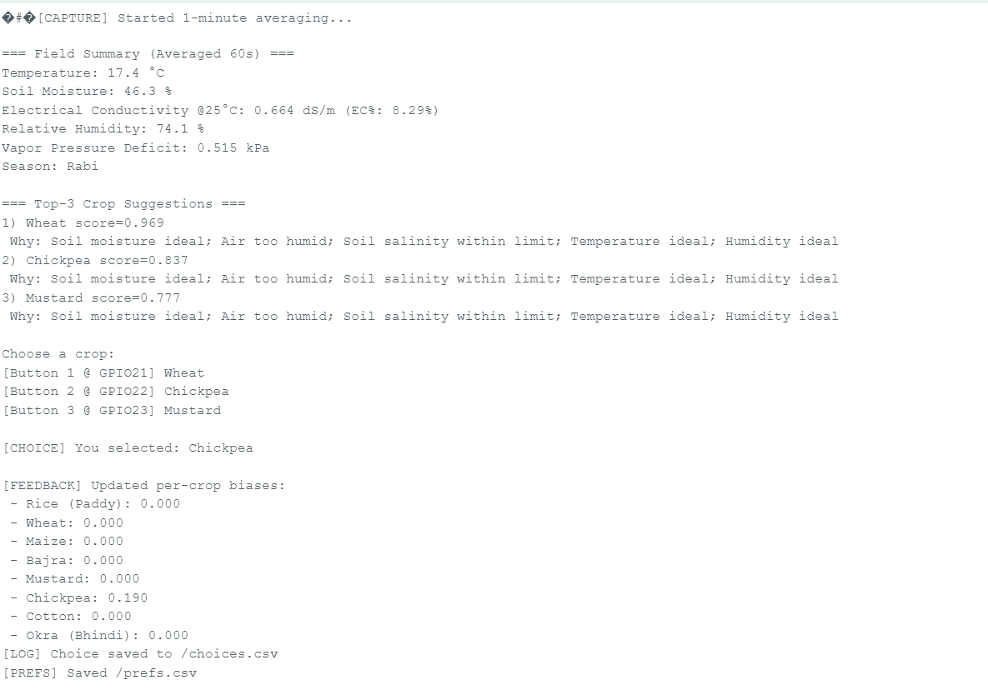
C. Observations
- Moisture weight (0.28) strongly influences ranking, aligning with irrigation-critical decisions.
- VPD provides intuitive messages like “Air too humid,” improving interpretability for farmers.
- EC@25 °C ensures salinity judgments are temperature-independent, avoiding misleading raw EC readings.
- Season factor discourages off-season crops without removing them, preserving farmer choice.
- Feedback learning adds personalization while maintaining agronomic logic through bias limits
.
VIII. Future Advancements
· Enhanced Sensor Accuracy
Upgrade DHT11 to DHT22 or SHT31 for better temperature and humidity precision, improving VPD calculations. Replace resistive soil moisture probes with capacitive sensors to reduce corrosion and drift.
· · Advanced EC Measurement
Implement AC excitation (~1 kHz) with synchronous sampling to prevent electrode polarization. Add calibration using KCl standards and store calibration curves in device memory.
· · User Interface Improvements
Integrate an OLED or LCD display for field-friendly visualization of summaries and recommendations. Provide multilingual support (e.g., Punjabi and English) for better accessibility.
· · Power Optimization
Add a rechargeable battery with deep sleep mode to enable portable, low-power operation. Estimate and optimize power consumption for extended field use.
· · Connectivity and Cloud Integration
Enable optional cloud sync when Wi-Fi is available for backup and analytics dashboards. Include Bluetooth for quick data transfer to mobile devices without requiring internet.
· · Data for Research and Surveys
Utilize logged data (/choices.csv and /prefs.csv) for agronomic studies, crop suitability analysis, and regional surveys. This dataset can support academic research and government planning for precision agriculture.
· · Algorithmic Upgrades
Introduce TinyML models (e.g., decision trees or quantized neural networks) for adaptive crop scoring based on regional datasets. Maintain explainability by pairing ML predictions with reason strings.
· · Weather and Forecast Integration
Incorporate short-term weather forecasts to adjust VPD expectations and season penalties, improving recommendation accuracy.
· · Risk Alerts and Automation
Add GSM/SMS alerts for critical conditions like low soil moisture or high EC. Implement threshold-based irrigation recommendations for semi-automated water management.
· · Regional Calibration and Versioning
Develop guided calibration routines for soil moisture and EC sensors using local soil samples. Implement regional tuning of crop bands and weights through field trials and feedback loops.

IX. Comparison with Similar Systems
Several existing solutions address crop recommendation and environmental monitoring, but most differ significantly in connectivity, explainability, and feature coverage. Table II summarizes the comparison:
Table II. Feature Comparison Across Representative Systems
System | Connect ivity | Explain ability | VPD / EC@25 °C / Season | Personal ization | Logg ing
This Work (ESP32) | Offline-first | Built-in reasons | Yes / Yes / Yes | Bias learning | SPIFFS CSV
AgroXAI [4] | Edge + Cloud | LIME/SHAP | Not explicit | Model-level only | Research logs
IoT DSS [7] | Cloud-integrated | Limited | Often No / EC raw / No | None on-device | Cloud DB
CRS IoT [6] | Cloud/server | Limited | Often No / No / No | None on-device | Server logs
ESP32 Monitoring [5] | Cloud | N/A (monitoring) | N/A | N/A | Cloud time-series
TinyML ESP32 [12],[14] | Offline inference | ML-native (no reasons) | Varies | N/A | Optional

Key Observations:
- Our system uniquely combines offline operation, explainability, VPD and EC@25 °C sensing, season awareness, and adaptive learning in a single ESP32 platform.
- Cloud DSS solutions offer richer analytics but require continuous connectivity and lack of transparency.
- XAI frameworks provide strong interpretability but demand higher compute resources unsuitable for microcontrollers.
- TinyML deployments enable offline inference but rarely include human-readable explanations or season-aware scoring.

X. Limitations

Despite the successful implementation and demonstration of core functionalities, the system does have certain limitations that must be addressed before large-scale deployment:
Electrode Polarization
The current DC-based EC measurement can cause electrode polarization and corrosion over time, reducing reliability. AC excitation or polarity alternation is needed for long-term stability.
Soil Moisture Drift
Resistive soil moisture sensors are prone to corrosion and calibration drift, impacting measurement consistency. Capacitive sensors offer better durability.
Generic Normalization and Crop Bands
Current normalization constants and crop suitability bands are generic. Regional calibration using local datasets is essential for deployment accuracy.
Limited UI and Connectivity
The prototype uses a serial console for output and lacks a graphical interface. Optional cloud sync and mobile integration are not yet implemented.
Data Volume for ML
Feedback learning is basic and requires more field data to enable advanced ML models and regional tuning.

XI. Acknowledgment
The authors thank faculty mentors and lab colleagues for guidance during prototyping and testing.

References
[1] H. G. Jones, Plants and Microclimate. Cambridge Univ. Press — VPD, transpiration fundamentals.
[2] R. G. Allen, L. S. Pereira, D. Raes, and M. Smith, FAO Irrigation and Drainage Paper 56 — evapotranspiration; VPD context.
[3] O. Tetens, “Über einige meteorologische Begriffe,” Z. Geophys., 1930 — saturation vapor pressure relation.
[4] O. Turgut, I. Kok, and S. Ozdemir, “AgroXAI: Explainable AI-Driven Crop Recommendation System,” IEEE BigData 2024; arXiv:2412.16196 — XAI for agriculture.
[5] G. Kırağ and M. Tenruh, “Cloud-Integrated, IoT-Enabled ESP32 for Real-Time Agricultural Monitoring,” IJCA, 2025 — ESP32 telemetry.
[6] U. K. Kori et al., “Crop Recommendation Using ML and IoT,” IRJIET, 2025 — CRS with sensors + ML.
[7] F. Siddiqui et al., “IoT-Enabled DSS for Crop Recommendation,” JETIR, 2025 — ML models with IoT datasets.
[8] Y. Akkem, S. K. Biswas, and A. Varanasi, “Role of Explainable AI in Crop Recommendation,” I.J. Intelligent Systems and Applications, 2025 — LIME/SHAP/DiCE.
[9] WO2021156478A1, “Methods & compositions for saline-tolerant plants,” WIPO, 2021 — salinity relevance.
[10] WIPO Patent Landscape Report: Soil & Fertilizer Management, 2024 — innovation trends in sensor/fertigation.
[11] H. El-Ramady et al., “Review of Crop Response to Soil Salinity Stress,” Soil Systems (MDPI), vol. 8, no. 1, 2024 — EC stress and mitigation.
[12] C. Kumar, S. B. Verma, and A. K. Singh, “Sustainable Soil Salinity Management with Smart Fertigation,” PNAS India Section B (Springer), 2023 — salinity thresholds and strategies.
[13] H. K. Puppala, J. Germer, and F. Asch, “Genotypic Responses to Combined Effects of VPD and Salinity,” Plant-Environment Interactions, 2025 — combined stress behavior.
[14] D. Donskoy et al., “TinyML Classification for Agriculture Objects with ESP32,” Digital (MDPI), 2025 — ESP32 + TFLM feasibility.
[15] A. Sharma, “Crop-Recommendation-Model-ESP32,” GitHub, 2025 — ESP32 + TinyML prototype.
[16] MJRoBot (M. Rovai), “ESP32-CAM: TinyML Image Classification,” Hackster.io, 2022 — edge inference practice.
[21] ThingSpeak/ESP32 cloud logging practices — typical cloud dashboards for agriculture monitoring.

fvvvvvvvvvvvvvvvvvvvvvvvvvvvvvvvvvvvvvvvvvvvvvv

Table I. Combined Bill of Materials and GPIO mapping for the ESP32-based crop recommendation system.
gyhvbhu
• normalizeFeatures()
• detectSeason()
• scoreCrops()
• displayTop3WithReasons()
• waitForChoice()
• updateBias()
• logToCSV()

VI. HARDWARE AND IMPLEMENTATION
A breadboard prototype integrates ESP32, three push-buttons, DHT11, a resistive soil moisture sensor, and EC electrodes in a soil cup. Analog pins use 11 dB attenuation; EC duty cycle is limited to reduce polarization. Output is printed to the serial console; an OLED/LCD can be added later.

Abstract—Agricultural decision making at the field level often overlooks two critical indicators: air dryness and soil salinity. These factors, expressed as Vapor Pressure Deficit (VPD) and Electrical Conductivity at 25 °C (EC@25 °C), strongly influence crop performance, irrigation needs, and nutrient uptake. Existing IoT-based solutions typically depend on cloud connectivity and provide opaque recommendations, limiting their usability in rural areas with poor networks. Low-cost devices often fail to compute VPD accurately or ignore temperature-compensated EC, leading to unreliable advice.
This work presents an offline, explainable crop recommendation system built on an ESP32 microcontroller. The device captures temperature, relative humidity, soil moisture, and EC readings, computes VPD and EC@25 °C, normalizes features, and applies season-aware scoring to rank the top three crops. Each recommendation includes clear, human-readable reasons, and the system learns from farmer selections through a lightweight feedback mechanism. Data is logged locally in CSV format for traceability. By combining affordability, transparency, and independence from cloud services, the proposed solution aims to deliver practical, trustworthy guidance directly at the farm gate, supporting smallholder farmers in making informed crop choices.
Keywords—Crop recommendation; ESP32; VPD; EC@25 °C; Explainable AI; On-device ML; IoT; SPIFFS; TinyML

Problem Statement
Crop selection is a critical decision that directly impacts yield, irrigation planning, and resource efficiency. However, most smallholder farmers rely on intuition or generalized advisories that fail to consider real-time environmental conditions. Two key indicators—Vapor Pressure Deficit (VPD) and Electrical Conductivity at 25 °C (EC@25 °C)—are essential for assessing plant water stress and soil salinity, yet they are rarely measuredthem unsuitable for rural areas with limited internet access. Low-cost devices typically omit VPD or compute raw EC without temperature compensation, resulting in inaccurate assessments. A practical solution must be offline, affordable, and explainable, delivering clear, human-readable recommendations and adapting to farmer preferences.

Literature Review
Several studies have explored IoT-based crop recommendation and environmental sensing, but most fail to combine critical agronomic indicators with offline, explainable decision-making. RFID-based agricultural monitoring systems [1] offer convenience but do not analyze dynamic environmental factors. NPK-driven crop recommendation tools [2] provide nutrient-based suggestions but ignore VPD and salinity, limiting accuracy. VPD-aware irrig

Table I. Hardware Components and GPIO Configuration
Component | Specification / Description | GPIO Pin / Notes
Microcontroller | ESP32 DevKit (Wi-Fi, 12-bit ADC, SPIFFS) | —
Temperature & RH Sensor | DHT11 (upgrade: DHT22/SHT31) | GPIO4 (Digital Input)
Soil Moisture Sensor | Analog resistive probe (future: capacitive) | GPIO34 (ADC1, 11 dB attenuation)
EC Sensor | Stainless steel electrodes + 10 kΩ divider | GPIO35 (Analog Input)
Capture Button | Momentary switch | GPIO18 (INPUT_PULLUP)
Choice Buttons | 3 push-buttons for crop selection | GPIO21, GPIO22, GPIO23 (INPUT_PULLUP)
Power Supply | USB 5 V (future: battery + deep sleep) | —
Storage | SPIFFS partition (~1.5 MB for logs) | —
Additional | Breadboard, jumper wires, optional LED | —

