Experiment-4
Creating and Configuring Amazon EC2 Instance and hosting a Basic HTML Web Page

STEP:1 Basic AWS Dashboard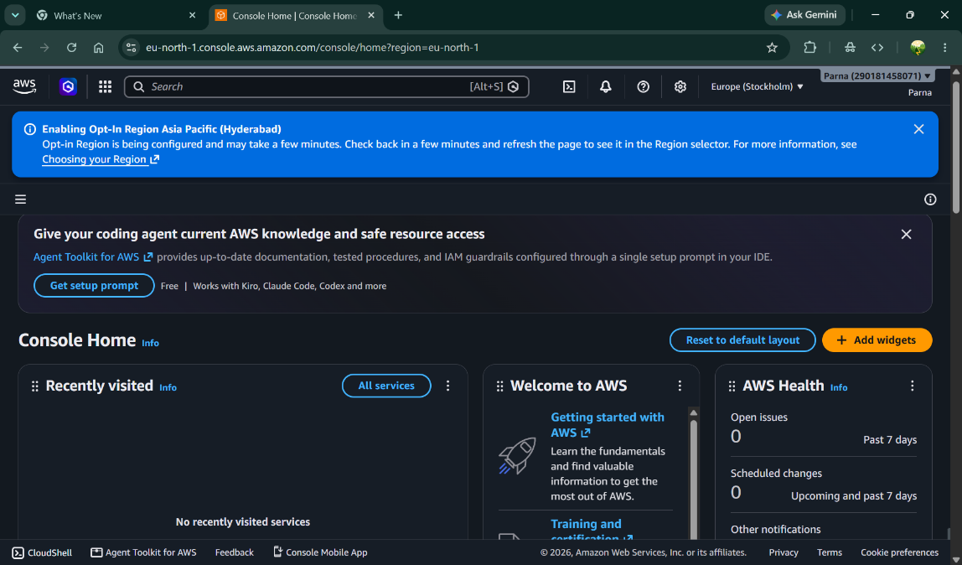

STEP 2: Configuration
- Give Instance name
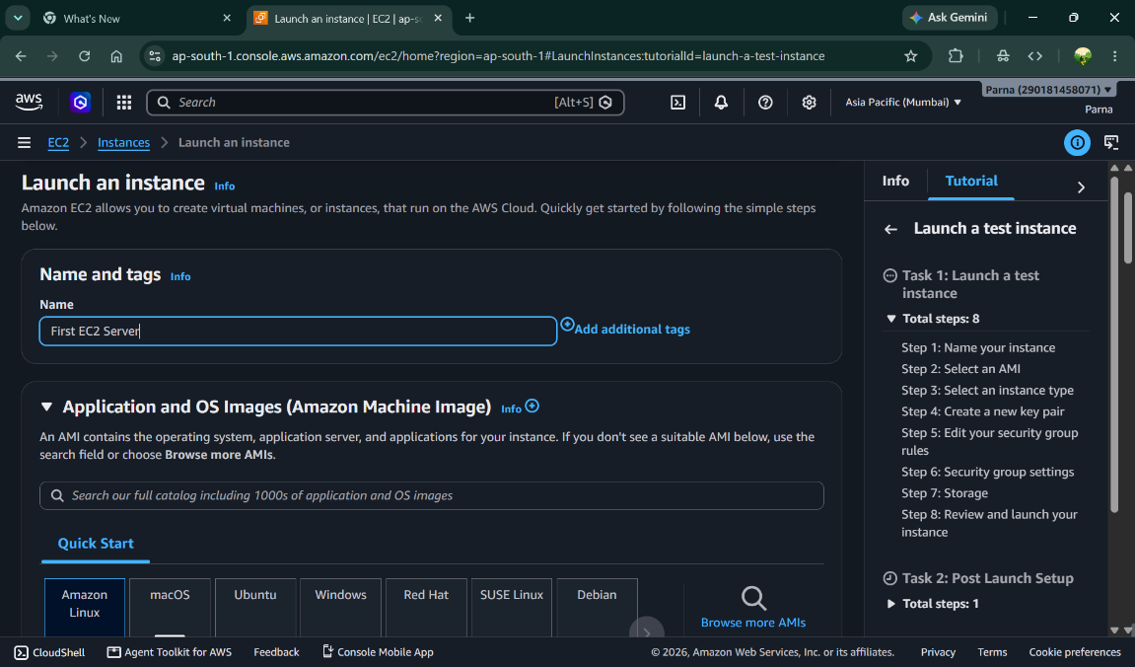

- Select OS Image- Amazon Linux
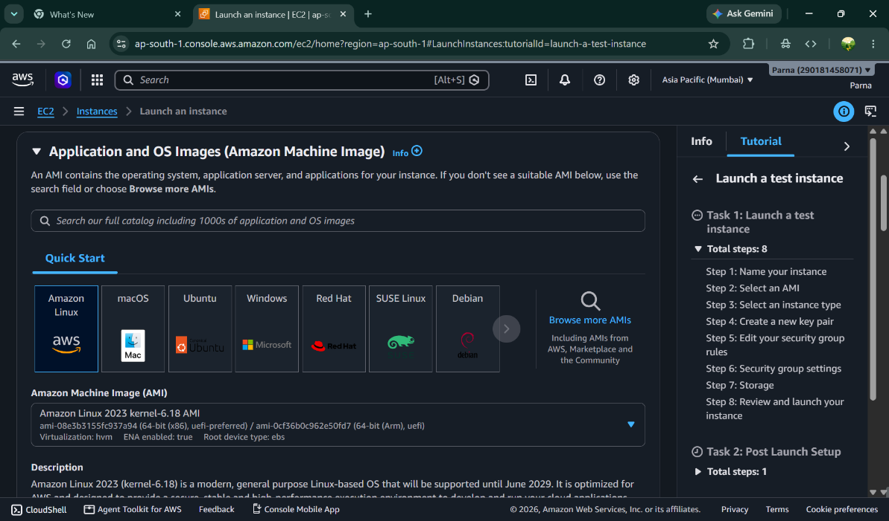

- Create Key Pair
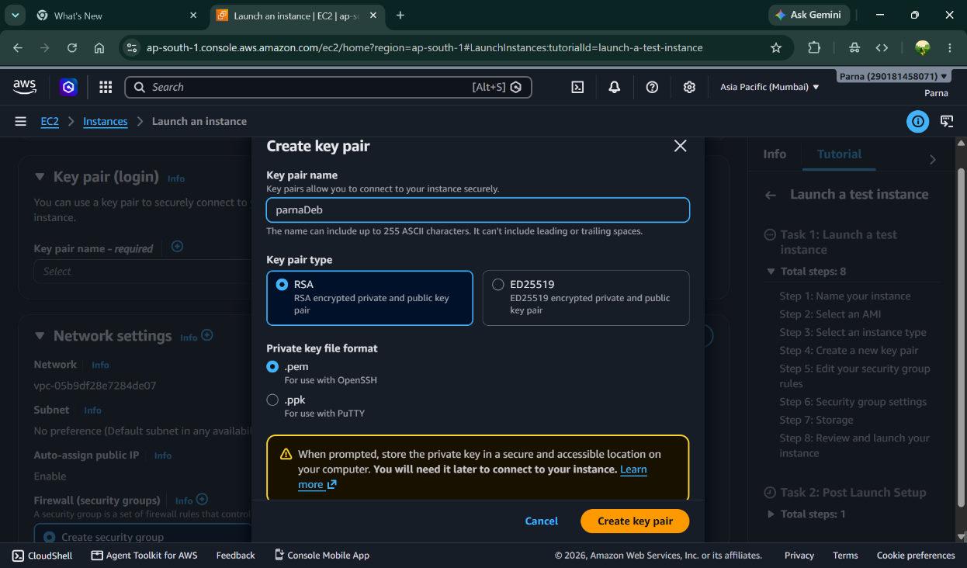

- Setup Network Setting
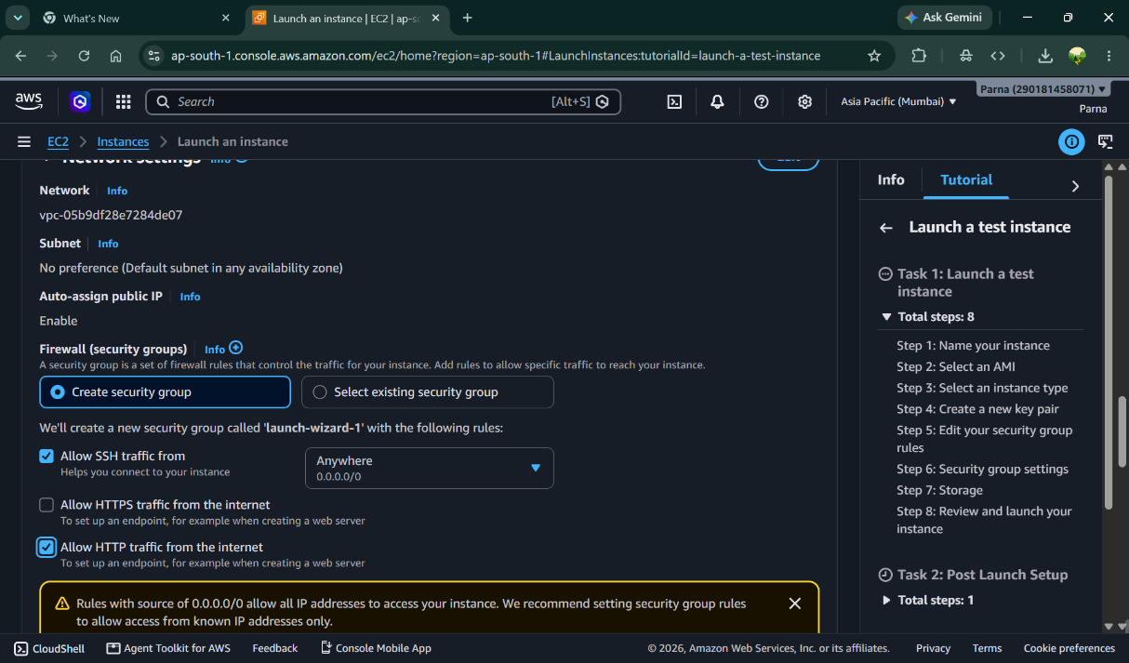

- Configure Storage
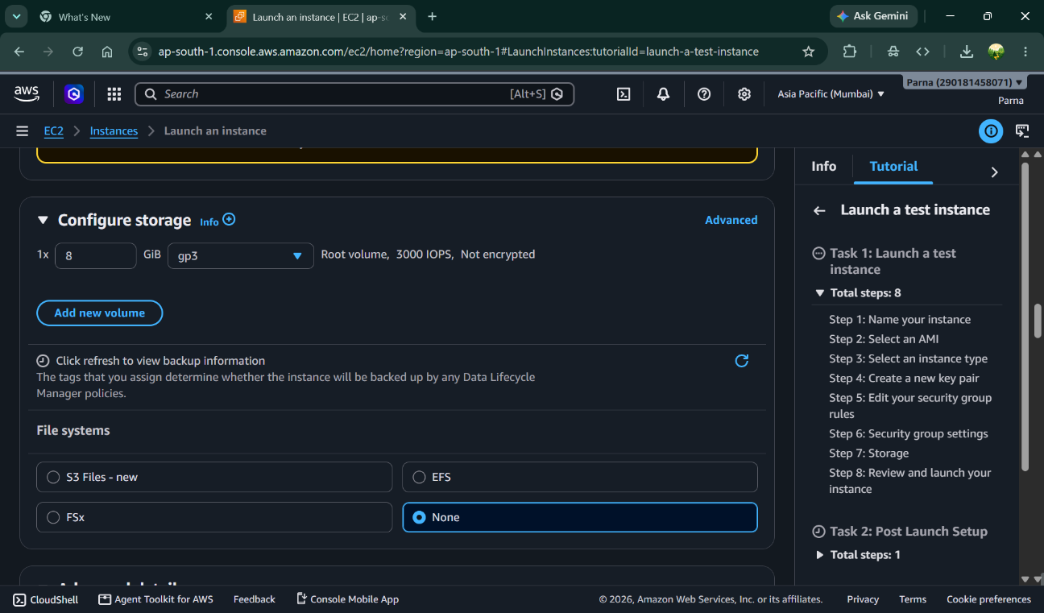

- Advance Setup- Add html script that will run on server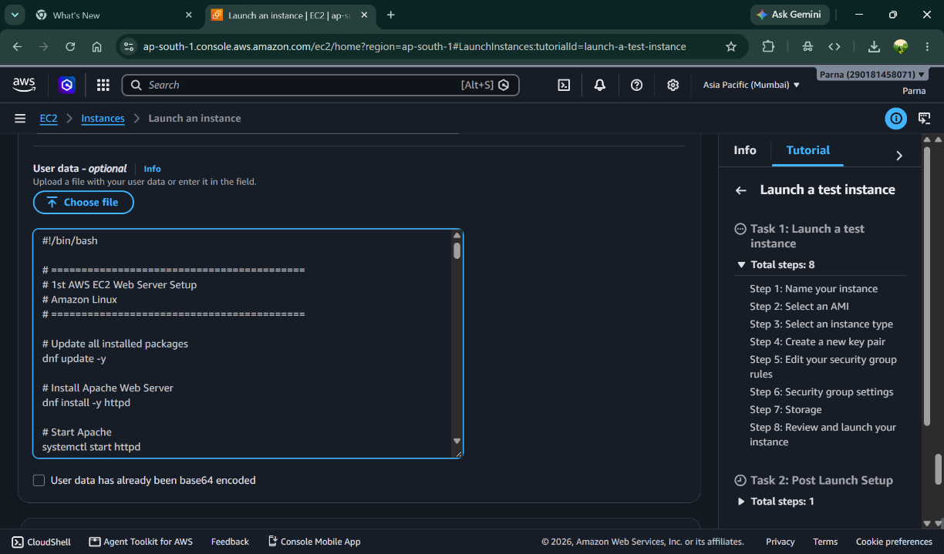

- Launch the instance
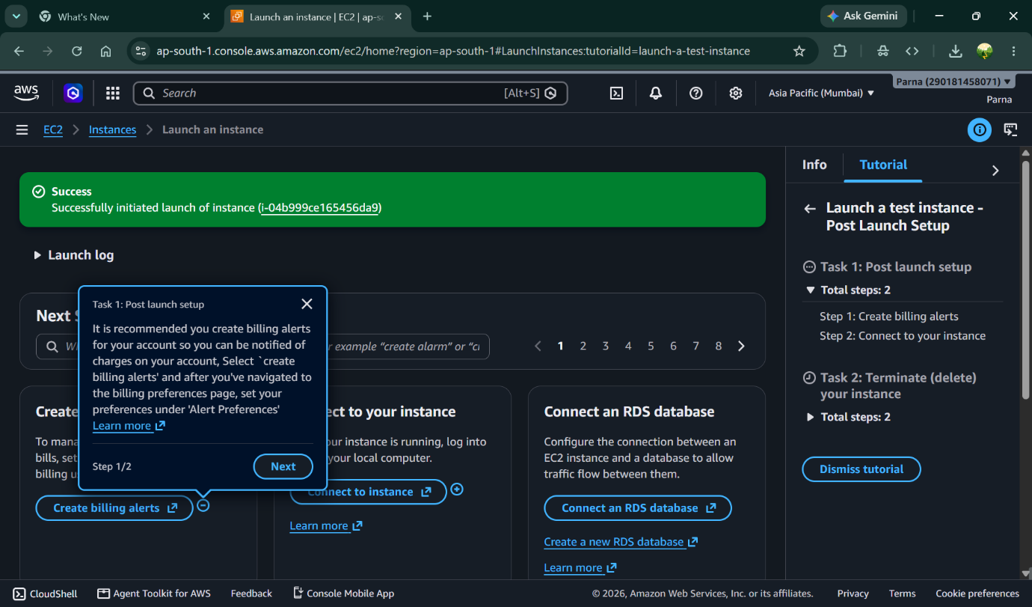

STEP 2: Instances Running
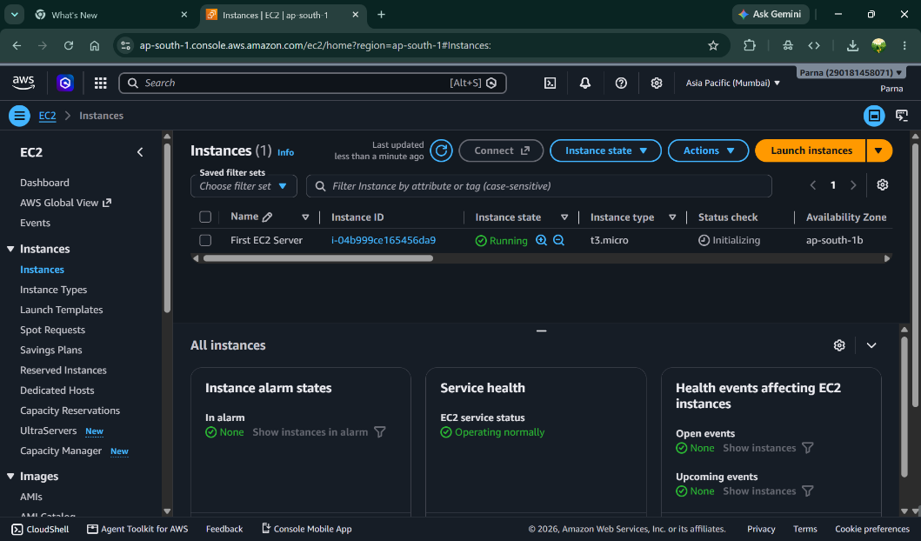

STEP 3: Intance Detail
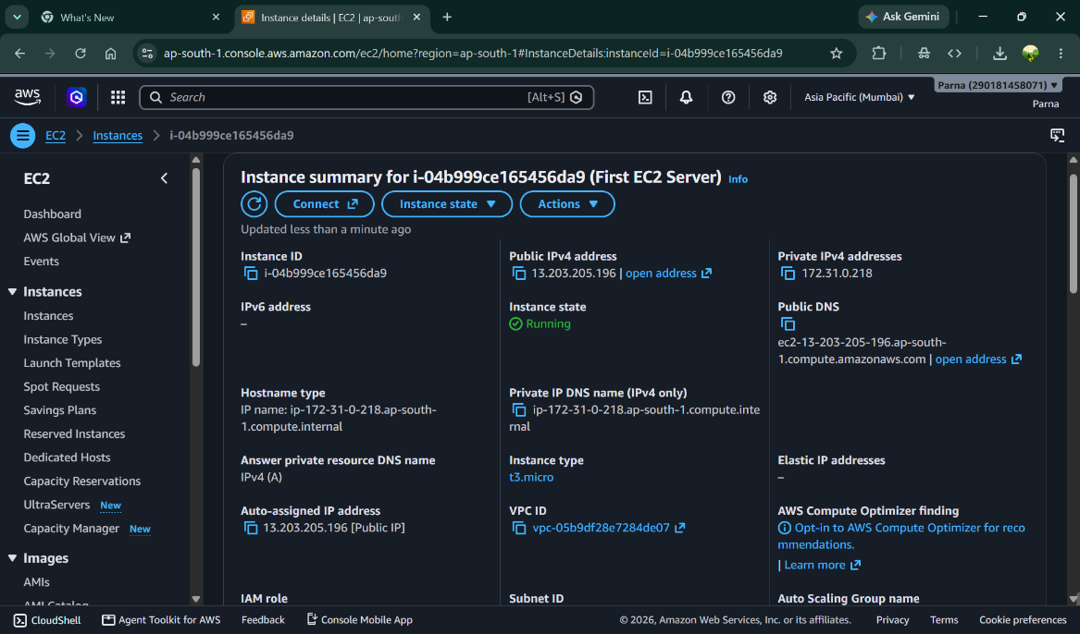

STEP 4: Connect to Linux Instance
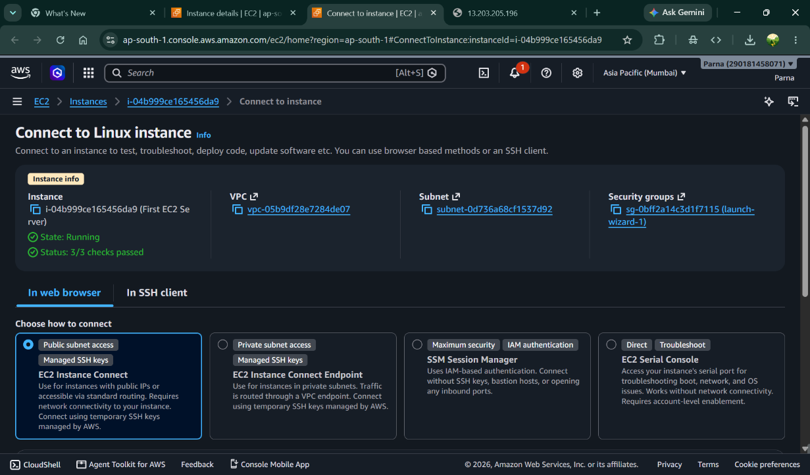

STEP 5: Inside Amazon Linux
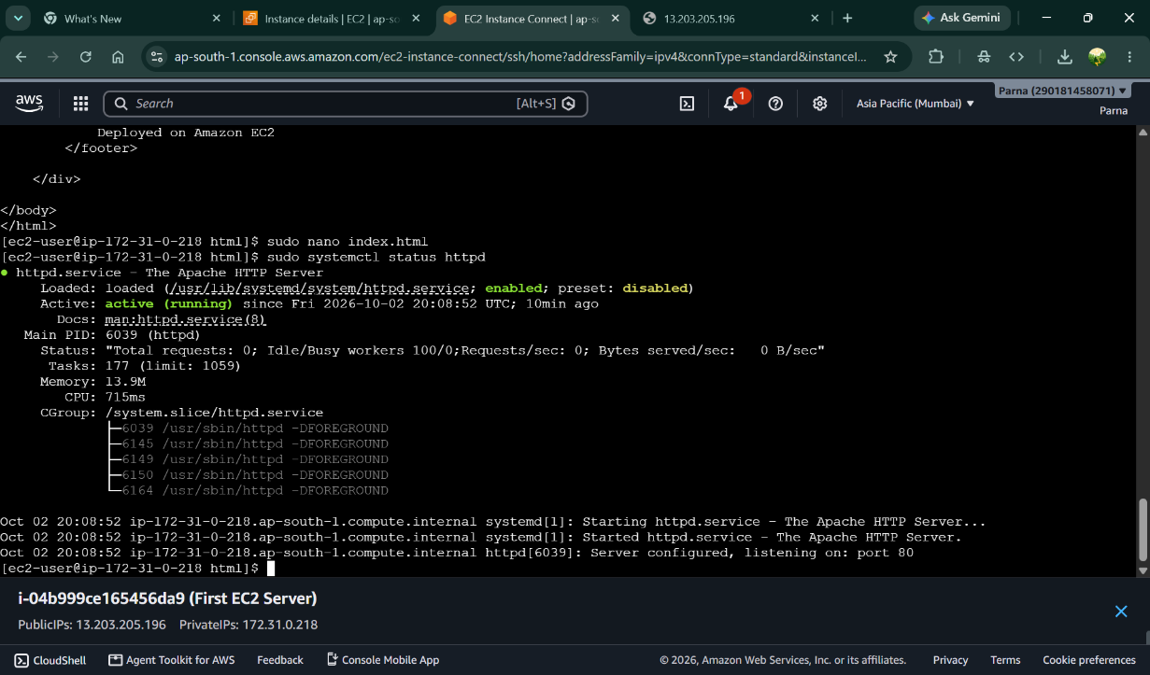

STEP 6: Html code and Web page running on Instance
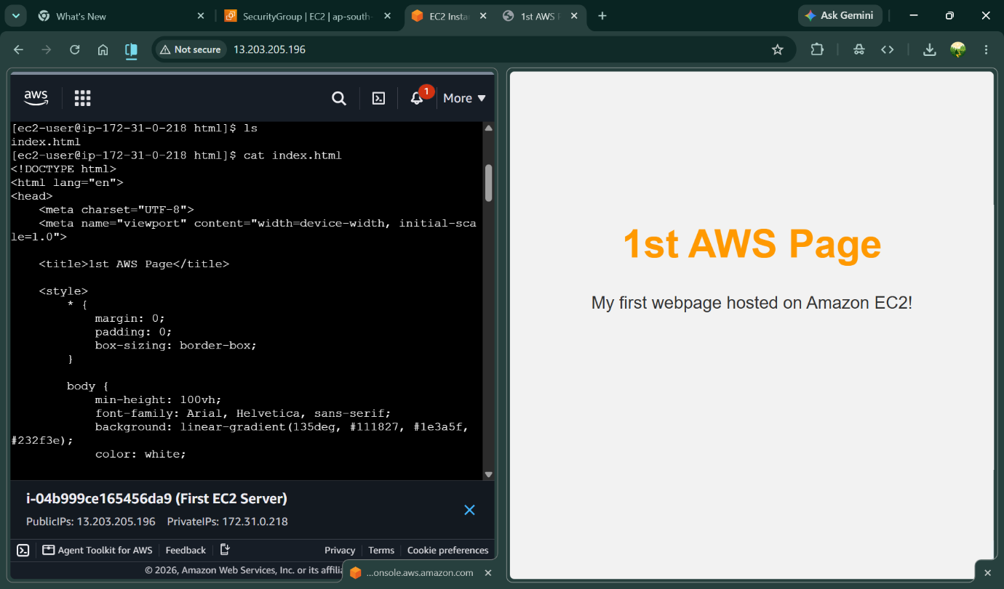

STEP 7:Termination of Instance