Feature ID: 2058220 | Release: 8.7 MP |  | Customer: PMI
PM Owner: Anuj Narkhede, Piyali Thite |  | Prioritization Bucket: Core
Requestor: Customers
Feature Title: Direct Approval from Email Notification

Contents
Problem Statement: 1
Functional Solution Summary 1
Use Case 1: Approve/Reject Directly from Email (Must Have) 1
Out of scope: 7
Assumptions: 7
Non - Functional Requirements: 8
Documentation Requirements: 8

Problem Statement:
​Approvers typically do not spend much time within the Icertis ICI CLM platform, focusing primarily on reviewing documents, adding notes (if necessary), and swiftly taking action to approve or reject. However, action users are currently required to log in to the ICI platform to approve or reject agreements, leading to delays and inefficiencies in the contract execution process. The need to navigate through multiple steps just to provide an approval decision introduces unnecessary friction, particularly for senior stakeholders who mainly operate via email, ultimately slowing down decision-making and impacting overall workflow efficiency.

Functional Solution Summary
This feature enables users to approve or reject agreements quickly from email notifications while ensuring a secure and seamless approval process. This enhancement reduces approval turnaround time and improves user efficiency while maintaining security.
- New seeded approval notification subscription templates
- Approval/Rejection Directly from Email (Without Login)
- Enhancements in quick approval (review) functionality

Use Case 1: Approve/Reject Directly from Email (Must Have)
As an Approver,
I want to approve or reject an agreement directly from the email notification, so that I do not need to log in to the ICI platform, enabling quicker decision-making.

Acceptance Criteria / Requirements:
- New Seeded Subscription Creation: A new seeded subscription should be created, in addition to the existing ones, to enable direct email approvals for:
  - Entities covered: Agreements, Amendments, Associations, Contract Requests, Clauses, Templates
  - Subscription Template: The seeded template should include the following:
    - Clickable Action Button for accessing Quick approver window (Quick URI)
    - Clickable Action Button for direct approve or reject from email body
    - Link to ICI
    - Other details / attributes as per following table: Email Attribute Details

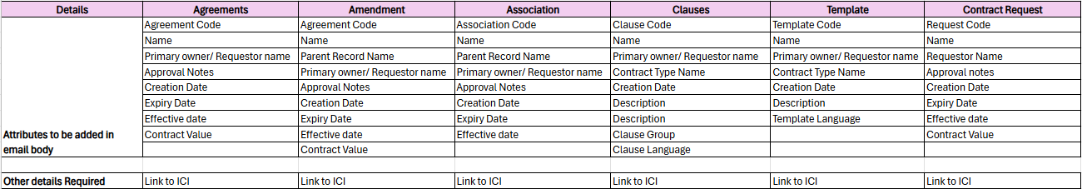
    - If the value of any attribute is not present for the contract, the attribute value should not be displayed/ rendered as ‘-’ in the email body.
  - The subscription should be restricted to the ‘Action user’ recipients. Only the intended action user should be able to approve or reject the agreement directly without logging in.
  - This seeded subscription should be available to admins during instance setup but should be disabled by default and require manual enabling.
  - The template should follow a predefined HTML design format.
    - There should be a provision to add/ subtract other attributes in predefined templates.

- Action User View for Direct Email Approval:
- Approve/Reject Action from Email:
  - The email should contain Approve and Reject buttons.
  - Clicking on a button should trigger an email reply with a structured format for adding notes / comments.
  - Post sending email reply, the response should be automatically captured without requiring the approver to log in.
- Approval/Rejection Notes via Email Reply:
- Upon clicking Approve/Reject, an email reply should be generated where the approver can enter notes.
- Notes entered in the reply must be captured in all relevant sections (e.g., notes, history, etc.), ensuring consistency with the existing functionality in ICI. (For both, list and grid view).
- If no comments are provided, the system should still record the action with a default note.
- In the rejection flow, users should not be required to enter a rejection code. If there is a mandatory rejection code to be added, for all rejections via email, we shall have a default one added.
- User guides should be included in the email reply, instructing users not to edit any content and to enter their response only within the specified area, as per the defined limitations.
- After submitting the email reply, a confirmation email should be triggered to the approver.
- During the approval or rejection process, no login to ICI should be required for action users to approve or reject the agreement.

- Enhancements in Quick Approval (review) Tag: {{QuickApprovalURI}}
  - The Quick Approval functionality, which currently supports review, should also support approval actions.
  - The quick approval functionality should also be extended for both internal and external users with login.
    - System should validate whether users have login privilege or not.
    - Users with login access should be required to log in with their credentials to access the customized approval window.
    - Users without login privileges should access it via a passcode, as per the existing functionality.
  - It should also support the entities covered: Agreements, Amendments, Associations, Contract Requests, Clauses, Templates
  - Document Preview:
    - For Agreements, Amendments, Clauses, Templates: Document preview should be there in quick approval window.
    - For Associations: For associations where document preview is possible, it should be displayed. For those where preview is not possible, provide a downloadable link on the quick approval screen.
    - For Contract Request: Document preview will not be applicable

- Action User View for Quick Approval (Review):
  - The Approver must see an action button for Quick Review within the email body, following the template design.
  - When approver clicks on action button from email, new browser window should open upon clicking the button.
  - When the approver clicks a button, the system should validate if the user is already logged in. If not, they should be required to login first.
  - In the new browser window, a customized (Quick approval) screen should appear, where the approver can:
    - Preview the document
    - Enter notes (Approval notes or Rejection notes)
    - Confirm their response of approve or reject
    - Rejection reason code (Where applicable)
    - Download / Upload / Edit (As per quick approval)
    - Link for details page in ICI
  - After the user submits their response, a confirmation text should appear on the customized screen, acknowledging their action.
  - In case of Rejection, there must be option to select Rejection reason code.
  - The response and notes entered by approvers must be captured in all relevant sections (e.g., notes, history, etc.), ensuring consistency with the existing functionality in ICI. (For both, list and grid view)

- Other requirements to be considered:
  - The system should authenticate whether the approver is the intended action user. Only authorized action users should be able to approve or reject the agreement.
  - The functionality to approve or reject should be valid only once. After confirming their response, if the Approver clicks the action button again, they should see a message / email reply indicating that the action has already been taken.
  - The functionality must also be mobile browser-friendly, ensuring that the UI and all design elements (such as layout, buttons, and font sizes) are fully compatible and responsive across mobile browsers.
  - After approval/rejection, the agreement should move to the next workflow state.
  - In case of delegation, system should validate the delegated user for approval.
  - Post approval it should create a major version of agreement
  - The functionality should also support sub-approvers.
  - If a user is no longer an approver for an agreement, they should not be able to approve or reject it. A separate message / email reply should be displayed in this case.
  - There must be provision for reminders to approvers
  - Security and Compliance requirements outlined in feature ADO 66622 / 2026638 should be adhered for this functionality.

User journey map: These are initial wires. Final ones will be added after UX signs off the same.
- User receives an email notification with Agreement details, Approve/Reject buttons, and Quick Review Link.
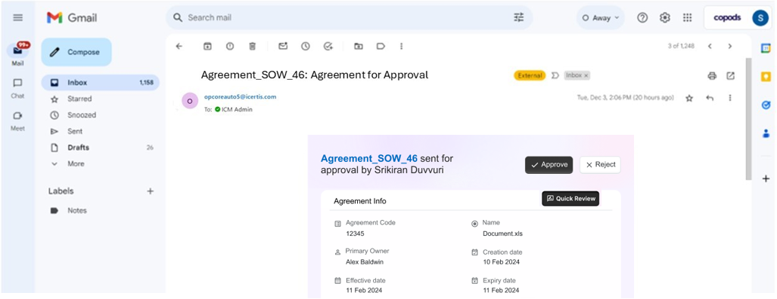
- User clicks on Approve/Reject button directly from the email. Email response gets constructed dynamically with the selected action to enter approver’s comments.
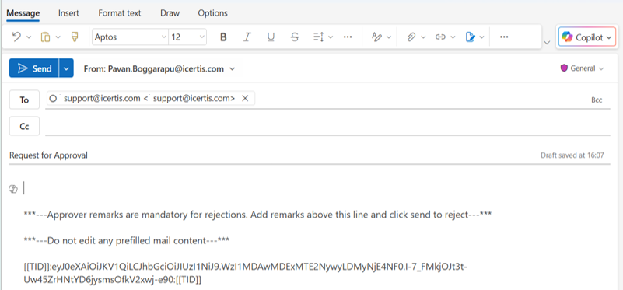

- User receives acknowledgment email upon successful action submission.
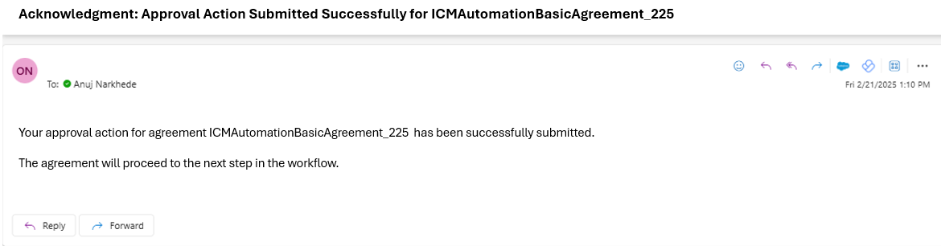
- Unauthorized users receive an error message if action is not permitted.
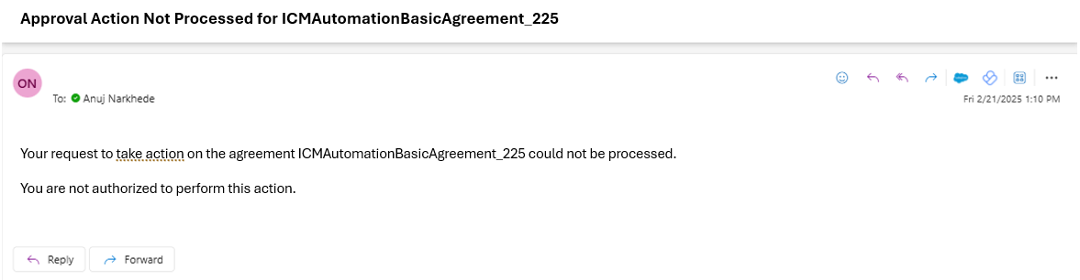
- User clicks on Quick Review Link, redirects to SSO page and then post authorization user will be landed on the quick review page.


Here user can take action / go to the agreement details
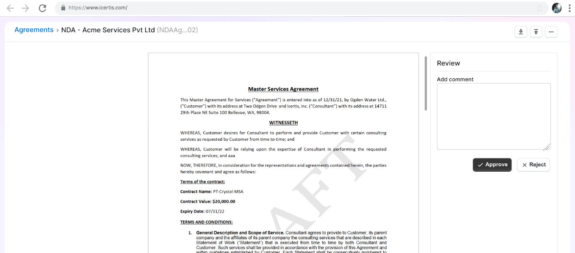
- Final confirmation screen appears upon action submission.
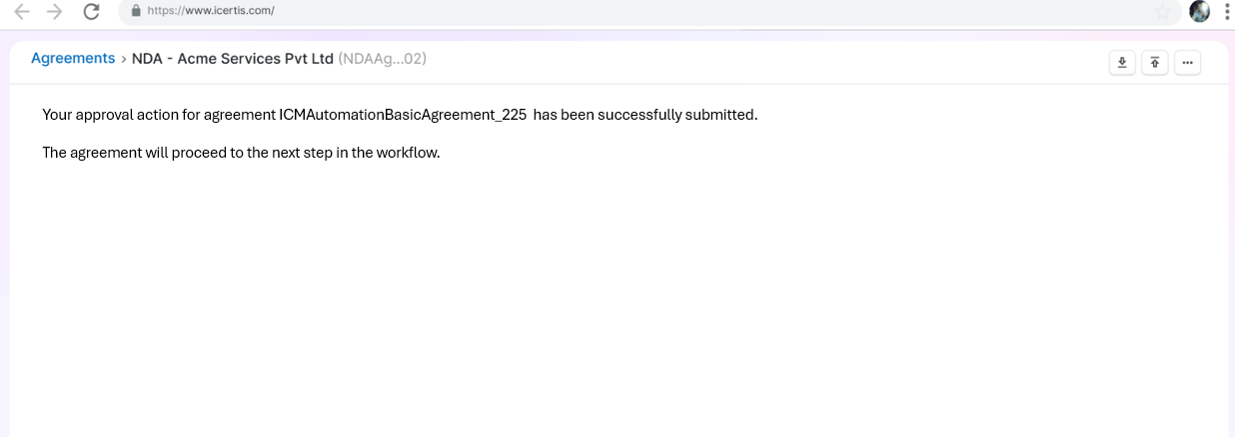

Out of scope:
- Deviation approvals are out of scope
- GovCon

Assumptions:
Likely functional impact areas due to this feature’s changes

E.g. - Impact of some requirement on add-ins, reports, mobile app, other plug-ins like AI components, etc. can be functionally analyzed, identified, and captured in this doc.

Sr. No. | Product area impacted | Impact Details
 | Notification | New Seeded Subscriptions
 | Quick Approval | Extended to more entities

Non - Functional Requirements:
- Config Requirement: Not Applicable
- Integrations – In scope - Iframe based testing.
- Upgrade Impact – Not Applicable
- Word Add-in impact – Not Applicable
- Mobile App- OOS
- Mobile Browser – Should be supported on mobile browser. Testing in scope.
- Outlook: The functionality should be tested on Outlook both through the Outlook application and Outlook in browsers
- The functionality should also be tested on other email applications, such as Gmail and Apple Mail, to ensure compatibility across different platforms.
- Localization – In scope
- Authorization requirements – Standard ICI authorization
- Browser specific needs / expectations: Compatible with all Browsers and versions along with mobile browsers supported by ICI on standard zoom levels.
- Security specific expectations, if any: As per access rights on entity
- Usability specific expectations, if any: As per standard ICI UX guidelines
- Accessibility specific expectations, if any: All pages should follow WCAG standard.
- Post Release Analytics:
  - Percentage of Approvals/Rejections via Email (vs. ICI Platform)
  - Percentage of actions performed per entity type
  - Total Number of Agreements Approved / Rejected directly from Email
  - Total notifications triggered with newly seeded templates
  - Number of Notes Entered with Approval/Rejection from custom window
  - Rate of attempts to approve or reject from forwarded emails
  - Rate of attempts to approve or reject after the action has already been taken

Documentation Requirements:
- Release Notes, Wiki documentation required as a standard feature enhancement.

