

**МИНОБРНАУКИ РОССИИ**

**федеральное государственное бюджетное образовательное учреждение**

**высшего образования**

**«Московский государственный технологический университет «СТАНКИН»**

**(ФГБОУ ВО «МГТУ «СТАНКИН»)**

|  |  |
| --- | --- |
| **Институт**  информационных  систем и технологий | **Кафедра**  информационных систем |

**Основная образовательная программа 09.03.02  
«Информационные системы»**

дисциплина **«Администрирование информационных сетей»**

**Отчет по лабораторной работе №6**

|  |  |  |
| --- | --- | --- |
| **Студент**  группы ИДБ-18-08 |  | Парфенова А.С. |
|  | подпись |  |
| **Руководитель**  к.т.н., доц. |  | Сосенушкин С.Е. |
|  | подпись |  |

Москва, 2021 г.

**Схема сети**

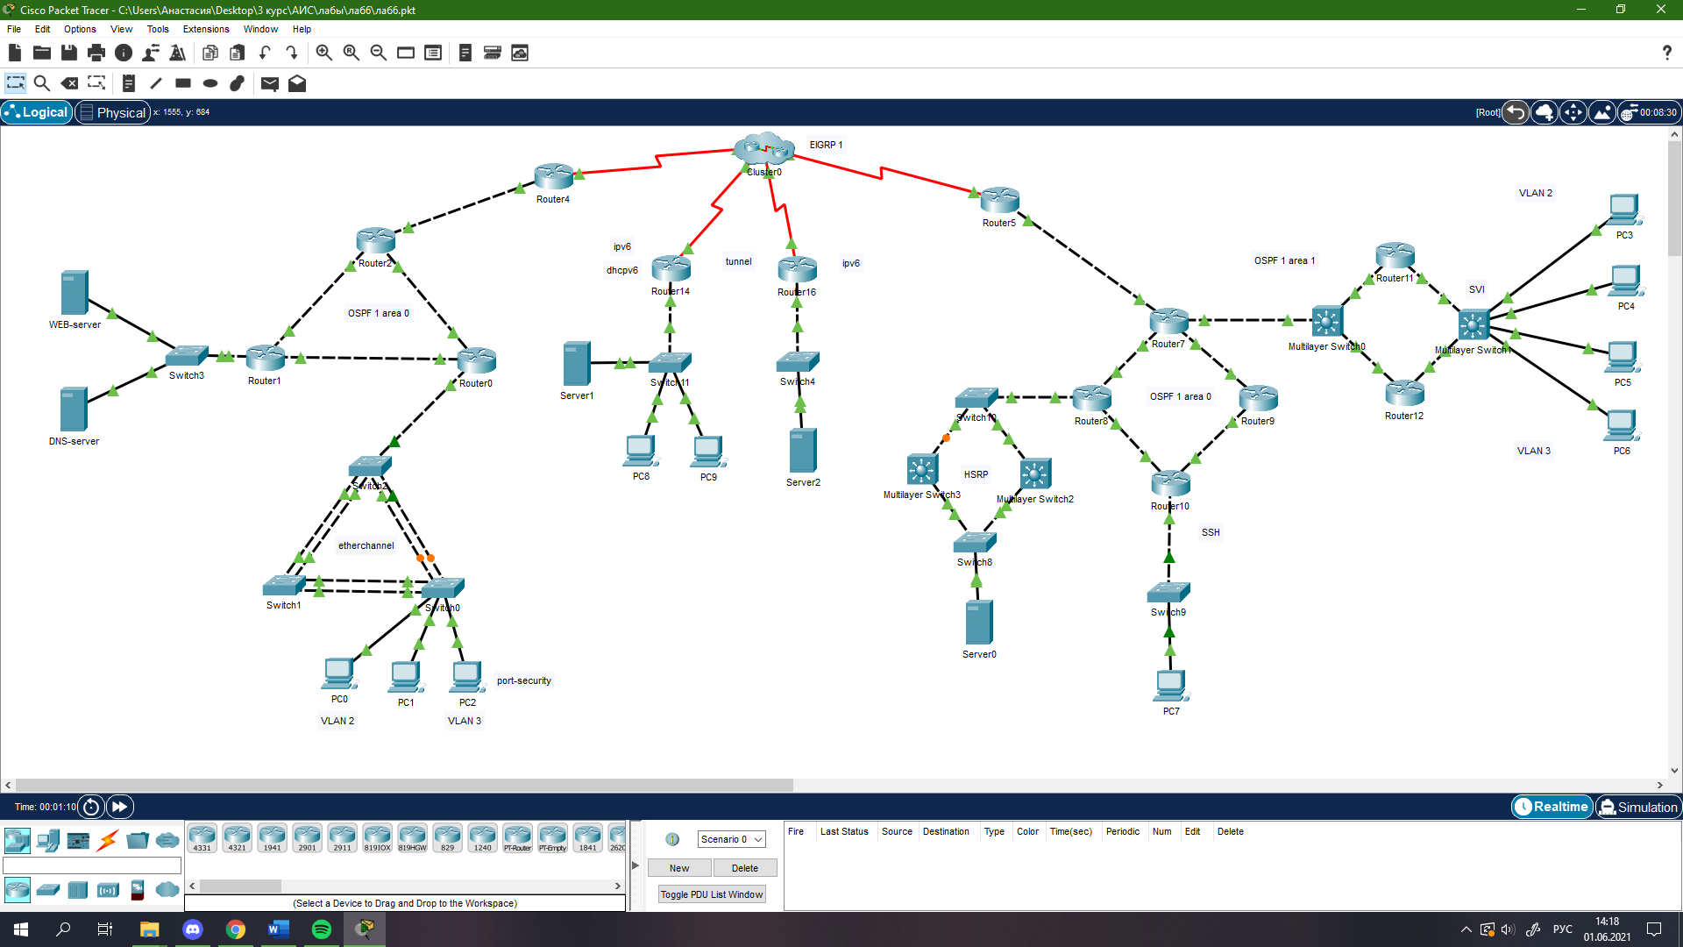

**Данные сети**

|  |  |  |  |  |
| --- | --- | --- | --- | --- |
| Устройство | Интерфейс | IP-адрес\IPv6-адрес | Маска подсети | Шлюз по умолчанию |
| Router 0 | F0/0 | 10.18.1.13 | 255.255.255.252 |  |
| F0/0.2 | 10.18.1.1 | 255.255.255.248 |  |
| F0/0.3 | 10.18.1.9 | 255.255.255.252 |  |
| F1/0 | 11.18.1.1 | 255.255.255.252 |  |
| F6/0 | 12.18.1.1 | 255.255.255.252 |  |
| Router 1 | F0/0 | 13.18.1.1 | 255.255.255.252 |  |
| F1/0 | 192.168.1.3 | 255.255.255.0 |  |
| F6/0 | 12.18.1.2 | 255.255.255.252 |  |
| Router 2 | F0/0 | 13.18.1.2 | 255.255.255.252 |  |
| F1/0 | 11.18.1.2 | 255.255.255.252 |  |
| F6/0 | 15.18.1.2 | 255.255.255.252 |  |
| Router 4 | Serial2/0 | 18.18.1.2 | 255.255.255.252 |  |
| GigabitEthernet6/0 | 15.18.1.1 | 255.255.255.252 |  |
| Router 3 | Serial2/0 | 18.18.1.1 | 255.255.255.252 |  |
| Serial3/0 | 18.18.1.5 | 255.255.255.252 |  |
| Serial4/0 | 18.18.1.13 | 255.255.255.252 |  |
| Serial9/0 | 18.18.1.9 | 255.255.255.252 |  |
| Router 5 | Serial2/0 | 18.18.1.6 | 255.255.255.252 |  |
| GigabitEthernet6/0 | 25.18.1.1 | 255.255.255.252 |  |
| Router 7 | F0/0 | 211.18.1.10 | 255.255.255.252 |  |
| F1/0 | 211.18.1.13 | 255.255.255.252 |  |
| GigabitEthernet6/0 | 25.18.1.2 | 255.255.255.252 |  |
| F7/0 | 14.18.1.1 | 255.255.255.248 |  |
| Router 8 | F0/0 | 211.18.1.14 | 255.255.255.252 |  |
| F1/0 | 202.168.1.1 | 255.255.255.248 |  |
| F6/0 | 211.18.1.1 | 255.255.255.252 |  |
| Router 9 | F0/0 | 211.18.1.6 | 255.255.255.252 |  |
| F1/0 | 211.18.1.9 | 255.255.255.252 |  |
| Router 10 | F0/0 | 211.18.1.2 | 255.255.255.252 |  |
| F1/0 | 210.18.1.1 | 255.255.255.252 |  |
| F6/0 | 211.18.1.5 | 255.255.255.252 |  |
| Router 11 | F0/0 | 14.18.1.26 | 255.255.255.252 |  |
| F1/0 | 14.18.1.2 | 255.255.255.248 |  |
| Router 12 | F0/0 | 14.18.1.30 | 255.255.255.252 |  |
| F1/0 | 14.18.1.3 | 255.255.255.248 |  |
| Router 14 | Tunnel0 | 2003::1 | 64 |  |
| GigabitEthernet0/0/0 | 2001:2::1 | 64 |  |
| Serial0/1/0 | 18.18.1.10 | 255.255.255.252 |  |
| Router 16 | Tunnel0 | 2003::2 | 64 |  |
| GigabitEthernet0/0/0 | 2005::1 | 64 |  |
| Serial0/1/0 | 18.18.1.14 | 255.255.255.252 |  |
| Server 0 |  | 202.168.1.6 | 255.255.255.248 | 202.168.1.4 |
| Server 1 |  | 2001:2::AAF5:9C53:703F:629D | 64 | FE80::206:2AFF:FEAD:BB01 |
| Server 2 |  | 2005::2 | 64 | 2005::1 |
| DNS-server | NIC | 192.168.1.1 | 255.255.255.0 | 192.168.1.3 |
| WEB-server | NIC | 192.168.1.2 | 255.255.255.0 | 192.168.1.3 |
| PC 0 | NIC | 10.18.1.5 | 255.255.255.248 | 10.18.1.1 |
| PC 1 | NIC | 10.18.1.6 | 255.255.255.248 | 10.18.1.1 |
| PC 2 | NIC | 10.18.1.10 | 255.255.255.252 | 10.18.1.9 |
| PC 3 | NIC | 14.18.1.22 | 255.255.255.248 | 14.18.1.18 |
| PC 4 | NIC | 14.18.1.21 | 255.255.255.248 | 14.18.1.18 |
| PC 5 | NIC | 14.18.1.14 | 255.255.255.248 | 14.18.1.10 |
| PC 6 | NIC | 14.18.1.13 | 255.255.255.248 | 14.18.1.10 |
| PC 7 | NIC | 210.18.1.2 | 255.255.255.252 | 210.18.1.1 |
| PC 8 | NIC | 2001:2::1AEE:FEBA:D285:D285 | 64 | FE80::206:2AFF:FEAD:BB01 |
| PC 9 | NIC | 2001:2::DBFA:BFC6:9392:8500 | 64 | FE80::206:2AFF:FEAD:BB01 |