CA6000 – Applied AI Programming
Bank Marketing Dataset: Data Inspection, Visualisation and MLP Classification
Team members:
Gu Shucheng (G2605220E)
Lim Renyi (G2609306E)
Source code: https://github.com/ParrotG/CA6000_Assignment
1. Introduction and Dataset Overview
1.1 Project Objective
The objective of this project is to construct a supervised machine learning model capable of predicting whether a customer will subscribe to a term deposit. Such predictive models can assist banks in identifying customers with higher likelihood of positive campaign response and support more effective marketing strategies.
1.2 Dataset Description
The Bank Marketing Dataset was downloaded from Kaggle and contains customer-level banking and campaign interaction information collected from a Portuguese financial institution. The target variable is deposit, which indicates whether a customer subscribed to a term deposit product.
Table 1. Dataset Overview
Attribute | Value
Total Records | 11,162
Original Features | 17
Target Variable | deposit
Dataset Format | CSV

The features include demographic information (age, occupation, education), financial characteristics (balance, housing loan, personal loan), and campaign history variables (contact type, call duration, previous outcomes). These attributes provide useful information for predicting customer behaviour.

2. Data Quality Assessment and Cleaning
2.1 Error Injection
A structured data-quality assessment was conducted by deliberately introducing six categories of common hard-data errors into a working copy of the dataset:
- Missing values
- Duplicate records
- Incorrect datatypes
- Invalid numeric values
- Invalid categorical values
- Inconsistent formatting
This approach enabled verification that the cleaning pipeline could identify and resolve real-world data issues.
2.2 Cleaning Process
The cleaning pipeline consisted of the following operations:
- Normalisation of text formatting using lowercase conversion and whitespace removal
- Datatype repair using pd.to_numeric()
- Invalid value replacement with missing markers
- Median imputation for numeric features
- Mode imputation for categorical features
- Removal of duplicate records

2.3 Cleaning Results
Table 2. Data Quality Assessment Results
Error Type | Before Cleaning | After Cleaning
Missing Values | 1 | 0
Duplicate Entry | 1 | 0
Wrong Datatype | 2 | 0
Invalid Numeric Values | 2 | 0
Invalid Categories | 1 | 0
Inconsistent Formatting | 2 | 0

All introduced hard-data issues were successfully detected and corrected. The final cleaned dataset retained the original dimensionality of 11,162 rows and 17 columns.
2.4 Logical Consistency Checks
Additional validation was carried out using campaign-related attributes:
- previous
- pdays
- poutcome
The consistency checks identified only two records where previous customer contact existed while campaign outcomes remained labelled as unknown. No major logical inconsistencies were detected.
This suggests that the dataset is internally consistent and suitable for predictive modelling.

3. Exploratory Data Analysis
3.1 Descriptive Statistics
Several numerical features exhibit substantial skewness and variance, indicating the presence of extreme observations and non-normal distributions.
Table 3. Selected Statistical Measures
Feature | Mean | Median | Skewness
Age | 41.23 | 39 | 0.863
Balance | 1,528.54 | 550 | 8.225
Duration | 371.99 | 255 | 2.144
Campaign | 2.51 | 2 | 5.546

The account balance feature demonstrates significant positive skewness, suggesting the existence of customers with exceptionally large balances. Campaign and duration variables also exhibit strong right-skewed distributions.

3.2 Target Variable Distribution
The target variable is relatively balanced:
- Positive subscriptions: 47.4%
- Negative subscriptions: 52.6%
This balanced distribution reduces concerns regarding severe class imbalance and supports the use of standard classification metrics.
Figure 1. Target Variable Distribution
Deposit Response | Percentage
No | 52.6%
Yes | 47.4%
The target classes are close to evenly distributed, reducing the likelihood of biased classification performance.

3.3 Special Encoded Values
The variable pdays contains a special encoded value of −1 representing customers who had never previously been contacted.
- Frequency: 8,324 records
- Percentage: 74.6%
This observation indicates that the majority of customers had no prior campaign interaction.

3.4 Semantic Missingness
Significant occurrences of the label “unknown” were identified:
Feature | Unknown Percentage
poutcome | 74.6%
contact | 21.0%
education | 4.5%
job | 6.3%
Although these values reduce interpretability, they may still contain useful predictive information for machine learning algorithms.

Figure 2. Numeric Feature Distribution Plots
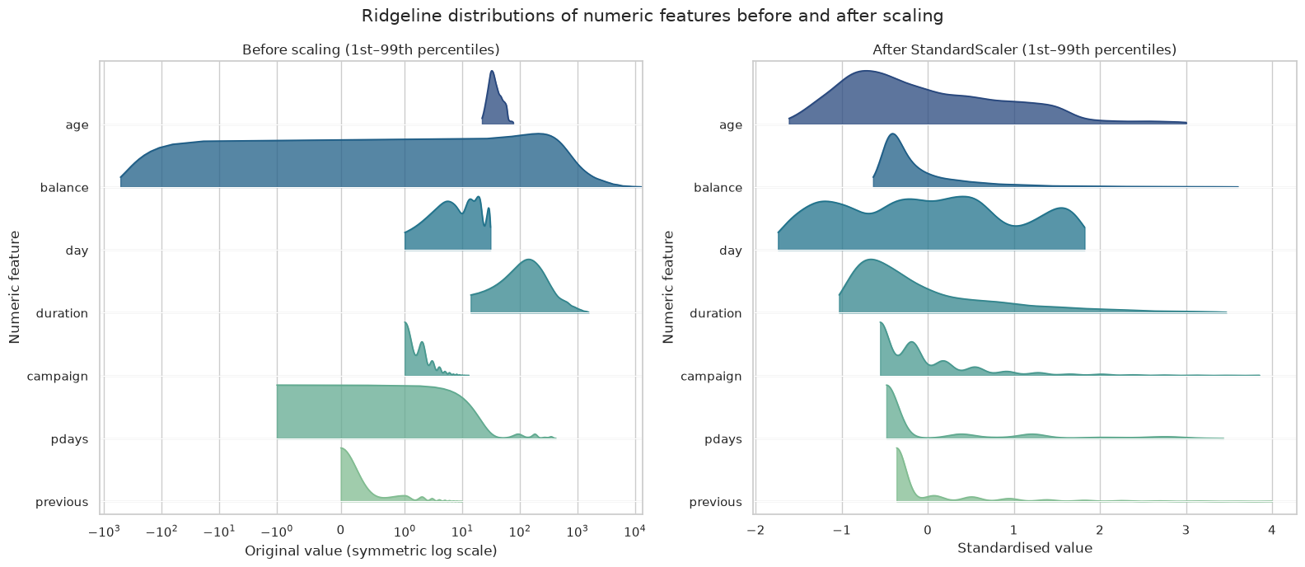Distribution plots reveal skewed variables, outliers, and feature ranges across the dataset.

4. Feature Engineering and Preprocessing
4.1 Feature Engineering
The variable pdays was transformed into two separate variables:
- previously_contacted
- pdays_since_previous
This conversion increased interpretability while preserving historical contact information.

4.2 Stratified Data Splitting
To preserve the target distribution across datasets, stratified sampling was used.

Table 4. Dataset Split
Dataset | Records | Percentage
Training | 7,812 | 70%
Validation | 1,675 | 15%
Test | 1,675 | 15%

The positive class proportion remained approximately 47.4% across all subsets.
4.3 Data Preprocessing
The preprocessing pipeline consisted of:
Numerical Features
- Median imputation
- StandardScaler normalisation
Categorical Features
- Most-frequent-value imputation
- One-Hot Encoding
After transformation, the final feature matrix contained 52 engineered features.

5. MLP Model Architecture and Training
5.1 Architecture
A Multilayer Perceptron (MLP) classifier was implemented using the following structure.
Table 5. MLP Configuration
Parameter | Value
Hidden Layer 1 | 64 neurons
Hidden Layer 2 | 32 neurons
Activation | ReLU
Optimiser | Adam
Batch Size | 64
Learning Rate | 0.001
Alpha | 0.0001

5.2 Early Stopping
Validation-based early stopping was applied to reduce overfitting.

Table 6. Training Summary
Parameter | Value
Best Epoch | 12
Best Validation Loss | 0.3438
Early Stopping Epoch | 24

The stopping strategy prevented unnecessary training and preserved generalisation performance.

Figure 4. Training Loss and Validation Loss Curves
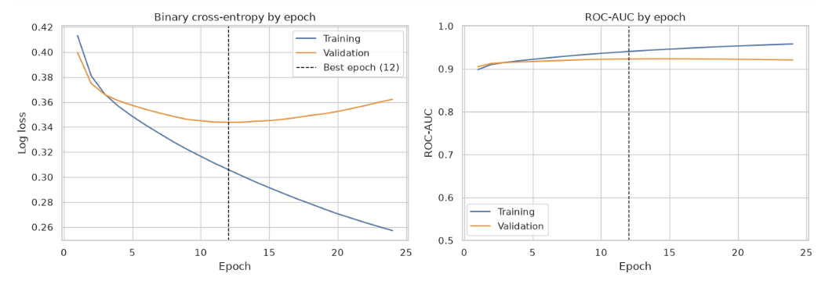
The model reached optimal validation performance around epoch 12 before training improvements plateaued.

6. Results and Evaluation
6.1 Overall Model Performance
Table 7. Test Set Results
Metric | Value
Accuracy | 0.849
Balanced Accuracy | 0.851
Precision | 0.813
Recall | 0.884
F1 Score | 0.847
ROC-AUC | 0.916
Log Loss | 0.358

The ROC-AUC score of 0.916 demonstrates excellent discrimination ability between positive and negative customer outcomes.

6.2 Classification Report
Table 8. Test Set Classification Metrics
Class | Precision | Recall | F1 Score
No Deposit | 0.887 | 0.817 | 0.851
Deposit | 0.813 | 0.884 | 0.847

The model demonstrates strong recall performance for the positive class, indicating that most subscribing customers are correctly identified.

Figure 5. Test Set Confusion Matrix
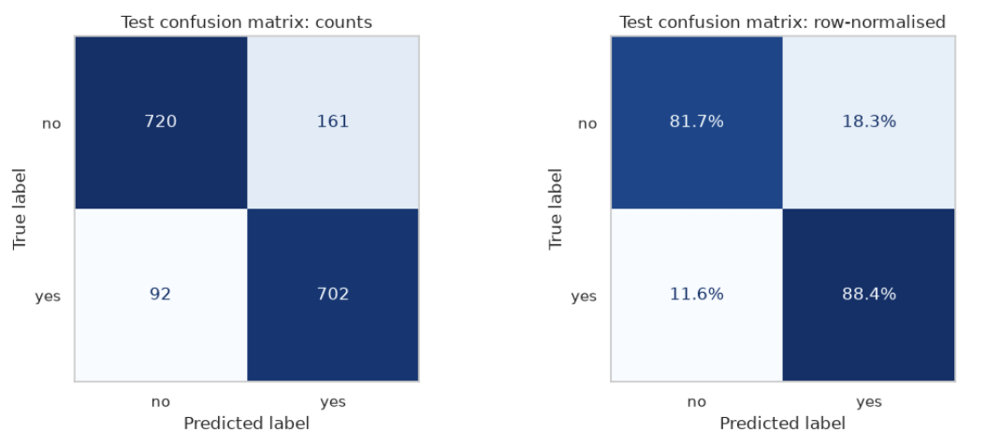The confusion matrix illustrates model classification behaviour across both classes.

Figure 6. ROC Curve
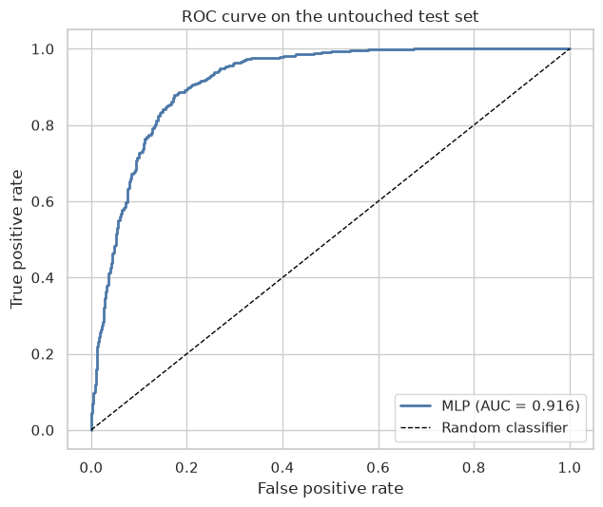The ROC curve demonstrates strong separation between positive and negative classes.

6.3 Overfitting Assessment
Table 9. Accuracy Comparison
Dataset | Accuracy
Training | 87.2%
Validation | 85.6%
Test | 84.9%

The performance differences are small, indicating that validation-based early stopping successfully reduced overfitting while maintaining strong predictive capability.

7. Conclusion and Recommendations
This project successfully implemented an end-to-end supervised machine-learning workflow using the Bank Marketing Dataset. A comprehensive data-quality assessment confirmed the robustness of the cleaning pipeline, while exploratory analysis revealed meaningful patterns within customer and campaign variables.
After preprocessing and feature engineering, an MLP classifier was trained using validation-based early stopping. The final model achieved:
- Accuracy = 84.9%
- Balanced Accuracy = 85.1%
- F1 Score = 84.7%
- ROC-AUC = 0.916
These results indicate strong predictive performance and good generalisation on unseen data.
Future Work
- Hyperparameter optimisation
- Ensemble learning models
- Feature-selection approaches
- SHAP-based explainability analysis
- Production deployment and monitoring frameworks
Future enhancements may further improve predictive performance and practical business value.

Generative AI Use Statement
Generative AI (GPT-5.6 Sol) was used during the code development process for this project. The project approach, system design, and implementation requirements were determined by the group members. AI-generated code and suggestions were reviewed, tested, and modified by the group under human supervision to ensure their correctness, suitability, and alignment with the project requirements.

