**PART 1:** Write the letter that corresponds to the correct answer in the space provided. You will ONLY be graded on the letter written and not on the circles made on the question. Each question is worth 1 point.

1. Which of the following statements is not true about computing systems?
2. An operating system is a special kind of software that enables other software to run
3. Software is typically written in a language that computers can understand
4. Recent computing advances are solely due to Moore’s law
5. The chip (i.e., central processing unit) is a part of computer responsible for executing operations
6. Which of the following statements is true about programming?
7. High level programming languages can only be understood by one operating system
8. Assembly language can be used on different computer architecture
9. It is difficult for humans to program in machine code
10. Snap is an example of an assembly language
11. Scratch is an example of a machine language
12. When building a classifier, if the training data is biased in some way then
13. The test data is biased in the opposite way
14. The test data is biased in the same way
15. The test data is unbiased
16. The biasing of the test data and the training data is not related
17. The test data will be fair
18. Which option best describes the color represented by the hexadecimal code: #A11F9F?
19. A shade of red
20. A shade of blue
21. A shade of green
22. A shade of purple
23. A shade of black
24. Which of the following visual representations is not based on position on an axis?
25. Bar Chart
26. Parallel Coordinates
27. Network Graph
28. Radar Chart
29. Star Plot
30. In visual representations when comparing items, shading is more accurate than which of the following
31. Length
32. Angle
33. Area
34. Color saturation
35. Curvature
36. Suppose you are sending an email, which is broken into packets for transmission over the internet. Which of the following statements is not true?
37. Each packet can take a different route
38. The packets may arrive out of order
39. Some packets may not arrive at all
40. None of the above
41. What component is the file in https://canvas.ubc.ca/courses/cpsc_100.png
42. courses
43. canvas.ubc.ca
44. https
45. cpsc_100.png
46. What helps direct data packets to the right destination?
47. A computer
48. A router
49. A modem
50. A circuiter
51. A memory parser
52. A residential switch
53. How do neurons in ANN work?
54. They use neural electrons to solve translation problems
55. They solve one tiny function and pass the result on to another neuron
56. They duplicate the functionality of biological neurons exactly
57. All of the above

**PART 2:** Write the answer in the space provided. Each question is worth 2 points.

1. _________________________________________ requires inferring parts of speech and sentence structure using a lexicon and grammar.
2. _________________________________________________________________ is the thought processes involved in formulating problems and their solutions so that the solutions are in a form that can be effectively carried out by an information-processing agent.
3. What is the name of the visual representation below? ______________________________________

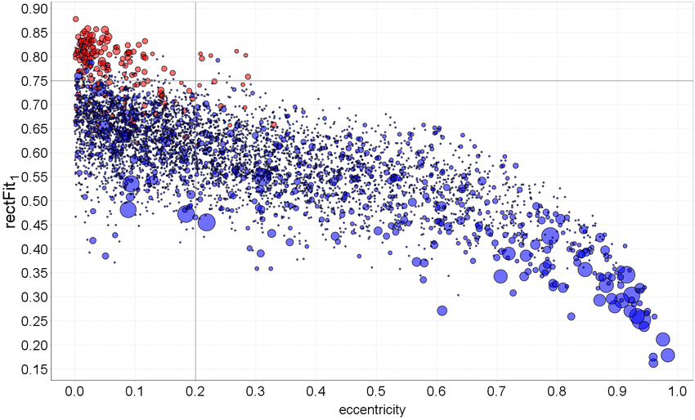

1. Translator/Compiler/Interpreter/Assemble___________________takes a high-level programming language and translates it into something the computer can understand, regardless of which high-level language is used.

Use the URL below to answer Questions 15 and 16  
https://www.cbc.ca/radio/spark/366-smelling-data-competing-for-amazon-and-more-1.4340869/getting-emotional-about-online-privacy-1.4341986

1. ________ca_______ is the top level domain name for the URL
2. ________radio___________ is the top level (i.e., root) folder for the URL
3. Let’s say that instead of having a base 10 number system, we had a new type of system where each digit represents 5 symbols, how many digits would I need to represent 56 symbols?   
     
   ____________________________________
4. Let’s say that instead of having a base 2 number system, we have a new type of system where each digit represents 4 symbols, how many symbols can we represent with 5 digits?

___________________________________

1. What is the name of the visual representation below? ______________________________________

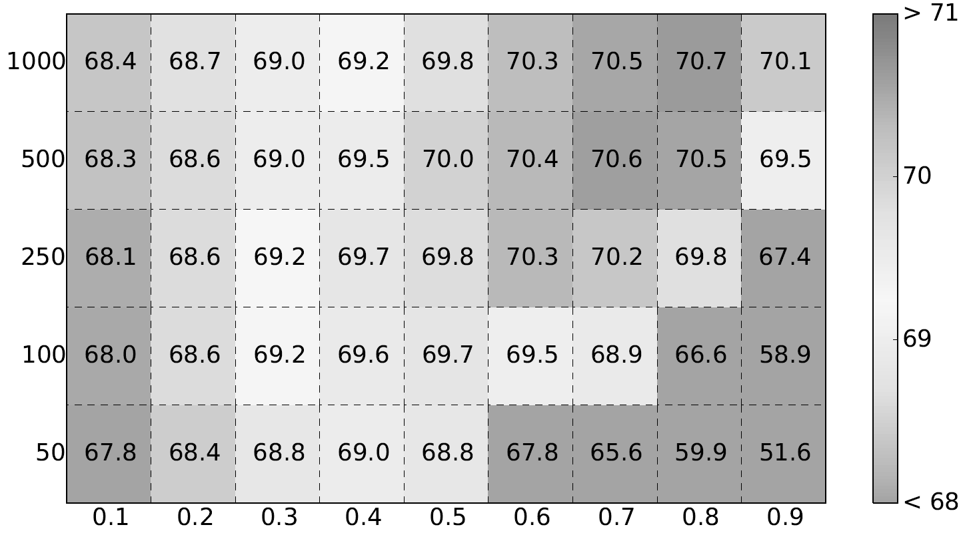

1. List two accomplishments of Alan Turing

___________________________________________________________________________________  
  
__________________________________________________________________________________  
  
___________________________________________________________________________________

**PART 3: Short Answer Questions**

Write the answer in the space provided.

1. [3pts] **List three ways** that we evaluated algorithms over the course of the term. Another way of the phrasing this question is *“besides correctness, what criteria would you use to select one algorithm over another”*?  
     
   _________________________________________________________________________________________  
     
   _________________________________________________________________________________________  
     
   _________________________________________________________________________________________
2. [6pts] **List four theories** as to why there is a lower percentage of women in computer science when compared to other disciplines.  
     
   ________________________________________________________________________________________  
     
   ________________________________________________________________________________________  
     
   ________________________________________________________________________________________  
     
   ________________________________________________________________________________________
3. [2pts] What does it mean to say that the k-means clustering algorithm *stabilizes*?  
     
   ___________________________________________________________________________________  
     
   ____________________________________________________________________________________

____________________________________________________________________________________

1. [2pts] What is the *maximum* number of clusters that the k-means algorithm can produce, when the input is a dataset with 50 points and k = 5? Explain your answer briefly.   
     
   ___________________________________________________________________________________  
     
   ___________________________________________________________________________________  
     
   ___________________________________________________________________________________
2. [2pts] What is the *minimum* number of clusters that the k-means algorithm can produce, when the input is a dataset with 100 points and k = 40? Explain your answer briefly.

___________________________________________________________________________________  
  
__________________________________________________________________________________  
  
__________________________________________________________________________________

1. [3 pts] What is an example of an adversarial attack in the context of machine learning models and why is it important for software developers  
     
   ___________________________________________________________________________________  
     
   ___________________________________________________________________________________

___________________________________________________________________________________

1. [6 pts] In class, we talked about garbage in garbage out in different modules. Give three examples of why garbage in garbage out is important. Your examples must be distinct and not reference the same idea. For instance, if we were talking about the concept of WYSIWYG, listing the New York Times mistake and the Iraq war mistake would be concerned the same idea. For each example, state the module you are referring. For example   
     
    ___________________________________________________________________________________

___________________________________________________________________________________  
  
___________________________________________________________________________________

___________________________________________________________________________________  
  
___________________________________________________________________________________  
  
___________________________________________________________________________________  
___________________________________________________________________________________  
  
___________________________________________________________________________________

**Use the snap program shown to answer Questions 28 – 30**

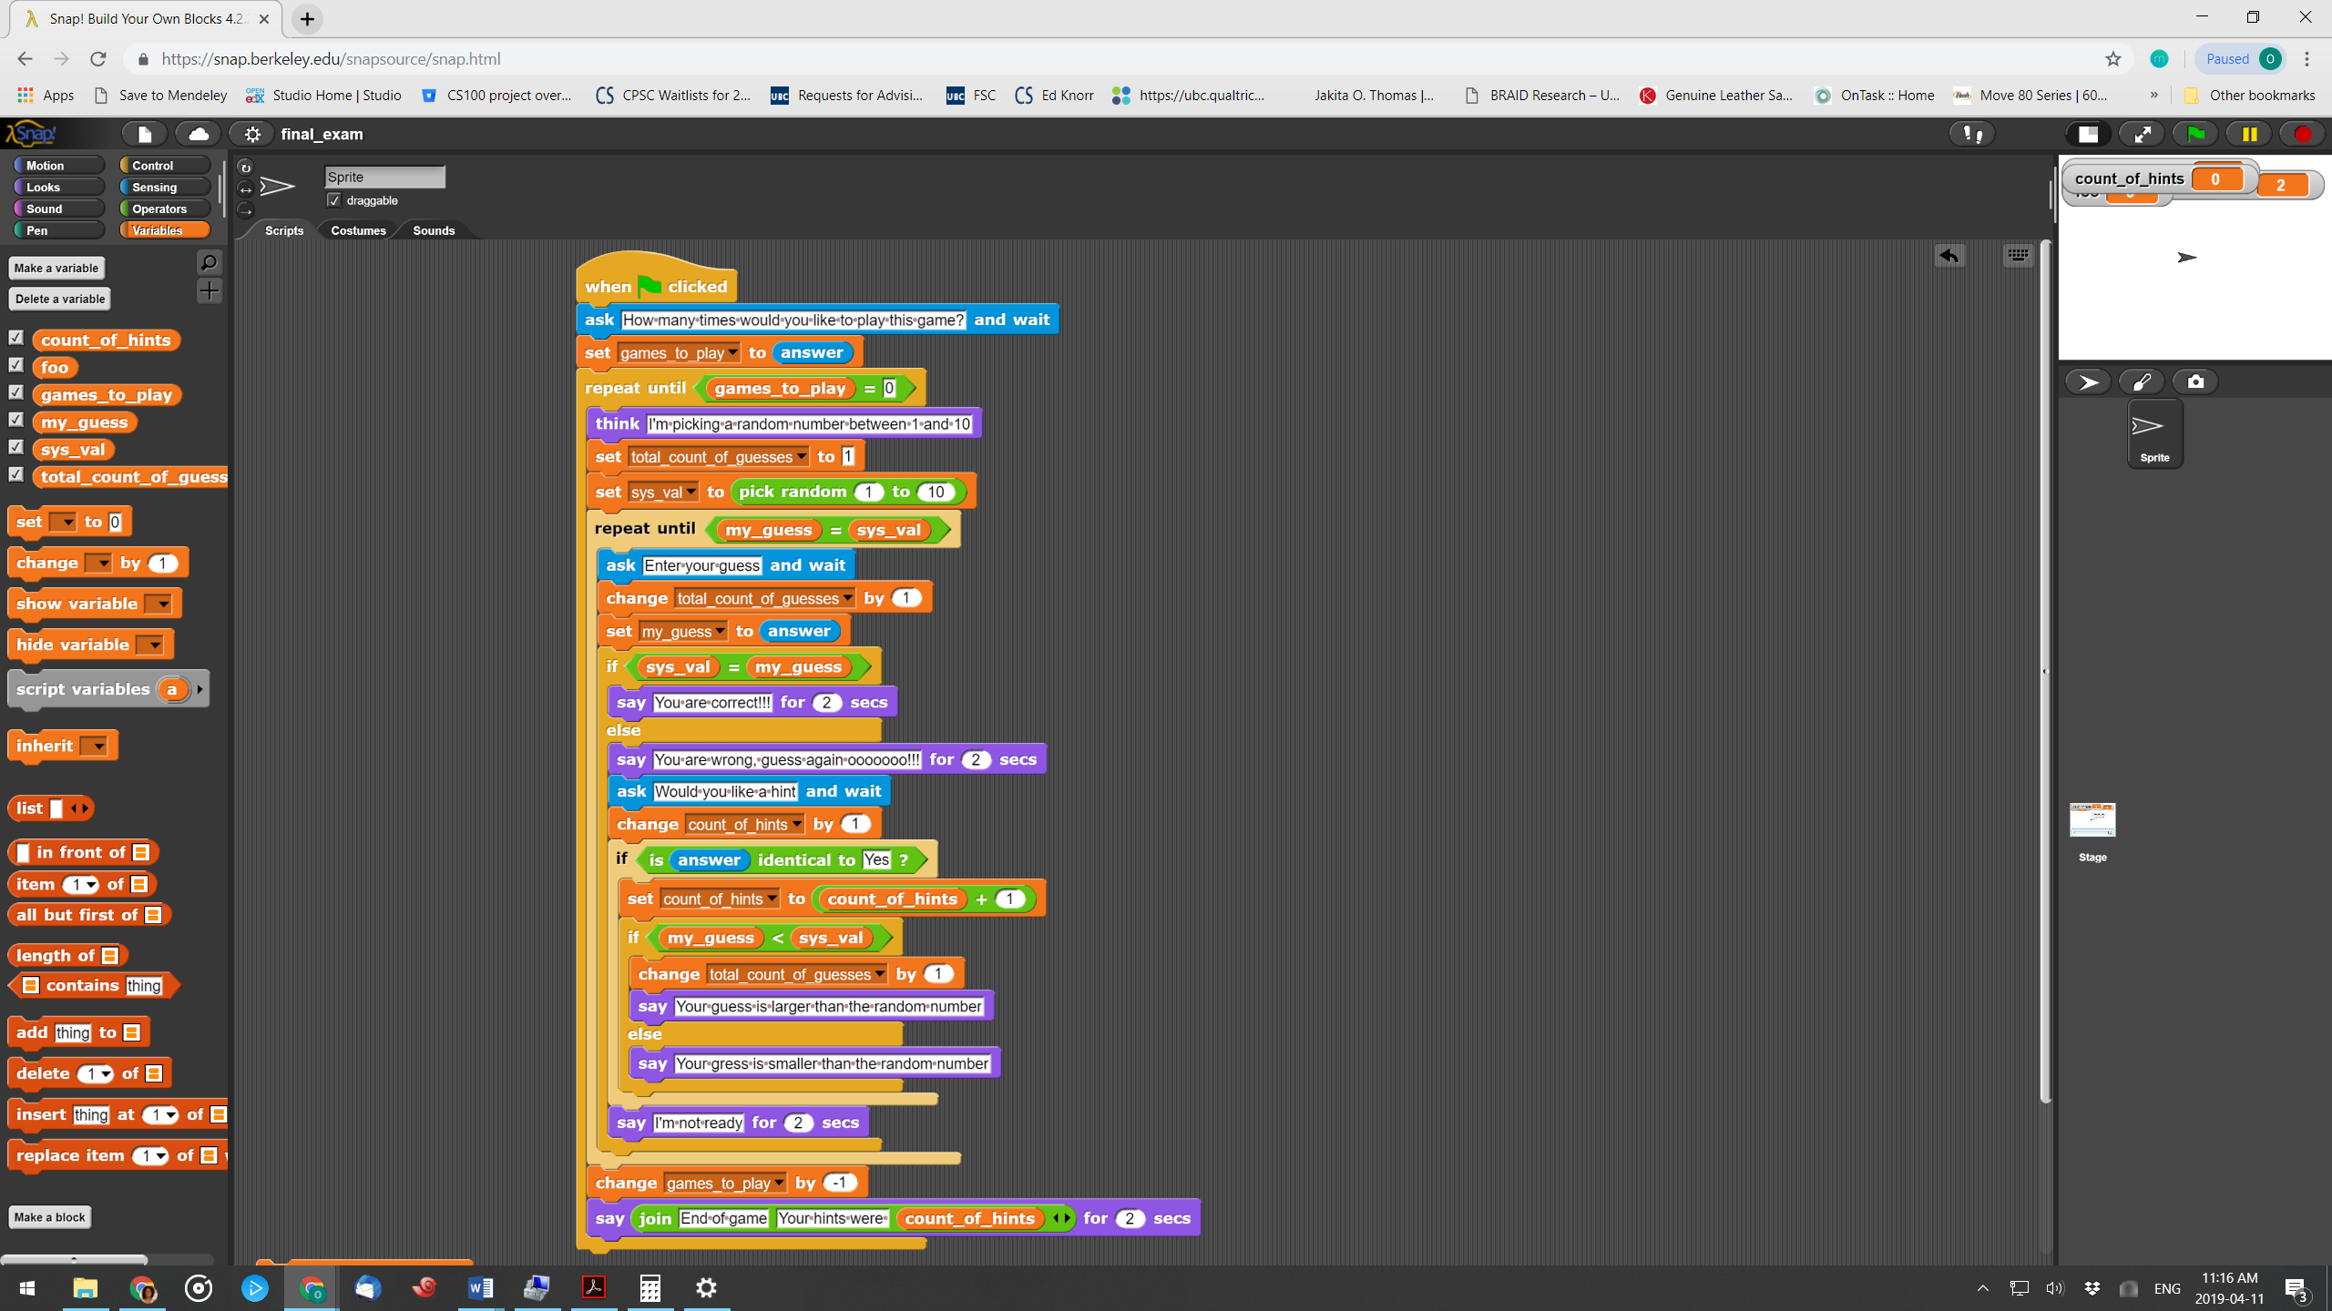

1. [1pts] If the user enters 3 for the number of times they would like to play the game. What is the final value in total_count_of_guesses if the user guesses the correct number on the first try for each round?  
   2

___________________________________________________________________________________

If the user enters 2 for the number of times they would like to play the game.

1. [3pts] What would be displayed to the screen (don’t include the questions), if for the first round, the random value was 4, and the user guesses were 5 and 8, and then they asked for a hint and then provided the right answer (i.e. 4).  
     
   ___________________________________________________________________________________  
     
   ____________________________________________________________________________________  
     
   ____________________________________________________________________________________

____________________________________________________________________________________

____________________________________________________________________________________

____________________________________________________________________________________

____________________________________________________________________________________  
  
____________________________________________________________________________________

1. [4pts] What would be displayed to the screen (don’t include the questions) if for the second round, the random value was 8, and the user guessed correctly on the first try

___________________________________________________________________________________  
  
____________________________________________________________________________________  
  
____________________________________________________________________________________

____________________________________________________________________________________

____________________________________________________________________________________

____________________________________________________________________________________

____________________________________________________________________________________  
  
____________________________________________________________________________________

1. [4 pts] What are two advantages of using ANN to address real-world problems?  
     
   ___________________________________________________________________________________  
     
   ____________________________________________________________________________________  
     
   ____________________________________________________________________________________

____________________________________________________________________________________

____________________________________________________________________________________

1. [4pts] Use the bitmap image for the next two questions. For all colours, where applicable, please write

the representation in hex. The darker color is green, while the lighter one is white.

|  |  |  |  |  |
| --- | --- | --- | --- | --- |
|  |  |  |  |  |
|  |  |  |  |  |

|  |  |
| --- | --- |
| Write out the non-compressed representation  __2 x 5  00FF00 FFFFFF FFFFFF FFFFFF 00FF00 00FF00 FFFFFF FFFFFF FFFFFF FFFFFF | Write the lossless compression representation  2 x 5  00FF00 1 FFFFFF 3 00FF00 2 FFFFFF 4 |

**PART 4: Real World Applications**

Write the answers in the space provided.

1. [6pts] Below is a screenshot of a real email that I received.   
   For some context, Rachel Pottinger is an associate professor and Associate Head of Undergraduate Program in the computer science department here at UBC.

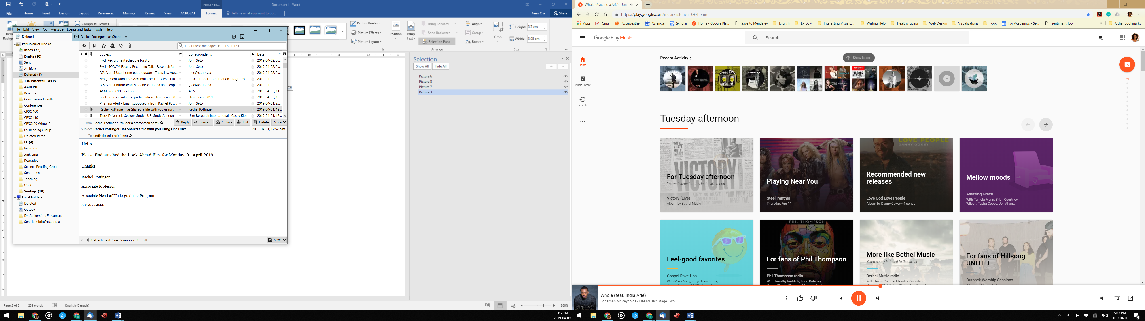

Should I download the attachment?

_____________________________  
  
Write out three reasons to support your answer

____________________________________________________________________________________

____________________________________________________________________________________

____________________________________________________________________________________

____________________________________________________________________________________

____________________________________________________________________________________

**Use the scenario below for the next 4 questions**Your cousin Ani is trying to decide whether a semester abroad is the best course of action. Ani interviewed 15 other UBC students who have done a semester abroad, but is not sure what to do with all the data he has. The table below shows the highlights of the notes collected by Ani.

* Level is the student’ level in university, where 1 represents first year and so on
* Faculty is the faculty in which the student is in
* Income is the household income for the student and their guardians/parents
* Language is the proficiency of the student in the language of the country in which they study abroad in
* Advice is the advice the student gave Ali based on their experiences.

|  |  |  |  |  |
| --- | --- | --- | --- | --- |
| **Level** | **Faculty** | **Income** | **Language** | **Advice** |
| **1** | Arts | Below $250,000 | Advanced | Stay here |
| **2** | Arts | Below $250,000 | Basic | Stay here |
| **2** | Arts | Below $250,000 | Medium | Go abroad |
| **3** | Arts | Above $250,000 | Basic | Go abroad |
| **3** | Arts | Below $250,000 | Basic | Stay here |
| **4** | Arts | Above $250,000 | Advanced | Go abroad |
| **4** | Arts | Below $250,000 | Basic | Go abroad |
| **1** | Science | Above $250,000 | Basic | Stay here |
| **2** | Science | Above $250,000 | Advanced | Go abroad |
| **2** | Science | Above $250,000 | Medium | Go abroad |
| **2** | Science | Below $250,000 | Medium | Go abroad |
| **3** | Science | Below $250,000 | Basic | Stay here |
| **3** | Science | Above $250,000 | Medium | Stay here |
| **3** | Science | Above $250,000 | Medium | Stay here |
| **4** | Science | Above $250,000 | Basic | Go abroad |
| **4** | Science | Below $250,000 | Medium | Go abroad |

1. [9pts] Use the data in the table on the previous page to create a decision tree using the approach presented in class.

1. [1pts] If Ani is thinking of going to Italy, and has an advanced fluency in Spanish and German, basic fluency in Italian, and is a third year Arts student whose parents make about one hundred and seventy thousand dollars each year, should he go to Italy next year?  
     
     
   _____________________________________________________________________________________
2. [6pts] Now that you have helped your cousin make a good decision, you start to think of other UBC students who might be struggling with this same decision. You decide to create an app, and reach out to a friend in Computer Science who has some experience in making Android app. Write out the algorithm that you need to provide your friend based on the decision tree created. The app should ask the student for all the relevant data and then let them know whether they should study abroad next year or stay at UBC?  
     
   ___________________________________________________________________________________  
     
   ___________________________________________________________________________________

___________________________________________________________________________________  
  
___________________________________________________________________________________  
  
___________________________________________________________________________________

___________________________________________________________________________________  
  
___________________________________________________________________________________  
  
___________________________________________________________________________________

___________________________________________________________________________________  
  
___________________________________________________________________________________  
  
___________________________________________________________________________________  
  
___________________________________________________________________________________

___________________________________________________________________________________  
  
___________________________________________________________________________________  
  
___________________________________________________________________________________

1. [2pts] Your app is a raving success and within the first week you have 1000 downloads. Thinking about all that we have covered in class this year, what is one limitation of your current application and how should you fix it?

___________________________________________________________________________________  
  
___________________________________________________________________________________

___________________________________________________________________________________  
  
___________________________________________________________________________________

1. [3pts] For the infographic shown below, **name one strategy** for designing infographics was done incorrectly?  
     
   ___________________________________________________________________________________  
     
   Based on your previous answer, what **one change** would improve the infographic?   
     
   ___________________________________________________________________________________

___________________________________________________________________________________

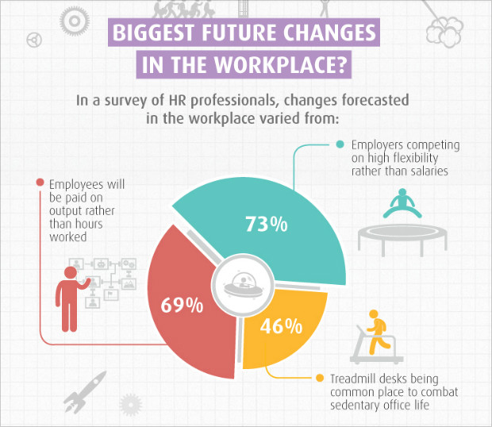

1. [3pts] Given the infographic below, **name one** principle that the infographic violates  
     
     
   ___________________________________________________________________________________  
     
   Explain how the infographic violates the principle you wrote above  
     
   ___________________________________________________________________________________

___________________________________________________________________________________  
  
___________________________________________________________________________________  
  
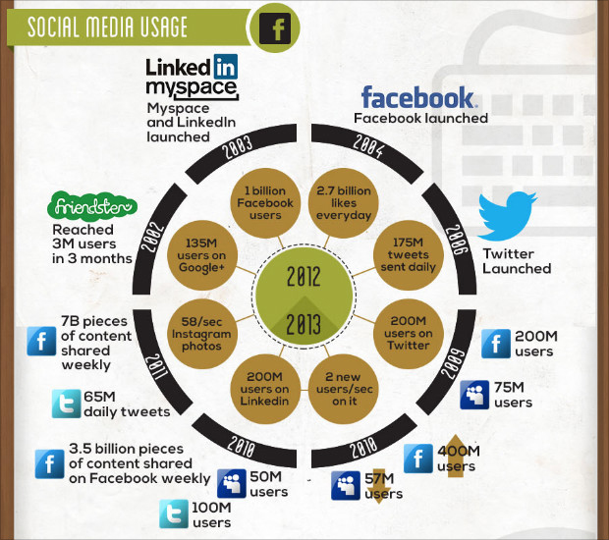

1. [4pts] Your grand uncle comes over for Thanksgiving and at dinner mentions that machines are going to take over the world very soon. To make his argument he cites the following
   1. Sophia, a social humanoid robot, has the ability to make more 50 facial expressions and she can also talk and converse with us.
   2. In a movie that he watched, he noticed that the robots had the ability to read human thoughts and were making human decisions.
   3. The recent closure of a General Motors car manufacturing plant shows that machines are replacing human jobs and very soon we will all be out of a job.

In a respectful manner (he is your uncle), explain, how each of the statements does not mean that machines are taking over. It is important, that your responses be grounded in the concepts explored in our course.

* 1. ________________________________________________________________________________  
       
     ________________________________________________________________________________  
       
     ________________________________________________________________________________  
       
     ________________________________________________________________________________
  2. ________________________________________________________________________________  
       
     ________________________________________________________________________________  
       
     ________________________________________________________________________________  
       
     ________________________________________________________________________________
  3. ________________________________________________________________________________  
       
     ________________________________________________________________________________  
       
     ________________________________________________________________________________  
       
     ________________________________________________________________________________  
       
     ________________________________________________________________________________

**This page has been intentionally left blank**

Note that any work that you do on this page will NOT be graded. If you want to do work here you MUST transfer it to the appropriate spot in the rest of the exam. The same holds for the page on the back of the cover sheet.