**PART 1:** Write the letter that corresponds to the correct answer in the space provided. You will ONLY be graded on the letter written and not on the circles made on the question. Each question is worth 1 point.

1. Which of the following statements is not true about computing systems?
2. An operating system is a special kind of software that enables other software to run
3. Software is typically written in a language that computers can understand
4. Recent computing advances are solely due to Moore’s law
5. The chip (i.e., central processing unit) is a part of the computer that is responsible for executing operations
6. Which of the following statements is true about programming?
7. High level programming languages can only be understood by one operating system
8. Assembly language can be used on different computer architecture
9. It is difficult for humans to program in machine code
10. Snap is an example of an assembly language
11. Scratch is an example of a machine language
12. When building a classifier, if the training data is biased in some way then
13. The test data is biased in the opposite way
14. The test data is biased in the same way
15. The test data is unbiased
16. The biasing of the test data and the training data is not related
17. The test data will be fair
18. Which option best describes the color represented by the hexadecimal code: #A11F9F?
19. A shade of red
20. A shade of blue
21. A shade of green
22. A shade of purple
23. A shade of black
24. Which of the following visual representations does not utilize position on a common axis?
25. Bar Chart
26. Parallel Coordinates
27. Network Graph
28. Radar Chart
29. Star Plot

1. In visual representations when comparing items, shading is more accurate than which of the following
2. Length
3. Angle
4. Area
5. Color saturation
6. Curvature
7. Suppose you are sending an email, which is broken into packets for transmission over the internet. Which of the following statements is not true?
8. Each packet can take a different route
9. The packets may arrive out of order
10. Some packets may not arrive at all
11. None of the above
12. What component is the file in https://canvas.ubc.ca/courses/cpsc_100.png
13. courses
14. canvas.ubc.ca
15. https
16. cpsc_100.png
17. What helps direct data packets to the right destination?
18. A computer
19. A router
20. A modem
21. A circuiter
22. A memory parser
23. A residential switch
24. How do neurons in ANN work?
25. They use neural electrons to solve translation problems
26. They solve one tiny function and pass the result on to another neuron
27. They duplicate the functionality of biological neurons exactly
28. All of the above

**PART 2:** Write the answer in the space provided. Each question is worth 2 points.

1. _____________________________________ requires inferring meaning from contextual information.

1. ____________________________________________ is used in defining patterns, generalizing from instances, and parameterization.  It is used to let one object stand for many.
2. What is the name of the visual representation below? ______________________________________

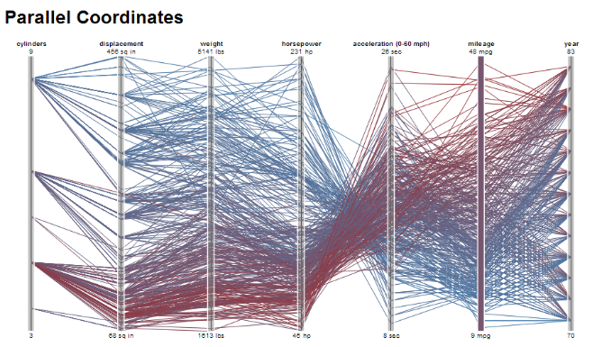

1. ___________________________________________________takes a high-level programming language and translates it into something the computer can understand, regardless of which high-level language is used.

Use the URL below to answer Questions 15 and 16  
https://www.cbc.ca/radio/spark/366-smelling-data-competing-for-amazon-and-more-1.4340869/getting-emotional-about-online-privacy-1.4341986

1. ________________________________________ is the top level domain name for the URL
2. ______________________________________ is the top level (i.e., root) folder for the URL
3. ___________________________ is the activity of defrauding an online account holder of financial information by posing as a legitimate company.
4. In animation, __________________________________ is the process of filling in frames between key frames.
5. Let’s say that instead of having a base 2 number system, we have a new type of system where each digit represents 5 symbols, how many symbols can we represent with 3 digits?

___________________________________

1. What is the name of the visual representation below? ______________________________________

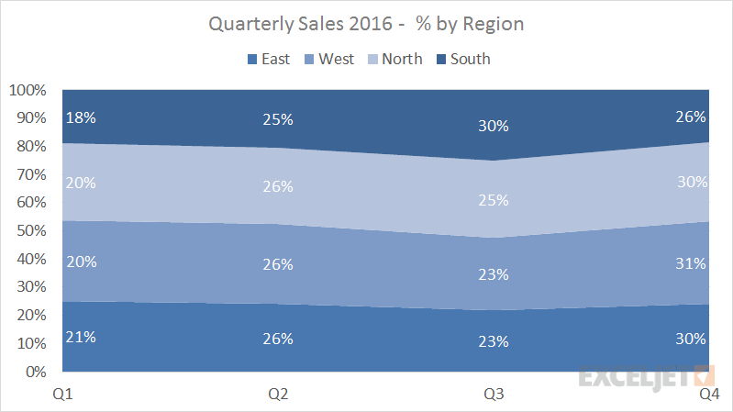

**PART 3: Short Answer Questions**

Write the answer in the space provided.

1. [3pts] Compare and contrast the Selection Sort and Simple Sort algorithms  
     
   ____________________________________________________________________________  
     
   ____________________________________________________________________________  
     
   ____________________________________________________________________________
2. [4pts] **List four theories** as to why there is a lower percentage of women in computer science when compared to other disciplines.  
     
   ________________________________________________________________________________________  
     
   ________________________________________________________________________________________  
     
   ________________________________________________________________________________________  
     
   ________________________________________________________________________________________
3. [4pts] Convert 0x10F to decimal  
     
     
   ________________________________________________________________________
4. [4pts]Convert decimal 250 to hexadecimal  
     
     
   ________________________________________________________________________
5. [3pts] What information does a TCP/IP packet contain?

_________________________________________________________________________________________  
  
_________________________________________________________________________________________

1. [3 pts] What is representation effect and why does it matter

____________________________________________________________________________________  
  
____________________________________________________________________________________

____________________________________________________________________________________

1. [3 pts] What are two limitations of static visualizations

____________________________________________________________________________________

____________________________________________________________________________________

____________________________________________________________________________________

**Use the snap program shown to answer Questions 28 – 30**

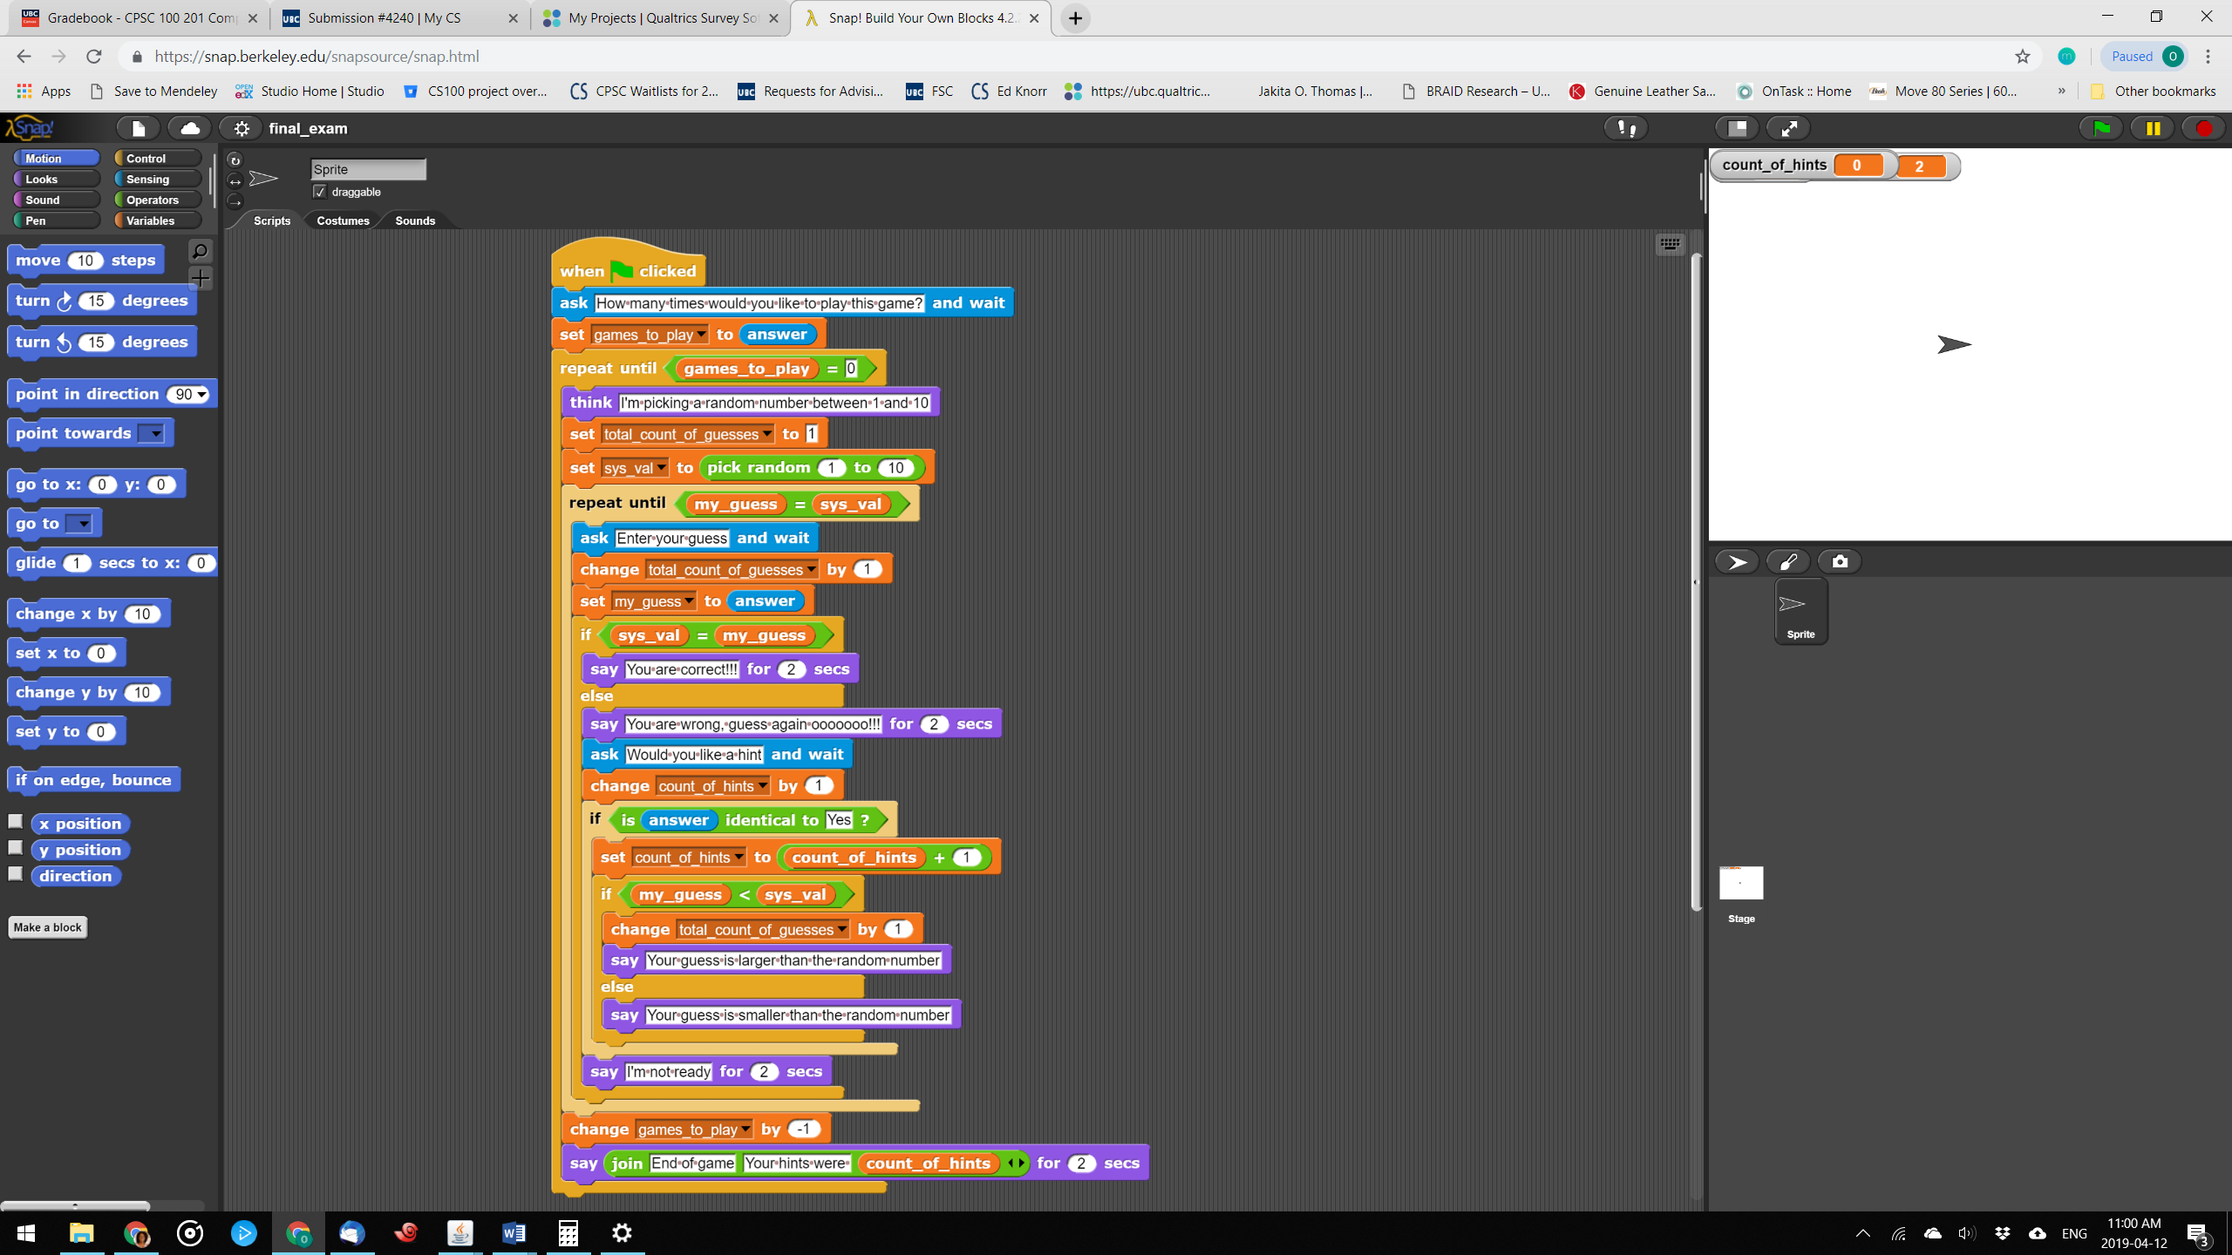

1. [1pts] If the user enters 3 for the number of times they would like to play the game. What is the final value in total_count_of_guesses if the user guesses the correct number on the first try for each round of the game?

___________________________________________________________________________________  
Let’s consider the case where the user enters 2 for the number of times they would like to play the game.   
For Question 29 you should write what will be displayed to the screen for the first round of the game.   
For Question 30 you should write what will be displayed to the screen for the second round of the game.

1. [5pts] What would be displayed to the screen (don’t include the questions), if for the first round of the game, the random value was 4, and the user guesses were 5 and 8, and then they asked for a hint and then provided the right answer (i.e. 4)?  
     
   ____________________________________________________________________________________  
     
   ____________________________________________________________________________________  
     
   ____________________________________________________________________________________

____________________________________________________________________________________

____________________________________________________________________________________

____________________________________________________________________________________

____________________________________________________________________________________  
  
____________________________________________________________________________________

1. [2pts] What would be displayed to the screen (don’t include the questions) if for the second round of the game, the random value was 8, and the user guessed correctly on the first try?

___________________________________________________________________________________  
  
____________________________________________________________________________________  
  
____________________________________________________________________________________

____________________________________________________________________________________

____________________________________________________________________________________

____________________________________________________________________________________

____________________________________________________________________________________

1. [3pts] What are two advantages of using ANN to address real-world problems?  
     
   ___________________________________________________________________________________  
     
   ____________________________________________________________________________________  
     
   ____________________________________________________________________________________

____________________________________________________________________________________

____________________________________________________________________________________

1. [4 pts] Give two situations where vector representation of data might be a better choice than bitmap representation

____________________________________________________________________________________

____________________________________________________________________________________

____________________________________________________________________________________

**PART 4: Real World Applications**

Write the answers in the space provided.

1. [4pts] Below is a screenshot of an email I received.   
   For some context, Rachel Pottinger is an Associate Professor and Associate Head of Undergraduate Program in the computer science department here at UBC.

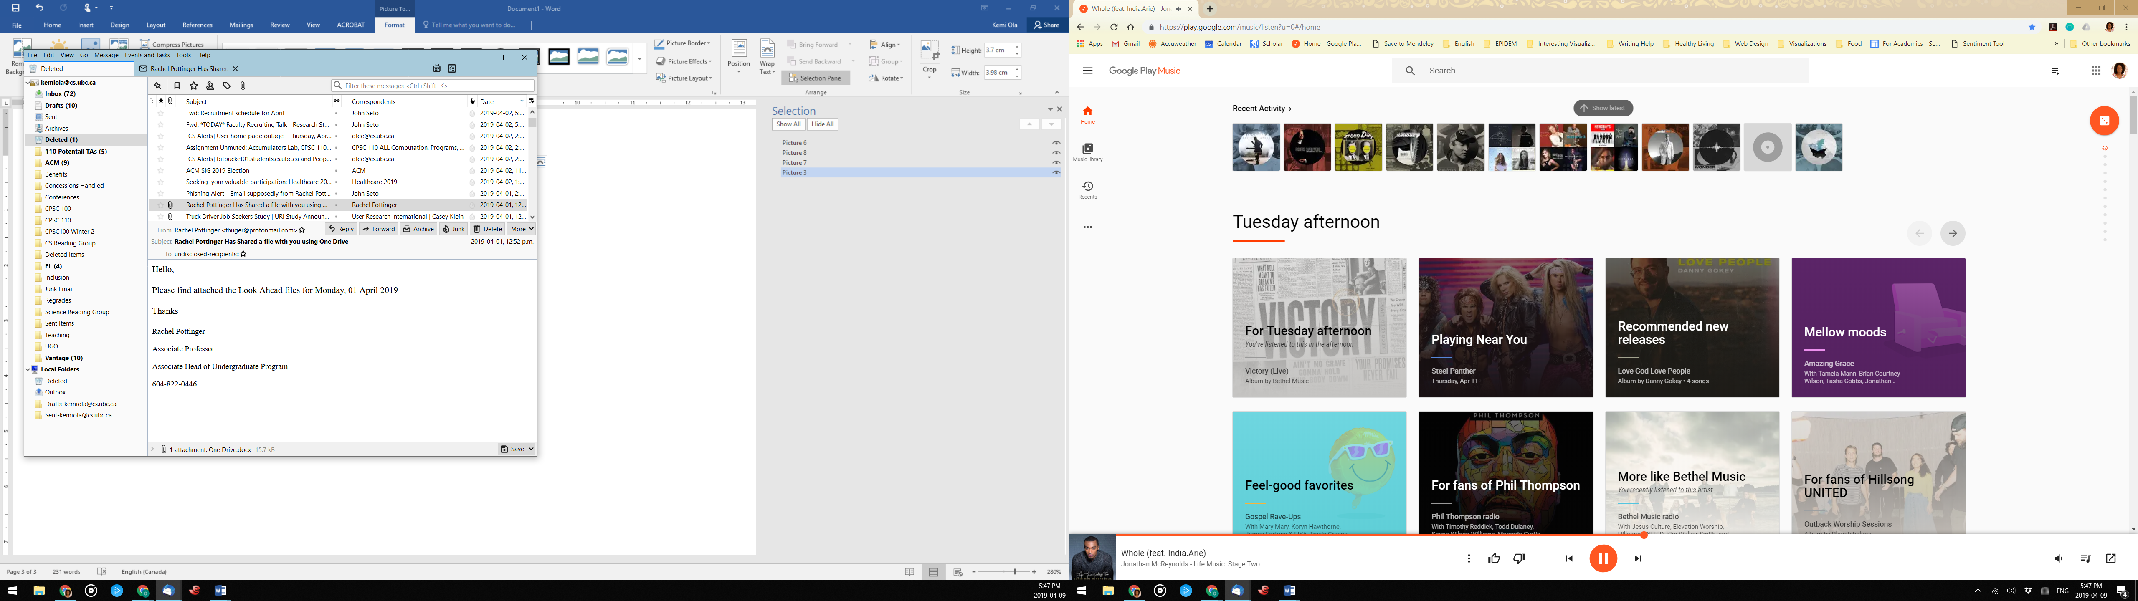

Should I download the attachment?

_____________________________  
  
Write out three reasons to support your answer

____________________________________________________________________________________

____________________________________________________________________________________

____________________________________________________________________________________

____________________________________________________________________________________

____________________________________________________________________________________

**Use the scenario below for the next 4 questions**Your cousin Ani is trying to decide whether a semester abroad is the best course of action. Ani interviewed 16 UBC students who have done a semester abroad, but is not sure what to do with all the data he collected. The table below shows the highlights of the notes collected by Ani.

* Level: student’s level in university, where 1 represents first year and so on
* Faculty: faculty in which the student’s family
* Income: household income for the student and their guardians/parents
* Language: proficiency/fluency of the student in the language of the foreign country in which they studied
* Advice: advice the student gave Ani based on their experiences

|  |  |  |  |  |
| --- | --- | --- | --- | --- |
| Level | Faculty | Income | Language | Advice |
| 1 | Arts | Below $250,000 | Advanced | Stay here |
| 2 | Arts | Below $250,000 | Basic | Stay here |
| 2 | Arts | Below $250,000 | Medium | Go abroad |
| 3 | Arts | Above $250,000 | Basic | Go abroad |
| 3 | Arts | Below $250,000 | Basic | Stay here |
| 4 | Arts | Above $250,000 | Advanced | Go abroad |
| 4 | Arts | Below $250,000 | Basic | Go abroad |
| 1 | Science | Above $250,000 | Basic | Stay here |
| 2 | Science | Above $250,000 | Advanced | Go abroad |
| 2 | Science | Above $250,000 | Medium | Go abroad |
| 2 | Science | Below $250,000 | Medium | Go abroad |
| 3 | Science | Below $250,000 | Basic | Stay here |
| 3 | Science | Above $250,000 | Medium | Stay here |
| 3 | Science | Above $250,000 | Medium | Stay here |
| 4 | Science | Above $250,000 | Basic | Go abroad |
| 4 | Science | Below $250,000 | Medium | Go abroad |

1. [8pts] Use the data provided to create a decision tree using the approach presented in class.

1. [1pts] Ani speaks a little Italian (basic fluency), and is a third year Arts student. Your uncle and aunt (his parents) have a household income of one hundred and seventy thousand dollars each year, would it be a good idea (based on his research) for him to study in Italy next year?  
     
     
   _____________________________________________________________________________________
2. [6pts] Now that you have helped your cousin make a good decision, you start to think of other UBC students who might be struggling with this same decision. You decide to create an app, and reach out to a friend in Computer Science who has some experience in making Android apps. Write out the algorithm that you need to provide your friend with (that is based on the decision tree created). The app should ask the student for all the relevant data and then let them know whether they should study abroad next year or stay at UBC.  
     
   ___________________________________________________________________________________  
     
   ___________________________________________________________________________________

___________________________________________________________________________________  
  
___________________________________________________________________________________  
  
___________________________________________________________________________________

___________________________________________________________________________________  
  
___________________________________________________________________________________  
  
___________________________________________________________________________________

___________________________________________________________________________________  
  
___________________________________________________________________________________  
  
___________________________________________________________________________________  
  
___________________________________________________________________________________

___________________________________________________________________________________  
  
___________________________________________________________________________________  
  
___________________________________________________________________________________

1. [2pts] Your app is a raving success and within the first week you have 5000 downloads. Thinking about all that we have covered in class this year, what is one limitation of your current application and how should you fix it?

___________________________________________________________________________________  
  
___________________________________________________________________________________

___________________________________________________________________________________  
  
___________________________________________________________________________________

1. [3pts] For the infographic shown below,   
   Name **one gestalt principle** that the infographic uses  
     
   ____________________________________________________________________________________  
     
   What is **one problem** with the infographic below?  
     
   ___________________________________________________________________________________  
     
   Based on your previous answer, what **one change** would improve the infographic?   
     
   ___________________________________________________________________________________

___________________________________________________________________________________

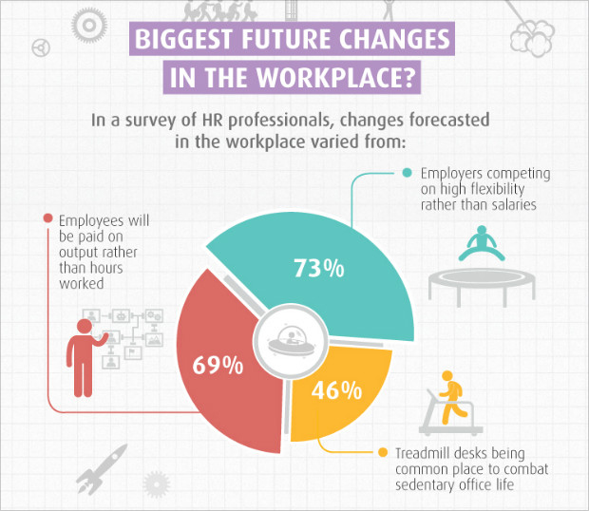

1. [3pts] Given the infographic below, **name one** **principle** that the infographic violates.  
     
     
   ___________________________________________________________________________________  
     
   Explain how the infographic violates the principle you wrote above.  
     
   ___________________________________________________________________________________

___________________________________________________________________________________  
  
___________________________________________________________________________________

___________________________________________________________________________________  
  
___________________________________________________________________________________

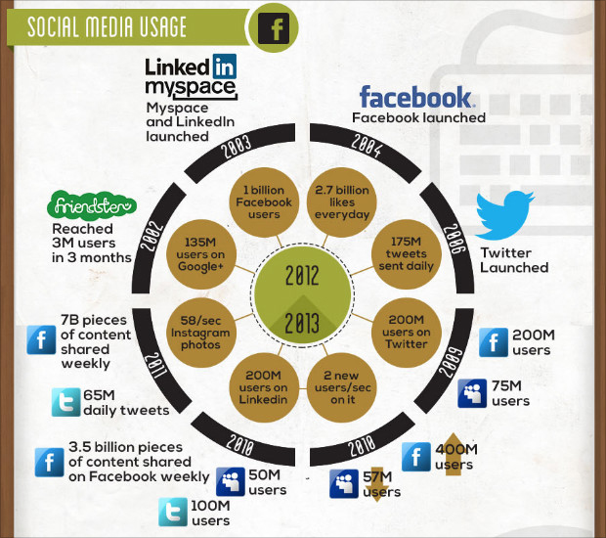

1. [4pts] Your grand uncle comes over for Thanksgiving and at the dinner table he mentions that machines are going to take over the world very soon. To make his argument he cites the following
   1. Sophia, a social humanoid robot, has the ability to make more than 50 facial expressions and she can also talk and converse with humans.
   2. In a movie he recently watched, he noticed that the robots had the ability to read human thoughts and were making human decisions.
   3. The recent closure of a General Motors car manufacturing plant shows that machines are replacing human jobs and very soon we will all be jobless.

Explain, in a respectful manner (he is your uncle), how each of the statements does not mean that machines are taking over. It is important, that your responses be grounded in the concepts explored in our course.

* 1. ________________________________________________________________________________  
       
     ________________________________________________________________________________  
       
     ________________________________________________________________________________  
       
     ________________________________________________________________________________  
       
     ________________________________________________________________________________
  2. ________________________________________________________________________________  
       
     ________________________________________________________________________________  
       
     ________________________________________________________________________________  
       
     ________________________________________________________________________________  
       
     ________________________________________________________________________________
  3. ________________________________________________________________________________  
       
     ________________________________________________________________________________  
       
     ________________________________________________________________________________  
       
     ________________________________________________________________________________  
       
     ________________________________________________________________________________

**This page has been intentionally left blank**

Note that any work that you do on this page may be graded. It is important that you clearly label which question you are working on here. You must also clearly state on the question page that your answer is on this page. Failure to do both of these steps may mean that your answer on this page is not graded.

**This page has been intentionally left blank**

Note that any work that you do on this page may be graded. It is important that you clearly label which question you are working on here. You must also clearly state on the question page that your answer is on this page. Failure to do both of these steps may mean that your answer on this page is not graded.

**Information you may find useful. This sheet will NOT be graded.**

|  |  |
| --- | --- |
| **Powers of two** | **Hexadecimal digits** |
| |  |  | | --- | --- | | 2 raised to the power of |  | | 0 | 1 | | 1 | 2 | | 2 | 4 | | 3 | 8 | | 4 | 16 | | 5 | 32 | | 6 | 64 | | 7 | 128 | | 8 | 256 | | 9 | 512 | | |  |  | | --- | --- | | Binary Representation | Hexadecimal representation | | 0000 | 0 | | 0001 | 1 | | 0010 | 2 | | 0011 | 3 | | 0100 | 4 | | 0101 | 5 | | 0110 | 6 | | 0111 | 7 | | 1000 | 8 | | 1001 | 9 | | 1010 | A | | 1011 | B | | 1100 | C | | 1101 | D | | 1110 | E | | 1111 | F | |