Parsa Rajabi

Parsa

CIS 100 – AB2

January 16, 2024

**Welcome to CIS 100! First Class Demo**

Anything that I type will show up **on** the keycaster. **I can bold text using this. You can also *italicize* *this text.* You can also underline text. You can also do so using CONTROL + U.** ~~You also have the option to strikethrough any text that you want.~~ The ~~shortcut for you to do this is~~. You can increase the text size. Or you can decrease the font size. You can specify the size of the font. You can also change the font. Comic Sans is not a professional font type. Make sure you do not submit any assignments using this font.

This is how you can add a new link to your document: [Link](http://www.google.ca/)

This is how you can highlight text

1. This is how you can add a new list to you document:
2. This is now a new bullet point

You can change the text heading or format using the panel on home page.

Example: Title

# Heading 1

[Research papers that use MLA format do not include a cover page unless requested by your instructor. Instead, start with the information shown. Do not bold the title or use all capital letters. Capitalize the first and last words of the title, and all principal words. If your paper includes a subtitle, separate it from the title by a colon and space, as shown. For more specific guidance on capitalization, see the MLA Handbook for Writers of Research Papers, 7th Edition (MLA 7th Edition).]

[All text—including titles, quotations, notes, and list of works cited—uses double line spacing. Body text and note text use a half-inch first-line indent. The list of works cited uses a half-inch hanging indent. Table titles and source text use a quarter-inch indent. To access all of these text formats, on the Home tab of the ribbon, check out Styles.]

[MLA format discourages extensive use of content notes. But, when you need to add notes, you can use either endnotes or footnotes. MLA 7th Edition indicates that you should use a superscript, Arabic numeral at an appropriate place in the text for the note reference. To begin the note text, use the same numeral, not superscript, and followed by a period.]

[If you use endnotes, they should be on a separate page, at the end of your text and preceding the list of works cited. If you use footnotes, consult your professor for preferred format.]

[For quotations of more than four lines, indent the quote one inch from the left margin and do not use quotation marks. This style is named Quote. Apply this or any text style with just a tap, on the Home tab, under Styles. Note that, for shorter quotations, you can put them in quotation marks and incorporate them directly into text.]

Table 1

[This sample table is formatted to follow MLA guidelines. To add a new table, on the Insert tab, tap Table. When you create a new table in this document, it will automatically use MLA formatting.]

|  | Column Heading | Column Heading | Column Heading |
| --- | --- | --- | --- |
| Row Heading |  |  |  |
| Row Heading |  |  |  |
| Row Heading |  |  |  |

Source: [This source text uses a style named Table Source.]

1. [This note text uses a style named Table Note. Table notes use a lowercase letter instead of Arabic numerals to differentiate them from the notes to body content.]

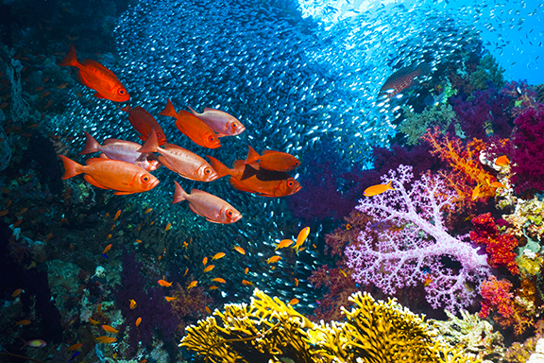

Fig. 1. [This figure caption uses the No Indent style. Label figures with the abbreviation “Fig.” and a figure number.]

[There is a sample Works Cited list that follows. The body content on that page uses the Bibliography style. Note that MLA rules for citations and references are extensive. So it’s a good idea to refer to MLA 7th Edition for further information.] (AuthorLastName Pages)

[To use this template when creating the outline for your paper, on the Home tab, in Styles, tap No Indent. Then, on the same tab, in the Paragraph group, tap the Multilevel List icon and then tap the MLA Outline style that appears under List Styles. The first six levels of this list style correspond to the outline levels defined in MLA 7th Edition.]

For additional guidance on formatting your research paper, consult MLA 7th Edition as well as your instructor.

Works Cited

AuthorLastName, FirstName. *Title of the Book Being Referenced*. City Name: Name of Publisher, Year. Type of Medium (e.g. Print).

LastName, First, Middle. "Article Title." *Journal Title* (Year): Pages From - To. Print.