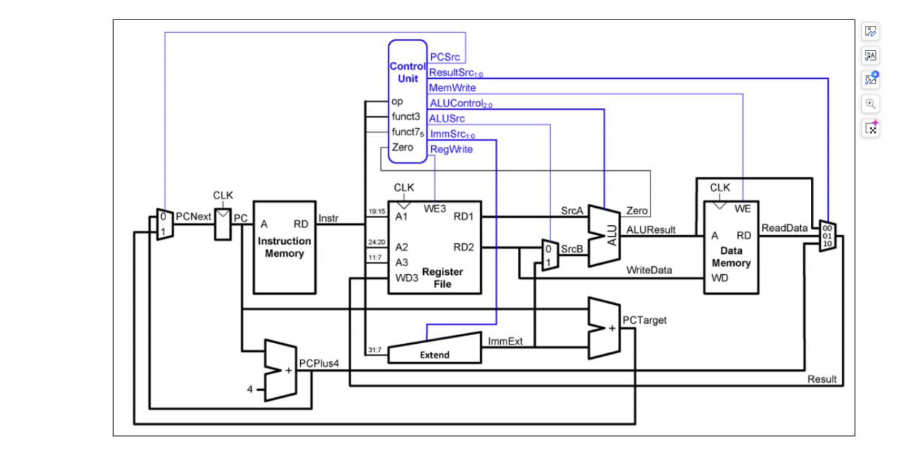As you can see, we have added a new controller signal and expanded a 4 to 1 multiplexer.  
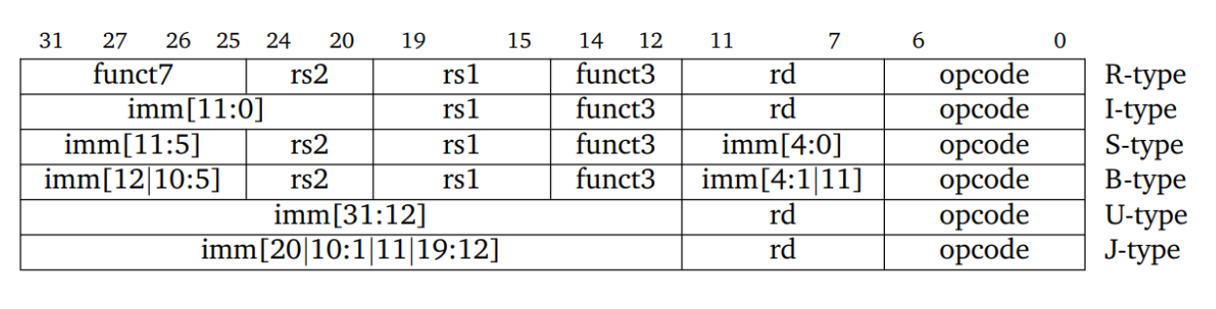After designing the controller we need to design the combinational controller since its single cycle RISC-V we are talking about.

Figure : Modified Datapath

