Introduction :

Coronavirus disease, or COVID-19, is an infectious disease caused by a newly discovered coronavirus[1], first identified in Wuhan, China, in December 2019[2], and declared as a pandemic in March 11, 2020. Up to this date, November 26 2020, 12.9M cases have been identified as COVID patients in the United States and 60.6M worldwide[3]. This makes the epidemiology of COVID-19 an interesting topic for further investigation.

Epidemiological compartmental models are useful and powerful tools that could provide an insight to the behavior of infectious diseases. These models intent to describe the relationship among sub-population where each sub-population is being represented by a compartment. The simplest model is the SIR model where the population is divided into Susceptible,Infected and Recovered. Even though SIR model is the simplest model, one could still gain useful information and assess the gravity of the disease and the efficacy of some protocols.

In this project COVID-19 outbreak is modeled using the simple SIR model [4] and a slightly modified version of it [5]. This work will try to simulate distinct scenarios in order to anticipate the behavior of this virus under distinct circumstances. One scenario that could result particularly interesting is the introduction of vaccines. The world is at a critical point since there are two great vaccine candidates that are in phase three of clinical trials. This work aims to answer, how this can affect the behavior of the outbreak, and more importantly, if there is an optimal vaccination rate. In addition, it tries to see if it would be possible to predict when everyone could resume a normal
lifestyle.

Answering all these inquiries requires implementation of a broad range of topics discussed during the semester, and the final goal is to infer some real world conclusions from the results of the models.

SIR model (no vaccine no quarantine) :

Although SIR model has its limitations (E.g. closed homogeneously mixed community)[6] ,this model could still provide some insight to what everyone has endured this year. This part of the project intends to shed some light on some of the currently implemented protocols (quarantine/lock down) as well as explaining some of the widely used terminologies such as the concept of Flattening the curve.

In this scenario, we are trying to understand and analyze the behavior of COVID-19 virus using a simple SIR model in the absence of a clinically proven vaccine. In order to do this work in a systemic fashion, one should start by constructing a system of reactions that describes different events :

Where S,I and R respectively represent susceptible, infected and recovered individuals and k’s represent the rate in which individuals travel across the three sub-population groups.

Now a system of reactions was constructed, a SIR dynamic model corresponding to this system will have the following form :

To efficiently utilize SIR model to predict a behavior of a virus and to try to predict what could have influenced the behavior of this virus in certain places. with the knowledge that all values must be >= 0 ,one could employ various techniques to determine the optimum values for the three reaction rates constant. In this part of the project we resorted to using data regarding COVID-19 first outbreak in Wuhan [7]. it is worth mentioning that an optimized values using the US data was the group first choice. However, due to the fact that the US data is going wild and following no specific pattern it seemed like a poor candidate for this application. (it hasn't completed a full cycle thus is difficult to fit to a SIR model). A Python code was developed [8] to perform this task using a package called lmfit[9]. The results of this work is shown in figure#1.
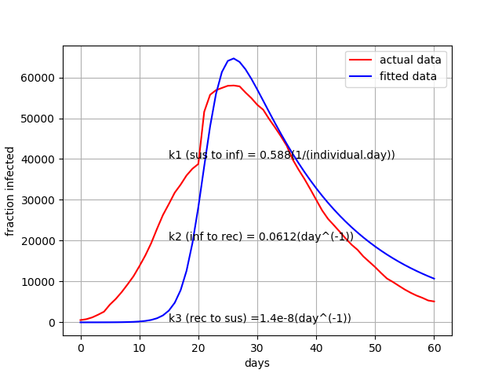
Figure 1 : SIR model parameterization

This set of optimized parameters for COVID-19 ( k_1 =0.58 ,k_2 =0.0612 and k_3 = 1.4e-8 almost 0) makes a general since keeping in mind how rapid this virus can spread. it is true that using this set this model was able to recapitulate the peak of the active cases however, the model tends to under-predict the actual number of active(infected) cases. This could be attributed to the fragility of this model that stems from the long list of assumptions that was made to simplify this model. Another factor that worth mentioning is the effect of human behavior. SIR model treats individuals as a homogeneously mixed system which goes without seeing is not applicable to humans. Even with all of the holes that were poked in the reliability of the SIR model, one could still use the model as a screaming tool to examine the stability of the steady states of this virus(if any existed) and to assess the efficacy of certain spread controlling protocols.

Steady states and Stability of steady states:

A crucial piece of information that one need when analyzing the behavior of a virus is to study the stability of the steady states that correspond to the describing system-simple SIR model. To spare readers the tedious lengthy details associated with mathematically finding steady states and assessing their stability, a summary of the solution is shown in Table #1.

Table 1 : Stability of steady states(SIR model no vaccination)

Steady state | Susceptible | Infected | Stability
1 | Entire population | No one | Unstable
2 |  |  | Stable

SIR model (quarantine no vaccine) :

The first protocol to asses using SIR model is the policy of mass quarantine or lock downs. It is safe to assume that everyone has questioned the benefits of such protocol. Two distinct quarantine scenarios were simulated in order to help establish a protocol that allows for a better control of the virus while minimizing cultural damages (E.g, economy, lifestyles,..etc.) The first scenario is applicable when an approved reliable testing method is not available or is not feasible. This scenario dictates that a random percentage of the population will be placed in quarantine. The goal of such practice is to flatten active cases’ curve. Flattening the curve implies squashing the peak of the curve(lower maximum number of infected individuals) and delaying such peak which would reduce the chance of overwhelming the health system of the region in which the outbreak is taking place. The results of this simulation is shown in figure 2. a quick look at figure#1 and figure#2 suggests that ,for the Wuhan’s outbreak(peak at 25 days) , if such practice was followed then a partial lock down of approximately 15%(peak at 27 days) was most likely implemented.
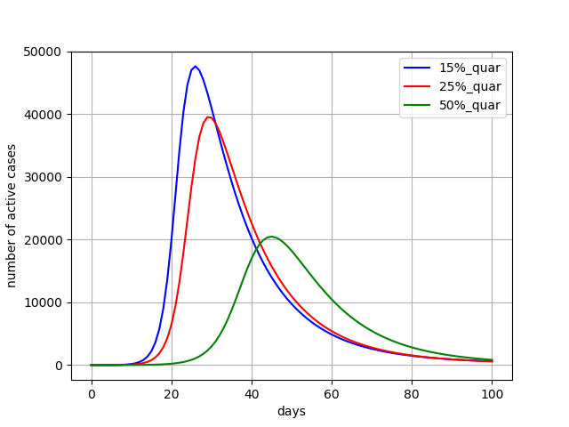
Figure 2 :Effect of random quarantine protocol

The second quarantining option comes with the challenge of having a reliable , affordable and easy to execute method of testing(it also depends on human behavior). It seems like currently there exist a good variation of affordable and accurate testing techniques. Taking this in consideration, SIR model could be modified such that where Q and UQ represent quarantined and unquarantined individuals. SIR system of ODE’s will become :

where ft is the fraction of individuals who were tested and then quarantined until recover. Simulating this slightly modified SIR model could provide an insight concerning the efficacy of such protocol especially when compared to random quarantining protocol. The results for this simulation is shown in figure# 3
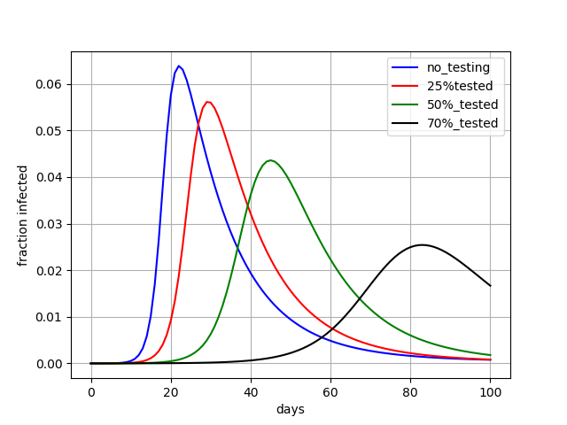
Figure 3: Effect of test_quarantine protocol

The results shown in figure#3 suggest that ,active case’s curve could be flattened by implementing test-quarantine protocol. This protocol will severe the purpose of effectively controlling the spread of the virus while minimizing its impact on economy and lifestyles. The biggest challenge associated with this protocol is to come up with an effective yet not overwhelming testing technique and plan.

References :

[1] https://www.who.int/health-topics/coronavirus#tab=tab_1
[2]- https://www.cdc.gov/coronavirus/2019-ncov/cdcresponse/about-COVID-19.html
[3]- https://www.nytimes.com/interactive/2020/us/coronavirus-us-cases.html
[4]- Adekola, Hafeez Aderinsayo, et al. “Mathematical Modeling for Infectious Viral Disease: The COVID‐19 Perspective.” Journal of Public Affairs, 2020, doi:10.1002/pa.2306.
[5] Anand, N., Sabarinath, A., Geetha, S. et al. Predicting the Spread of COVID-19 Using 𝑆𝐼𝑅 Model Augmented to Incorporate Quarantine and Testing. Trans Indian Natl. Acad. Eng. 5, 141–148 (2020). https://doi.org/10.1007/s41403-020-00151-5

[6] Cooper, I., Mondal, A., & Antonopolous, C. G. (2020). A SIR model assumption for the spread of COVID-19 in different communitiesIan. Elsevier Public Health Emergency Collection. doi:10.1016/j.chaos.2020.110057.
[7] China. (n.d.). Retrieved December 07, 2020, from https://www.worldometers.info/coronavirus/country/china/
[8] https://github.com/ParsaGhadermazi/COVID_Project.git

[9] Non-Linear Least-Squares Minimization and Curve-Fitting for Python¶. (n.d.). Retrieved December 07, 2020, from https://lmfit.github.io/lmfit-py/

