# COMP 189: Homework 10

Assigned April 9, 2022

Due midnight April 18, 2022

30 points total

# Technical Exercises

*For each problem, show all your work (required for credit). For answers requiring written answers, while no more than five or six sentences are expected, sufficient justification must be given for any position, opinion, or perspective taken.*

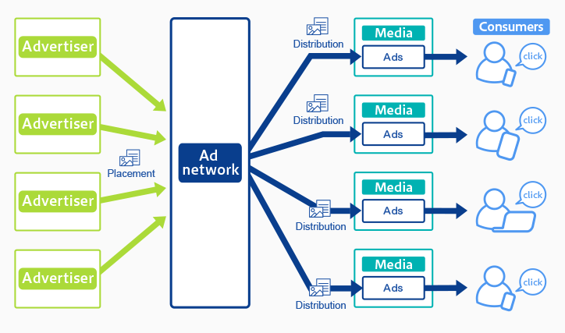

## 1. IP address Tracking (10 pts)

Using the image above, create a diagram (along the lines shown in class) that depicts how an Ad Network can use IP addresses to track your behavior across the web. Your diagram should indicate where soft linking is done.

|  |
| --- |
|  |

2. Cookie Tracking (10 pts)

Using the image above, create a diagram (along the lines shown in class) that depicts how an Ad Network can use cookies to track your behavior across the web. In your diagram include yourself using two different devices.

|  |
| --- |
|  |

## 3. Soft Linking (10 pts)

Using your solution from Q2, show how IP addresses can be used to soft link cookies in order to to expand what an Ad Network knows about a specific individual’s browsing behavior. The solution should include a table (as sketched in class) of the cookie-site events. Add IP addresses to this table and show how cookies from different devices can be linked.

|  |
| --- |
|  |