How to run the code:

* Install PyCharm Community Edition and Python 3.9
* Open PyCharm Community Edition
* Go to File tab and Open
* Select the directory of the project, then click ok:

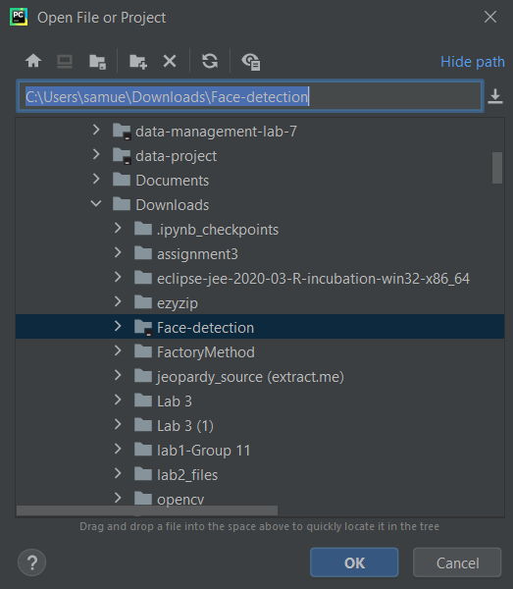

* Configure the Python Interpreter in bottom right and Select Interpreter settings:

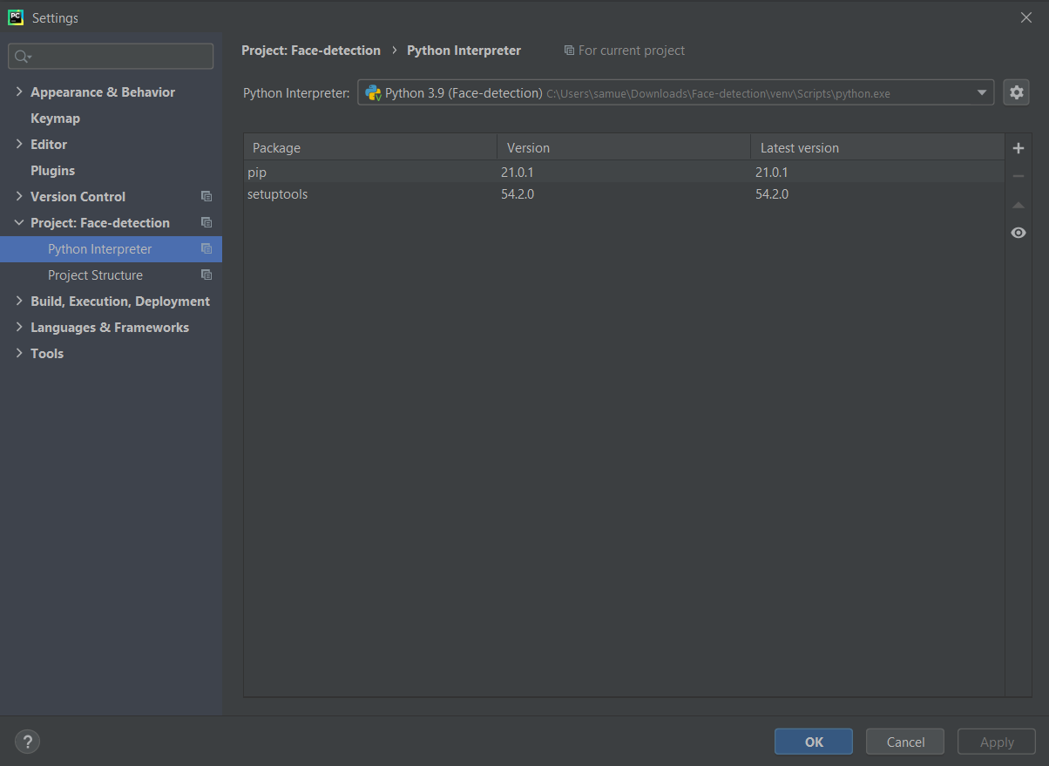

* Press the  button, then **Add:**
* Go to Virtualenv Environment, **Select** new Environment, and Choose the Base Interpreter (Python 3.9):

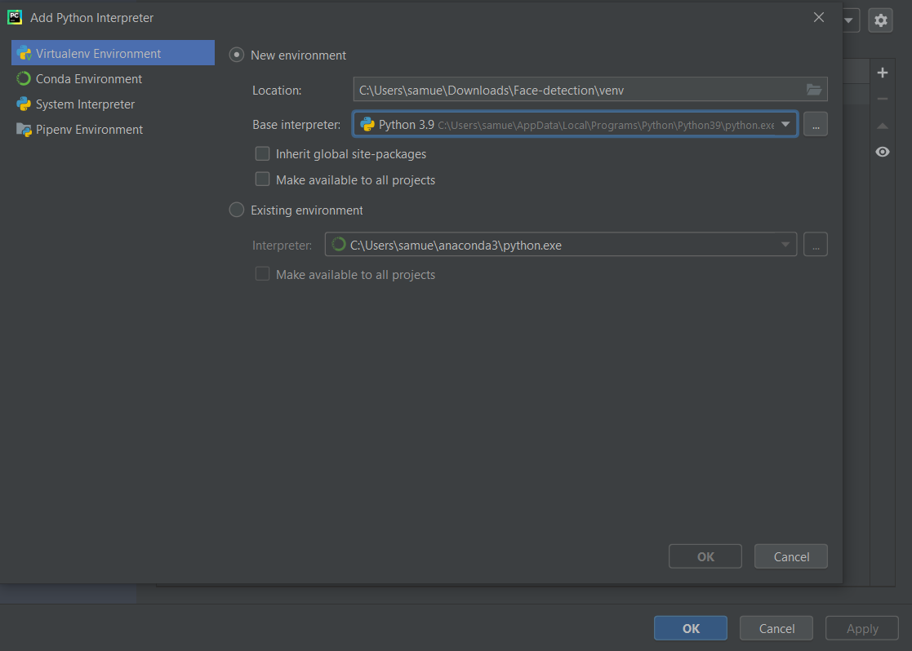

* Press the terminal tab and install the OpenCV libraries and Numpy Libraries (pip install opencv-python and pip install numpy):

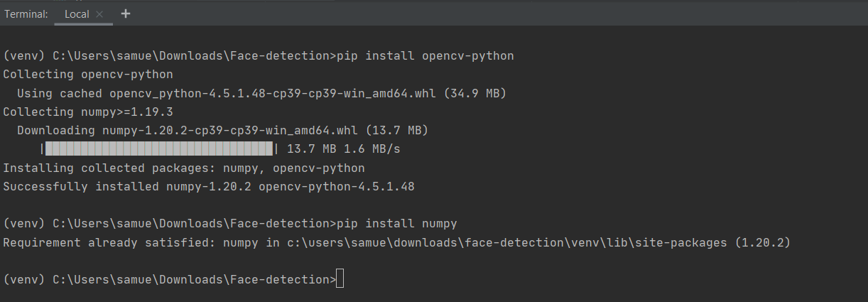

* Go to **Add configuration tab,** and click the  button and choose **Python** to add the configuration to run the code:

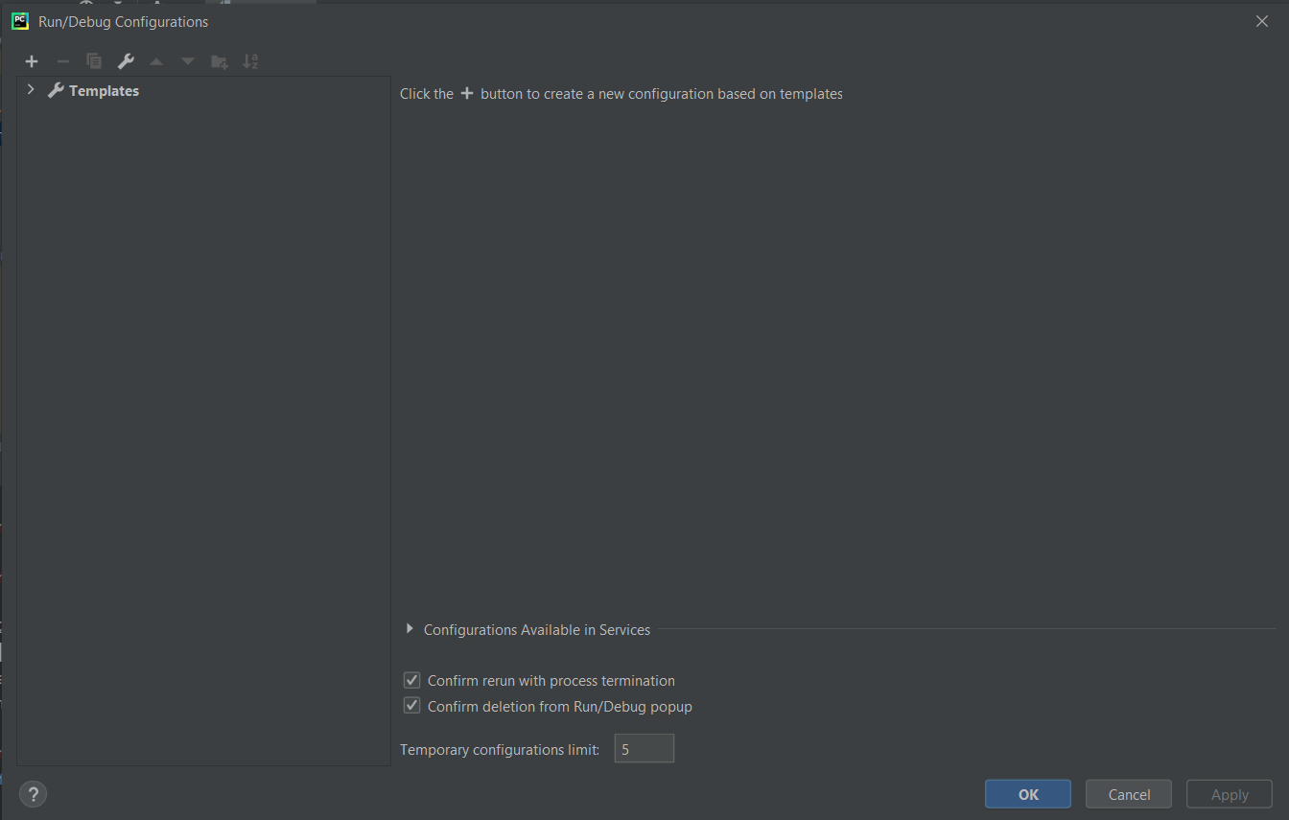

* Insert the name to **main,** and set the script path to the main.py, then click **OK:**

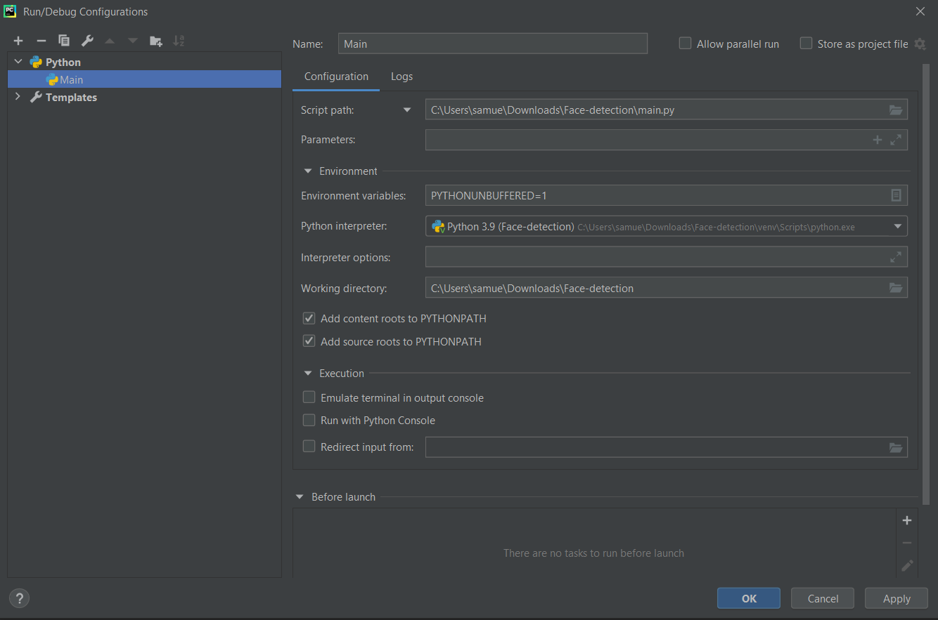

* Press the  button to run the code:

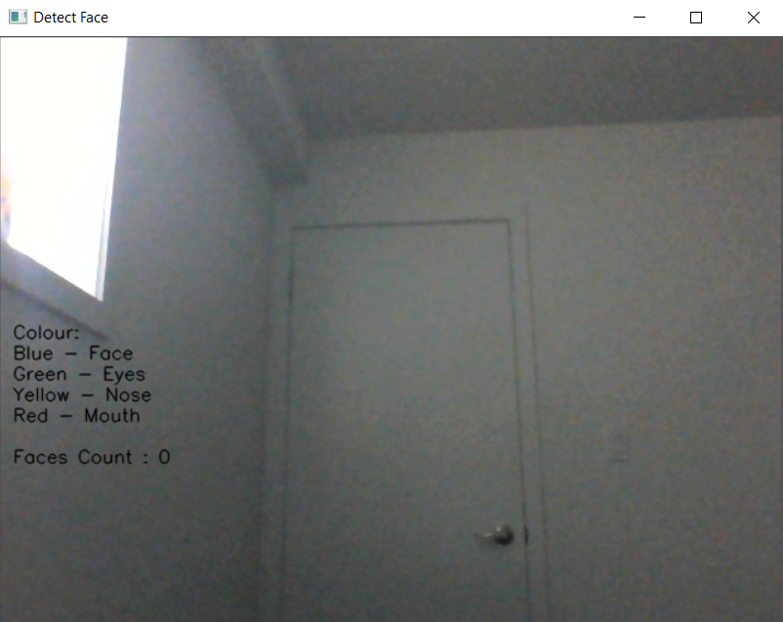

* Press the “Enter” button or  button to exit the code