The Ice Memory Programme

The Ice Memory Programme
Information Paper submitted by France and Italy
Summary
The purpose of this paper is to provide an update about the Ice Memory Programme within the framework of the Antarctic Treaty Consultative Meeting (ATCM), following its initial presentation during the 42nd ATCM meeting in Prague in 2019. The worldwide importance of the Ice Memory (IM) Programme, launched in 2015, was acknowledged by UNESCO (through the solicitation of its French and Italian National Commissions), calling on its Member States to support the initiative. The IM Programme features international scientific collaboration between national Antarctic programmes.
The first phase of the Programme is currently underway, and involves collecting ice cores from the deep layers of key endangered glaciers along the world before they lose their ability to preserve environmental history in optimal conditions. The second phase of the Programme involves the long-term storage of these ice cores for future generations of scientists. The safest long-term storage place on Earth is the Antarctic plateau, where the ice never melts, even in summer. Mean annual temperatures are such that cold storage will be possible for hundreds to thousands of years, even in the current context of global warming. The IM Programme initiators therefore intend to store on the Antarctic plateau the precious samples collected in the endangered glaciers.
Discussions are still needed between ATCM Parties and observers on the Programme’s next steps, given that collaboration and endorsement by Parties would be beneficial as the goal of the Programme is of global importance to humanity. This means launching a process that complies with the Antarctic Treaty and its Protocol on Environmental Protection (Madrid Protocol), especially Annex I on Environmental Impact Assessment.
Background
The Ice Memory (IM) Programme was launched by France and Italy in 2015. Its international dimension has grown following contributions by Russia and Switzerland. The international scientific community is now working to make it a global initiative in the coming years. A notable progress toward this goal was the creation of an Ice Memory Foundation (FIM) in January 2021, under the auspice of the Foundation University Grenoble-Alpes in France, supported actually by 7 founding research institutions (4 in France, 2 in Italy, 1 in Switzerland) and open to new international founders during the following steps. The FIM strategic board includes at the moment researchers from France, Italy, Switzerland, Russia, China and the United States.
At a later stage of the Programme, a governance framework will need to be defined with involvement of the ATCM Parties which plan to contribute to the long-term storage of ice cores in Antarctica, particularly to ensure this complies with the Antarctic Treaty and the Madrid Protocol.
Goals of the IM Programme
The IM Programme is based on the observation, made 60 years ago, that the natural snow and ice forming glaciers contains environmental information for periods ranging from decades to hundreds of thousands of years. Natural snow and ice are mainly constituted of water vapour, which condenses and solidifies in the atmosphere to form snowflakes. During this natural process, impurities are trapped in snowflakes and buried in snow precipitation for long periods of time.
Every year, new snow covers earlier precipitation. Under this accumulated weight, snow layers densify until they become impermeable ice. The resulting glacier flows towards lower altitudes, powered by gravity. In mountain ranges, glaciers end up becoming rivers. In Greenland and Antarctica, they mainly result in icebergs, which leave the coast and melt in seawater.
Around the world, glaciologists seek to study glaciers that contain the oldest possible information stored in their depths. When they identify these glaciers, they drill through them until they reach bedrock. This drilling results in several sections of ice core measuring generally one metre in length and 8 to 10 centimetres in diameter. Their total accumulated length can reach 100 to 250 metres for mountain glaciers, and up to 3,700 metres in Antarctica.
Small sections of these ice cores are used for geochemical and physics studies in laboratories. In some cases, scientific investigations are non-destructive and the ice core samples remain untouched. They are used to research past climate conditions (temperature and precipitation levels), atmospheric concentrations of greenhouse gases (GHGs), natural and anthropogenic aerosols, the intensity of desert dust events, sea ice surface area, radioactive fallout from nuclear testing, volcanic activity, solar activity, and the intensity of cosmic rays. For example, ice cores have been used to demonstrate how GHGs affect natural climate variability, and how human activity has resulted in accelerating levels of GHGs over the past 200 years.
Although the ice caps in Antarctica and Greenland are not yet threatened by climate change to the point that they will disappear in the short term, this is not the case for mountain glaciers at low or medium latitudes, nor of smaller ice caps in the Arctic or sub-Antarctic areas. The surface areas and volumes of most glaciers around the world are shrinking rapidly. As this happens, we are losing forever precious information on the history of our planet.
The overall goal of the IM Programme is to: 1- Collect an ice core archive from the deep layers of key endangered glaciers before they lose their ability to preserve environmental history in optimal conditions; 2- Store these ice cores on a long-term basis (possibly hundreds to thousands of years) for future generations of scientists and humanity in general.
The idea underlying the IM Programme is that scientific ideas and technologies will continue to evolve in the future, making new discoveries possible using ice cores. However, for this to happen, snow and ice cores must be available to future generations of scientists when valuable glaciers will have gone forever from the surface of the planet, the resulting ice cores being protected from the harmful effects of climate change and becoming the only remains of extremely precious environmental archives accumulated over centuries to millennia before global warming definitely affected the glaciers.
Relationship between the IM Programme and ATCM and CEP activities
The goal of the IM Programme is to ensure the safest possible cold storage of the ice core archive collected for this Programme. Safe storage should be guaranteed for the longest possible periods, possibly up to several centuries to millennia.
Currently, no cold storage chamber is capable of guaranteeing the conservation of ice cores with 100% certainty. In other words, long-term conservation is threatened by the risks of technical and economic failure. Indeed, there are recent examples of commercial storage failures that led to the definitive loss of previous ice core archives. Consequently, the IM Programme involves creating a repository (or series of repositories) in Antarctica, where the ice core archive will be stored on a long-term basis. The Antarctic plateau is naturally very cold and does not experience melting, even during summer in the southern hemisphere. Mean annual temperatures are such that cold storage will be possible for hundreds to thousands of years, even in the context of current global warming scenarios.
France and Italy, which jointly run the Concordia research station on the Antarctic plateau, have agreed to support the Programme at Concordia station where ice cores collected as part of the IM Programme could be transported using existing logistical means. This means to give the logistic assistance in the building and maintenance of the future repository and in the management of the access and transportation of the ice cores.
Other interested Parties are warmly welcome to forward proposals to build repositories on the Antarctic plateau, taking the commitment to provide the necessary logistical long term means for construction, transportation, monitoring and maintenance. The participation of other interested Parties in the building of repositories could lead to the creation of an international repository network, which would facilitate the constitution of ice core archives by the country managing the repository where these are stored, through its national Antarctic programme. Interested Parties could also contribute by facilitating the transportation of ice cores from different places of the world to the Concordia station repository, once built. The Ice Memory initiative would have therefore a beneficial effect in terms of increasing collaboration among Parties. However, such scheme is not mandatory, France and Italy being ready to collaborate with other Parties in order to take in charge the transfer to Concordia station of IM samples resulting from their own drilling projects.
As every activity carried out in the Antarctic Treaty area, the creation of a long-term storage repository will need to follow the requirements of the Antarctic Treaty and of the Protocol on Environmental Protection, and the appropriate authorization process. To minimize the impact, the environmental aspects will be considered since the planning activities, and the decommissioning phase will be examined too. The implementation near Concordia Station, will allow to use the available expertise and logistics. An environmental impact assessment will be carried out and will be completed in accordance with the provisions of Annex I of the Protocol on Environmental Protection. France and Italy will collaborate during all the process. Future access to the IM ice cores will rely on agreements made through the National Antarctic Programs managing the repository.

Design of the ice core repository
To ensure that ice cores are stored in optimal conditions, not only must the temperature be kept well below 0°C, but variations in temperature must also be avoided as they could damage the physical and chemical information in ice cores. For this reason, the IM Programme will involve storage of the cores at approximately 10 metres depth below the surface.
At this depth, due to temperature smoothing by thermal diffusion, the snow temperature corresponds to the mean annual temperature for any given site, meaning that seasonal variations in temperature in the atmosphere are smoothed out at the corresponding depth.
At the time of the WP41 submitted to the 42nd ATCM meeting in Prague in 2019, two different concepts of repository were under evaluation: the first one had foreseen the construction of a metallic structure, made of interconnected shipping containers with reinforced roofs to bear the weight of accumulated snowfall. The second one involved accommodating a set of normal containers placed on sledges inside a set of buried ice caves of around 5 m diameter each. This second concept brought the advantage of a lower environmental impact during both construction (approximatively 7 days of work for each cave) and decommissioning, as the ice caves are obtained by putting thin layers of snow (using a snow blower) over an inflatable balloon that is deflated and removed once the roof is solid, leaving the ice cave with an arched roof only made of snow on its top. The access to these caves would be initially via a slope that would be buried once the cave is closed, and then via traps prepared in the upper part during construction.
The second concept was retained for a pilot scale trial implementation and stability assessment at Concordia station, considering its lower environmental impact.

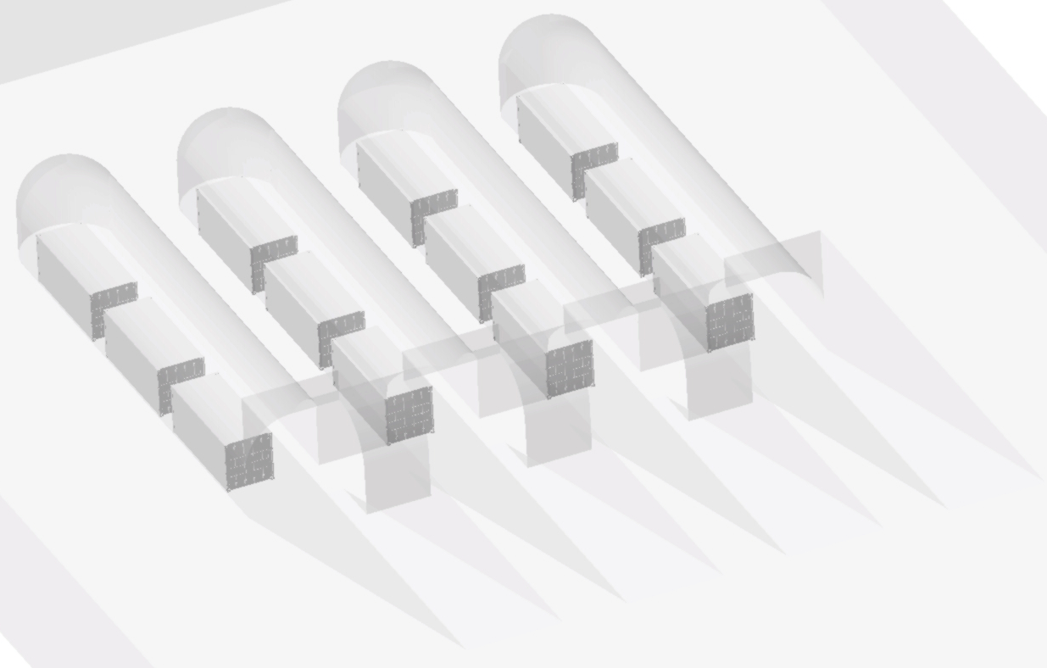
The ice cave repository concept, with containers installed inside parallel snow caves

During the 2018-2019 summer campaign, in the immediate vicinity of Concordia station, a first pilot snow cave was built, under technical coordination of ENEA-UTA in Italy and manpower help from IPEV in France. A second pilot cave succeeded during the 2019-2020 summer campaign, made with an improved procedure. Snow was blown on top of the inflated balloon through several successive steps of a few tens of centimetres each, using a large snow blower (4 meter width), leaving time between each sequence for the snow to sinter and to become denser. A complete 3D model was obtained on both pilot caves using a laser scan. Sensors were placed to study the vertical temperature profile inside the cave. These data coupled with analysis of deformation and of ice cores extracted from the ice cave roof allowed to evaluate grain sintering of the snowflakes, the overall strength of the construction and to feed a 3D model of snow / ice deformation developed in France, in order to estimate the life span of future snow caves.

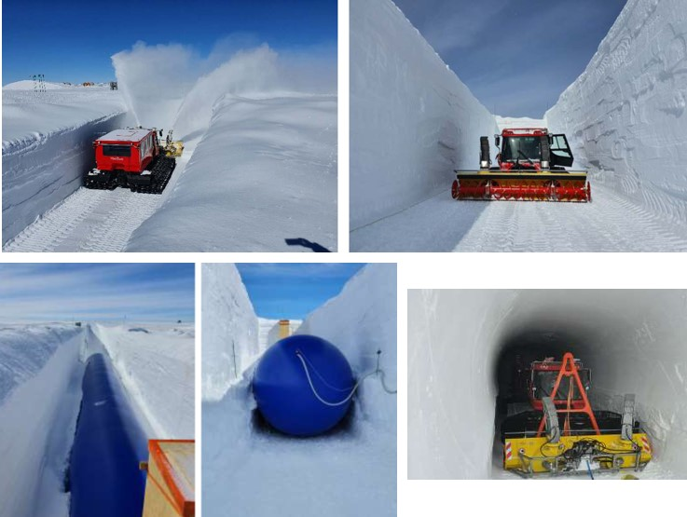
Construction of a pilot snow cave at Concordia station during the field campaign 2019-2020. The resulting snow cave with the arched roof made of snow can be visualized in the lower right picture.
Modelling of IM snow cave deformation
To assess the duration over time of such a facility, computer simulations were performed. The Elmer/Ice finite-element software for ice sheet, glaciers and ice flow modelling was used to model the temporal deformation of a snow cave in the conditions of Concordia station (Brondex et al., 2020). Different scenarios were evaluated to compare the deformation rate, depending on the shape and density of the snow layers recovering the cave and making the columnar structure alongside.
Simulations of the temporal evolution of the shape of a snow cave under Concordia conditions. Original shape (@0a), shape after 50 years of deformation (@50a) and after 100 years of deformation (@100a). From left to right : using a standard snow density profile (black), with blown snow focused on the top of the cave (green), with blown snow on top and alongside the cave (blue), with blown snow following a T-shape.
The results from the simulations appear encouraging. When building a snow cave using blown snow on top and alongside the cave, the snow cave would loose about half of its original height after one century of deformation. Simulation results indicate that the need to reconstruct the IM snow caves will be unfrequent, albeit requiring regular monitoring. A precautionary approach could consider rebuilding the ice caves every few decades. A process requiring about 30 days of work and no extra material.
The status of the IM drilling operations
To date, the IM consortium, made up of French, Italian, Russian and Swiss scientists involved in the mountain fields (others may join in the future), has drilled into four mountain glaciers with a view to collecting ice cores and achieving the Programme’s goals. The first drilling operation took place at the Col du Dôme glacier, near the summit of Mont-Blanc in the French Alps, at an altitude of 4,300 metres. Three ice cores were successfully retrieved down to bedrock in 2016. In 2017, another drilling operation took place on Nevado Illimani in Bolivia, at an altitude of 6,300 metres. Here, two ice cores were retrieved down to bedrock. In 2018, a Swiss-Russian team successfully drilled two ice cores at Belukha glacier in the Russian Altai Mountains. Lastly, a Russian team retrieved two ice cores from Mount Elbrus in the Russian Caucasus. These ice cores are all stored in commercial freezers in Grenoble, France, or in Switzerland or in Russia, pending the construction of the long-term storage repository in Antarctica.
A fifth IM operation was conducted on the Grand Combin glacier in the Alps, at the Swiss-Italian border, on Fall 2020. Unfortunately, after about 20 metres of drilling, the operation was stopped due to the too warm snow/ice conditions encountered, illustrating that for some glaciers such as Grand Combin, it is already too late. In June 2021, a sixth IM operation was successful on the Colle Gnifetti glacier in the Swiss Alps, recovering two ice cores down to 82 metres of depth, encompassing 10,000 years of environmental history. The next IM drilling project is expected to take place on Kilimanjaro (Tanzania).

Current governance of IM: the Ice Memory Foundation (FIM)

On January 18th, 2021, seven founding research institutions have signed the agreement officialising the creation of the Ice Memory Foundation (FIM) under French law. From France: French national center for scientific research (CNRS), University Grenoble-Alpes, French national institute for research and development (IRD) and the French polar institute IPEV. From Italy: Italian national center for scientific research (CNR) and University Ca’Foscari in Venice. From Swizerland: Paul Scherrer Institute.
The missions of the FIM are the following:
- Define, run and ensure the implementation of the IM Programme at the strategic, scientific and technical level, in particular within the framework of the drafting of a charter laying down the conditions for membership of this Programme and access to the IM heritage by the entire international scientific community,
- Develop fundamental links with international and national institutions in order to ensure the sustainability of the IM Programme,
- Coordinate communication with the stakeholders involved in the IM Programme,
- Coordinate and contribute to ensure the implementation of the fundraising campaigns required for the implementation of the IM Programme,
- Coordinate the establishment of long-term governance and ensure the timely transfer of the IM Programme to (a) sustainable institution(s).
The FIM is open to new founders wanting to contribute to the international IM endeavour.

Important questions for the ATCM and CEP
Could importing “foreign material” to Antarctica result in the introduction of biological material and invasive species?
Bacteria, pollen and other microorganisms are naturally present in Antarctica, transported long distances by atmospheric aerosols from places such as South America. For instance the few available estimates concerning pollens indicate values of around 20 to 30 pollen particles per kilogramme of surface snow.
In principle, the IM project’s ice cores could introduce bacteria that are not naturally found in Antarctica, but that are present in the atmosphere over mountain glaciers in remote regions and then incorporated in the ice. However, it is known that human beings are themselves a source of bacterial contamination as they expel in their immediate environment a large number of bacteria, from their skin and from their respiration. The human emission rate in the atmosphere has been evaluated at 40 millions of bacteria per person and per hour, corresponding to about 30 milligrams of bacteria being dispersed in its immediate environment from any human being per hour (Qian et al., 2012). This implies that Antarctica is already contaminated by non-native bacteria expelled by the thousands of expeditioners sent to Antarctica each year by all Parties to the ATCM, with a large bacterial variety resulting from the wide geographical origin of expeditioners. It has already been demonstrated that the Antarctic snow pack thus harbours diverse, active and viable microbial populations that represent almost all the major phylogenetic groups (Antony et al., 2016).
As long as the Ice Memory ice cores will remain frozen in the repository, they will not risk to release non-native living organisms into the Antarctic environment and they will not increase the existing contamination due to expeditioners. In addition, specific procedures concerning packaging, transportation and handling will be applied to limit or even suppress the possible risk of dispersion in the environment in case of sample melting.
Who will be responsible for the ice core repositories in the long term?
We suggest that the leaders of national Antarctic programmes, who are in charge of the research station where the ice core repository is located, be responsible for securing it and granting access to future research projects.
Any sub-sampling operation would be decided on/accredited by a suitable international research committee on the model of the current International Partnerships in Ice Core Sciences (IPICS), an international group composed of all ice core scientists from around the world. It would be carried out in accordance with Article VII of the Antarctic Treaty (on informing the ATCM of activities taking place in the Antarctic) and Article 3 of the Madrid Protocol (on conducting activities in Antarctica).

Why not storing the Ice Memory heritage ice cores in an industrial freezer next to research laboratory outside Antarctica ?
It could appear easier to store the Ice Memory ice cores nearby a research facility of one or several of the ATCM Parties, as this is the case for most of the currently drilled and analysed ice cores in the world. However, experience has shown that unfortunately accidents happen, leading to the loss of extremely precious samples. We know of such accidents that took place in Canada in 2017, leading to the loss of part of the world’s largest collection of ice cores from the Canadian Arctic (The Guardian, 2017). Other commercial freezer failures have been experienced for instance in Russia (at Moscow, loss of precious ice core samples from the Elbrous glacier) or in France (loss of samples for the Vostok ice core), usually due to human error. The IM ice cores are expected to be stored untouched for decades to centuries. The naturally cold conditions provided by the high plateau in Antarctica are guaranteed.
Transfer of IM ice cores to Concordia station will rely on a reliable logistical chain already in place and active nearly each Antarctic field season to transfer ice core samples in the opposite way, from Concordia station to Europe. As a reminder, about 40% of the EPICA ice cores are still stored in a cave at Concordia. Nearly each year, one or two scientists are present at Concordia station to sub-sample the EPICA ice core archive at the request of the EPICA consortium. IPEV / ENEA then ensure the safe cold transfer of the sub-samples back to Europe.

References
Antony R., Sanyal A., Kapse N., Dhakephalkar P.K., Meloth T. and Nair S.
Microbial communities associated with Antarctic snow pack and their biogeochemical implications
Microbiological Research, volume 192, 192-202, doi.org/10.1016/j.micres.2016.07.004, 2016.

Brondex J., Gagliardini O., Gillet-Chaulet F. and Chekki M.
Comparing the long-term fate of a snow cave and a rigid container buried at Dome C, Antarctica
Cold Regions Science and Technology, n° 180, Article number 103164, DOI: 10.1016/j.coldregions.2020.103164, Dec. 2020.

Qian J, Hospodsky D., Yamamoto N., Nazaroff W.W. and Peccia J.
Size‐resolved emission rates of airborne bacteria and fungi in an occupied classroom
Indoor Air, 22, 339–351, 2012.

The Guardian
22,000 years of history evaporates after freezer failure melts Arctic ice cores
https://www.theguardian.com/environment/2017/apr/16/arctic-ice-cores-melt-university-alberta-canada

