Operationalizing the use of Unmanned Aerial Vehicles (UAV) for assessing Antarctic wildlife populations

Operationalizing the use of Unmanned Aerial Vehicles (UAV) for assessing Antarctic wildlife populations

**Submitted by Germany**

Summary

This paper discusses opportunities to operationalize UAV surveys for the assessment of wildlife populations in the Antarctic. On the basis of three publications, it is shown how, beyond taking spectacular pictures, reliable, comprehensible and reproducible results can be achieved.

Background

The use of unmanned aerial vehicles (UAVs)[1] has increased during the last decade worldwide and in the Antarctic. A number of studies have demonstrated the general suitability of this technology to support the assessment of wildlife populations. However, the questions of how different species can be identified and differentiated operationally, and how efficient flight planning can be combined with high recognition quality, have received little attention so far. In order to identify regional differences or temporal changes, it is also necessary to achieve comparability with data collected by using other methods.

Study site

The studies were performed in season 2016/2017 at Fildes Peninsula (King George Island) and an adjacent 30 km coastal section adjoining thereto to the west of north-western Nelson Island and south-western King George Island, (South Shetland Islands, maritime Antarctic). While Fildes Peninsula is the largest ice-free part of King George Island with diverse topography, the coastal section is characterized by hundreds of small ice-free islands and rocks within 5 km of the coastline.

Detecting flying seabirds and seals by UAV

One (Mustafa et al., 2019) of the three studies presented here investigated the detectability of five seal and six flying seabird species by UAV, leading to practical advice for the planning of UAV missions in terms of mapping and data analysis. Whether certain species qualify for UAV based population assessment depends on their detectability from the distance and the distinctiveness of their characteristics in comparison to other species. Mustafa et al. (2019) evaluated how and under which conditions, particularly flight height, Antarctic flying seabird and seal species are detectable in aerial imagery. The detection rates of different observers were compared for several Antarctic species in aerial images of different ‘ground sample distances’. A ground sample distance refers to the distance between pixel centres measured on the ground. Descriptions of individual appearance as well as body size dimensions are delivered for all species. For most of the investigated species, population assessment proves to be possible from flight heights which allow efficient mapping missions, while others are still very hard to detect even at low altitudes. A concluding table (Appendix 1) is given with the aim to provide guidance for future surveys on which flight altitudes to choose and how to identify focal study objects.

Mapping colonies of chinstrap penguins and Antarctic shags by UAV

Two further studies (Pfeifer et al., 2019 & 2021) demonstrated the successful implementation of a mapping mission to simultaneously survey colonies of chinstrap penguins (*Pygoscelis antarctica*) and Antarctic shags (*Phalacrocorax atriceps*). Apart from the planning and realization of the data acquisition, the studies also describe how to distinguish the species, derive breeding pair numbers and make comparisons with heterogeneous historical data.

Multiple flights of a battery-powered fixed-wing micro UAV were used to map the rocks, cliffs and islands of a coastal section that is difficult to access over a total distance of 317 km at a flight height of 30 - 100 m above ground level to achieve a ground sample distance of 1-3.4 cm. The characteristics of breeding sites and the habitus of individuals were elaborated for both species from the UAV images (Appendix 2). The figures in Appendix 3 illustrate exemplarily that it is necessary to consider these characteristics when analyzing images. The surveys were able to determine the exact positions of 14 chinstrap penguin colonies and four colonies of Antarctic shag, with some of the colonies not known before.

In total, 35,604 adult chinstrap penguins were detected by analysing the UAV images. Terrestrial time-lapse imagery was used to model the number of occupied nests based on the number of adults, resulting in a total of 29,396 ± 1,722. Comparison with the rare published historic data revealed a general decline in the total abundance of occupied nests in the South Shetland Island area. However, four chinstrap penguin colonies in this region showed an increase since the 1980s (see Appendix 4).

For Antarctic shags, in sum 106 occupied nests were counted. For comparison with historic abundance data it was necessary to adjust their unprecise position information and to apply a factor to obtain numbers of occupied nests. This revealed evidence of a population increase by a factor of 2.86 compared to the end of the 1980s (see Appendix 4).

The results of these studies were submitted to the MAPPPD database (www.penguinmap.com) and will be included in the next database update.

Operationalizing UAV-based population assessment of Antarctic wildlife

In addition to the results mentioned above, the three studies (Pfeifer et al. 2019 & 2021, Mustafa et al. 2019) also provide useful information for planning and operationalizing future UAV surveys. Necessary issues that need to be clarified prior to an UAV survey are:

* Topography of the survey area,
* Size of the survey area in relation to the flight range of the UAV model,
* Necessary flight height to detect the target species and to distinguish it from similar species,
* Optimal flight date (regarding e.g. the visibility of juveniles or the ratio between chicks and adults),
* Sufficient weather conditions (e.g. fresh snow, direct sunlight, wind speed and direction).

For the analysis of population assessment data from UAV surveys, the following issues need consideration:

* The characteristics of the species regarding habitus of the individuals and appearance of the breeding site should be known from the perspective of UAV images,
* The assessment of seabird population trends should be based on numbers of breeding pairs or occupied nests as the target variable,
* Changes in abundance during day and during the course of a breeding season should be taken into account.

Considering these aspects, UAVs are a useful tool to significantly increase the data base on the status and dynamics of populations of certain animals in Antarctica. They allow access to areas that were previously inaccessible or difficult to reach. The risk of serious accidents is lower since these aircrafts do not carry personnel. Furthermore, it is time and cost saving compared to ground-based methods, as it is possible to map large areas in a relatively short time. Provided the Environmental Guidelines for operation of Remotely Piloted Aircraft Systems (RPAS) in Antarctica (ATCM Resolution 4 (2018)) are followed, UAV overflights also have a lower impact on animals and vegetation than traditional methods. Typically, the flight paths are programmed in detail before UAV missions. This makes them highly repeatable, which is particularly valuable for determining trends in population development. Another advantage of this method is the reproducibility of the results, since the images are also available as basic data for later evaluations with other methods or for other studies. Satellite-based methods surpass some of these advantages, yet do not provide the high resolution of UAV imagery which allows recognizing single animals. Satellite-based methods are also highly dependent on the cloud coverage in the area which is particularly frequent in the maritime Antarctic. All these characteristics qualify the use of UAVs as a very suitable tool for carrying out monitoring programs and complementing the methodological set of ground-based mapping and population census and satellite-based remote sensing techniques.

References

Mustafa, O., Braun, C., Esefeld, J., Knetsch, S., Maercker, J., Pfeifer, C., Rümmler, M.-C., 2019. Detecting Antarctic seals and flying seabirds by UAV. ISPRS Ann. Photogramm. Remote Sens. Spatial Inf. Sci. IV-2/W5, 141–148. <https://doi.org/10.5194/isprs-annals-IV-2-W5-141-2019>

Pfeifer, C., Barbosa, A., Mustafa, O., Peter, H.-U., Rümmler, M.-C., Brenning, A., 2019. Using Fixed-Wing UAV for Detecting and Mapping the Distribution and Abundance of Penguins on the South Shetlands Islands, Antarctica. Drones 3, 39. <https://doi.org/10.3390/drones3020039>

Pfeifer, C., Rümmler, M.-C., Mustafa, O., 2021. Assessing colonies of Antarctic shags by unmanned aerial vehicle (UAV) at South Shetland Islands, Antarctica. Antarctic Science 1–17. <https://doi.org/10.1017/S0954102020000644>

Appendix 1

|  |  |  |  |  |  |
| --- | --- | --- | --- | --- | --- |
|  | Antarctic Fur Seal  *Arctocephalus gazella* | Crabeater Seal  *Lobodon carcinophagus* | Leopard Seal  *Hydrurga leptonyx* | Southern Elephant Seal  *Mirounga leonina* | Weddell Seal  *Leptonychotes weddelli* |
| Length  Width [m] | 1.09-1.50  0.38-0.48 | 2.06-2.30  0.48-0.56 | 2.64-3.08  0.57-0.69 | 2.51-3.73  0.58-1.00 | 2.30-2.70  0.58-0.71 |
| Description | Colorful: brown, blonde, black, grey; smallest seal in the Antarctic; hind flippers are mostly not visible, as they are rotated forward; head often turned to the side | Color variably: brown, blonde, creamy, grey, silver-white; usually brighter than other seals, body relatively slender | Grey, dorsal almost black, large head, usually stretched, cigar-like, often at floating ice, appears a little stiff | Color variably: dark to pale grey, brown, blotchy during moult; relatively rotund body shape; head end often appears cigar-shaped pointed; adult males larger than all other seals; immature like females; often close together in groups | Grey, ventral brighter, small head, small flippers, rotund body shape, often with bend posture |
| Confusion risk | - | Weddell Seal | Weddell Seal, Crabeater Seal | Weddell Seal | Leopard Seal, Crabeater Seal |
| GSD* [mm] (min/recom.) | 86/86 | 30/<30 | 100/30 | 170/30 | 30/<30 |

* ground sampling distance

|  |  |  |  |  |  |  |
| --- | --- | --- | --- | --- | --- | --- |
|  | Antarctic Shag  *Phalacrocorax* *atriceps* | Antarctic Tern  *Sterna vittata* | Kelp Gull  *Larus dominicanus* | Skua  *Catharacta spec.* | Snowy Sheathbill  *Chionis alba* | S. Giant Petrel  *Macronectes giganteus* |
| Length  Width [m] | 0.42-0.54  1.11-1.65* | 0.25-0.30  0.11-0.13 | 0.42-0.50  0.20-0.25 | 0.45-0.55  0.21-0.30 | 0.27-0.33  0.13-0.15 | 0.53-0.68  0.28-0.32** |
| Description | Nests are distinct circular with star-shaped guano stains; usually at rocks and cliffs; adult individuals appear irregular black and white; juveniles brown | Greyish and white; black cap and deeply forked tail are distinctive | White head and tail; dorsal slate-black back often with a white mark close to the tail; curved boundary between head and back coloring; in high resolutions the yellow bill can be visible | well camouflaged; heterogeneous in color and pattern; greyish-brown in different variations; tail and head mostly darker than the back | Entirely white with slight shades of grey; distinct drop-shaped; often in colonies of other birds | Adult: mostly heterogeneous greyish-brown; head, neck and breast often brighter or white; completely dark or white morphs possible; large pale yellowish bill; Juvenile: gray with lighter head; roundish; fluffy appearance |
| Confusion risk | Penguins | Snowy Sheathbill | - | S. Giant Petrel | Antarctic Tern | Skua |
| GSD [mm] (min/recom.) | 120/90 | 70/<70 | 44/16 | 17/<17 | 40/20 | 50/10  (50/30) |

* nest diameter/nest distance; ** ‘length and width’ for juvenile Giant petrels not suitable

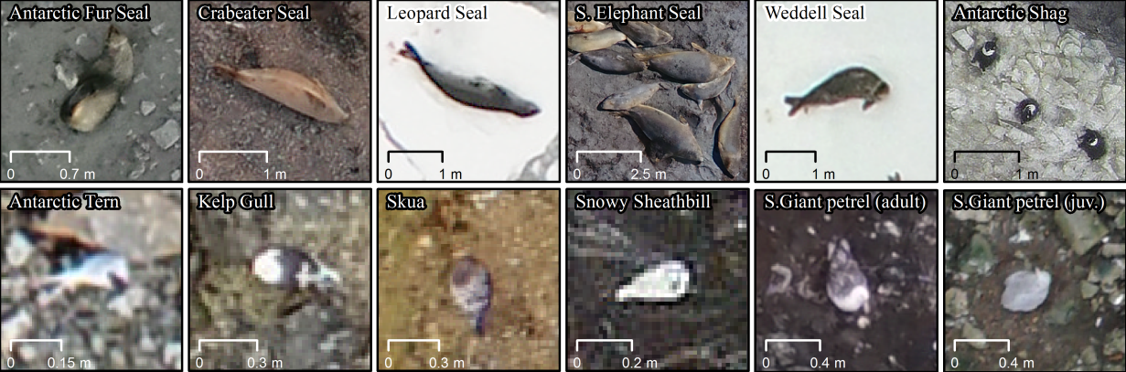

This guide is intended to support the identification of seals and birds in aerial images based on (Mustafa et al., 2019)

Appendix 2

Comparison of Antarctic shag and chinstrap penguins features visible in aerial images of the study area.(Pfeifer et al., 2021)

|  |  |  |
| --- | --- | --- |
|  | Antarctic shags | Chinstrap penguins |
| Colony position | highest part of plateau, close to cliff | above supralittoral zone |
| Guano colour | whitish | reddish |
| Guano ring radius (cm) | 50–80 | 30–50 |
| Mean min. nest distance(cm) | 142 | 70 (Carrascal et al.1995) |
| Nest appearance | bowl shaped, sometimes bright edge | not visible |
| Nest shadow | visible | not visible |
| Nest height (cm) | 10–40 | 5–20 |
| Density on guano covered ground | 0.2–0.37 nest m-2  0.31–0.6 adults m-2 | not detectable  0.6–0.97 adults m-2 |
| Mean visible body length/width (cm) | 29/17 | 30/18 |
| Adults upper back | white | black |
| Adults neck | long | short |
| Adults tail width (cm) | 4 | 2 |
| Adults wings/flippers | folded | sometimes spread |
| Chicks colour | brown | light grey |

Appendix 3



a. & b. At Fregata Island Antarctic shag and chinstrap penguin colonies were impossible to distinguish by guano colour after rain (20 December 2016)

c. & d. At Kwarecki Point Antarctic shags breed within a chinstrap penguin colony. Single nests of both species were difficult to distinguish reliably from each other (28 December 2016).

e. & f. At the eastern part of Rzepecki Islands Antarctic shag and chinstrap penguin colonies overlap partially, but predominantly use different topographic positions (28 December 2016). (Pfeifer et al., 2021)

Appendix 4

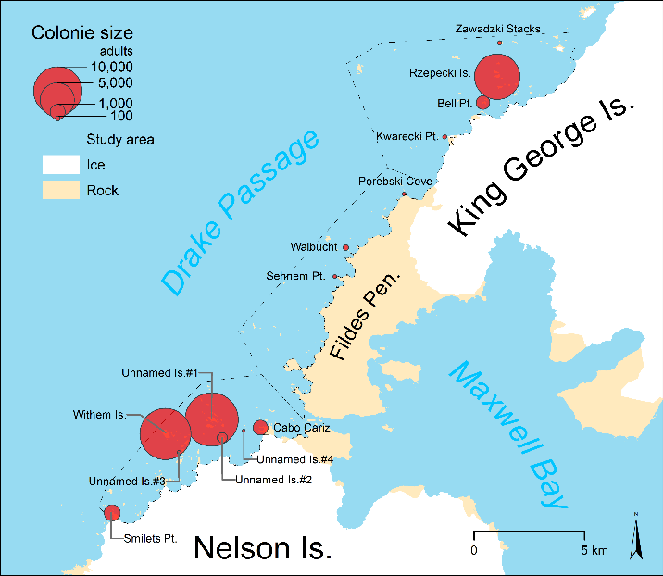 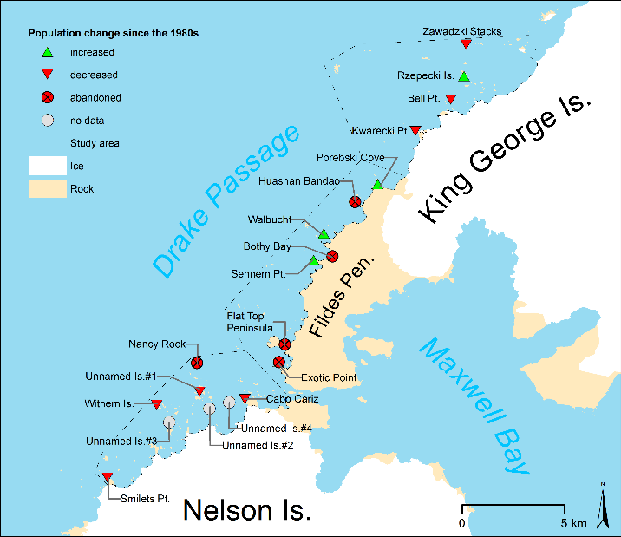

Left: Size and location of chinstrap penguin colonies in the study area. Right: Estimated changes in the population compared to previous counts (Pfeifer et al., 2019)

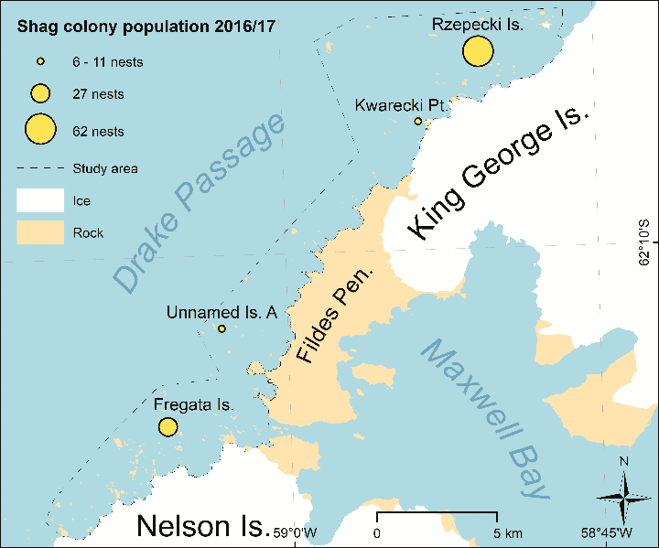 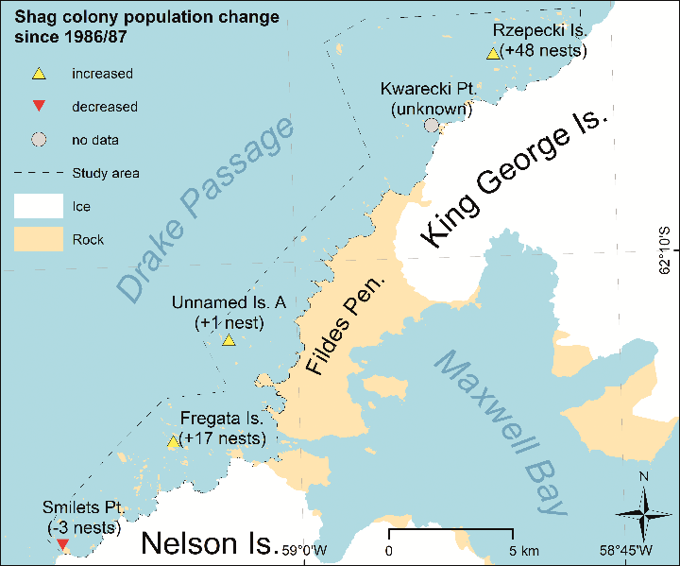

Left: Positions of the Antarctic shag colonies in the study area. Right: Change in the distribution and abundance of Antarctic shag colonies compared to previous counts 2016/17 (Pfeifer et al., 2021)

1. Also known as remotely piloted aircraft systems (RPAS) or colloquially as "drones".