Report on the tasks completed by the Naval Hydrographic Service in Antarctica 2020/21

English version provided by the author

Report on the tasks completed by the Naval Hydrographic Service in Antarctica 2020/21

**Document Presented by Argentina**

***Summary***

This document describes the activities carried out by the Argentine Republic in the Antarctic Peninsula, through its Naval Hydrographic Service, to improve navigation safety and the protection of the maritime and Antarctic coastal environments. The latest news about beaconing and particularly aids to navigation (AIS AtoN) are also presented here. Finally, updates related to Argentine nautical charts and to the works on bathymetry and topography in the adjacent coastal area of interest are also presented.

***Introduction***

The Automatic Identification System (AIS) facilitates the automatic identification and tracking of vessels from other ships, aircraft and coastal stations. Although its primary objective was to contribute to avoid collisions at sea, its applications have exceeded the initial expectations, transforming AIS into a multiple capacity aid to navigation.

The Argentine Republic, in response to increase of navigation in Antarctica, continues its work, through joint efforts between the Naval Hydrographic Service, the Argentine Navy, Hidrovía S.A. (company responsible for providing dredging and signalling services) and the Joint Antarctic Command, to maintain and increase the capacities of the AIS AtoN installed in Antarctica, with the purpose of complementing the beaconing process.

As part of the national efforts within the scope of the Antarctic Summer Campaign 2020/2021, 11 beacons were given maintenance and repairs, and one AIS AtoN device was renewed, increasing the total number of signals capacity of this AtoN.

Regarding nautical cartography, during 2020/21 three new international nautical charts were presented, as well as a new electronic chart. Likewise, new bathymetric and topographic surveys have been carried out in the adjacent coastal area of interest in Isla Media Luna / Half Moon Island and Bahía Esperanza / Hope Bay.

***Development***

1. **AIS AtoN**

During the Antarctic Summer Campaign 2020/2021, aware of the need to increment aids to navigation and after ten years of successful service, the Argentine Republic has conducted maintenance on AIS AtoN devices installed at Orcadas Station (LAT. 60º 44’S, LON 044º 44’ W), Carlini Station (LAT. 62° 14’ S, LON. 58° 40’W), San Martín Station (LAT.68° 08’S, LON. 67°08’W) and Esperanza Station (LAT. 63° 24’S, LON. 56° 59’W).

The Capacity of the Esperanza AIS AtoN was increased, adding a meteorological station that allows the equipment to transmit meteorological and hydrological data (message 8), as well as signal identification and basic data on functioning status (message 21). This unit has an ultrasonic sensor with AIRMAR heater, which provides data on wind speed and direction to the transmitter.

1. **Beaconing**

During the Antarctic Summer Campaign 2020/2021, preventive and corrective maintenance duties were conducted on the beacons, as follows:

|  |  |  |  |
| --- | --- | --- | --- |
| **National Numbers** | **Name** | **Location** | **Tasks Performed** |
| 1848 | Entrada Beacon | Caleta Potter / Potter Cove | General inspection and change of winds. |
| 1849 | Cámara Beacon | Caleta Potter / Potter Cove | Installation |
| 1851 | Potter Beacon | Caleta Potter / Potter Cove | Structure base construction. |
| 1872 | Vale Beacon | Puerto Yankee / Yankee Harbor | Inspection. Regular state. |
| 1873 | Ramos Beacon | Puerto Yankee / Yankee Harbor | Not found. |
| 1877 | Rosales Beacon | Isla Media Luna / Half Moon Island | Installation |
| 1967 | Faro Esperanza Beacon | Bahía Esperanza / Hope Bay | Maintenance. Put into service. |
| 1968 | Denticulada Anterior Beacon | Bahía Esperanza / Hope Bay | Maintenance. Put into service. |
| 1969 | Denticulada Posterior Beacon | Bahía Esperanza / Hope Bay | Light bulb replacement. Put into service. |
| 1970 | Rojo Beacon | Bahía Esperanza / Hope Bay | Painting |

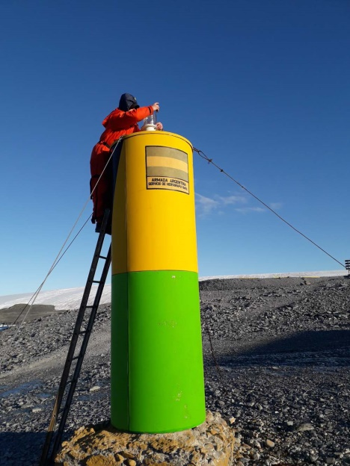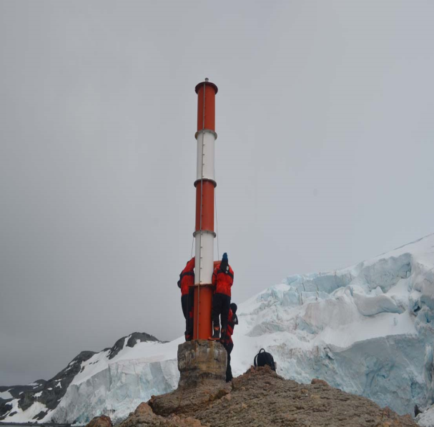

DENTICULADA POSTERIOR Beacon ENTRADA Beacon

Potter Beacon

1. **Nautical cartography:**

During 2020/21, the following nautical charts were edited:

**INT 9140 / H-611** Tierra del Fuego, Antártida e Islas del Atlántico Sur Province. Islas Orcadas del Sur /SouthOrkney Islands.

**INT 9101 / H-757** Tierra del Fuego, Antártida e Islas del Atlántico Sur Province. Peninsula Trinidad – Base Esperanza– Caleta Choza / Trinity Peninsula - Esperanza Station - Hut Cove.

**ENC AR507570** Península Trinidad. Bahía Esperanza. / Trinity Peninsula. Hope Bay.

**INT 9120 / H-762** Tierra del Fuego, Antártida e Islas del Atlántico Sur Province. Islas Shetland del Sur / South Shetland Islands. Isla Decepción / Deception Island. 2nd Edition.

**Quadroon:** Fuelles de Neptuno /Neptunes Bellows. 2nd Edition.

1. **Bathymetrical and Topographical Tasks:**

A complete topographical and bathymetrical survey of the area corresponding to the quadroon of Isla Media Luna / Half Moon Island, chart N° 138, was carried out. Bathymetrical tasks were also performed in the east, north and west of Punta Foca / Seal Point in the proximity of Esperanza Station.

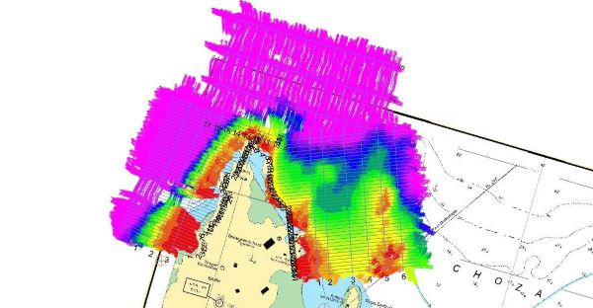 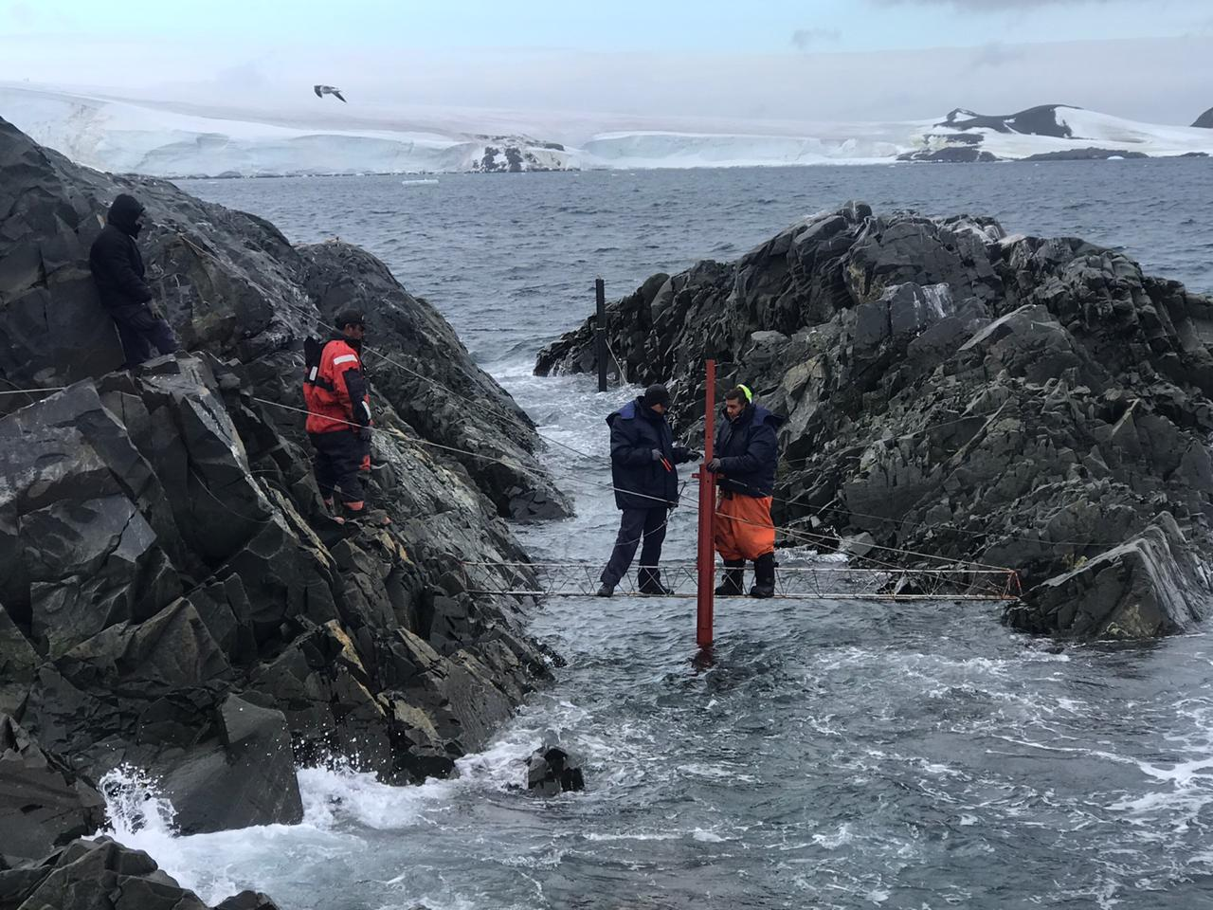

**Bathymetry in the N, E and W of Punta Foca / Seal Point Establishing tide gauge station**

**Conclusion**

In accordance with national dispositions to prevent the spreading of the COVID-19 outbreak to Antarctica, activities in the continent were considerably reduced, preventing the normal opening of temporary stations and limiting the operation of vessels. However, given the priority assigned by Argentina to the safety of human life at sea and the assigned SAR responsibility, the Naval Hydrography Service has continued working in its permanent effort towards cartographical production, the maintenance of beaconing and the use of technology compatible with new navigation systems, in order to increase nautical safety, safeguard human life at sea and prevent marine and coastal pollution in Antarctica.