COMNAP Antarctic Aviation Project: Update

COMNAP Antarctic Aviation Project: Update

Background

After discussions at ATCM XLII (2019) on “Safety and Operations: Aviation” the Meeting requested COMNAP report on innovative technologies in order to improve air operations safety, for guidance on what minimal but non-mandatory survival equipment should be carried (on personned aircraft) and welcomed information on the intended workshop on the practical and technical aspects of safe air operations in Antarctica (*ATCM XLII Final Report*, paragraphs 263–265, 267–268). To address these ATCM requests and in support of our common goal to promote operational safety in Antarctica, through the COMNAP Air Operations Expert Group, COMNAP began the “COMNAP Antarctic Aviation Project”. The global pandemic has seen the project timeline shifted and the workshop postponed to early 2022. Never-the-less, progress on many of the outputs has been possible. This paper serves as an update on the status of the COMNAP Antarctic Aviation Project and its component outputs.

Summary of the project

The project was developed with five outputs:

* Output 1: Review ATCM Resolution 1 (2013) and provide COMNAP advice to ATCM XLIII (2021).
* Output 2: Perform Air-related Technology Audit.
* Output 3: Develop minimum survival equipment recommendations (non-mandatory) for carriage on aircraft.
* Output 4: Convene Antarctic Aviation Workshop (AAW).
* Output 5: COMNAP paper(s) to ATCM XLIII (2021) & ATCM XLIV (2022).

Status: Output 1

Review of practical and technical aspects of ATCM Resolution 1 (2013) by COMNAP Membership is completed and preliminary advice was presented to ATIP 2019/2020 IP033 and to ATCM XLIII (2021) as WP008.

Status: Output 2

A paper-based air-related technology audit was performed by way of the COMNAP Air Operations Expert Group. The initial list of technologies is provided as Annex 1 to this document and will be further enhanced and discussed at the COMNAP Antarctic Aviation Workshop (see Status: Output 4 below).

Status: Output 3

A draft of the minimum survival equipment recommendations (non-mandatory) for carriage on aircraft was prepared. The draft list in the form of preliminary advice to the ATCM XLIII (2021) can be found as Annex 2 to this document and will be further enhanced and discussed at the COMNAP Antarctic Aviation Workshop (see Status: Output 4 below).

Status: Output 4

Planning was well-advanced for the COMNAP Antarctic Aviation workshop to be hosted by the Australian Antarctic Division, in Hobart, Tasmania, Australia, on 30 & 31 July 2020. The global pandemic forced the postponement of the workshop and the hosts of COMNAP Annual General Meeting (AGM) 2021, Japan’s National Institute of Polar Research, kindly agreed to take on organisational responsibilities for the workshop on the margins of the AGM in Toyama, Japan, 15 & 16 July 2021. Due to the global pandemic the AGM has been moved to a virtual format. The Workshop Steering Committee have determined that the workshop would be most effective and successful if it was postponed in order to meet in-person. There is a strong indication that the workshop will take place in late April/early May which would be the normal time for a COMNAP Search and Rescue (SAR) triennial workshop (SAR Workshop V 2022). It is likely the two meetings could be combined with the Antarctic Aviation Workshop being the focus of discussions since it is anticipated that the SAR community would also participate. The Workshop Steering Committee intends to make a formal announcement of dates, host and venue in the very near future. For the time-being, the proposed workshop agenda and schedule is presented as Annex 3 to this document. COMNAP welcomes full participation by the aviation/air operations community in the development of the agenda or schedule, and for suggestions of experts to present, facilitate or chair sessions of the workshop.

Status: Output 5

If the workshop is held in late April/early May 2022, COMNAP anticipates submitting the project and workshop reports, and any additional papers that may be required based on the outcomes of the project, to ATCM XLIV (2022). Upon completion of this output, the project will end. The Air Operations Expert Group is a standing Expert Group and will remain convened to continue to focus on promoting operational safety in Antarctica.

Annex 1: Air-related Technology Audit

1. Items that were considered:

* Situational Awareness
* Tracking systems (COMNAP Asset Tracking System (CATS) and others)
  + Participation
  + Opportunities
    - Potential obsolescence
    - Enhancement
* Automatic Dependent Surveillance-Broadcast (ADS‐B) out
  + Fixed wing, rotary wing and RPAS
* Flight Aware
  + Ground receiver distribution
    - National Antarctic Programs
    - Non-Governmental Operators, including non‐IAATO members
* De-confliction
  + Traffic Information Broadcast by Aircraft (TIBA) relevance
  + Transponder Landing System (TLS)
  + ADS‐B in
  + Traffic Collision Avoidance System (TCAS)
  + Other technologies?
* Search and Rescue
  + Autonomous Distress Tracking (ADT)
  + ADS‐B/Flight Aware
  + SARSAT
  + Other technologies?

1. Detailed descriptions with Pros/Cons for the Antarctic situation

TRAFFIC COLLISION AVOIDANCE SYSTEM (TCAS)

Automated visual and voice warning of potential mid-air collision between TCAS equipped aircraft and transponder equipped aircraft. International standards vary, but most countries require TCAS for aircraft with 30 or more passengers.

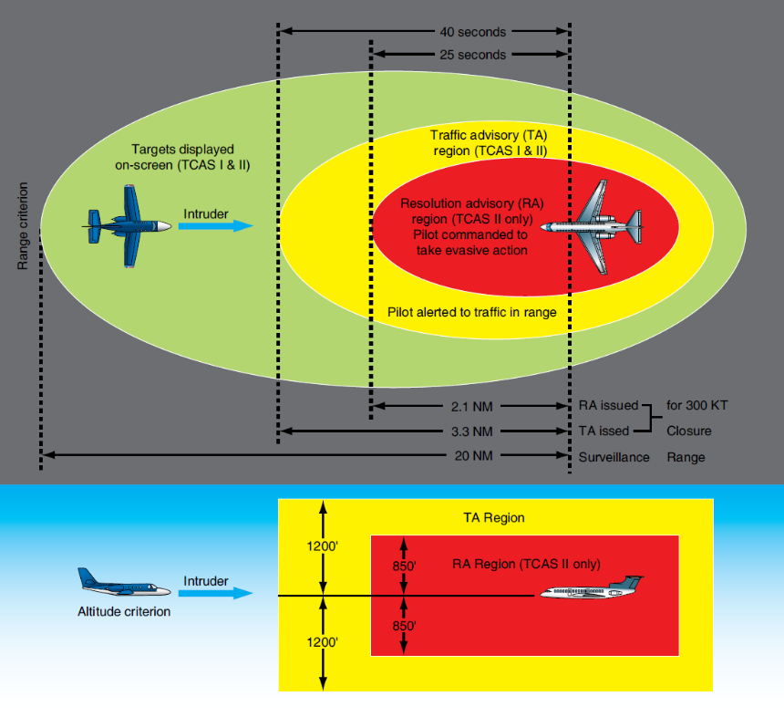

Depiction of TCAS threat ring:

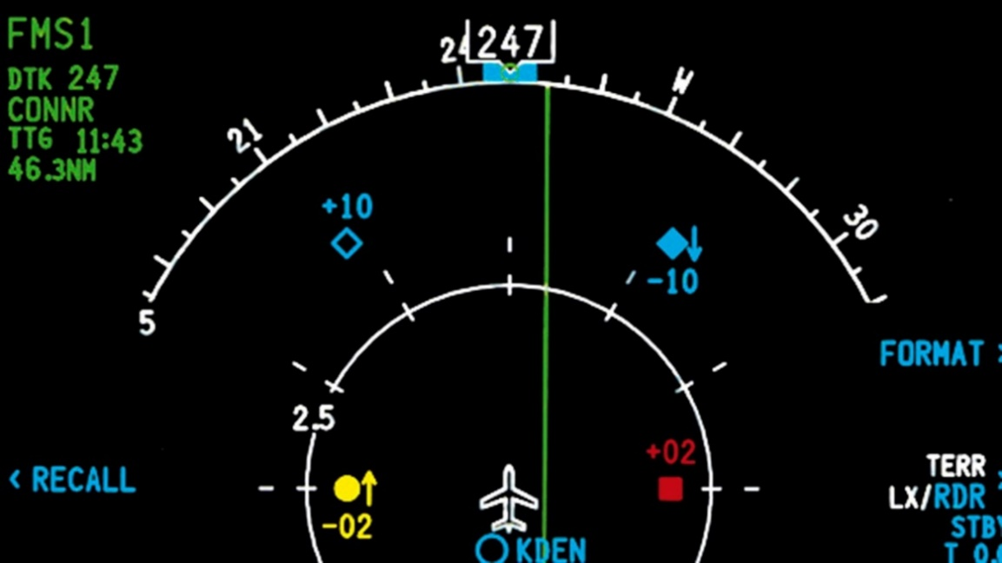

Depiction of transponder equipped aircraft identified on typical flight management system (FMS) on TCAS equipped aircraft.

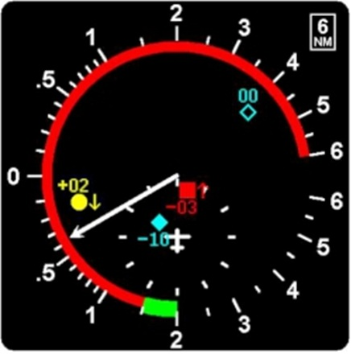

Depiction of alert warning on typical vertical velocity indicator (VVI) on TCAS equipped aircraft. Threat aircraft is 300’ below TCAS aircraft. TCAS aircraft is descending at 400’/minute toward the threat aircraft.

**PROS**

Existing, off-the-shelf technology

Mandated in most countries

Can see transponder equipped RPAS

**CONS**

Only sees transponder equipped aircraft with system turned on

**AUTONOMOUS DISTRESS TRACKING (ADT)**

On 1 January 2021 ICAO requirement for all large (> 27,000 kg) new production aircraft to have ADT installed. Possible recommendation for all operators to consider install of ADT on aircraft operating in Antarctica. Rescue Coordination Centre’s (RCCs) prepare for ADT implementation.

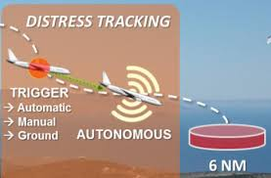

Distress signal automatically activates when aircraft deviates from specific parameters. No pilot interface required.

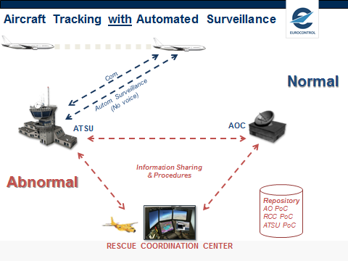

RCC response accelerated, data automatically captured in secure repository for SAR.

PROS

Immediate and automatic alert prior to crash

CONS

Not widely manufactured and mature technology

ADS-B out may make this redundant

**AUTOMATIC DEPENDENT SURVEILLANCE - BROADCAST**

**(ADS-B)**

Various ATCM papers advocate for safety improvements largely built on ADS-B. Some equipment, like ADS-B out, will be mandatory ICAO requirement for international flight.

Features are depicted below.

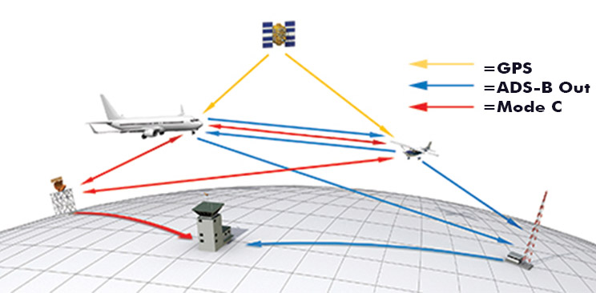

ADS-B out – equipped aircraft broadcast GPS and transponder data via multiple paths to air traffic control. The signal eliminates/supplements ground based radar for broader surveillance. Trans-oceanic monitoring can be near real-time with satellite (Iridium) interface.

ADS-B in - Properly equipped aircraft can receive the signals of ADS-B and transponder equipped aircraft for collision avoidance. Big airplane “sees” little airplane from little airplane signal and/or ground based broadcast of little aircraft position (black arrow).

ADS-B in traffic signal received



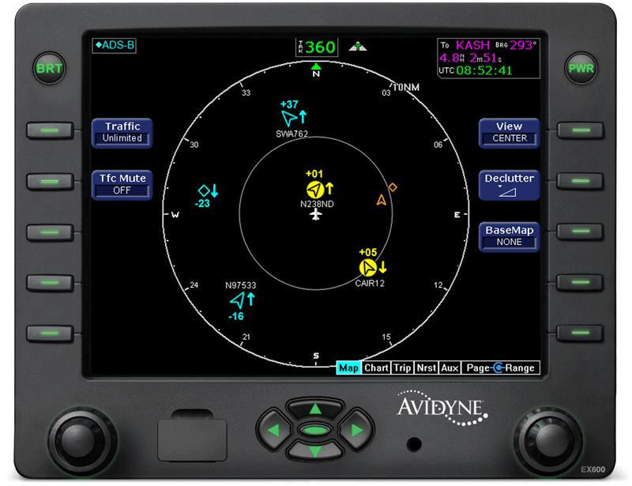

Typical ADS-B in depiction of near real-time pilot awareness of near traffic.

**COMNAP SAR MEETING DISCUSSION – FLIGHT AWARE INTERFACE**

Flight Aware is a commercial entity that supplies ground-based ADS-B receivers to airfields for around $100 and ask the owners to tie-in the signals to the internet. Owners need an unobstructed antenna mounting position, power, and internet access. The incoming data is automatically sent to the Flight Aware server and presented to all global users for the global picture of aircraft in flight.

There is a huge void of information in Antarctica. Any willing participants, NAP or NGO, would improve the real time picture of aviation activities around the continent.



Flight Aware provided receiver

Any station in Antarctica with internet could “feed” the Flight Aware global traffic picture

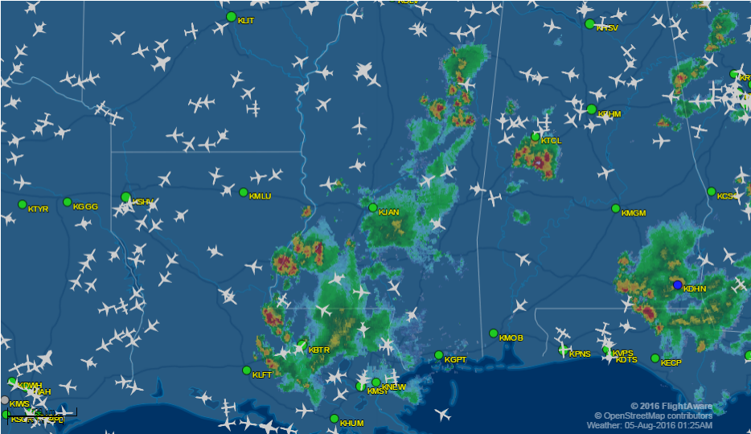

This is a typical Flight Aware image with traffic and weather. Live images are easily accessed by internet. This image example shows weather and traffic in the USA Gulf States region.

Annex 2: Minimum survival equipment recommendations   
(non-mandatory) for carriage on aircraft

Personal Equipment

• Thermal underwear

• Mid layer

• Outer layer - parka and bibs

• Socks

• Hat

• Balaclava

• Sunglasses / goggles

• Gloves / Mittens

• Spare socks - Spare mittens/ gloves - Spare hat

• Winter boots with thermal liner

Food / Drinks

• Dehydrated rations

• Tea bags / Instant coffee / Chocolate

• Chocolate bars/ nuts / Energy bars

• Energy drink powder

Cooking Equipment

• Matches / lighter

• Stove / Burner - Repair kit for stove

• Fuel bottle(s) / Hose to drain fuel from fuel tank

• Cutlery

• Cooking pot with lid

• Thermos / Water bottle

• Funnel

Sleeping Equipment

• Sleeping bag / Bivy bag / Recue blanket

• Sleeping pad

• Tent / Tarp

• Spade

• Snow saw

Group Equipment

• First Aid kit

• Toilet paper

• Multi tool / knife

• Plastic bags / Ziploc bags

• Ice screws

• Snow anchor

• Rope / String / Para cord

• Compass / with mirror

• Mirror – Whistle

Communications Equipment

• Satellite telephone / Iridium / Inmarsat

• PLB / EPIRB – Emergency locator

• Inreach / Satellite tracking device

• HF / VHF radio

Annex 3: Proposed Antarctic Aviation Workshop   
Agenda and Schedule

1. Agenda

The Workshop Agenda Items are as follows:

1. Opening, introductions, workshop background
2. Session 1: Regulatory Review
3. Session 2: Technology Innovations
4. Session 3: Safety
5. Session 4: Communications Initiatives
6. Reporting of key outcomes
7. Close
8. Overview of Programme Schedule

The Workshop will be held in four main sessions. Each session includes presentations, time for questions to presenters and a panel-led discussion with all participants. The broad Overview is as follows:

|  |  |  |
| --- | --- | --- |
|  | Day 1 | Day 2 |
|  |  |  |
| 0830 | Participants arrive/Registration | Participants arrive/Summary of key points day 1/Additional comments |
| 0930 | Welcome/background | Session 3: Safety |
| 1000 | Session 1: Regulatory Review |
| 1100 |
| 1200 |
| 1300 | Lunch | Lunch |
| 1400 |
| 1500 | Session 2: Technology Review | Session 4: Communications Initiatives |
| 1600 |
| 1700 |
| 1800 |  | Discuss draft reporting/Next steps |
| 1900 |  |