Delivering the Promise of Antarctic Science through Inclusiveness and Diversity

**Delivering the Promise of Antarctic Science through Inclusiveness and Diversity**

***Information Paper submitted by the United States and United Kingdom***

Summary

On November 12, 1969, the first women arrived together at the South Pole. It was a pivotal moment in the history of Antarctic science. Now, just over 50 years from that historic moment, it is timely to renew our collective commitment to a fair, safe and inclusive Antarctic science enterprise. As the importance of the Antarctic region in the global earth system is becoming ever more apparent, the value of progressing Antarctic science for the sake of all of humanity cannot be overstated. Treaty Parties are urged to leverage their inherent diversity and promote full participation of all underrepresented groups in their national Antarctic activities, especially in science, technology, engineering and mathematics (STEM), in order to promote the enduring quality and accelerate the progress of Antarctic research.

Background

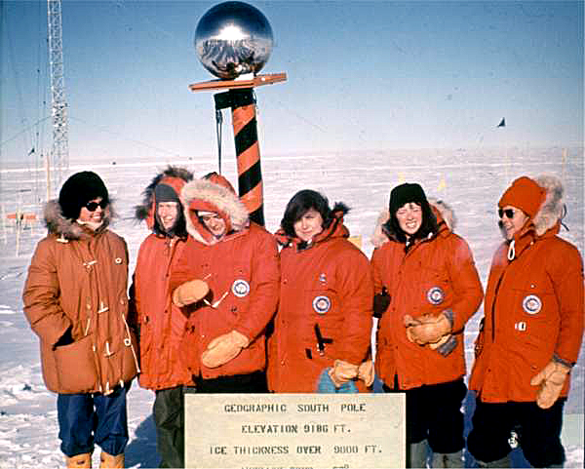

*Caption: From left, Pam Young (New Zealand), Jean Pearson (USA), a reporter for the Detroit Free Press, Terry Tickhill Terrell (USA), Lois Jones (USA), Eileen McSaveney (USA) and Kay Lindsay (USA) at the South Pole. Photo Credit: U.S. Navy*

The history of women in Antarctica is a relatively short one. The history of women scientists in Antarctica even shorter. It began with participation by Dr Maria V. Klenova, a geologist, who was on-board the vessel Ob as part of the Soviet Union’s Antarctic International Geophysical Year (ICG) research team of 1957-58. A small number of women scientists worked at sub-Antarctic stations and on vessels in the Southern Ocean over the next decade.

On November 12, 1969, the first female scientists visited the South Pole. The five female scientists and one reporter pictured above locked arms to step out together off the cargo ramp of a ski-equipped aircraft onto the ice at South Pole Station. The first U.S. women science team to deploy to Antarctica had asked for the opportunity to make a day trip to the South Pole aboard a regular cargo flight while they were waiting a few days at McMurdo Station before going to their Dry Valleys field sites. The opportunity was extended to three other women on the ice and two accepted. Fulfilling their quest generated considerable publicity as a “first” that heralded new possibilities for women scientists in Antarctica.

Although symbolic of opportunity, the 1969 South Pole visit did not exactly fling doors wide-open to women thereafter[1],[2]. Despite significant barriers, a small group persisted to make worthy Antarctic research contributions. Were it not for the collective efforts of these pioneering women, there surely would not have been the progress we know today.

Fifty years after the IGY, women scientists conceived, planned, led and participated in major programs of the intensified globally coordinated research in Polar regions during the 2007-08 International Polar Year (IPY).[3] That effort entrained more than 50,000 researchers, local residents, educators, students and support personnel from 60 nations. IPY’s 228 projects covered a wide variety of scientific disciplines that resulted in major advances led by and including women. These ranged from the first high resolution images of the Alps-sized Gamburtsev mountain range buried beneath the Antarctic ice sheet, to observations and modelling of the geologic past that advanced understanding of risks and uncertainties of regional and global climate change. The IPY 2007-2008 efforts also saw the establishment of the Association of Polar Early Career Scientists (APECS), a network which is dedicated to enhancing pathways for a diverse range of early career persons into Antarctic science careers.

***Importance of Diversity***

A growing body of evidence demonstrates that diversity enhances idea generation, improves decision making and produces more effective problem solving[4]. At the same time, there is recognition that the demographic make-up of the scientific community is not reflective of national or global population demographics[5] and diversity in the Antarctic science community remains particularly limited. This is a problematic situation and, as a community, we need to resolve it.

While participation of women in Antarctic science improved markedly from very few in the IGY to nearly one quarter of participants during the IPY, women remain underrepresented in Antarctic endeavours by at least a factor of 2 with respect to their fraction of the global population. Gender is not the only factor that is not in balance with respect to populations. Although comprehensive data are more difficult to come by, participation by minority groups in national Antarctic science programs appears to be considerably less representative than their fraction in national populations. For example, the vast majority of the IPY female scientists were white with very low participation rates of those who identified with other ethnicities.

As in many sectors all over the world, there are grass roots efforts underway to promote diversity and inclusiveness in Antarctic research. On November 18, 2020, on the occasion of the International Day of LGBTQ+ people in STEM, “Polar Pride” day was launched.

Today, social media provides a powerful platform for the polar research community to support and engage with one another as well as reach wider society. Self-organised polar research community groups, including Women in Polar Science and Pride in Polar Research, celebrate diversity and showcase role models for the next generation. While these self-organised groups play an influential role in changing perceptions and attitudes to diversity in Antarctic science more needs to be done at organizational level to support a culture of inclusivity that is needed to achieve diversity and it benefits. It is noted that SCAR established a Women in Antarctic Science website (<https://www.scar.org/antarctic-women/>) upon which it can build in this regard.

Media reports in recent years indicate that some women and under-represented minorities experienced distressing and inappropriate behaviors from colleagues. Our diverse community of researchers should be confident of safety from discrimination or harassment in the workplace, including in Antarctica, and harassment of any kind should never be tolerated. Initial steps have been taken by national programs and to work together to ensure fair and safe work environments, such as the Council of Managers of National Antarctic Programs “Preventing Harassment in Antarctica” Safety Expert Group Forum (July 2019). More work remains to be done in a “whole of community” approach toward promoting inclusivity and cultural change.

Importance of Antarctic Science

The Antarctic Treaty System (ATS) has underpinned the fundamental importance of peace and science for the Antarctic Treaty region for decades. The research sponsored under the aegis of the ATS has led to a global awakening of the importance of Antarctic science for all of humanity. Critical observational data informing global models have confirmed that:

* Antarctica and the Southern Ocean are key driving components of the global climate system.
* Net loss of Antarctic land ice and attendant global sea level rise are significant and accelerating.
* Grounding of the West Antarctic Ice Sheet below sea level renders vulnerable that part of the ice sheet holding 3+ meters of equivalent global sea level rise.
* Southern Ocean marine nutrients support a disproportionate fraction of global productivity.
* The Southern Ocean supports invaluable fish resources & uniquely adapted ecosystems.
* The Southern Ocean acts as a primary global carbon sink.
* Atmospheric teleconnections with Antarctica impact weather patterns in the Southern hemisphere.
* Antarctica is a key location to advance our understanding of space weather that poses risks to critical infrastructures such as satellite navigation and electrical grids.
* Antarctica remains a superb platform for fundamental astrophysics research regarding the nature and origins of the universe.

Conclusion

It has become increasingly apparent that the Antarctic region is a critically important component of the earth system. Science and research results from Antarctica have never been more needed than they are today. Supporting diversity and inclusiveness in our science community and within our national Antarctic programs will ensure we have the capacity and capabilities to deliver the results from Antarctica that the global community requires from us.

With Antarctica at the heart of solutions to many of society’s grandest challenges, the Treaty Parties, having set aside Antarctica for peaceful, scientific purposes have a special responsibility to ensure that the Antarctic science enterprise is as robust as possible. It is clear that there is considerable room for enhancing diversity and inclusion in Antarctic research. The 54 nations that have acceded to the Antarctic Treaty, along with the Antarctic Treaty’s Observers and Experts, comprise an inherently diverse community. This diversity is a strength of the system that should be utilized to deliver common goals.

We encourage all Parties to redouble efforts to intentionally and inclusively nurture talent broadly and to draw and support Antarctic research participants from throughout their diverse national populations.

1. Land, B. (1981) “*The New Explorers: Women in Antarctica”,* Dodd, Mead & Co, NY, USA, pp. 1-224.
2. Burns, R. (2001) “Just Tell Them I Survived: Women in Antarctica”, Allen & Unwin, Australia, pp. 1-232.
3. National Research Council. 2012. *Lessons and Legacies of International Polar Year 2007-2008*. Washington, DC: The National Academies Press. https://doi.org/10.17226/13321.
4. # Page, S. E. (2007) “*The Difference: How the Power of Diversity Creates Better Groups, Firms, Schools, and Societies (The William G. Bowen Series)*”, Princeton University Press, pp. 448.

  
5. Huntoon, J. E., Tanenbaum, C., & Hodges, J. (2015). Increasing diversity in the geosciences. *Eos*, *96*(5), 13–15.; National Center for Science and Engineering Statistics. (2017). *Women, Minorities, and Persons with Disabilities in Science and Engineering: 2017* (Special Report NSF 17-310), <https://www.nsf.gov/statistics/wmpd/>; Bernard, R.E., Cooperdock, E.H.G. No progress on diversity in 40 years. *Nature Geosci* **11,** 292–295 (2018). https://doi.org/10.1038/s41561-018-0116-6