High-precision Map of Antarctic Ice Sheet Bed Topography

**High-precision Map of Antarctic Ice Sheet Bed Topography**

***Information paper submitted by the United States***

***Summary***

An international team led by Mathieu Morlighem at the University of California Irvine has released a high-precision map of the bed topography of Antarctica (Morlighem et al., 2020). The new map helps identify which regions of the continent are most vulnerable to the impacts of climate change. It reveals broad subglacial ridges that may stabilize the ice flowing across the Transantarctic Mountains. But the map also shows bed geometry that increases the risk of rapid ice retreat in the Thwaites and Pine Island Glacier sector of West Antarctica. Portions of the bed under Recovery Glacier and Support Force Glacier are hundreds of meters deeper than previously thought, making those glaciers more susceptible to retreat, and the map reveals the world’s deepest land canyon at 3,500m below sea level under Denman Glacier in East Antarctica. This product, which is continually upgraded as new data becomes available, constitutes a major advancement that underpins a wide array of research activities.

***Background***

The new Antarctic bed topography product (Figure 1) was constructed using ice-thickness data from 19 different research institutes. These data encompass roughly 1.5 million line-kilometers of radar soundings, some dating back to 1967. In addition, the team used ice-shelf bathymetry measurements from airborne campaigns, as well as seismic information.

Despite the many prior radar-sounding campaigns, more than half of Antarctica is at least 5km from any radar line, and radars have had difficulty resolving deeper bed features. Previous mapmakers have applied interpolation techniques to fill in the areas between the radar lines, but this has presented challenges for accuracy, especially with fast-flowing glaciers. The new approach, called BedMachine, relies on a physics-based method of mass conservation to estimate what lies between the radar-sounding lines. The method also integrates satellite-derived information on ice-flow velocity. These data indicate how ice moves around the uneven contours of the bed. By basing results on ice-surface velocity in addition to ice-thickness data from radar soundings, the BedMachine methodology is able to present a more accurate and higher-resolution depiction of the bed topography.

***Key Outcomes***

The new description of bed topography redefines the high- and lower-risk sectors for rapid sea-level rise from Antarctica. The results reveal previously unknown basal features with implications for glacier response to climate change. Most differences from previous maps are at the smaller scale, yet these local differences

have a disproportionate impact on modelled glacier evolution. For example, 62 percent of slopes are steeper in the new map because the smoothing effects of interpolation are corrected. In addition, the details of deep connections to the ocean are revealed, and these are critical for correctly capturing ice-ocean interaction in models. In the marine basin of Wilkes Land, East Antarctica, there are retrograde slopes along Ninnis and Denman glaciers that show vulnerability to marine ice-sheet instability. Conversely, there are stabilizing slopes beneath Moscow University, Totten and Lambert glacier systems even though the new methodology corrects bed elevation by up to 1 km for the latter.

The new map is dynamic and is updated as new data are collected. The authors note key areas where future collaborative work would yield particularly valuable data to enhance the map and the ice-sheet model projections of sea-level rise that depend on accurate bed topography. For example, there remains a lack of ocean bathymetry on the continental shelf and beneath ice shelves over a large portion of coastal Antarctica.

***International*** ***Collaboration***

This is the result of international collaboration and cooperation. Support for the work was provided by the U.S. National Science Foundation, NASA, the Australian government’s Cooperative Research Centres Programme and the National Natural Science Foundation of China. The team participants (in order of listing from the publication) are from University of California Irvine, NASA Jet Propulsion Laboratory, Alfred Wegener Institute, University of Texas Institute for Geophysics, British Antarctic Survey, Technical University of Denmark, Northumbria University, Polar Research Institute of China, The Ohio State University, Geological Survey of Denmark and Greenland, Korea Polar Research Institute, Institute for Marine and Atmospheric Research at Utrecht University, Norwegian Polar Institute, Grenoble Alps University, NSF’s Center for Remote Sensing of Ice Sheets at University of Kansa, Université Libre de Bruxelles, and the Australian Antarctic Division.

***Figure 1*** *– Bed Topography of Antarctic from the BedMachine mass conservation methodology (Morlighem et al., 2020)*

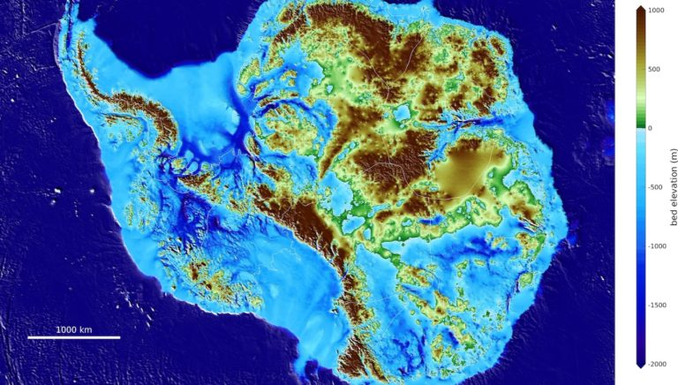

***Reference***

Morlighem, M., Rignot, E., Binder, T., Blankenship, D., Drews, R., Eagles, G., Eisen, O., Fausto Ferraccioli, F., Forsberg, R., Fretwell, P., Goel, V., Greenbaum, J., Gudmundsson, H., Guo, J., Helm, V., Hofstede, C., Howat, I., Humbert, A., Jokat , W., Karlsson, N., Lee, W.S., Matsuoka, K., Millan, R., Mouginot, J., Paden, J., Pattyn, F., Roberts, J., Rosier, S., Ruppel, A., Seroussi, H., Smith, E., Steinhage, D., Sun, B., van den Broeke, M., van Ommen, T., van Wessem, M., and Young, D. (2020). Deep glacial troughs and stabilizing ridges unveiled beneath the margins of the Antarctic ice sheet. *Nature Geoscience* **13,** 132–137. [*https://doi.org/10.1038/s41561-019-0510-8*](https://doi.org/10.1038/s41561-019-0510-8)