Autonomous Science Operations at Halley Research Station

Autonomous Science Operations at Halley Research Station

Information Paper submitted by the United Kingdom

***Summary***

Halley Research Station is located on the Brunt Ice Shelf and was operated as a year-round facility until 2016. As a result of changes to the behaviour of the ice shelf, the decision was made to temporarily suspend winter operations on safety grounds. To maintain long-term datasets, many of the instruments at Halley were automated. This was achieved through providing reliable power using a micro turbine, automation of instruments and developing communication systems to enable data transfer and systems monitoring.

***Background***

Halley Station was designed and built to provide excellent laboratory and living accommodation that is capable of withstanding extreme winter weather, of being raised sufficiently to stay above metres of annual snowfall, and of being relocated upstream periodically to avoid calving events as the floating ice shelf moves towards the sea. It is made up of a series of eight pods sitting on skis that can be uncoupled and towed across the ice using specialist heavy vehicles: the world’s first relocatable research facility.

In 2012, satellite monitoring of the Brunt Ice Shelf revealed the first signs of movement in a chasm that had lain dormant for at least 35 years. This chasm could eventually cut Halley Station off from the rest of the ice shelf, so in the 2015-16 austral summer, a new location was identified and initial preparations for relocating the station began. During the 2016-17 summer season, the station modules were uncoupled and transported 23km across the ice. During that season, another chasm (named Halloween crack) formed and it was not considered prudent to leave staff at the station over the winter.

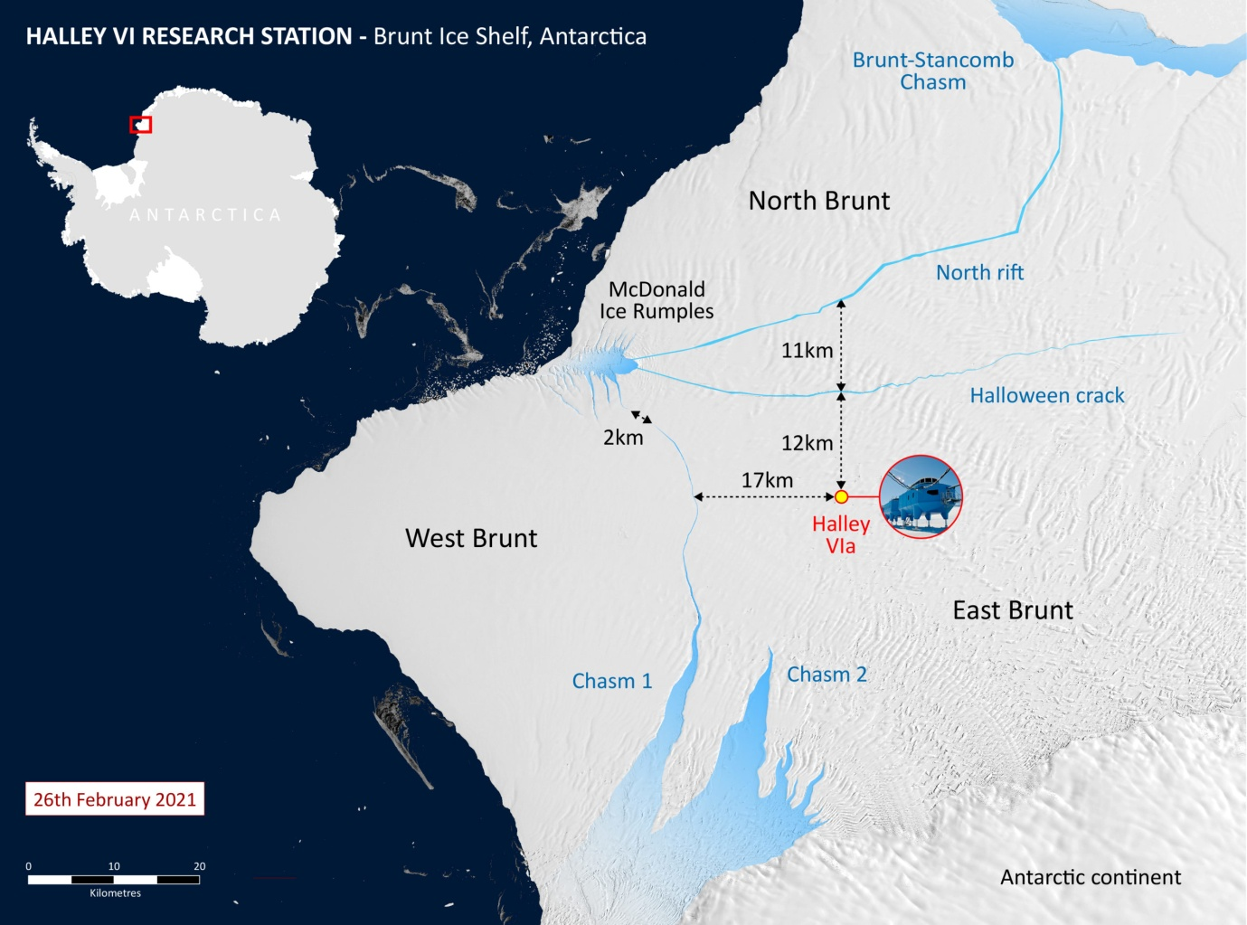

The Brunt Ice Shelf (January 2021) and the location of Halley

This interrupted important scientific research programmes that were building on the legacy of 60 years of occupation. The expectation was that it would be several years before wintering might resume. The British Antarctic Survey (BAS) therefore examined options to maintain year-round scientific outputs. An additional complicating factor was that the chasms were expected to temporarily cut off access to any ship relief sites, so any proposal for future operation of the station had to rely on air support only.

***Methodology***

The power and heat demands of the scientific instruments and the various supporting infrastructure, such as computer servers and satellite communications, were well understood. It was therefore possible to estimate that much of the science (in 2017) required around 10kW of power. Future proofing, and the option to expand to around 20kW, was a further consideration. Reliably providing power at this level in Antarctica, fully autonomously for around nine months per year, is a considerable challenge. Advice was sought from other Antarctic operators and organisations that had similar challenges, such as those operating oil rigs or arctic communication networks. This research showed the most promising option was a micro-jet turbine. Not only could this be implemented in a very short timeframe, it could also be air-transported to Halley using BAS aircraft.

|  |  |  |  |  |  |  |
| --- | --- | --- | --- | --- | --- | --- |
| Options for autonomous winter power at Halley station | | | | | | |
|  | Time to implement | Infrastructure required | Short term C02 | Long term C02 | Power Flexibility | Air input possible? |
| Wind/Solar/Battery | >4 years | Very High | High | Low – medium | Low | Difficult |
| Extended service interval diesel generators | >3 years | Medium | Low | High | Medium | Yes |
| H2 fuel cells | >5years | Medium | Medium | Low | Medium | No |
| Micro-jet turbine | 1 year | Low | Low | Medium | High | Yes |

A micro-jet turbine is similar to an aircraft jet engine but configured to maximise shaft take off power rather than thrust. A micro-jet generator manufactured by Capstone Turbine Corporation was selected on the basis of; reliability, one moving part only, minimal servicing requirements and the ability to run on station stocks of aviation diesel. The challenge for BAS was to provide a thermally stable enclosure and supply the micro-jet turbine with nine months of fuel in such a manner that a fuel spill was of an extremely low probability. This latter challenge was addressed by having multiple levels of protection around the fuel and extensive monitoring to ensure that the protections were working. For a fuel spill to occur, multiple failures would have to take place and these would be detected allowing action to be taken before fuel was released.



Capstone micro-turbine cut away.

The micro-jet turbine was installed at Halley in a bunded 20ft ISO container with a fuel tank of 48 hours duration inside the container. Additional 25 tonne bulk bunded fuel tanks were sited 10m away (for snow management reasons) from which the fuel is periodically and autonomously pumped.

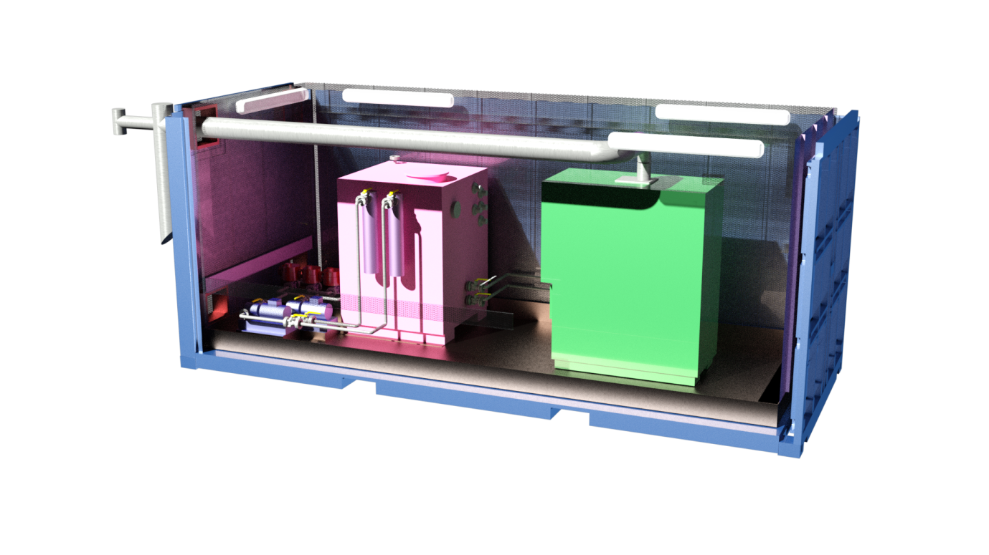

A cutaway render of the micro-jet turbine (green) and the fuel tank (pink) inside a bunded 20ft ISO container.

The main engineering challenges around the micro-jet turbine are the thermal management and accounting for all the fuel – this is made difficult because of the large thermal expansion coefficient of diesel based fuels.

The science experiments at Halley range from climate, atmospheric chemistry, glaciology and space physics. Some instruments were effectively already automatic (or controlled over the internet) whereas some experiments were based around people undertaking tasks. BAS undertook an internal prioritisation process that took into account the ease of automation and the value of the continued data set. To date around 75% of the experiments have been automated, and BAS continues to add experiments each season. Automation of a previously manually operated instrument has allowed for finer-scale scientific study, undertaking a far higher number of regular measurements than could be taken by a person.

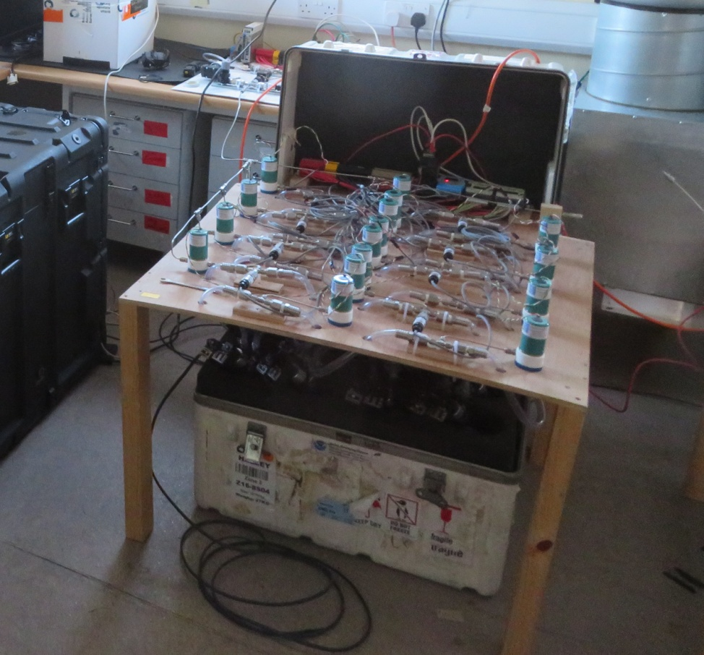

Automated flask air sampling – previously a manual process

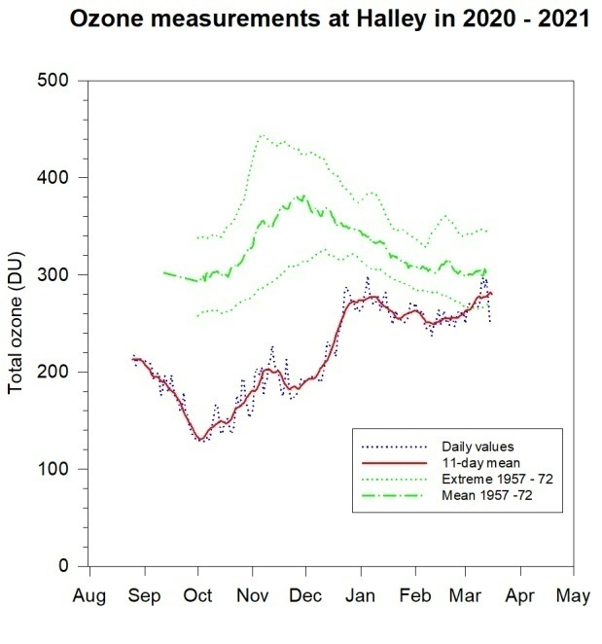

Stratospheric Ozone measurements undertaken by an automated Dobson.

Much of the existing computing and communication infrastructure from the station was capable of running in autonomous mode, although more resilience and fail-safe options were added. For example, an Iridium Open port satellite terminal was added to back up the existing VSAT link. The science experiments could all be run from small, thermally efficient buildings so the main station living units were put in a safe dormant state.

***Timeline***

The project was initiated in April 2017 and in September that year a micro-jet turbine (fitted in its container) was loaded on the RRS Shackleton, arriving at Halley in January 2018. It was not possible to finish all the necessary works that season and completion was undertaken in the 2018-19 season using air support. The station successfully ran autonomously throughout the whole of winter of 2019. Further science experiments were added during the air supported season of 2019-20 with successful autonomous operations throughout the winter of 2020. In the 2020-21 season, further air-supported servicing was undertaken and additional science experiments were brought on line. The station is now entering its 3rd year of autonomous operation.

***Data***

A key part of the operation of the system, both for science and infrastructure, is the continual transfer of data to the UK. This gives us a high degree of assurance that the systems, and in particular the fuel containment, are working correctly. Over 100 parameters are sent back every 5 seconds and eight webcam images are returned at 5 minutes intervals. This also aids preparation for service visits.

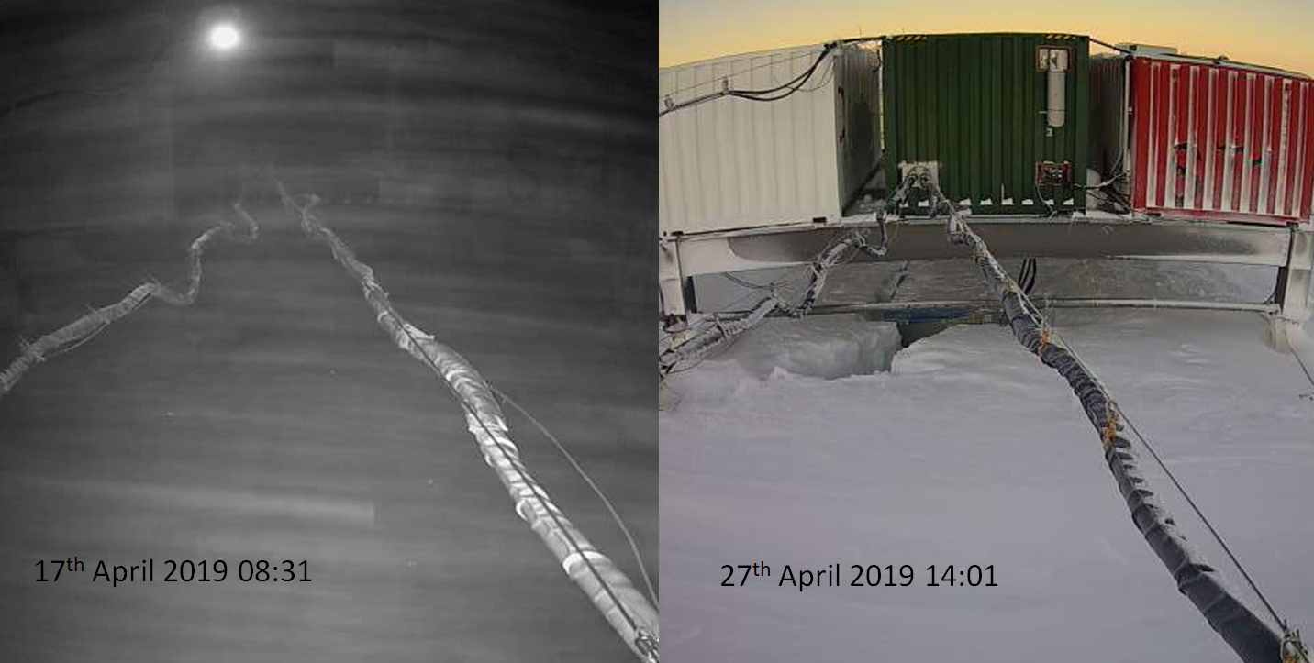

Continual data and webcam images returned to UK.

***Conclusion & Benefits of Science Automation at Halley***

The micro-jet turbine has been the key enabling technology that has allowed the British Antarctic Survey to maintain the scientific output of Halley station in an autonomous manner. Equally important is the philosophy of the system design, with a data rich implementation and a focus on reliability, resilience and replication all contributing to the success of the project.

Delivering year round science outputs from a summer only operation has been a significant challenge. However, while some science experiments are no longer possible, others have been improved as a result of the move to automation. Automation has resulted in a significant reduction in the logistics and resources required to run the station, particularly in respect of staff numbers, fuel usage, and ship time.

***The Future***

Additional science experiments will be added each season. When ship access is re-established some large instruments such as a meteor scatter radar will be added, along with a second micro-jet turbine to provide further resilience.

These technologies represent a successful proof of concept for future power supply to automated scientific instruments that could transform the way scientific data is gathered across Antarctica.