WMO Annual Report

WMO Annual Report

An Information Paper submitted by WMO

The World Meteorological Organization[1] (WMO) is a specialized agency of the United Nations and includes 193 Member States and Territories. It is the UN system's authoritative voice on the state and behaviour of the Earth's atmosphere, its interaction with the oceans, the climate it produces and the resulting distribution of water resources.

WMO has framed its Polar and High Mountain activities as part of the WMO Strategic Plan 2020-2023 along the following priorities: (i) integration of surface and space observations, (ii) polar prediction and services, including climate services, (iii) the Global Cryosphere Watch pre-operational phase, (iv) high mountain activities, (v) transition from research to operation and services, and (vi) resources and partnership.

The activities of WMO related to Antarctica has been coordinated through the Executive Council Panel on Polar and High Mountains Observations, Research, and Services (EC-PHORS), since 2007. In 2021, EC-PHORS held its 10th session and the report in available [online](https://community.wmo.int/final-reports-ec-phors-sessions). The meeting recommended revised terms of reference of the Panel including a focus on the evolution of the coordination of those activities on Antarctica where WMO could make contributions to advance specific current and emerging goals, as well as the engagements with other actors in the region, e.g. SCAR, COMNAP, etc.

WMO Observations and Data activities relevant to Antarctica:

WMO continues to play a key role in facilitating programmes of surface and upper-air meteorological observations in the Antarctic by working with relevant scientific organizations, and the standardization of observing, coding, data exchange and data management practices applied to the Antarctic. Following the governance reform of WMO activities, these will receive active support through the structures of the WMO Commission for Observation, Infrastructure and Information Systems (Infrastructure Commission).

The 73rd session of the WMO Executive Council ([E](https://meetings.wmo.int/EC-73/English/Forms/AllItems.aspx)[C-73](https://meetings.wmo.int/ec-73/SitePages/Session%20Information.aspx)), which will take place in June 2021, will consider for approval the [pre-operational plan of the Global Cryosphere Watch (GCW](https://meetings.wmo.int/EC-73/English/1.%20DRAFTS%20FOR%20DISCUSSION/EC-73-d04-2(12)-GOVERNANCE-TRANSITION-PLAN-GCW-draft1_en.docx?Web=1)). A summary on the GCW Sea Ice objectives was published in the WMO Bulletin [Vol 70(1) - 2021[2].](https://library.wmo.int/doc_num.php?explnum_id=10595)

The observing stations operated in Antarctica provide critical input to global prediction models and the availability of their data in real time is critical. To facilitate the registration of available surface stations in the WMO’s Observing System Capability and Analysis Tool ([OSCAR/Surface](https://oscar.wmo.int/surface/#/)) WMO has provided further clarification regarding the allocation of WIGOS Station Identifiers (WSI) for stations operating in [Antarctica.](https://meetings.wmo.int/EC-73/English/1.%20DRAFTS%20FOR%20DISCUSSION/EC-73-d04-2(6)-WIGOS-GUIDE-No-1165-draft1_en.docx?Web=1) Specifically, station operators are invited to connect with their national OSCAR/Surface Focal Points who are authorised to issue WSIs for Antarctica-based stations operated by national institutions. These Focal Points will also provide guidance on the registration process, based on the nationally agreed policies. The list of the OSCAR/Surface national focal points is available from https://community.wmo.int/governance/commission-membership/national-focal-points-oscarsurface.

Additionally, several other programmes, including the Global Cryosphere Watch, has been authorized to issue WSIs, where these are not issued by the National Focal Points. This clarification should further facilitate the engagement of station operators in Antarctica, with the goal of facilitating the real time data exchange from these stations.

During the current intersessional period, WMO is developing two critical policies, which will be discussed at [EC-73](https://meetings.wmo.int/ec-73/SitePages/Session%20Information.aspx). The first is on the [Unified Data Policy for the International Exchange of Earth System Dat](https://meetings.wmo.int/EC-73/_layouts/15/WopiFrame.aspx?sourcedoc=/EC-73/English/1.%20DRAFTS%20FOR%20DISCUSSION/EC-73-d03-4(1)-WMO-UNIFIED-DATA-POLICY-draft1_en.docx&action=default)a and the second is on establishing the regulatory framework for a [Global Basic Observing Network](https://meetings.wmo.int/EC-73/English/1.%20DRAFTS%20FOR%20DISCUSSION/EC-73-d04-2(2)-GBON-draft1_en.docx?Web=1), to which the observing stations in Antarctica are expected to make a critical contribution.

A concept of a WIGOS Data Quality Monitoring System (WDQMS) developed by WMO is relatively mature. A pilot project using the existing monitoring capabilities of the global NWP Centres for the surface component of the Global Observing System is being transitioned to pre-operational status and has already demonstrated the value of such a system. WMO is interested to support the implementation of this concept for the stations operated in Antarctica and collaborate with interested organizations, in this sense.

Winter Antarctic Targeted Observing Periods and Further Plans of the Year of Polar Prediction in the Southern Hemisphere (YOPP-SH)

The Year of Polar Prediction (YOPP) 2017-2019 galvanised extra observation and modelling efforts in both the Arctic and Antarctic. YOPP is part of the World Meteorological Organization's Polar Prediction Project (PPP). From July 2019, the PPP moved into its Consolidation Phase. This final phase of PPP (until end of 2022) is crucial to synthesize the data and research from the Preparation and Core Phases and to determine the long-term success of YOPP. YOPP-SH is currently planning a second Special Observing Period, mid-April to mid-July 2022, coinciding with the rapid expansion of the sea-ice cover (see associated IP 94).

Antarctic Polar Regional Climate Centre (AntRCC) Network: the Ccope and Concept

WMO, with partners, continued with the development of an Antarctic Polar Regional Climate Centre (AntRCC) Network. To facilitate the engagement of countries (including Treaty Parties, WMO Members etc.) interested in climate services for the Antarctic Region, including representatives from operational, research and user communities, WMO in coordination with the Secretariat of Antarctic Treaty and other partners, organized a “Scoping Workshop on Climate Services for Polar Regions: Towards Implementing an Antarctic RCC- Network”. A majority of country representatives expressed a clear indication of interest to contribute to Antarctic RCC-Network activities, and mutually agreed that the RCC implementation for the Antarctic would likely be based on a distributed-function model, similar to that of the WMO Regional Association VI serving Europe, that is countries with strong capabilities in mandatory functions could take the lead responsibility for specific functions and involve other contributors to form a consortium. Further details are provided in the associated IP 95.

Antarctic Science activities of the World Climate Research Programme

Through its co-sponsored World Climate Research Programme2, WMO carries out a number of research activities and modelling on a variety of scales in which the climate of the Antarctic region is a key aspect. For example, its Climate and Cryosphere Core Project (<http://www.climate-cryosphere.org>) with an international office at the Bjerknes Centre in Norway, focusses on the cryosphere component of the climate system. This includes coordinating a number of research activities (often in partnership with SCAR) on ice sheet mass balance and sea level, sea ice, permafrost and other cryosphere components. WCRP also coordinates a number of modelling activities of relevance to Treaty Parties, including Antarctic CORDEX[3] (the Coordinated Regional Downscaling Experiment, with an office at the Swedish Meteorological and Hydrological Institute), and the Coupled Model Intercomparison Project that produces the scenario runs used by the IPCC[4] (now also with a new project office hosted by the European Space Agency in the UK).

As part of the implementation of its Strategic Plan 2019-2028[5] WCRP has started a number of new activities of interest to Parties. Key among these are the new WCRP Lighthouse Activities[6] being developed (see Figure 1, below). We welcome engagement in the development of these activities and intend to provide additional information on the relevance of these to the Antarctic region at a future ATCM.

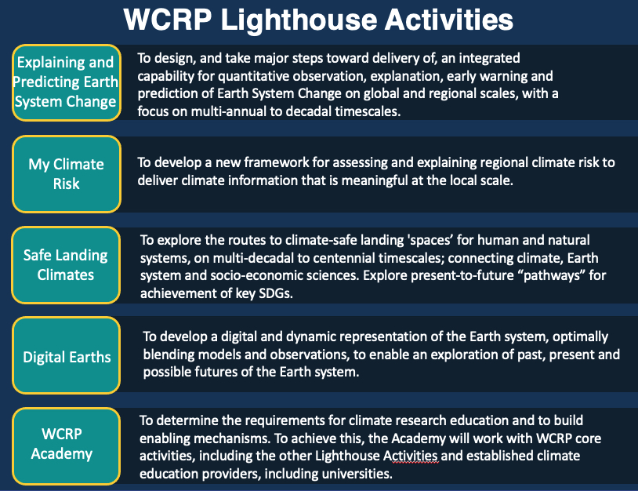

*Figure 1: WCRP’s new Lighthouse Activities. See:* [*https://www.wcrp-climate.org/wcrp-ip-la*](https://www.wcrp-climate.org/wcrp-ip-la) *for details.*

A number of regionally-based Climate Research Forums[7] to exchange ideas, discuss new activities and opportunities are being developed by WCRP, to explore ways that our community of scientists, partner programs, funders and end-users of our climate science can engage. We invite interested Parties and others to take part.

WMO Statement on the State of the Global Climate

Each year WMO produces a high-level “Statement on the State of the Global Climate”[8] with key partners, including SCAR. These statements are presented at the Conference of Parties (COP) meetings and other fora and are available in English, Spanish, Russian, French, Chinese and Arabic. Copies can be downloaded from: https://library.wmo.int/doc_num.php?explnum_id=10618

WMO continues to look forward to a positive, mutually beneficial engagement with Treaty Parties in Antarctic weather and climate observations, services and research. For further queries please contact Mike Sparrow ([msparrow@wmo.int](mailto:msparrow@wmo.int)) in the first instance.

1. www.wmo.int
2. https://library.wmo.int/doc_num.php?explnum_id=10595
3. https://cordex.org/domains/region-10-antarctica/
4. https://www.wcrp-climate.org/wgcm-cmip
5. https://www.wcrp-climate.org/wcrp-sp
6. https://www.wcrp-climate.org/wcrp-ip-la
7. https://www.wcrp-climate.org/climate-research-forums
8. https://public.wmo.int/en/our-mandate/climate/wmo-statement-state-of-global-climate