Detection and eradication of a non-native *Lepidoptera* incursion in a food deposit at Carlini Station

Detection and eradication of a non-native *Lepidoptera* incursion in a food deposit at Carlini Station

**Information Paper submitted by Argentina and Germany**

Summary

On December 9, 2020, specimens of a non-native species (insect) were detected in the food storage facilities of the Dallmann Laboratory. During the first observations, it was determined that the stored flour contained different stages of the life cycle (eggs, larvae, pupae and adults) of these insects, but they had also reproduced and colonized the whole facility. Based on this finding, the scientific staff and personnel from the Environmental Management and Tourism Program (PGAyT) of the National Antarctic Directorate (DNA) applied the pre-established Response Protocol for implementation upon discovery of a potential non-native species introduced inadvertently to the Antarctic Treaty area (Response Protocol - 2019): immediate response, immediate eradication. For long-term eradication and continuous monitoring, information was forwarded to the German Environment Agency (UBA).

Non-Native Species Detection

On December 09, 2020, the presence of specimens of a possible non-native species of insect (Lepidoptera) in different stages of its life cycle, was detected at the Grocery Depot facilities of the Dallmann Laboratory at Carlini Station (GPS coordinates -62.23, -58.66). Immediately the scientific staff of the Argentine Antarctic Institute (IAA) brought the episode to the attention of the DNA's PGAyT staff to coordinate the measures to be taken. The scientific staff were made aware of the provisions of the Response Protocol(2019) and caution was taken, until further information was obtained, to consider the species observed as NNS and therefore to apply the aforementioned protocol.

This decision was based on the fact that, as established in the document ATCM33_att011, there are no winged insects native to continental Antarctica but that there is a high probability of transfer of winged insects by means of human activities. As stated in the mentioned document, winged insects will probably survive in Antarctica for more than a few days if they are in research station buildings.

As a first measure, the origin of the appearance of this NNS was established. The scientific staff verified that the most significant presence was found in some bags of flour located in the depot (Figure 1). On the other hand, it was determined that specimens (adults, pupae, larvae and eggs) were only observed within the depot, and that they were not recorded in other dependencies or in the surroundings of the station.

Immediate Response

PGAyT staff requested station personnel to collect all information set out in the Response Protocol. Photographs (Figure 2) of the specimens were received and this material was immediately sent to scientific staff of the Patagonian National Center (CENPAT) in the city of Puerto Madryn (Argentina), who through consultations with specialists determined provisionally that it was the species *Ephestia kuehniella* (Zeller, 1879) (Lepidoptera: Pyralidae) known as The Flour Moth. Given the association with a food product, a consultation was carried out with the scientific and technical staff of the National Institute of Agricultural Technology (INTA) at their Río Gallegos Office in the Province of Santa Cruz (Argentina), who determined that it was the aforementioned species.

Both assessments were made with the photographic material provided and are therefore taken as provisional. To obtain the final classification, station personnel have preserved material in their different stages to be sent to specialists in Lepidoptera and thus obtain the final classification. The preservation of the material was carried out in accordance with the Response Protocol established by the specialists.

The general characteristics allowed to deterimine that it belongs to Lepidoptera, widely distributed in all temperate, tropical and subtropical regions across the planet. Very harmful because it destroys flours, its favourite food, also attacks stored grains, bran, cookies, chestnuts, nuts, chocolate, dried fruits, meat and bee hive wax. Adults are moths with a wingspan of 18 to 25 mm. The fore wings are plump grey, crisscrossed by dark zig-zag lines and there are also some apparent dark maculas. The hind wings are greyish white, bordered with visible hairs (Urretabizcaya, Vasicek and Saini, 2010).

Eggs are laid on or near the food of future larvae in a number of approximately 200; a week later these hatch and at their maximum development reach 15 mm, they are whitish or pink; both in the protorax and in the last uromera they show a darker coloration than in the rest of the body. After weaving the cocoon, they remain in that state for 10 to 15 days. It takes them 8 to 10 weeks to reach adult status (Urretabizcaya, Vasicek and Saini, 2010).

Immediate Eradication

Based on consultations with CENPAT and INTA specialists and confirmation of NNS status, the station´s scientific staff was told what immediate measures were necessary for eradication. In this way, all packages of flour contaminated with the presence of the moth were introduced into closed bags to ensure that they do not continue to colonize the depot. The entire depot was then cleaned and disinfected by collecting all the material and put it in the bags along with the contaminated flour bags for ~~further~~ incineration (Figure 3).

To ensure the elimination of all specimens and stages of the ENN, the depot's heating was shut down for more than a month so as to achieve the drastic decrease of the temperature of the site below the known values for the survival of the specimens of this species (Pakyari et al, 2018). The specialists consulted suggested that this was the most environmentally appropriate measure as it did not involve the use of chemicals (insecticides) and therefore the environmental impact was non-significant (Annex I of the Protocol on Environmental Protection to the Antarctic Treaty (the Protocol)).

The specialists consulted ensured that at a temperature below 7 to 10°C, the species does not develop its life cycle and would therefore affect the specimens of this species present in the depot. For this reason, it was decided to extend the shutdown of the depot's heating for more than a month to ensure the full effect of the measure. This thermal stress was considered especially sufficient to eliminate, the eggs and larvae found in the depot. As for adults it is considered that there is no oviposition at less than 7°C and the latest published results indicate that the lower limit for immature stages is 9°C (Pakyari et al, 2018).

Finally, the collection and introduction into bags of all contaminated flour packages plus all specimens collected inside the depot (and their subsequent incineration), together with the disinfection and cleaning of the facilities and finally to the control of the biological cycle by lowering the temperature below the known values for the species, ensured the immediate eradication of the NNS through measures with an appropriate level of environmental impact as required by Annex I of the Protocol on Environmental Protection to the Antarctic Treaty. To date, no other specimens have been found again.

Long-term eradication

From what is suggested by specialists and the implemented measures (collection, cleaning, incineration and temperature drop), these actions are feasible in the medium and long term to ensure the eradication of the found NNS. In case the presence of this species might become recurrent in the depot, INTA staff has suggested the use of some insecticides that are commonly used for this species. However, depending on continuous measures of low or no environmental impact, the use of chemicals will not be implemented until it is verified that the species has not been able to be disposed of efficiently.

For additional control, a periodic monitoring of the facilities and the environment is undertaken to determine the effectiveness of the eradication measures, particularly cautious for remaining eggs as these could cause the recurrence of the species. If eradication did not achieve satisfactory results, further eradication efforts or, alternatively, permanent control and biosecurity measures will be considered.

As a result of this event, control and biosecurity measures will be coordinated with the German Environmental Agency in the reception and subsequent storage of foodstuffs to try to ensure that the species is not reintroduced at the station.

Based on consultations with INTA personnel in Argentina UBA in Germany was informed about the following long-term control measures are established, considering that it is not possible to detect the presence of eggs in the flour in advance:

* Use of an anti-aphid mesh to prevent dissemination within the warehouse.
* Installation of chromatic traps to attract adults, preventing their dissemination and functioning as an early warning for the presence of this or other insect species.
* Control and monitoring of the areas and buildings surrounding the Dallmann Laboratory to ensure that no specimens of this species are observed.

Conclusions

Non-native species discovered in the Antarctic Treaty Area may be imported anthropogenic species (associated with human activities). According to Annex II of the Protocol, human-introduced species must be eradicated, while natural populations and long-term residents must be protected.

The detection at Carlini Station of a possible and then confirmed allochthonous species (*Ephestia kuehniella*), was notified to the national authorities and this allowed coordinating the necessary tasks for an immediate response, immediate eradication, preservation and identification of specimens, long-term eradication and monitoring and control of the detection site. The main task is the establishment of mitigation measures to be incorporated into logistical procedures to avoid the reintroduction of this or other food-associated species.

Bibliography

Pakyari, H., Amir-Maafi, M., Moghadamfar, Z., & Zalucki, M. (2019). Estimating development and temperature thresholds of Ephestia kuehniella: toward improving a mass production system. Bulletin of entomological research, 109(4), 435-442.

Urretabizcaya, N, Vasicek, A y Saini, E. (2010). Insectos perjudiciales de interés agropecuario: 1. Lepidópteros. Buenos Aires, INTA Ediciones.

Figure 1: packages of flour containing the specimens of Flour Moths in the Dallmann depot.

Figure 2: specimens of the non-native species found in the Dallmann laboratory depot.

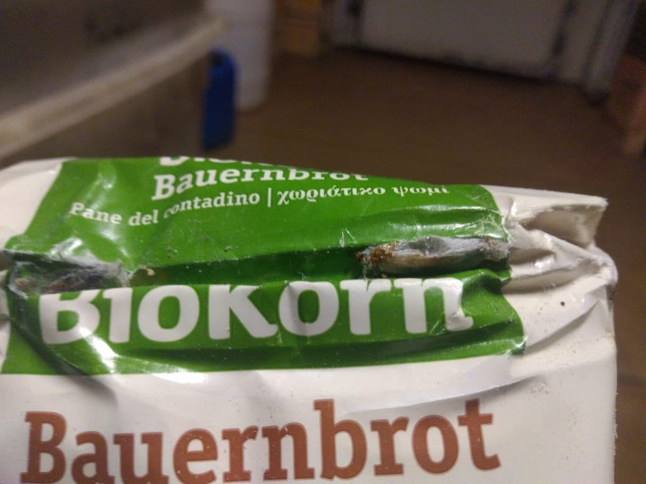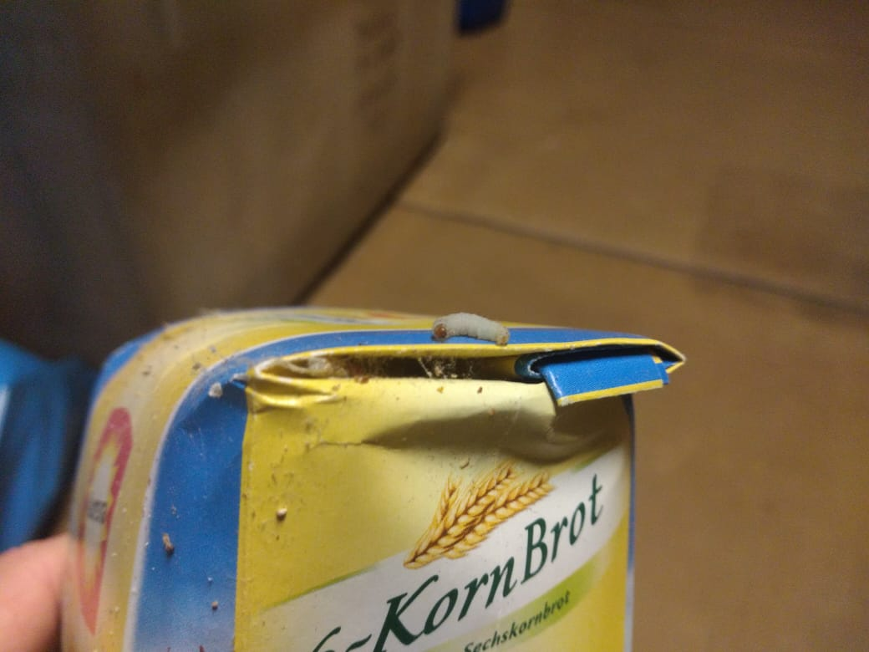

Figure 3: presence of different stages in the tank material.