Evaluation of Ecosystem Services and preliminary identification of   
their trade-offs

**Evaluation of Ecosystem Services and preliminary identification of their trade-offs**

Information Paper submitted by Spain

***Summary***

Spain presents the recently published assessment (Pertierra et al. 2021)[1] towards the identification and evaluation of Ecosystem Services (nature’s contribution to people) in Terrestrial Antarctica. The study centres around the examination of the current status and trends on the utilization of the service-providing units (i.e., those biotic and abiotic elements of Antarctic that provide values and services to humankind). For example, penguin colonies provide recreational and scientific services in the form of tourist and scientific visitation, but they also have a role in the regulation of the ecosystems. The Ecosystem Services Assessment framework can deliver a comprehensive identification of the stakeholders, drivers of change and future scenarios that would assist with the effective preservation of the Antarctic values.

***Introduction***

Cumulative increase of human activities in the continent (science, logistics and recreation) imposes a pressure to Antarctic conservation values (intrinsic, instrumental, wilderness and aesthetic). Our cumulative presence erodes some of the outstanding features of Antarctica, thus causing it to provide diminishing returns. In turn these presential activities generate a diverse list of cultural services with direct and indirect beneficiaries across global societies. Thus, we face an important dilemma on how to find a sustainable use of the Antarctic values where we preserve usage benefits at minimal costs. Therefore, the Antarctic values active usage needs to be balanced against non-use benefits (e.g. heritage and bequest values). Identification of the main trade-offs (positive and negative) between services utilization provides the tools to build future scenarios and support decision-making to develop a strategic management. For instance, the absence of tourism in a site severely limits the capacity to service aesthetic values, but a strong concentration of visitors generates substantial visual impacts. Future development of local and regional ES cartographic assessments can contribute to the protection of Antarctic Ecosystems by setting spatially-explicit assessments of potentially conflicting land uses around local activities.

Ecosystem services are the many and varied benefits that humans freely gain from the natural environment and from properly-functioning ecosystems (figure 1). Such ecosystems include, for example, the terrestrial tundra in ice-free areas, coastal grounds and aquatic ecosystems of Antarctica. There, ecosystem services are grouped into three broad categories: 1) provisioning, such as the production of water for facilities (but other provisioning exploitations are largely excluded by the Antarctic Treaty System); 2) regulating, such as the control of climate and disease (and notably sea level, oceans salinity and other services largely absent elsewhere) while also supporting nutrient cycles and oxygen production (including the rich Antarctic native biodiversity); and 3) cultural, such as scientific (e.g. Antarctic multidisciplinary sciences), spiritual (Antarctic vast wilderness) and recreational (Antarctic tourism) benefits. While Ecosystem Services Assessment (ESA) methodology has been already discussed in the Southern Ocean in a very comprehensive manner (Grant et al. 2013)[2], this has yet to be mirrored in the terrestrial environment. Understanding and assessing the current and future state of Ecosystem Services in Antarctica provides a logical framework to operate. It allows to consolidate strategic actions in the planning ahead towards the Antarctic values sustainable utilization and long-term preservation.

***Research findings***

A preliminary quantification of spatial and temporal trends of Ecosystem Services in Antarctica have been published in Pertierra et al. (2021). Regulation services (climate regulation, sea level balance, etc) derived from Antarctica are practically immeasurable, representing a major contribution to humankind welfare (Figs 2-3 in Pertierra et al. 2021). Provisioning services are an important contribution of the marine domain (Fig 4 in Pertierra et al. 2021), but are currently diversifying, particularly in the form of bioprospecting, and rely in a delicate balance between resource preservation against extraction. Lastly, cultural services in Antarctica are remarkably rich and diverse, and yet they often wider lack recognition (Figs 5-8 in Pertierra et al. 2021). For one, scientific research knowledge in Antarctica has a strong impact in worldwide sciences, a key engine for the modernization of societies. However, field research activities inevitably contribute to hinder Antarctic intrinsic values. Despite the best efforts to operate under impact minimization protocols that generate minor or transitory disturbances science still contributes to a cumulative footprint in Antarctica. Resilience of Ecosystem Services (including research opportunities themselves) and the associated carrying capacities to research activities remain to be determined. In turn, Antarctic tourism brings a social benefit from the experiential use of the intrinsic and aesthetic values on the continent. IAATO promotes safe operations within the continent but faces increasing challenges in the coordination of fast-growing operator activities. In addition, unregulated visits also occur and risk the infringement of environmental provisions. Visitations levels increase annually and call for establishment of carrying capacities of Ecosystem Services. Future scenarios ought to account for visitation trends and the diminishing return of wilderness for the consideration of expanding the Protected Area System. Overall these trends indicate that cultural ES require further regulation but the operating mechanisms need to be established and communicated. A prominent three-way trade-off was identified by the authors between science, recreation and conservation in order to maintain ecosystems productivity, health, resilience and services in the terrestrial domain (Pertierra et al. 2021, Fig. 9). In turn the marine domain finds an important trade-off between provisioning uses (fisheries) and biotic regulation services in the form of the supporting marine ecosystems (also see Fig. 9).

***Conclusions***

This surging research line provides a complementary conceptual framework that could be used as a tool for being informed on the prevailing trade-off between ecosystem services. The Ecosystem Services Assessment framework can deliver a comprehensive identification of the stakeholders, drivers of change and future scenarios that would assist with the effective preservation of the Antarctic values. Systematic ES assessments would help to prioritize area protection and conservation measures, based on the best available data, and ultimately contribute to maximize the likelihood of meeting the objectives of the Protocol on Environmental Protection to the Antarctic Treaty and thus ensuring long-term protection and conservation of Antarctic biodiversity.

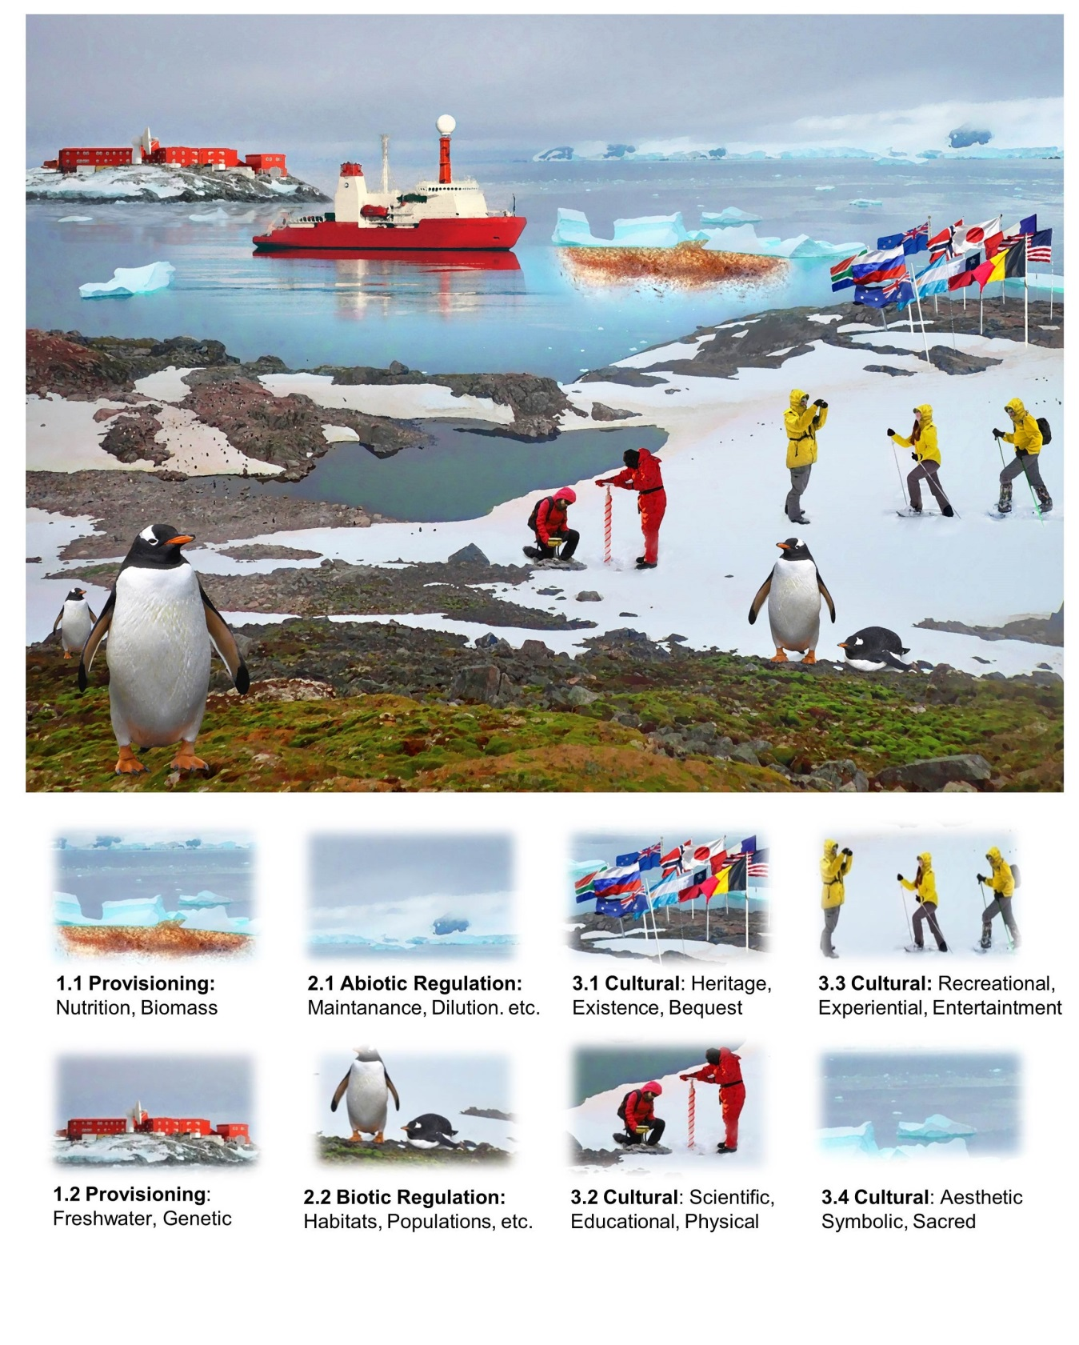

**Figure 1.** Antarctic Ecosystem Services visual representation. Ecosystem services in Antarctica have been represented using common/iconic features.

1. Pertierra, LR. Santos-Martin, F. Avila C. Caceres J. De Pablo M.A., Hughes, K.A, Gonzalez, S. Lynch H., Marina-Montes, C. Tejedo, P. Tin, T. Quesada, A. Benayas, J. (2021) Ecosystem Services in Antarctica: global assessment of the current state, future challenges and managing opportunities. Ecosystem services, in press.
2. Grant, S., Hill, S., Trathan, P., & Murphy, E. (2013). Ecosystem services of the Southern Ocean: Trade-offs in decision-making. Antarctic Science, 25(5), 603-617. doi:10.1017/S0954102013000308.