New Ferraz Station book and stamp

New Ferraz Station book and stamp

On 15 January 2020, the opening ceremony of the new Brazilian station was held with the presence of the Vice-President of Brazil and the Science and Technology Minister, among other guests.

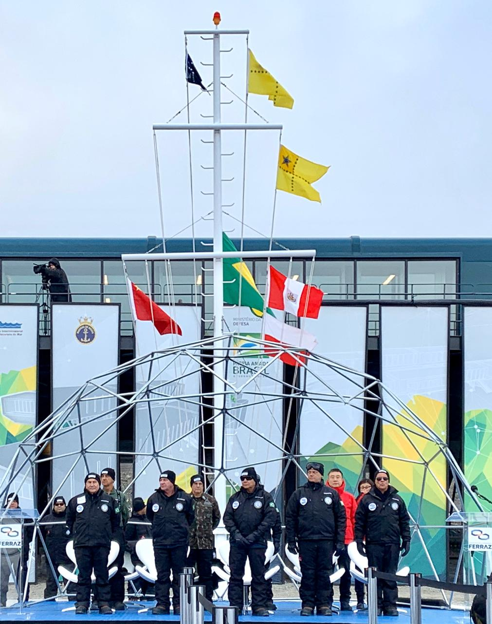

The new station was built on the site of the previous facility, which was established in 1984 and mostly destroyed at a fire in 2012 caused by a fuel leak. Scientific research continued in temporary facilities on Keller Peninsula, as well as on board the Brazilian Navy vessels NApOc Ary Rongel and NPo Almirante Maximiano.

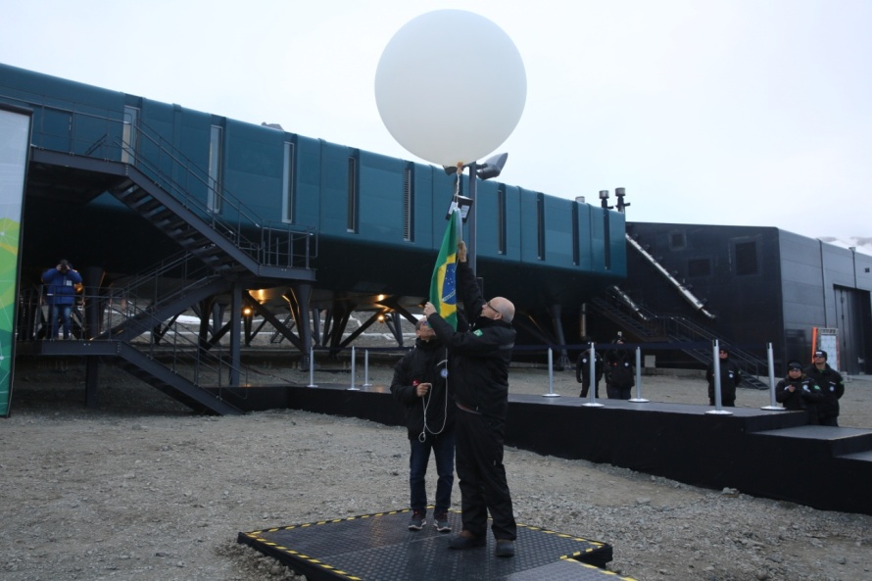

The ceremony was streamed live at this link: <https://www.facebook.com/marinhaoficial/videos/315701069350960/>

The opening of the new station was a milestone, celebrated with the publication of the book "Comandante Ferraz Station - Brazil's House in Antarctica", a collection of interesting stories about the station’s history, crew and the supportive community that surrounds them. All proceeds from the book’s sales will be given to the station’s new Offshore Rescue Craft (ORC).

Ferraz´s book, translated into English and Chinese, shows the story of the construction through photographs. The book is available in PDF format on the PROANTAR website at: <https://www.marinha.mil.br/secirm/sites/www.marinha.mil.br.secirm/files/proantar/publicacoes/livro_eacf.pdf>

A special stamp was produced by the Brazilian Postal Service (Correios) to celebrate this event. Philatelic community can buy the stamps at the Correios virtual store:

<http://shopping.correios.com.br/wbm/store/script/wbm2400901p01.aspx?cd_company=ErZW8Dm9i54=&cd_product=183fP/V4Lsk=>

[](http://shopping.correios.com.br/wbm/store/script/wbm2400901p01.aspx?cd_company=ErZW8Dm9i54=&cd_product=183fP/V4Lsk=)