Comandante Ferraz Antarctic Station

Comandante Ferraz Antarctic Station Opening ceremony

Brazil’s new Comandante Ferraz Antarctic Station was officially opened on January 15th 2020. The ceremony was attended by 70 guests, including Vice-President Hamilton Mourão and the ministers of Science, Technology and Innovation, Mr. Marcos Pontes, and of Defense, Mr. Fernando Azevedo e Silva.

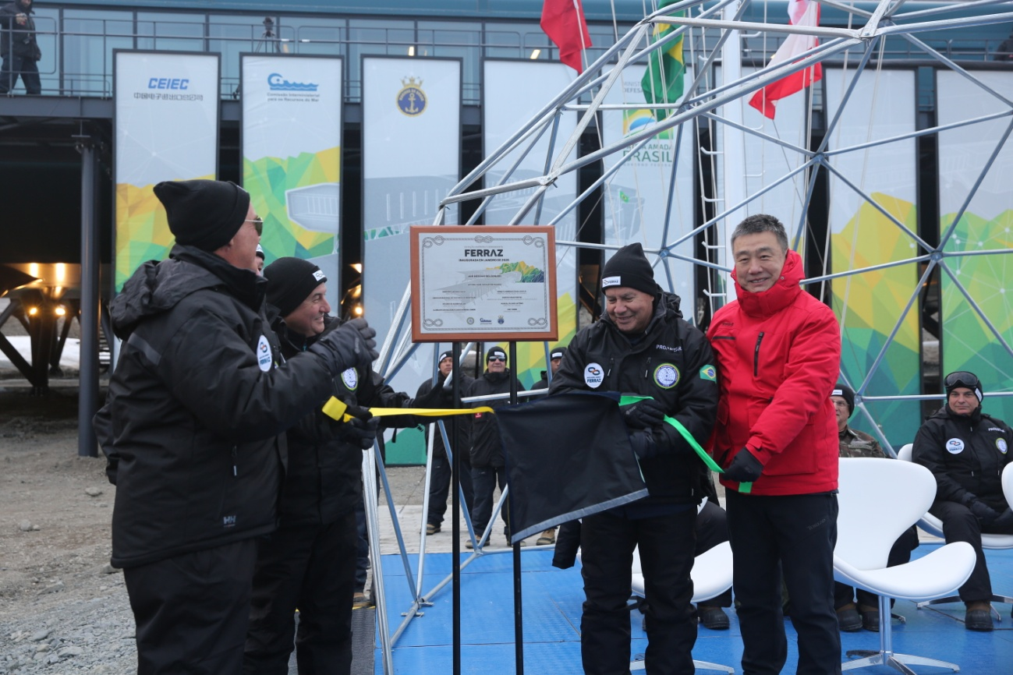

Figure 1: Opening Ceremony

The new station was built on the site of the old one, which was constructed in 1984. In 2012, a fire in the station killed two Brazilian Navy personnel and left around 70% of its facilities destroyed. Three years after that the reconstruction work began and with an investment of approximately $100 million the Brazilian Antarctic Program (PROANTAR) completed the new Brazilian Comadante Ferraz Antarctic Station.

Ferraz stands out for its sleek architecture, designed by the Brazilian firm Estúdio 41. The Station was awarded the 2020 Instituto Tomie Ohtake Akzo Nobel Architecture Prize and also the 2021 São Paulo Association of Art Critics Architecture Prize Laureate.

The new Station is 4,500-square-meter state-of-art facility than can accommodate up to 64 people. It consists of 17 laboratories with modern equipment for research in the fields of meteorology, biology, chemistry, medicine, anthropology, meteorology, physics, oceanography and astronomical sciences.

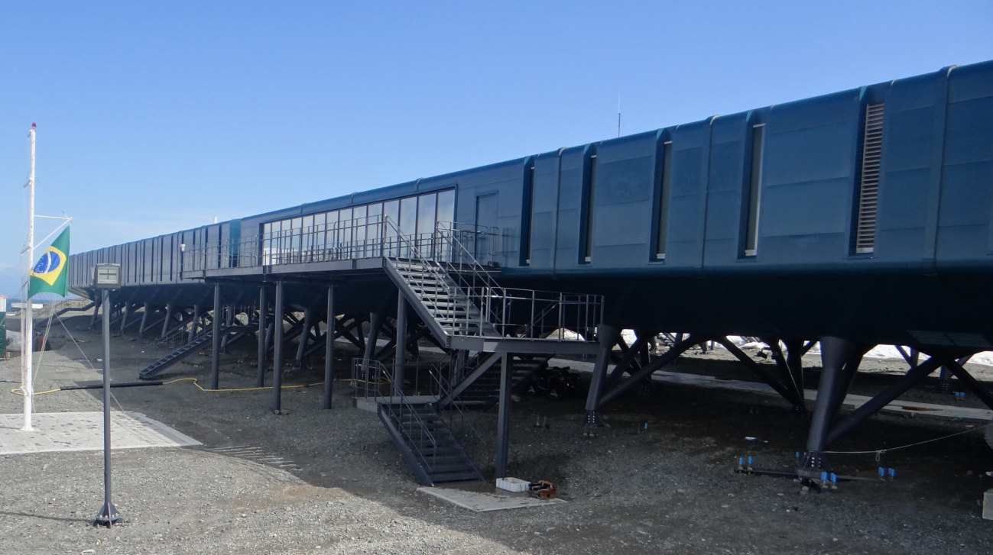

Figure 2 - The new Comandante Ferraz Antarctic Station.

***The first year of operation***

Safety and operational systems went through a commissioning phase during the 2020-2021 season. After staff training and testing, Ferraz Station is now fully operational.

***Seismic Activity***

To stay above the snow during the winter, the modules were installed on precaste concrete foundations weighing up to 70 tons and pilotis, lifting the Brazilian station three meters high above the ground.

More than 30,000 seismic events occurred during the last summer season in the Antarctic Peninsula, and the resulting movement suffered by the Ferraz Station structure did not cause damage to the facilities.

Figure 3 - Ferraz Station’s foundations.

***Fire-fighting system***

Installed at every station unit are fire doors as well as smoke detectors and fire alarms. In the rooms where the machines and generators are stored, the walls are made with an ultra-resistant material. They can withstand fire for two hours not allowing it to spread to other places before the arrival of a anti-fire team.

During the 2020/2021 season, many fire-fighting training and exercises were carried out with the station staff and temporary residents. Small adjustments were made to the fire protection and fire-fighting systems, as well as the guidelines for fighting a fire at Ferraz Station.

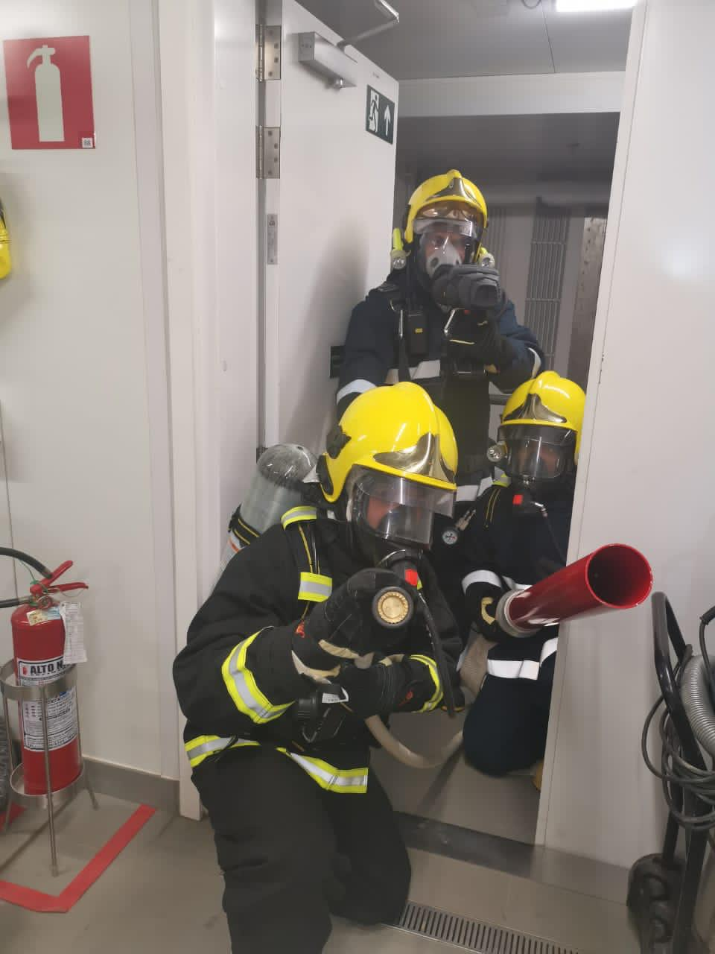

Figure 4 - Fire safety exercise.

***Energy efficiency***

One of the important factors taken into account for the station reconstruction project was energy efficiency. Since its opening, the building's efficient fuel consumption and energy production from renewable sources are been monitored.

To guarantee a continuous power supply, Ferraz Station has a diversified energy matrix composed of:

* a main source of energy integrated by 4 diesel-generator sets associated with combined heat and power (CHP) plants, also known as cogeneration; and
* a renewable energy generation system, consisting of 8 wind turbines (6kWp total) and solar-photovoltaic panels (9.3 kWp total), combined with lithium-ion batteries to smooth daily ﬂuctuations of production and consumption, and controlled by a management system (Figure 5).

Figure 5 - Energy Management System (EMS) screen – electrical energy.

Thermal insulation reduces the unit's energy consumption by preventing the loss of heat through a three-tier building envelope. The frames are made of three layers of glass separated by inert gas and sealed to create an insulated window that keeps the heat in and mimimizes heat loss to the outside environment.

The contribution of renewable energy sources corresponds to approximately 20.5% of Ferraz Station's energy supply and the heat produced by the cogeneration plant met almost completely the demand for thermal energy to heat the water supply system and the building's internal space, minimizing the use of diesel heater (Figure 6). It is estimated that the generation of renewable electricity will save up to 22,500 liters of fossil fuel for every year of operation of the station.

Figure 6 - Building management System (BMS) – thermal energy.

**Scientific research**

Parte superior do formulário

Parte inferior do formulário

Brazilian researchers have continued to conduct research in Antarctica over the last 8 years with the support of two Brazilian Navy vessels – Ary Rongel and Almirante Maximiano – and a series of container modules on land (MAE) that are now deactivated and will be removed from the Antarctic Treaty area.

Several of the selected research projects involve the molecular study of Antarctic biodiversity, environmental microbiology and human physiology, whereas others will try to shed light on the geological and paleontological history of the continent and its climatic, oceanographic, biological, and geophysical connections to South America. Brazilian scientists have been working on the Antarctic continent for almost four decades and will continue their research in 17 laboratories at the new Comandante Ferraz Antarctic Station.

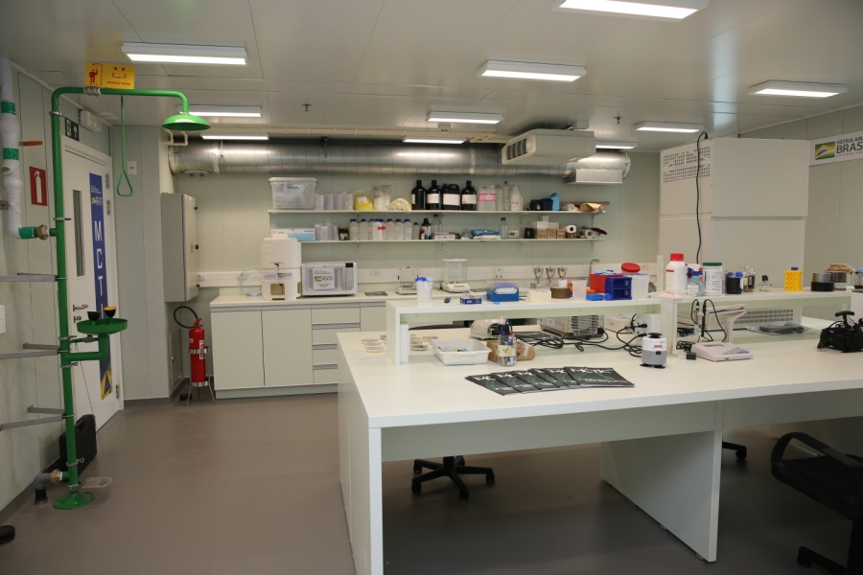

Figure 7 - Ferraz Station microbiology lab.