Microplastics in the Antarctic marine food web: evidence from penguins

Microplastics in the Antarctic marine food web: evidence from penguins

**An Information Paper submitted by Portugal and the United Kingdom**

***Summary***

Microplastic pollution (plastic particles < 5 mm in diameter) has been found in Antarctic waters and sediments, but the presence and effects of microplastics within food webs still little understood. This paper describes recent research reporting the presence of microplastics in the marine food web of the wider Antarctic region, with microplastics found in 20% of examined penguin faecal samples. Portugal and the United Kingdom encourages future studies on the potential effects of microplastic on penguins and other Antarctic organisms and support further assessments of the levels, origins and fates of microplastics within Antarctica.

***Introduction***

Within marine debris, plastic is the most commonly recovered item. Microplastics has been reported in Antarctic sediment and onshore surface waters, but recent studies show that offshore surface waters have very low levels of microplastics. In one study that examined benthic invertebrate fauna near Mario Zucchelli station, 83% of the macrobenthic species contained microplastics. Further scientific evidence shows that Antarctic krill (*Euphausia superba*) can turn microplastics into smaller, nanoplastic particles through its digestive system, with reduced acute toxicity, which may give us information on the fate of microplastics. Here we report the occurrence of microplastics in penguins in the Southern Ocean (Bessa et al. 2019).

***Assessing microplastics in penguins***

Eighty penguin faecal samples (as a proof of ingestion), from gentoo penguins from the Antarctic and sub-Antarctic, were collected and analysed (Bessa et al. 2019). Microplastic was found in 20% of faecal samples. The microplastics included microfibers (58%), fragments (26%) and films (16%) and were of different sizes, colours and polymer compositions. Microplastic levels were lower than those found in seabirds in other regions worldwide, which could be attributed to the geographic isolation of the region and low levels of human activity compared to other regions of the world. Recently, microplastics have also been found in king penguins (*Aptenodytes patagonicus*) (Le Guen et al 2020) from the sub-Antarctic and other penguins (Fragão et al. 2021).

***Conclusions***

This research encourages Parties to conduct future studies on the potential effects of microplastics on penguins and other Antarctic organisms and supports further assessment of the levels, origins and fates of microplastics within Antarctica in line with Resolution 5(2019).

***Supporting references***

Absher, T.M., Ferreira, S.L., Kern, Y., Ferreira, A.L., Christo, S.W., Ando, R.A. (2019). Incidence and identification of microfibers in ocean waters in Admiralty Bay, Antarctica. Environmental Science and Pollution Research 26:292-298 <https://doi.org/10.1007/s11356-018-3509-6>

Bessa, F., Ratcliffe, N., Otero, V., Sobral, P., Marques, J.C., Xavier, J.C. (2019). Microplastics in gentoo penguins from the Antarctic region. Science Reports9: 14191. doi:10.1038/s41598-019-50621-2

Dawson, A.L., Kawaguchi, S., King, C.K., Townsend, K.A., King, R., Huston, W.M., Nash, S.M.B. (2018a)

Turning microplastics into nanoplastics through digestive fragmentation by Antarctic krill. Nature

Communications 9:1001

Dawson, A., Huston, W., Kawaguchi, S., King, C., Cropp, R., Wild, S., Eisenmann, P., Townsend, K., Nash S. (2018b). Uptake and depuration kinetics influence microplastic bioaccumulation and toxicity in Antarctic krill (*Euphausia superba*). Environmental Science and Technology 52:3195-3201 <https://doi.org/10.1021/acs.est.7b05759>

Fragão, J., F. Bessa, V. Otero, A. Barbosa, P. Sobral, C. M. Waluda, H. R. Guímaro, and J. C. Xavier. 2021.

Microplastics and other anthropogenic particles in Antarctica: Using penguins as biological samplers.

Science of the Total Environment **788**:147698.

Kuklinski, P., Wicikowski, L., Koper, M., Grala, T., Leniec-Koper, H., Barasiński, M., Talar, M., Kamiński, I., Kibart, R., Małecki, W. (2019). Offshore surface waters of Antarctica are free of microplastics, as revealed by a circum-Antarctic study. Marine Pollution Bulletin 149:110573 <https://doi.org/10.1016/j.marpolbul.2019.110573>

Lacerda, A.L.d.F., Rodrigues, L.d.S., van Sebille, E., Rodrigues, F.L., Ribeiro, L., Secchi, E.R., Kessler, F., Proietti, M.C. (2019). Plastics in sea surface waters around the Antarctic Peninsula. Scientific Reports 9:3977 <https://doi.org/10.1038/s41598-019-40311-4>

Le Guen, C., Suaria, G., Sherley, R.B., Ryan, P.G., Aliani, S., Boehme, L., Brierley, A.S. (2020). Microplastic study reveals the presence of natural and synthetic fibres in the diet of king penguins (*Aptenodytes patagonicus*) foraging from South Georgia. Environment International 134:105303 <https://doi.org/10.1016/j.envint.2019.105303>

Sfriso, A.A., Tomio, Y., Rosso, B., Gambaro, A., Sfriso, A., Corami, F., Rastelli, E., Corinaldesi, C., Mistri,

M., Munari, C. (2020). Microplastic accumulation in benthic invertebrates in Terra Nova Bay (Ross

Sea, Antarctica). Environment International 137:105587 [https://doi.org/10.1016/j.envint.2020.105587](https://doi.org/10.1016/j.envint.2020.105587" \t "_blank" \o "Persistent link using digital object identifier)

Suaria, G., Perold, V., Lee, J.R., Lebouard, F., Aliani, S., Ryan, P.G. (2020). Floating macro- and microplastics around the Southern Ocean: Results from the Antarctic Circumnavigation Expedition. Environment International 136:105494 <https://doi.org/10.1016/j.envint.2020.105494>

Waluda, C.M., Staniland, I.J., Dunn, M.J., Thorpe, S.E., Grilly, E., Whitelaw, M., Hughes, K.A. (2020). Thirty years of marine debris in the Southern Ocean: Annual surveys of two island shores in the Scotia Sea. Environment International 136:105460 <https://doi.org/10.1016/j.envint.2020.105460>

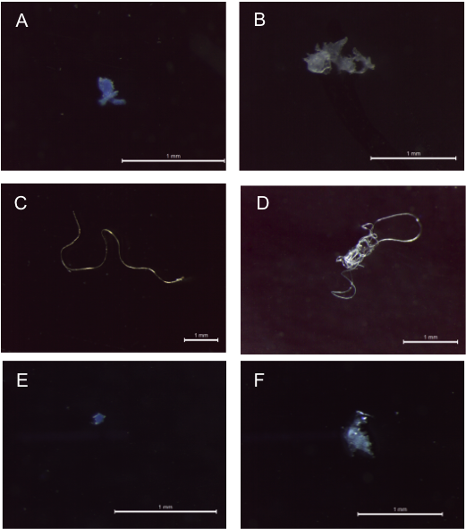

Figure 1. A) Blue polyester fragment; B) transparent polyethylene film; C) transparent polyacrylonitrile fibre D) mixed polyester fibres. Scale Bars = 1 mm (Bessa et al. 2019).