International Thwaites Glacier Collaboration: The Future of Thwaites Glacier and its Contribution to Sea-Level Rise

International Thwaites Glacier Collaboration: The Future of Thwaites Glacier and its Contribution to Sea-level Rise

**Information paper submitted by the United States and United Kingdom**

***Introduction***

Considerable uncertainty remains in projections of timing and magnitude of future global sea-level rise, and much of this uncertainty arises from projections of ice-loss from West Antarctica. Thwaites Glacier would contribute ~0.65m by itself—but is thought to be a keystone to broader collapse of West Antarctica, which contains ~3m of sea-level equivalent. Projections of the demise of Thwaites Glacier vary from millennia to just two centuries. This uncertainty arises from gaps in data, inadequate understanding of the key processes involved, and a lack of data to test computer models. Reducing this uncertainty is an international priority that was underscored by the Scientific Committee on Antarctic Research in its “Horizon Scan 2020” ([*http://www.scar.org/horizonscan*](http://www.scar.org/horizonscan)). This was also the top Antarctic research priority of the National Academies of Sciences, Engineering, and Medicine report, *A Strategic Vision for NSF Investments in Antarctic and Southern Ocean Research* ([*https://www.nap.edu/catalog/21741/a-strategic-vision-for-nsf-investments-in-antarctic-and-southern-ocean-research*)](https://www.nap.edu/catalog/21741/a-strategic-vision-for-nsf-investments-in-antarctic-and-southern-ocean-research)).

Since the 1990s, satellites have shown accelerating ice loss driven by ocean change in five neighboring glacier catchments in West Antarctica, including the massive Thwaites and Pine Island glaciers (see Figure 1), which, together, drain more than one third of the West Antarctic Ice Sheet (WAIS). The rate of ice loss from this region grew significantly in the period 2005-2010 and has since accounted for more than 10 per cent of global sea-level rise. Significant net ice-loss was first observed on Pine Island Glacier, which was the focus of several recent U.S. National Science Foundation (NSF)-funded projects and the U.K. Natural Environment Research Council (NERC) iSTAR Programme (2010-2017, [*http://www.istar.ac.uk/*](http://www.istar.ac.uk/)). However, a consistent result obtained by recent ice-sheet modeling studies is that, on societally-relevant decade-to-century timescales, the most significant, and potentially irreversible changes in West Antarctica are likely to occur on Thwaites Glacier (e.g., National Academies of Sciences, 2015). Satellite studies confirm that significant changes are already underway on this glacier, with the grounding line retreating at several hundred m/year and sub-shelf melt rates of up to 200 m/year (Milillo et al., 2019). The ice-mass loss from Thwaites Glacier has increased six-fold over the past 25 years (Shepherd et al., 2019), but its future trajectory, and thus its potential contribution to sea-level rise, cannot currently be assessed with certainty.

Building on shared priorities, and recognizing that such research is becoming an increasingly global endeavor, with demands that exceed the capacities of any one nation, NSF and NERC launched a collaborative program in 2017 with the objective to substantially improve both decadal and longer-term (century-to-multi-century) projections of ice loss and sea-level rise originating from Thwaites Glacier (NSF Program Solicitation [*https://www.nsf.gov/pubs/2017/nsf17505/nsf17505.htm*](https://www.nsf.gov/pubs/2017/nsf17505/nsf17505.htm)).

Grants to science teams, each involving a core of U.S. and U.K. participants, were awarded in April 2018 (see <https://thwaitesglacier.org>). Together, these projects form the International Thwaites Glacier Collaboration (ITGC), which is intended to produce a direct and significant improvement in understanding of the stability of marine ice sheets and specifically the West Antarctic Ice Sheet in the vicinity of Thwaites Glacier. The eight ITGC science projects collectively address boundary conditions, external drivers of change, processes leading to collapse, past change, and forecasts of future change. The program will improve understanding of the key processes that are leading to ice-sheet change, and the ice-sheet modeling community’s capability to simulate ice sheets and thus reduce the uncertainties in sea-level projections. In addition, the program will contribute to improving risk assessments that coastal communities need for decisions about adaptation and long-term planning.

***An integrated and collaborative research program***

ITGC is supporting observational campaigns on the Thwaites Glacier (TG) and the neighboring Amundsen Sea to understand the changes taking place and the processes driving these changes. At the same time, modeling work will help optimize observational strategies, decipher external drivers, and, ultimately, deliver improved projections of sea-level rise. Observational evidence collected on three science cruises and from mountains flanking the Thwaites basin will constrain the extent and timing of past deglaciation of TG. This will provide a key opportunity to test hypotheses regarding the instability of marine ice sheets.

A Science Coordination Office facilitates collaboration; science synthesis; data management; education and outreach; integration of early career scientists; action on inclusion, diversity, equity, and accessibility; and media engagement for the ITGC as a whole. Each project includes U.S. and U.K. researchers from a total of 39 institutions, with scientific and logistical collaboration with partners in South Korea, Sweden, Germany, Norway, Finland, France, New Zealand, and Abu Dhabi.

***Field seasons***

The Collaboration was initially planned to include four major field seasons starting in 2018/19. That first field season focused on marine science, and, on the ice, on logistics staging and scoping of field sites, as well as initial aerogeophysical surveys. The major overland field component began successfully in 2019/20 with deployment of glaciological and oceanographic instruments on the Thwaites Eastern Ice Shelf and its grounding zone, operation of an underwater robot in the Thwaites ocean cavity, coring of sub-shelf marine sediments, deployment of instrumentation along the eastern shear margin and at Dotson Ice Shelf, surface and subglacial geological sampling to determine ice-sheet thinning history at Mount Murphy, and further aerogeophysical surveys. A second science cruise aboard the Nathaniel B Palmer (in January 2020) focused on the marine sedimentary record, marine mapping, seal tagging, deployment of gliders, testing of an autonomous underwater vehicle, and mooring visits.

The 2020/21 field season was heavily curtailed due to COVID constraints. Technicians were able to download data and remove glaciological instrumentation on the Thwaites Eastern Ice Shelf and to visit sites on the eastern shear margin. Slightly more activity was possible in the COVID-affected 2021/22 season, with successful removal of instrumentation from the eastern shear margin and Dotson Ice Shelf, and data download and instrument repair on the eastern shelf. The third and final cruise successfully completed its work in March 2022, having been able to intensively study ocean circulation under and in front of Dotson Ice Shelf with autonomous vehicles, gliders, profiles, and tagged seals. Further sediment cores were retrieved for ice-sheet history. Collaborators on the Korean vessel Araon installed a mooring under the Dotson Ice Shelf and deployed ocean profiling instruments through openings in thick sea ice near Thwaites Glacier.

Preparation is now underway for another ambitious over-snow field campaign in 2022/23, with a final major over-snow campaign in 2023/24. In the meantime, insights from the Collaboration are entering the literature (see <https://thwaitesglacier.org/resources/publications>).

***Contacts for international collaboration and cooperation***

Additional international collaboration would be welcomed. The contacts listed below are interested in learning of other nations who are or intend to be engaged in research in this region over this time frame, with the hope that synergistic activities might be developed. The primary contacts are:

NSF and NERC:

Paul Cutler, NSF; telephone: +1 (703) 292-4961, email: [pcutler@nsf.gov](mailto:pcutler@nsf.gov)

Lizzie Garratt, NERC; telephone: +44 (0)1793 411600, email: lizzie.garratt@nerc.ukri.org

Science Coordination Office:

Ted Scambos, University of Colorado; telephone: +1 (303) 492-1113, email: tascambos@colorado.edu

Rob Larter, British Antarctic Survey; telephone: +44 (0) 1223- 221573, email: rdla@bas.ac.uk

*Figure 1 – Location map for Thwaites and Pine Island glaciers. The background image shows the ice-loss 2010-2013 measured using data from ESA’s Cryosat-2 satellite (McMillan et al. 2014).*

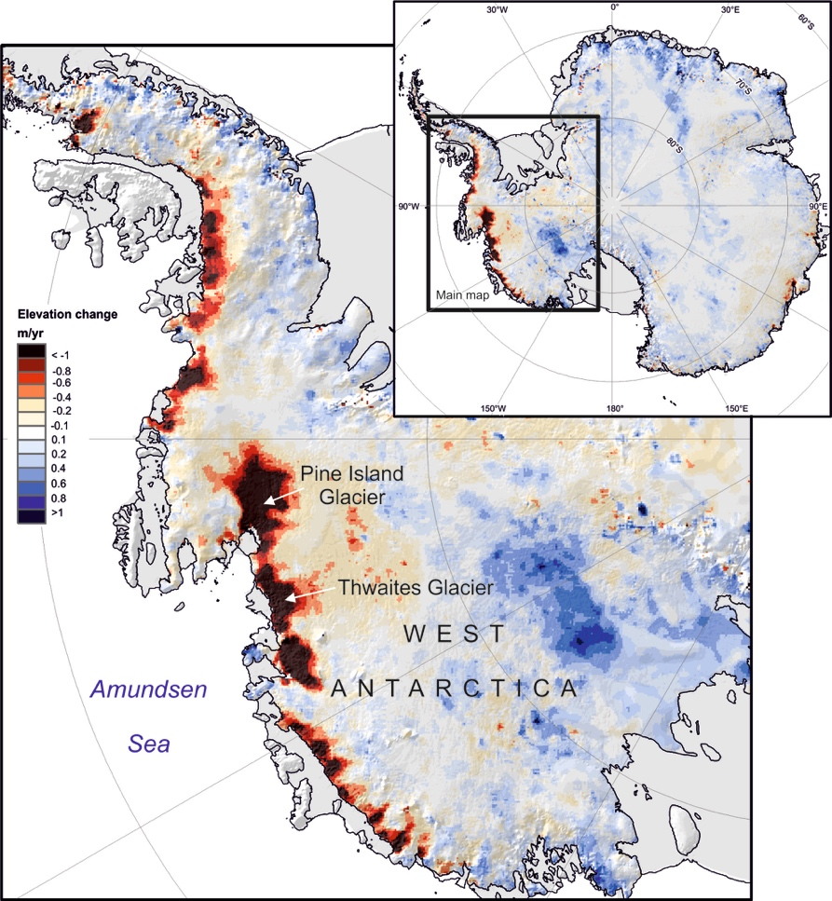

***References***

McMillan, M., Shepherd, A., Sundal, A., Briggs, K., Muir, A., Ridout, A., Hogg, A., & Wingham, D. (2014). Increased ice losses from Antarctica detected by CryoSat‐2. *Geophysical Research Letters*, *41*(11), 3899-3905. [*http://onlinelibrary.wiley.com/doi/10.1002/2014GL060111/full*](http://onlinelibrary.wiley.com/doi/10.1002/2014GL060111/full)

Milillo, P., Rignot, E., Rizzoli, P., Scheuchl, B., Mouginot, J., Bueso-Bello, J., & Prats-Iraola, P. (2019). Heterogeneous retreat and ice melt of Thwaites Glacier, West Antarctica. *Science Advances* 5. *https://advances.sciencemag.org/content/5/1/eaau3433*

National Academies of Sciences, Engineering, and Medicine. (2015). A Strategic Vision for NSF Investments in Antarctic and Southern Ocean Research. Washington, DC: National Academies Press. [*https://www.nap.edu/catalog/21741/a-strategic-vision-for-nsf-investments-in-antarctic-and-southern-ocean-research*](https://www.nap.edu/catalog/21741/a-strategic-vision-for-nsf-investments-in-antarctic-and-southern-ocean-research)

Shepherd, A., Gilbert, L., Muir, A. S., Konrad, H., McMillan, M., Slater, T., et al. (2019). Trends in Antarctic Ice Sheet elevation and mass. *Geophysical Research Letters*, 46, 8174–8183. *https://doi.org/10.1029/2019GL082182*