Update on the Australian Antarctic Strategy and 20 Year Action Plan and major initiatives

Update on the Australian Antarctic Strategy and 20 Year Action Plan and major initiatives

Summary

The 2022 update to the *Australian Antarctic Strategy and 20 Year Action Plan* (the Strategy and Action Plan) further strengthens Australia’s capabilities in the Antarctic region. It reaffirms Australia’s strong commitment to the Antarctic Treaty system and to ensuring Antarctica remains valued, protected and understood. This paper highlights new measures associated with the updated Strategy and Action Plan and reports on progress on major initiatives, including: the entry into service of Australia’s new, state-of-the-art icebreaker, RSV *Nuyina*, modernising Australia’s Antarctic research stations, and contributing to the search for a million year ice core.

2022 update to the Australian Antarctic Strategy and 20 Year Action Plan

Australia has reviewed and updated the *Australian Antarctic Strategy and 20 Year Action Plan* (the Strategy and Action Plan), which was first released in 2016. The Strategy and Action Plan sets out Australia’s Antarctic interests and vision for future engagement in Antarctica. The 2022 update further strengthens Australia’s logistic and scientific capabilities in the region, and reaffirms Australia’s strong commitment to the Antarctic Treaty system and to ensuring Antarctica remains valued, protected and understood.

New measures in the 2022 update to the Strategy and Action Plan include:

* an expansion of Australia’s scientific capabilities, including:
* research focused on Antarctic ice sheet science to build global understanding of climate change impacts
* new research to improve our understanding of Antarctica and the Southern Ocean’s role in the global climate system by expanding Australia’s logistical capability, including new long‑range helicopters and autonomous vehicles.
* providing logistical shipping support to allow Australia’s new icebreaker, RSV *Nuyina*, to focus on extended scientific voyages, and
* marine science in the Southern Ocean and a new state-of-the-art krill aquarium in Hobart.
* greater support for Australia’s environmental management including a ‘Cleaner Antarctica Strategy’, and
* support for Hobart as a gateway to East Antarctica.

These measures anticipate and present new opportunities for collaboration amongst Antarctic Treaty Parties to build scientific understanding of the region, to ensure the region is protected and continues to be dedicated to peace and science.

The updated Strategy and Action Plancan be found on the [Australian Antarctic Division’s website](https://www.antarctica.gov.au/about-us/antarctic-strategy-and-action-plan/).

Updates on major initiatives

Consistent with the updated Strategy and Action Plan, Australia is continuing with major initiatives announced in 2016, including: making use of Australia’s new, state-of-the-art icebreaker, RSV *Nuyina,* planning for infrastructure upgrades to our Antarctic research stations, and contributing to the international search for a million year ice core.

RSV *Nuyina*

Australia achieved a major milestone in 2021 with the delivery of its new Antarctic icebreaker, RSV *Nuyina*. The vessel provides a state-of-the-art capability to conduct multidisciplinary science, both in sea ice and open water. It is the main lifeline for delivering essential personnel, cargo and equipment to and from Australia’s Antarctic and sub-Antarctic research stations.

Following the first steel cutting in 2017 and the successful completion of a range of trials during 2020 and 2021, RSV *Nuyina* arrived in its home port of Hobart, Australia in October 2021.

A comprehensive commissioning program was undertaken in 2021-22 to prepare the vessel and crew for Antarctic operations.

RSV *Nuyina* completed its maiden voyage to Antarctica in late January 2022. As part of the voyage, *RSV Nuyina* delivered helicopters to Davis research station, refuelled Casey research station, and underwent commissioning of marine science systems. The vessel then supported a second voyage to retrieve helicopters from Davis research station and conduct a resupply of Macquarie Island research station, concluding in March 2022. RSV *Nuyina* has now sailed to Singapore for a pre-planned dry dock inspection and works program, in readiness for the 2022-23 Antarctic season.

The scientific research capability of RSV *Nuyina* is being progressively commissioned over the first two seasons (2021-22 and 2022-23), before the first major marine science campaign planned for early in the 2023-24 Antarctic season. Scientific research commissioning during the 2021-22 season focussed on underwater and hull-mounted science capabilities, so that any issues identified can be rectified during the dry docking.

Further information about RSV *Nuyina’s* [achievements](https://www.antarctica.gov.au/news/2022/season-of-achievement-for-australian-antarctic-program/) in the 2021-22 season and results from [commissioning](https://www.antarctica.gov.au/nuyina/stories/2022/ship-of-firsts/) of marine science systems is available from the [Australian Antarctic Division’s website](https://www.antarctica.gov.au). Further information about RSV *Nuyina* is available from the [Australian Antarctic Division’s dedicated RSV *Nuyina* website.](https://www.antarctica.gov.au/nuyina/)

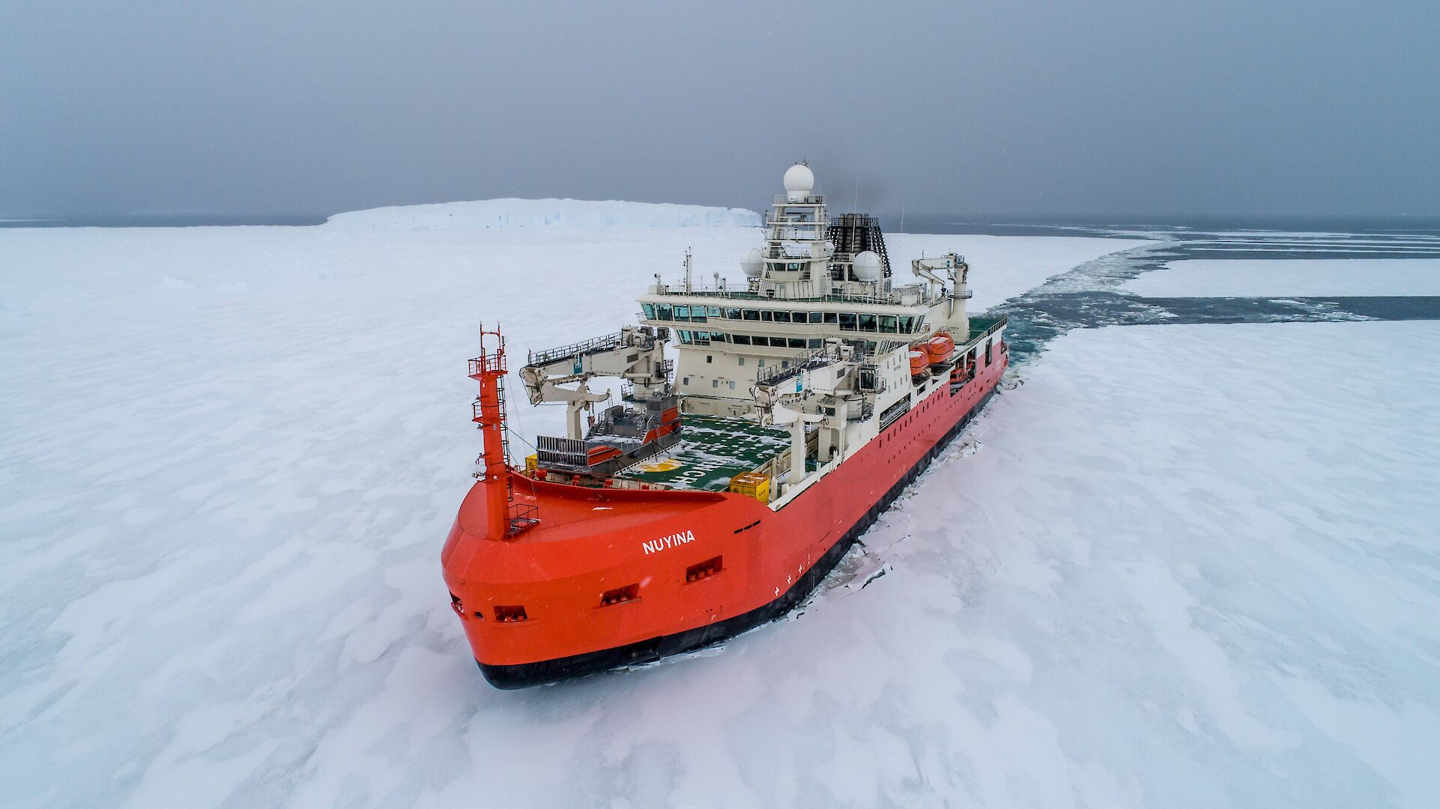

**Figure 1: RSV *Nuyina* moves through fast ice. © Pete Harmsen/Australian Antarctic Division**

Modernising Antarctic research stations

In ATCM XLIII/IP103 Australia reported on progress to investigate options for refurbishing or rebuilding Australia’s Antarctic research stations and associated infrastructure. In that paper Australia noted master plans were in development for Davis, Mawson and Casey research stations, and for the seasonal Wilkins aerodrome.

The updated Strategy and Action Plan continues Australia’s commitment to develop modern research infrastructure, and to consider options for more efficient and flexible use of existing stations.

The station modernisation program will provide infrastructure that will support Australia’s long‑term scientific objectives and operational needs.

Initial master plans for modernising Davis research station and Wilkins aerodrome have been completed, and work is underway to plan the delivery of these projects. Work is also continuing on the development of master plans for Casey and Mawson research stations.

Master plans aim to address the challenges of living and working in Antarctica, while delivering sustainable, world-class facilities to support Antarctic science and operations.

Further information about the Davis research station master plan is available from the [Australian Antarctic Division’s website](https://www.antarctica.gov.au/news/2020/modernisation-planning-begins-for-antarctic-stations/).

**Figure 2: Casey Station and Newcomb Bay. © Justin Chambers/Australian Antarctic Division**

Enhanced traverse capability and million-year ice core

In ATCM XLIII/IP 103 Australia reported on the Traverse and Inland Station Project, developed to support the scientific and operational requirements of the Australian Antarctic Program, through the delivery of a mobile research station and associated equipment.

The initial focus of the enhanced traverse capability is to support Australia’s involvement in a collaborative project to recover an ice core with a million year climate history. Drilling for the million year ice core will take place at Little Dome C, approximately 30 kilometres south of Concordia station. Drilling is expected to occur over four or five seasons, depending on the weather and other conditions.

The traverse capability is now approaching completion with key machinery and equipment delivered to Australia’s Casey research station in 2020, 2021 and 2022. This includes the delivery of tractors and snow groomers, which will be used to prepare the traverse route from Casey research station to Little Dome C (approximately 1200 kilometres). This route is expected to be confirmed in coming months, with the first route-proving traverse scheduled to depart Casey in December 2022.

Australia has completed construction of a mobile research station, which was successfully delivered to Casey research station during the 2021-22 season. Power generation units are scheduled to be delivered next season, prior to deployment to Little Dome C in 2023-24.

Further information about the Traverse and Inland Station Project is available from the [Australian Antarctic Division’s website.](https://www.antarctica.gov.au/science/climate-processes-and-change/antarctic-palaeoclimate/million-year-ice-core/inland-traverse/)

**Figure 3: Traverse tractor in Antarctica. © Chris Burns/Australian Antarctic Division**

Davis Aerodrome Project

In ATCM XLIII/IP103 Australia informed Parties about progress towards establishing year-round aviation access capability in East Antarctica, to enhance the aviation capability in East Antarctica. Australia reported on dedicated field investigations to identify a proposed site for a paved runway, approximately 4.5 kilometres from Davis research station in the Vestfold Hills, East Antarctica, and to inform preparations of a draft Comprehensive Environmental Evaluation (CEE) for the proposal to construct and operate the aerodrome (the Davis Aerodrome Project).

Australia has decided not to proceed with the Davis Aerodrome Project, following careful consideration of the likely environmental impact, cost and complexity of the project. Significant progress had been made on assessing the environmental values of the Vestfold Hills and potential impacts of the proposal. This enhanced knowledge will support Australia’s commitment to best practice environmental stewardship in Antarctica, including through the rigorous planning, assessment and conduct of future activities, and consideration of options for ongoing and enhanced environmental protection and management in the region.

Further information is provided in an Information Paper submitted to CEP XXIV on *Davis Aerodrome Project: Decision by Australia not to proceed, and knowledge gained of the Vestfold Hills environment*.