Report on the Replacement of the Cape Shirreff Field Camp, Livingston Island, Antarctica

Report on the Replacement of the Cape Shirreff Field Camp, Livingston Island, Antarctica

**Information Paper Submitted by the United States**

Summary

The Cape Shirreff field camp is a temporary, seasonally-occupied, multi-year field camp located within ASPA 149 Cape Shirreff and San Telmo Island, Livingston Island, South Shetland Islands. It was constructed in the 1996/97 Austral summer and since its assembly, it has served as a shelter for scientists conducting integrated marine ecosystem assessments with the U.S. Antarctic Marine Living Resources (AMLR), a program operated by the National Oceanic Atmospheric Administration (NOAA). Due to degradation from 27 years of use, a rebuild of the shelter is required to ensure the safety and reliability of the research scientists to effectively conduct their surveys. In 2021, NOAA started an Initial Environmental Evaluation (IEE) to analyze the potential environmental impacts of building a new structure and determined that there is no more than a minor or transitory impact on the Antarctic environment from the planned construction activities. Preparation for the rebuild started in December 2022 and will resume in January 2024. Proposed impact mitigation and monitoring observations will occur in accordance with the IEE.

***Background***

Since 1996, the [U.S. Antarctic Marine Living Resources (AMLR) Program](https://www.fisheries.noaa.gov/about/antarctic-ecosystem-research-division-southwest-fisheries-science-center), National Marine Fisheries Service (NMFS), National Oceanic and Atmospheric Administration (NOAA), located at the Southwest Fisheries Science Center (SWFSC), has conducted integrated assessments of the marine ecosystem at Cape Shirreff in the South Shetland Islands. The Cape Shirreff field camp (hereafter “the camp”) is a temporary, seasonally-occupied, multi-year field camp located at 62°28'S, 60°46'W. The camp was constructed during the 1996/97 Austral summer and is located within [ASPA 149 Cape Shirreff and San Telmo Island, Livingston Island, South Shetland Islands](https://www.ats.aq/devph/en/apa-database/53#true). Operations at the camp are subject to management and mitigation protocols found in the [Management Plan for ASPA 149](https://www.ats.aq/devph/en/apa-database/53). The U.S. AMLR Program chose Cape Shirreff for the camp because it is located near an area where krill (and other) fisheries occur, and krill-dependent seabirds (particularly penguins) and pinnipeds (particularly Antarctic fur seals) breed at this location. After 27 years of use, the infrastructure at Cape Shirreff has degraded and requires replacement. New structures will ensure safe and reliable shelter for research scientists who are responsible for implementing the scientific mission of the U.S. AMLR Program.

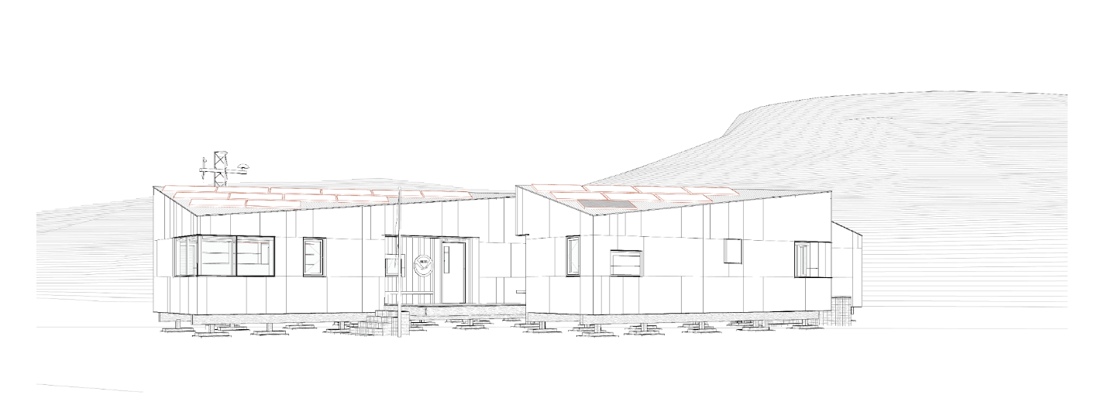

***Environmental Impact Assessment (EIA)***

In 2021, NOAA began analysing potential impacts of installing new structures, as well as decommissioning the existing buildings. The analysis also included potential impacts of installing a temporary tent camp that would house the ten-person construction team for approximately 30 days during each year (nominally 2) of the rebuild period.

NOAA’s environmental assessment analysing these potential impacts is described in an [Initial Environmental Evaluation (IEE)](https://documents.ats.aq/EIES/EIA/02369enSigned_Cape%20Shirreff%20IEE%2005-27-22_KK.pdf). A determination that no more than a minor or transitory impact on the Antarctic environment resulting from construction activities was made. This determination is consistent with the National Science Foundation's (NSF) implementing regulations for the Protocol on Environmental Protection to the Antarctic Treaty. The IEE was made publicly available and can be found on the Secretariat of the Antarctic Treaty’s webpage in the [EIA database](https://www.ats.aq/devAS/EP/EIAList?lang=e).

***Replacing the Existing Structures***

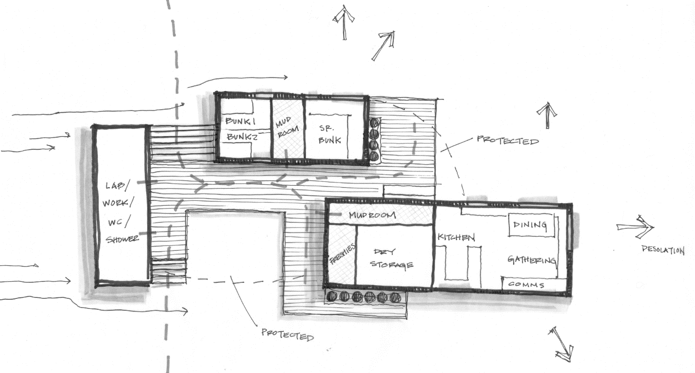

During 2021/22, NOAA staff worked closely with architects and engineers to design new structures that support seasonal residence for up to eight scientists. The new buildings were designed to meet specific research and operational requirements and include main camp buildings with central decking, and an emergency shelter at a separate site. Centralizing the decking at the main camp minimizes the total amount of decking required and minimizes the impact to the surrounding terrain of foot traffic between buildings.

Among the key features of the new main camp design is a smaller footprint (~240 m2) compared to the original camp (~280 m2). The main camp includes a galley, bunkhouse, laboratory and a latrine. All structures are semi-permanent and can be disassembled and removed with minimal impact at a time when research is either concluded or the structures have reached the end of their lifespan (estimated 30 years). The new structures are oriented to maximize solar exposure and water collection while reducing moisture, snow, and ice accumulation. Finally, the foundation was designed to minimize contact and impact on underlying substrates and soil.

A replacement emergency shelter, approximately 1.6 km away from the main camp, was also designed. This structure is located close to penguin colonies and helps facilitate seabird research on a daily basis. The replacement shelter was designed using the same concepts as the main camp and will occupy the same footprint (43 m2) as the old structure.

The new structures are scheduled to be installed over a period of two field seasons (austral summers): Phase 1 during the 2022/23 season, and Phase 2 during the 2023/24 season. Each Phase is scheduled for approximately 30 days and decommissioning of the old buildings will occur as new buildings become operable.

***Phase 1 Completed***

As described in the IEE, the prefabricated building materials were shipped from the U.S. to Punta Arenas, Chile, and then to Cape Shirreff. Part of the construction team arrived at Cape Shirreff in December 2022 and quickly installed a tented camp (Figure 1) to house the ten-person construction team. They also opened and prepared the nearby Guillermo Mann Field Camp (Chile) to provide additional shelter, an infirmary, and cooking and eating space for the construction team.

The team spent the next several days setting the foundation for the new galley and bunkhouse structures (Figures 2 and 3). In early January 2023 the rest of the construction team arrived and began construction of the galley and the bunkhouse (Figure 4). When the construction team departed in early February 2023, the two new building structures were nearly complete, including the exterior decking that connects the two buildings (Figure 5 and watch video [here](https://players.brightcove.net/659677166001/4b3c8a9e-7bf7-43dd-b693-2614cc1ed6b7_default/index.html?videoId=6324533791112)).

The existing emergency shelter was decommissioned (watch video [here](https://players.brightcove.net/659677166001/4b3c8a9e-7bf7-43dd-b693-2614cc1ed6b7_default/index.html?videoId=6324837712112)) during the 2022/23 field season, taken down from the inside out over the course of seven work days spanning roughly 39 hours. All insulation was bagged and removed from the island at the end of the field season. Wood, metal, and glass debris was bundled and securely stored on-site for removal from the island in 2023/24. The new emergency shelter is set to be built on the vacant site during the 2023/24 field season.

Impact mitigation measures and site monitoring observations were conducted in accordance with the IEE. Movement was restricted away from sensitive vegetation and animal breeding sites, and regular visual, photo, and video surveys of the site were completed before and after construction. Preliminary analysis of impacts from collected observations were minor and transitory, consistent with those described in the IEE.

***Next Steps, Phase 2***

NOAA staff and the construction team will return to Cape Shirreff in January 2024 when work will resume to outfit Phase 1 buildings with power, water collection, and communications systems. Construction of the laboratory and the emergency shelter will occur, and the team will decommission the original structures in the main camp. At the end of the field season, the tent camp will be decommissioned, and materials from the construction of the new structures and decommissioning of the old structures will be packaged for transport and removed from the island for proper disposal. Proposed impact mitigation and monitoring observations will occur before, during, and after Phase 2 construction in accordance with the IEE.

Figure 1: Tented camp site installed during early deployment.

Figure 2: Setting the foundation.

Figure 3: Foundation designed and constructed to minimize contact and impact on underlying substrates and soil.

Figure 4: Intermediate stage of building.

Figure 5: Main camp at the end of Phase 1.