Renovation of the Deception Island Volcanic Surveillance Network

English version provided by the author

Renovation of the Deception Island volcanic surveillance network

Summary

Since the 2021-2022 campaign, Spain has been updating and completing the volcanic surveillance network that it has been deploying on Deception Island during the Antarctic summer operating months of the Gabriel de Castilla Spanish Antarctic Station. Recording more data and parameters enables better observation and assessment of volcanic activity on the island, increasing the safety of operations. We invite the Parties to share similar information on their surveillance networks, and to work together to forge regional networks.

Introduction and background

Deception Island is one of the most active volcanoes in the Antarctic, and one of the most interesting areas from a tectonic standpoint, owing to its location within a complex geodynamic context consisting in the confluence of different tectonic units: the South American Plate, Antarctic Plate, and the Scotia, Phoenix and South Shetland Microplates.

Over the past two centuries, 20 volcanic eruptions have been recorded that generated lava flows, lahars, ejections of pyroclastic material, pyroclastic flows, and phreatic explosions. The first eruption on which data is available occurred in 1842, and the most recent between 1967 and 1970. The latter events changed and expanded the island’s morphology, destroying two Antarctic stations: the Pedro Aguirre Cerda Station (Chile) and Station B (United Kingdom). Since 1970, no eruptions have been recorded on Deception Island, although there have been three seismic crises: in 1992, 1999, and 2014-2015. It is, therefore, an active volcanic island, with major periods of activity.

Since 1986, the surveillance and study of this seismic activity and of the deformation of the island have been conducted mainly as part of Spanish campaigns during the Antarctic summer. To carry out comprehensive volcanic surveillance, and to open the Gabriel de Castilla Station under safe conditions, it is necessary to observe and analyse volcanic activity before the summer campaign. Therefore, since 2020 the Spanish National Geographic Institute (IGN) has monitored, assessed, and generated alerts for volcanic activity on Deception Island.

During the 2021-2022 campaign, IGN (the agency responsible for the surveillance in Spain of seismic and volcanic activity, as well as other geophysical phenomena) launched a renovation of its volcanic surveillance network by installing permanent seismic and geodetic stations, which send signals in real time to IGN’s headquarters in Madrid. This network will be expanded until it is able to maintain sufficient and ongoing monitoring.

Composition and renovation of the volcanic surveillance network

The Deception Island volcanic surveillance network comprises a seismic network and a geodetic network.

* The seismic network currently has five broadband stations (installed during the 2021-2022 and 2022-2023 campaigns) distributed across the island, as shown in Figure 1 of the Appendix. Real-time seismic data are sent via Wi-Fi to Gabriel de Castilla Station, from which they are transmitted via satellite to the data reception centre of the Spanish National Seismic Network in Madrid.

To improve seismic surveillance on the island, a number of actions were taken during the 2022-2023 campaign to improve the initial configuration of the network following its 2021-2022 installation. This renovation work focused on the following:

*Improving sensor sites*

The seismic stations are heavily impacted by meteorological conditions on the island. The strong winds there seriously disrupt seismic surveys. To mitigate these issues, sensors were sunk approximately 180 cm underground. This resulted in a substantial improvement to data registration.

*Improving the hypocentral location*

To achieve better hypocentral location for earthquakes in the region, a seismic station was installed on Livingston Island (LVN), near Juan Carlos I Station (see Figure 2).

*Analysing seismic activity*

The procedure employed to analyse seismicity is similar to that used in recent years. First, an automatic picking system, using a short-time average over long-time average (STA/LTA) algorithm, was installed, which operates for each station independently. Once the P and/or S phases have been detected and automatically picked, the system looks for a possible association for the formation of a seismic event. For this second purpose, the difference in arrival times between the S and P phases observed is calculated, and if it is lower than a set limit, they are associated with the same event (Figure 7). Once the event is declared, it is hypocentrally located with the routine automatic and manual processes established for 24/7 continuous monitoring by the National Seismic Network.

* *Geodetic volcanic surveillance network on Deception Island*

Deployment has begun for an IGN geodetic network, which to date has comprised the four permanent global navigation satellite system (GNSS) stations installed (Figure 3).

In the immediate surroundings of these four permanent GNSS stations, levelling pins have been installed to serve as reference and control points in case movements are observed at the stations that could be due to the movement of the mounting cases themselves, especially the newly installed ones.

Lastly, survey points have been established to be observed using a real-time kinematic (RTK) system, which surrounds the entirety of Port Foster Bay. This itinerary comprises 13 points, some of which formed part of the pre-existing geodetic network and others of which were installed during the present campaign. The addition of these survey points to the permanent stations means that the network now has observation points of no more than 1 km apart all around the inner ring of Deception Island. Their distribution, together with that of the permanent stations, can be seen in Figure 4.

*Analysis of ground deformation*

The analysis of ground deformation is conducted based on data obtained from GNSS observations and the use of interferometric synthetic aperture radar (InSAR).

The strategy proposed for analysing the data obtained through GNSS observation involves three different processes for the entire network: processing daily data to generate daily coordinate solutions; processing hourly data to generate sub-daily coordinate solutions; and calculating baselines between the different network stations.

In addition to GNSS observation, ground surface deformation analysis is conducted for the entire island using InSAR. At present, work is being conducted using Sentinel-1 satellite images, as part of the Copernicus European Earth Observation Programme. With each new satellite acquisition, three outputs are generated: an interferometric coherence map, a phase interferogram, and a displacement map.

Conclusions

Through these IGN efforts, Spain has continued to strengthen the volcanic surveillance network on Deception Island, installing new stations and improving their locations. A 24/7 year-round seismic analysis protocol has been established by the Spanish National Seismic Network.

The deployment of a geodetic network has begun, with the installation of GNSS instruments featuring newly built mounting cases. The transmission of GNSS data to Spain has begun, and different processing flows have been developed for these data, both at IGN headquarters and at Gabriel de Castilla Station.

The more comprehensive the surveillance network, the better the observation of seismic activity will be. These local networks should be incorporated into regional networks to enable more precise interpretation of the data observed. The Parties are urged to share information about their surveillance networks, and to work together to create regional networks.

**Appendix**

Figure I. Sites of the five real-time broadband seismic stations installed by IGN on Deception Island

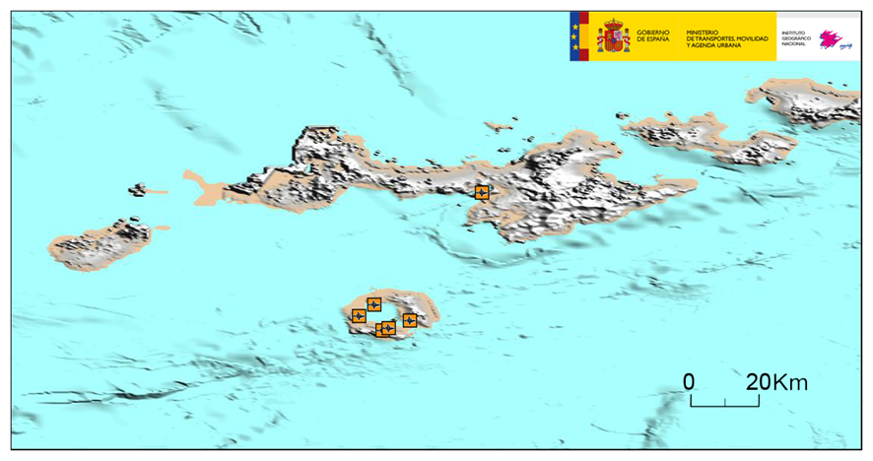

Figure 2. Site of the seismic station installed on Livingston Island to improve signal discrimination and the location of regional seismic activity

Figure 3. Location of the GNSS stations on Deception Island

Figure 4. Location of survey points in the RTK system