Deployment of the first permanent Argentine Volcano Monitoring Network in Deception Island

Deployment of the first permanent Argentine Volcano Monitoring Network in Deception Island

*Information Paper submitted by Argentina*

Summary

In this document we provide a summary of the efforts made by a consortium of Argentinian institutions to install the first permanent Argentine volcano monitoring network in Deception Island, one of the most active volcanoes in Antarctica. The deployment of the monitoring network will improve our understanding of this volcanic system and contribute to forecast future volcanic events. This is relevant from a scientific point of view, but more importantly because Deception Island receives thousands of visitors every summer. This network will contribute to the volcanic risk management of the island and the Antarctic region, providing early warning to people in the proximity of the island, as well as to air and naval traffic.

Background

Volcanic activity in southern South America is principally linked to the Andean volcanic arc along the Pacific margin. In this tectonic setting, the subduction of the Nazca and Antarctic plates beneath the South American plate controls the occurrence of volcanism, which is distributed in three volcanic zones. Further south, in the Antarctic and sub-Antarctic areas, tectonic plates also conjugate to constitute two zones with active volcanism: 1) South Sandwich Islands, with several active volcanoes and, 2) South Shetland Island, with Penguin, Bridgeman and Deception Island as the main active volcanic structures (Figure 1).

**Figure 1**: Simplified regional tectonic map and location of the South Shetland Islands (Taken from Geyer et al. 2019)

Deception Island is located in the South Shetland Islands archipelago, northeast of the Antarctic Peninsula, and is considered one of the most active volcanoes in Antarctica. It is a < 750,000 years old horseshoe-shaped shield volcano of basaltic to andesitic composition, with a below-sea-level diameter of 25 km and an above-sea-level diameter of around 13 km. A sea-flooded depression known as Port Foster, –related to the partial collapse of the volcano edifice–, occupies the central part of the island.

Deception Island eruptive record includes more than 20 volcanic events during the Holocene. The last eruptions of this volcano occurred in 1967, 1969, and 1970 and generated important impacts within the island, including the destruction of the British and Chilean stations and forcing the evacuation of the Argentine station. Also, volcanic unrest episodes in 1992, 1999, and 2014–2015 demonstrated that the occurrence of future volcanic activity is a valid and pressing concern for scientists, technical and logistic personnel, and also tourists, who visit or work on or near the island. Currently, the island shows fumarolic activity, thermal anomalies, active deformation processes and seismic activity.

Volcanic eruptions are generally preceded by signs of “unrest” that can be detected by instrumental monitoring networks. Some of these signals, such as earthquakes, increased degassing, or changes in hydrothermal systems, can be detected by local communities or casual observers. However, not all the pre-eruptive signals are so evident and not all the episodes of unrest lead to an eruption. These are the reasons why qualified scientific-technical institutions must analyze the scenario, deal with uncertainties and advise civil authorities. This can be particularly challenging if instrumentation is limited, as was demonstrated in several eruptions that took place in different parts of the world during the last decades. This way, volcano observatories are institutions or specific areas within organizations (Geological Surveys, Universities, Research institutions, Meteorological Offices) whose primary responsibility is to monitor volcanoes considered active, producing early warnings for authorities and population, with the goal of saving human lives and mitigate the impacts over infrastructure and regional economies.

The Geological and Mining Survey of Argentina (SEGEMAR)

In Latin America, until a few years ago Argentina and Bolivia where the only two countries with active volcanoes in their territory that did not have permanent volcano observatories. This was particularly relevant considering Argentina is among the top 10 countries with the most active volcanoes in the world, as well as having been affected by repeated eruptions in the last century (Quizapu 1932; Láscar 1986–1993; Hudson 1991; Chaitén 2008; Planchón-Peteroa 1991, 2011, 2018; Cordón Caulle 2011, Copahue 2012; Calbuco 2015), which brought about serious damage on thousands of people and economic and material losses valued in millions of US dollars, specially hindering civil aviation.

It was not until 2017 that the activities of the “Observatorio Argentino de Vigilancia Volcánica” (OAVV) from the Geological and Mining Survey of Argentina (SEGEMAR) officially began. The observatory was created as a specialized area within SEGEMAR dedicated to the study and monitoring of active volcanoes that may affect Argentine territory. Currently, OAVV is the youngest volcano observatory in Latin America -and probably the world- and the official institution in Argentina that issues volcanic alerts.

Since then, OAVV has grown over time, becoming operational in 2019, and so far has already deployed 4 of the 10 planned monitoring networks, including Copahue, Lanín, Laguna del Maule, and Planchón Peteroa volcanoes. Up to this moment, the observatory is formed by a multidisciplinary team of 10 people, including geologist, geophysicist, geodesists, and electronic and computer engineers, that use a standard suite of geophysical, geochemical, and visual techniques employed at observatories around the world to monitor active volcanoes in the country. In 2023 the OAVV plans to expand its staff to 19 professionals.

Volcanic monitoring in Deception Island

Volcano monitoring instrumentation in Deception Island began with the installation of the first seismometer in 1950, which operated in the basement of the then Argentine Naval Station. Since 1985, several research projects entailing Argentine and Spanish collaboration have deployed temporal monitoring stations and arrays to characterize seismo-volcanic activity on the island. Efforts have also been made to study the geological structure of the island in order to understand the dynamics of the volcano and guarantee volcanic surveillance during the summer months, when personnel are stationed on the island.

During the 1991-1992 summer seismic crises, volcanic surveillance allowed the evacuation of all staff from the island. In 1993, the Deception Volcano Observatory (OVD) was created as a collaboration between the Argentine Antarctic Institute (IAA), the University of Buenos Aires (UBA), the University of La Plata (UNLP) and the National Museum of Natural Science (MNCN) from the Spanish National Research Council (CSIC). In 1998-1999 another seismic crisis was recorded, demonstrating the temporal and spatial migration of the seismic sources from greater depths in the center of Port Foster to areas closer to the surface.

In 2015, over a period of 5 months, there were a series of seismic swarms from deep sources (<10 km) of large magnitudes, with epicenters distributed all around the island. These swarms evidenced the presence and displacement of large volumes of magma to the shallower part of the volcanic edifice.

In 2020, the Geographical Institute of Spain (IGN) installed the first permanent online seismic station on the island.

In 2022, by an agreement between SEGEMAR and the Argentine Antarctic Institute (IAA), a decision was made to install the first permanent online monitoring network on Deception Island. The project was presented as part of Argentina’s Annual Antarctic Plan 2022-2023.

In this context, during March 2023 a team of professionals from OAVV installed a total of 4 multiparametric monitoring stations (Figure 2), including 3 broadband seismic stations, 2 Global Navigation Satellite Systems (GNSS), 1 IP Camera, and 1 satellite node.

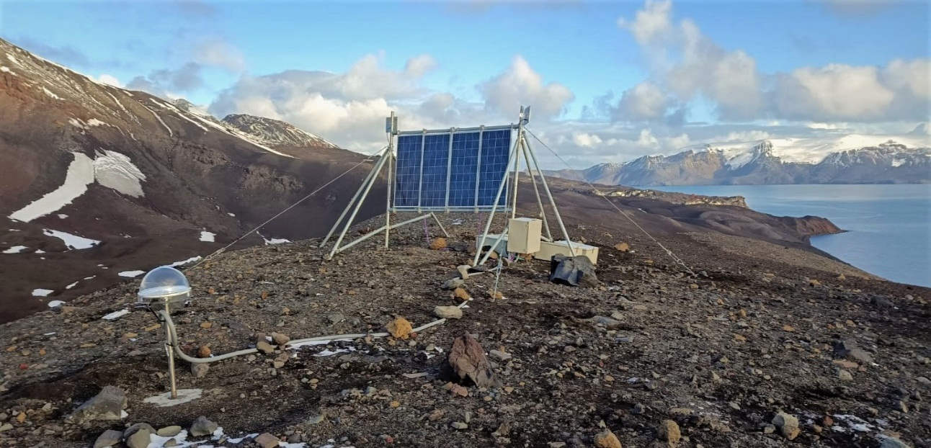

**Figure 2**: OAVV-SEGEMAR Pendulum Cove (PEN) multiparametric volcano monitoring station.

The network is already working, allowing us to monitor the volcano in real-time, 365 days a year, and issue volcanic alerts and also Volcanic Activity Reports (Figure 3). Besides, a new section within the OAVV online website was created where online monitoring information can be found (in Spanish only): <https://oavv.segemar.gob.ar/monitoreo-volcanico/isla-decepcion/>

Finally, to complement this and also to support and strengthen scientific cooperation within the Antarctic continent between Argentine and Spain, SEGEMAR and IGN Spain will sign a cooperation agreement, with the support from the Antarctic Institutions from both countries, with the goal of creating a joint volcano monitoring network in Deception Island and to coordinate volcanic risk management activities on the island.

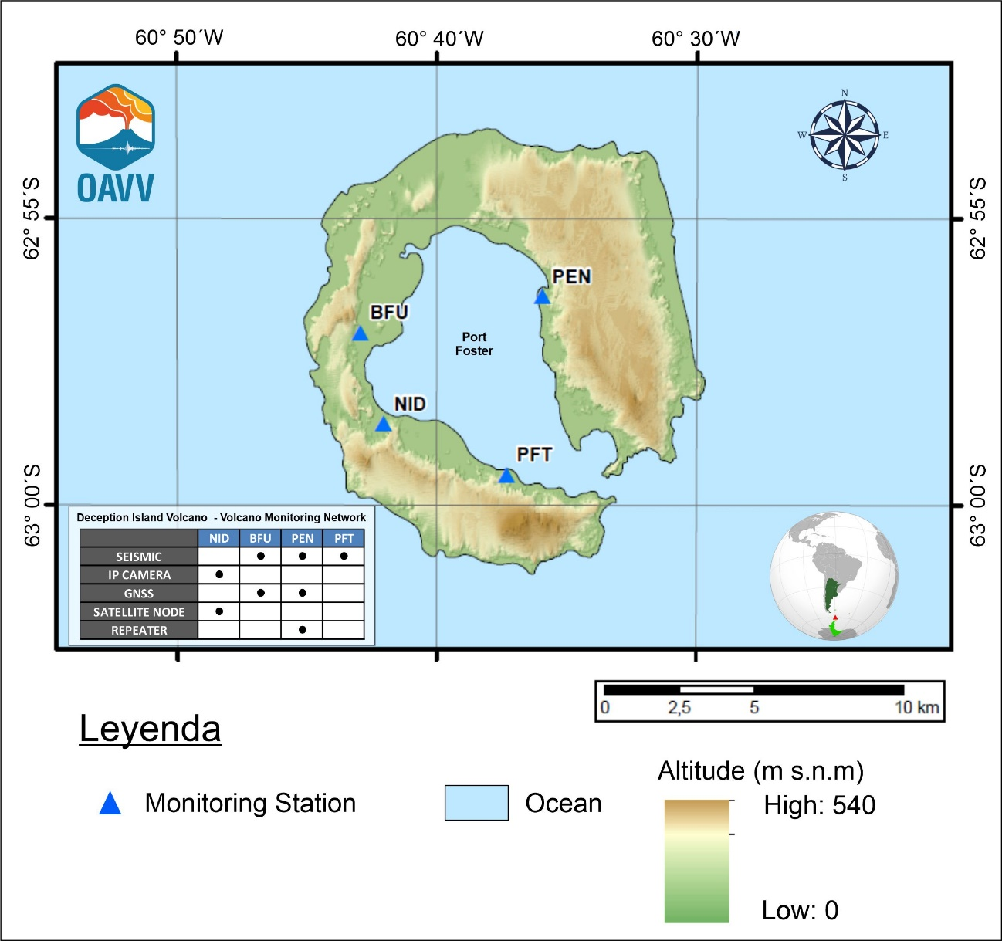

**Figure 3**: Deception Island Argentine permanent volcano monitoring network.