Eclipse in the Antarctic Peninsula

**Eclipse in the Antarctic Peninsula**

**Working Paper submitted by Argentina and Chile**

Summary

In December 2021, a Total Solar Eclipse will be visible in the Antarctic Peninsula, the Antarctic Ocean and the South Atlantic, which could generate an increase in tourist and non-governmental activities in its observation area. This document seeks to alert the Parties about the possible risks that may arise as a result of the possible increase in activities in the eclipse observation area, as well as to promote coordination and communication between the Parties to the Treaty in order to guarantee the effective control and monitoring of activities during this event.

Background

On 4 December 2021, around 07:00 UTC, there will be a total solar eclipse that will be visible from the Antarctic Peninsula [Figure 1]. These phenomena are not extraordinary and occur in this region approximately every 20 years.

*Figure 1 – Path of the Eclipse.*

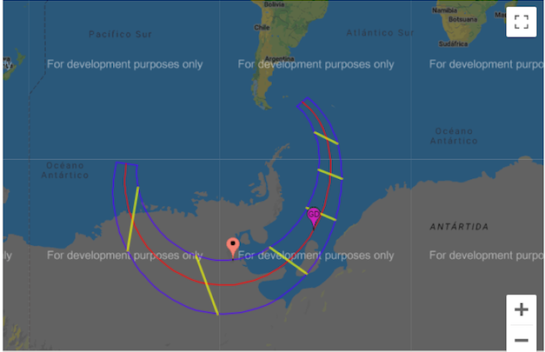

Figure 1. Path of the Moon's shadow on the Earth's surface during the solar eclipse. [Google Maps and Solar Eclipse Paths, <https://eclipse.gsfc.nasa.gov/SEgoogle/SEgoogle2001/SE2021Dec04Tgoogle.html>]

Total solar eclipses generate great interest from the scientific community and the general public. The scientific motivation to observe these events in person is due to the fact that these phenomena allow very specific studies and innovative research to be performed. Additionally, a large number of researchers is expected in the area, given the unique conditions of the Antarctic Peninsula, which constitute a reference and a constraint that no laboratory conditions can reproduce, and considering that such measurements have only been carried out there once before (Kameda et al. 2009). It is also foreseeable that this event will attract the general public, and we anticipate a high demand for tourist services.

It should be noted that the development of tourist activities during the eclipse could be affected by the coronavirus pandemic and the presence of public health restrictions. As we know, during the 2020-2021 season there was an unprecedented decrease in tourist activity in the Antarctic Peninsula that could be replicated in the 2021-2022 season if the global health situation does not improve.

Currently, because of the evolution of the pandemic in the world, there is uncertainty about whether the next Antarctic season will unfold normally. It is likely that few tourist boats will actually attend the eclipse observation. However, this does not impede the possible increase in the presence of vessels that decide to carry out expeditions without requesting authorization in accordance with ATS rules.

As an illustration of the interest generated by these events, in 2020, despite public health restrictions, thousands of tourists travelled to Chile and Argentina to observe the solar eclipse that took place in December of that year.

Possible risks associated with greater activity during the eclipse

In recent years there has been an increase in interest in visiting the Antarctic Peninsula as a tourist using cruises and sports yachts as a means of transport. Considering this trend and the tourist magnet that this astronomical event represents, we consider that there are reasons to believe that on the date of the eclipse there may be an increase in navigation and a high concentration of boats and yachts in the observation area. This is taking into account the impact that the pandemic may still have on Antarctic activities for the 2021-2022 period.

Therefore, we want to draw the attention of the Parties to the possible increase in vessel traffic. This could lead to an increase in navigation in Antarctic waters by authorized vessels, but also by unauthorized yachts and vessels in the area. Furthermore, public health restrictions related to the pandemic could have the indirect result of an increased presence of unauthorized vessels in the Antarctic Treaty area. Although this situation may be limited to a small number of vessels, it may represent a greater demand for search and rescue (SAR) operations and an increase in environmental risks associated with the development of activities related to observing the eclipse.

It should be noted that the development of unauthorized activities in the area has been addressed by the ATCM on multiple occasions and controlling such activities constitutes one of the main challenges of the STA. At ATCM XLII, in IP 107 *Data Collection and Reporting on Yachting Activity in Antarctica 2018-2019* presented by the United Kingdom, Argentina, Chile and IAATO, seven vessels were reported to have operated in the region without the authorization from a Party to the Antarctic Treaty, and the paper urged that "the issue of unauthorized yachts be thoroughly considered”. Likewise, 12 unauthorized vessels were reported in the 2019-2020 period.

In this context, and in order to prevent the departure of unauthorized expeditions, it is essential to maintain a continuous exchange of information and an effective and fluid communication between the Parties to the Treaty through existing mechanisms (EIES, bilateral contacts and diplomatic channels).

Furthermore, we call on the Parties to consider the risks that may be generated by the presence of vessels that lack safety standards and have crews without sufficient preparation to carry out expeditions in Antarctic waters.

In this sense, it should be noted that the area in which the duration of the eclipse will be the longest is in a sector of the Weddell Sea that is difficult and dangerous to navigate as a result of its proximity to ice shelves, and in the area of the Amundsen Sea, where there is no permanent presence of vessels.

Both countries, as part of the International Convention for the Safety of Human Life at Sea (SOLAS) of 1974 and the Maritime Search and Rescue Convention (SAR) of 1979 and in compliance with their obligations, deploy constant and coordinated efforts in order to protect and assist human life at sea. In this context, the increase in trips on yachts and sports boats can increase the risk of accidents and emergencies in the area, which could generate overloads in SAR operations for Antarctic operators. Consequently, both countries remain willing to intensify cooperation and collaboration with the actors involved in SAR operations and urge the Parties to coordinate joint actions in the event of emergencies in the area.

Finally, we want to draw attention to the impacts that a high concentration of vessels in the area can generate on the Antarctic environment and its associated ecosystems, especially considering that the Antarctic Peninsula has the most pristine environment on Earth and that relatively small disturbances can have significant effects.

In this sense, the increase in expeditions and the risks of SAR operations could generate pressures on the Antarctic environment and its associated ecosystems and cumulative impacts in the visibility area and at the eclipse observation points (Figure 2).

*Figure 2 - Observation Points in Antarctica*

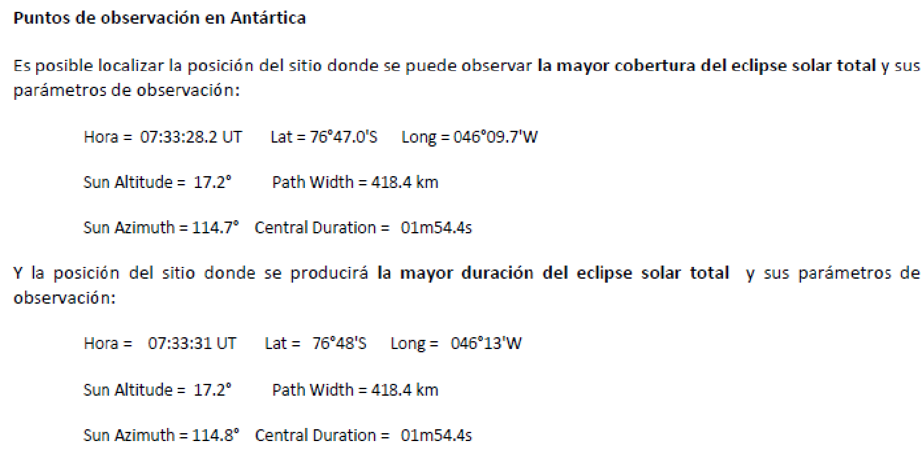

Figure 2. Eclipse observation points with greater coverage and duration. (Figure 1). These parameters were calculated using the Javascript Solar Eclipse Explorer application, available at <https://eclipse.gsfc.nasa.gov/JSEX/JSEX-index.html>

Therefore, in order to minimize the impact of human activities and the risks of contamination of the Antarctic environment, we would like to emphasize that activities be more carefully evaluated by each Competent Authority, taking into account that multiple activities would be carried out simultaneously in the area.

Recommendations:

1. Take note of the possibility of an increase in vessel traffic in the observation area of the Total Solar Eclipse that will take place on 4 December 2021, and the risks associated with the potential increase in the presence of unauthorized vessels in the area, in SAR operations, and the environmental risks that tourism and non-governmental activities related to this phenomenon could generate in the Antarctic Treaty area.
2. Promote compliance with Resolution 3 (2004) *Tourism and Non-Governmental Activities:* *Greater cooperation between the Parties* approved at ATCM XXVII in Cape Town, South Africa.
3. Intensify the exchange of information regarding vessels navigating in the Antarctic Treaty area during eclipse observations, and promote the use of current communication and coordination mechanisms in order to exercise rigorous control of tourist and non-governmental activities in the area. In particular, we encourage the use of the Competent National Authorities forum to exchange information in the authorization processes of tourism and non-governmental activities on the occasion of the eclipse.
4. Intensify cooperation between the Parties to inform the countries with Antarctic SAR responsibilities regarding any vessels that depart from any of their ports and that plan to be in the eclipse area during 4 December 2021.