Communication of CEP science needs to researchers and national science funding agencies

Communication of CEP science needs to researchers and national science funding agencies

**Working paper presented by Norway and the United Kingdom**

***Summary***

Norway and the United Kingdom are concerned that science funding agencies are not sufficiently informed about prioritized science needs for the support of the management of the Antarctic environment. The co-authors recommend that the Committee:

1. initiate a process to consider how the list of CEP science needs for Antarctic management, in the CEP Five-Year Work Plan, can be further developed to clarify research needs in a way that can be more easily understood and actioned by researchers and funding agencies; and
2. advise the ATCM that Parties should ensure that CEP science needs are regularly communicated to national science funding agencies, with the aim of supporting timely delivery of policy-relevant science to inform CEP advice to the ATCM

***Background***

Since 1998, the Committee for Environmental Protection (CEP) has provided advice and formulated recommendations to the Parties in connection with the implementation of the Protocol, including the operation of its Annexes, for consideration at Antarctic Treaty Consultative Meetings (ATCMs). During that time, the Committee has looked to the best available science to inform its advice to the ATCM on environmental issues.

The CEP has regularly identified subject areas where it needs further scientific information to support its work and discussions. Consolidating these science needs into one list, at CEP XX, the CEP Chair proposed the “list of CEP science knowledge and information needs” as a tool to help with promoting and supporting science to better understand and address the environmental challenges facing Antarctica (ATCMXL WP34). The list contained science knowledge and information needs identified in the CEP Final Reports, the CEP Five-Year Work Plan, the CEP Climate Change Response Work Programme and other CEP Manuals.

The Committee agreed that this was a useful initiative and would serve as a valuable tool both for CEP and ATCM discussions. The Committee also noted that this item aligned with ATCM discussions on future Antarctic science challenges and priorities (CEP Final Report pg. 25, para. 38). Most recently, CEP XXIII agreed that research requirements identified in the updated draft CEP Climate Change Response Work Programme should be consolidated into the existing list of CEP science needs, as inter alia found in this [document](https://documents.ats.aq/ATCM43/att/ATCM43_att054_e.docx) (CEP XXIII Report, para. 35).

It should be recognized that the questions and issues contained in the list of CEP science, knowledge and information needs are, to a large degree, not framed in a manner that is easily translated into relevant scientific efforts. Consequently, it may prove a challenge for scientists to identify the specific research that will help answer the science needs communicated by CEP.

Furthermore, the current manner in which CEP science needs are framed may also affect the ability of funding agencies to prioritize relevant research in funding schemes.

***Sources of scientific information***

Scientific information can and has been made available to the CEP from scientists via individual Parties or groups of Parties. Alternatively, information can be made available via international science bodies, such as the World Meteorological Organisation (WMO) and the Scientific Committee on Antarctic Research (SCAR). SCAR, whose membership includes scientists from all of the Consultative Parties and many non-Consultative Parties, has a role of providing independent and objective scientific advice to the Antarctic Treaty Consultative Meetings and other bodies.

In recent years SCAR has provided science summaries to the CEP on a diverse range of topics including designation of specially protected species status (ATCMXLIII WP37), the designation of protected area (ATCMXLII IP52), pollution (ATCMXLIII IP137), wildlife disturbance (ATCMXXXVIII WP 27; ATCMXL WP 20), non-native species (ATCMXXXV WP5), ocean acidification (ATCMXLIII WP36) and climate change (ATCMXLIII WP17). SCAR also hosts the Antarctic Environments Portal ([www.environments.aq](http://www.environments.aq)) (ATCMXLIII WP19) which aims to link Antarctic science and Antarctic policy, by providing easy access to information on a range of scientific issues relevant to Antarctic environmental governance and management.

Further demonstrating SCAR’s commitment to the effective delivery of policy-relevant science, in 2021, SCAR established the Scientific Research Programme ‘Ant-ICON’ (Integrated Science to Inform Antarctic and the Southern Ocean Conservation; <https://www.scar.org/science/ant-icon/home/>) which **aims to answer fundamental science questions relating to the conservation and management of Antarctica and the Southern Ocean.  Importantly, it focusses on research to drive and inform international decision-making and policy change, which would be delivered to policymakers via the SCAR Standing Committee on the Antarctic Treaty System.**

***Recent developments***

In recent years the Parties have engaged in discussions concerning future Antarctic science challenges and factors influencing the setting of national science goals and objectives (see ATCM XLII WP32). Participants in ATCM discussions reported that their national Antarctic science objective setting is informed by external research prioritisation and coordination schemes, broader national priorities, funding schemes, and areas of research excellence.

Many participants referenced the importance of science priorities and research programmes facilitated through SCAR and highlighted the importance of the connection between SCAR and the Antarctic Treaty System. Other drivers of national objective setting included research priorities relevant to the forums of the Antarctic Treaty system including the CEP’s work to identify and promote the science needed to better understand and address the environmental challenges facing Antarctica.

While policymakers have made efforts to better communicate their science needs to researchers, and the Antarctic science community has shown a strong desire to provide policy-relevant research and information, it may not always the case that national funding agencies are aware of these science priorities or provide appropriate targeted funding. In 2016, at the SCAR mini-symposium ‘Linking Antarctic Science with Environmental Protection: celebrating the 25th Anniversary of the Madrid Protocol’, researchers and environmental managers observed that purposeful consideration of funding opportunities for policy-relevant science, would greatly enhance international policy development and protection of the Antarctic environment (see [Hughes et al., 2018](https://www.sciencedirect.com/science/article/pii/S1462901117311279)).

Direct communication of the science needs relevant to decision-making by national governments to both their science organisations and national funding bodies would help facilitate the delivery of targeted science in a timely manner (see Figure 1).

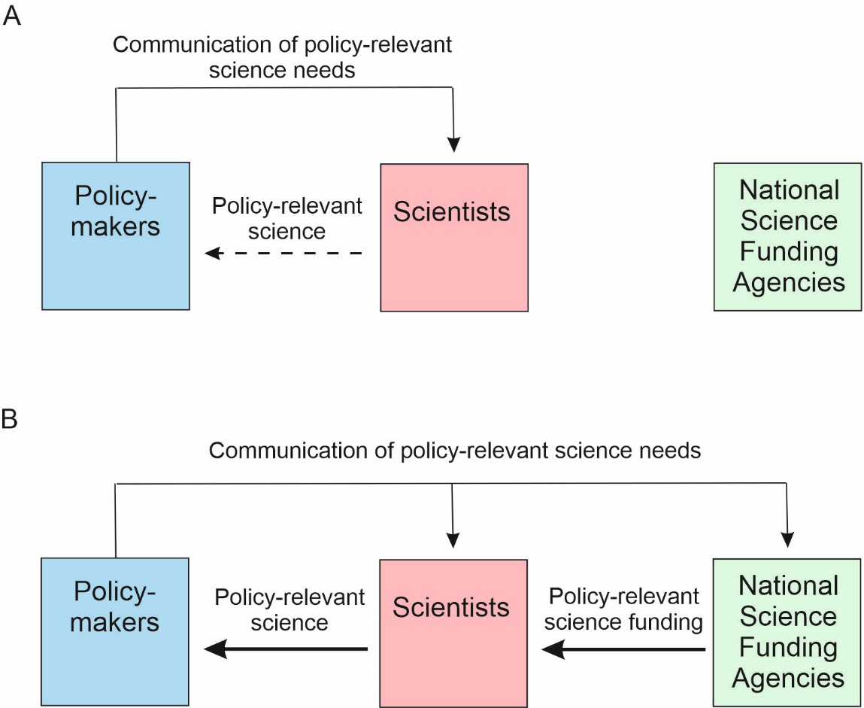

Figure 1. For delivery of policy-relevant scientific information, it is important to communicate the science needs not only to the science community (Scenario A), but also to national science funding agencies (Scenario B).

***Recommendation***

Norway and the United Kingdom recommend that the Committee:

1. initiate a process to consider how the list of CEP science needs for Antarctic management, in the CEP Five-Year Work Plan, can be further developed to clarify research needs in a way that can be more easily understood and actioned by researchers and funding agencies; and
2. advise the ATCM that Parties should ensure that CEP science needs are regularly communicated to national science funding agencies with the aim of supporting timely delivery of policy-relevant science to inform CEP advice to the ATCM.