Japan’s Antarctic Research Highlights 2020–21

**Japan’s Antarctic Research Highlights 2020–21**

***Summary***

Among various research activities carried out by the Japanese Antarctic Research Expedition (JARE) in the Japanese Antarctic Syowa Station area, three topics are introduced; (1) High-resolution observations of the Antarctic atmosphere with the PANSY radar and complementary instruments; (2) Start of year-round observation of precipitation in the vicinity of Syowa Station using precipitation radar; (3) Demonstration of the Antarctic Mobile Base Unit during the Antarctic winter.

1. ***Introduction***

The headquarters of the Japanese Antarctic Research Expedition (JARE), Japan’s national Antarctic program, was established in 1955 by the Ministry of Education, Science and Culture (now the Ministry of Education, Culture, Sports, Science and Technology, or MEXT). The headquarters comprises departments and agencies of various government ministries, including the Ministry of Foreign Affairs; the Ministry of the Environment; the Ministry of Defense; the Ministry of Land, Infrastructure, Transport and Tourism; and the Ministry of Agriculture, Forestry and Fisheries. The scientific research and observation programs of JARE are considered and adopted as midterm research plans at general meetings of the headquarters.

This Information Paper introduces selected highlights from scientific projects carried out by overwintering and summer members of the 61st and 62nd JAREs, respectively, at and around Syowa Station (69°00′ S, 39°35′ E) during the 2020-21 season. Although there was a significant reduction in the number of scientists and projects in the summer activities in the 2020-21 Antarctic season because of precautionary measures against the COVID-19 pandemic, the JARE 62nd wintering team is conducting as many year-around science projects at Syowa Station as in previous winters.

1. ***Selected Research Highlights***

Year-round observations have been carried out by overwintering JARE personnel at and around Syowa Station. Seasonal observations are also carried out by summer expedition personnel aboard the *Shirase* of the Japan Maritime Self-Defense Force for oceanographic observations and in the vicinity of Syowa Station.

* 1. **High-resolution observations of the Antarctic atmosphere with the PANSY radar and complementary instruments**

A study on the global atmosphere system based on high-resolution observations of the Antarctic atmosphere is subtheme 1 of the prioritized project of JARE’s term IX (2016-2022) which was planned and lead by the headquarters of JARE. This project aims at understanding the atmospheric teleconnection in the vertical and meridional (i.e., inter-hemispheric) through intensive observations with the large-aperture atmospheric radar PANSY (Program of the ANtarctic SYowa Mesosphere, Stratosphere, and Troposphere/Incoherent Scatter [MST/IS] Radar), resonance scatter lidar, millimeter-wave radiometer, etc. at Syowa Station and the international observation network composed of radars, lidars, imagers, etc. from the Antarctic to the Arctic.

The PANSY radar has continued its standard observation of the troposphere, stratosphere, and mesosphere, which reached 5 years with the full system and 9 years with the partial system. The 6th Inter-hemispheric Coupling Study by Observations and Modeling (ICSOM6; see http://pansy.eps.s.u-tokyo.ac.jp/icsom/) campaign was successfully conducted from December 26, 2020, to January 20, 2021. The ICSOM6 campaign was based on a combination of GCM simulations and simultaneous observations by several MST/IS radars around the world, including PANSY (Fig. 1), with some complementary instruments at Syowa Station, such as medium-frequency (MF) and meteor radars, lidars, imagers, etc. This campaign was approved as a project for ROSMIC (Role Of the Sun and the Middle atmosphere/thermosphere/ionosphere In Climate) of the Scientific Committee on Solar-Terrestrial Physics (SCOSTEP) under the International Science Council (ISC). International collaborative studies based on the four ICSOM campaigns are ongoing.

*Figure 1. Global MST/IS radar network participating in the ICSOM6 campaign.*

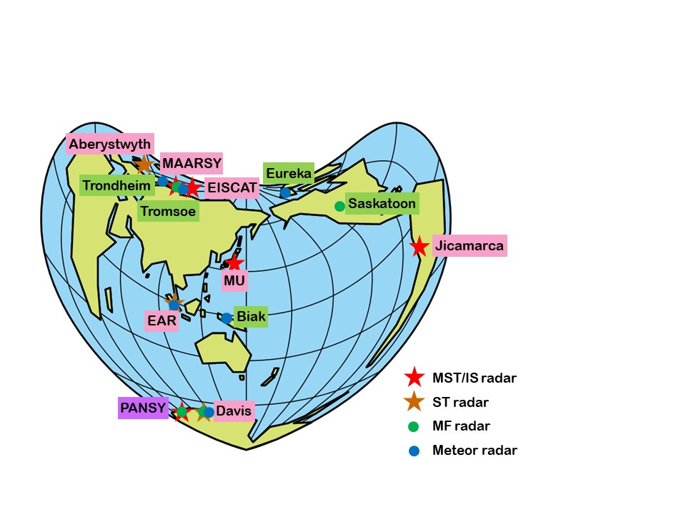

* 1. **Start of year-round observation of precipitation in the vicinity of Syowa Station using precipitation radar**

In order to clarify the amount of precipitation near Syowa Station as well as fluctuations and changes in precipitation clouds and blizzards, precipitation radar units were installed at Syowa Station in January 2021, and radar observations have been caried out.

On December 30, 2020, work on the construction of the radome (6.1 m in diameter and 3.7 m in height) to house the precipitation radar units began, and the assembly of the radome itself was mostly completed on January 14, 2021. After that, the assembly of the two radar units and a rotation test were conducted, then the radar transmission and reception tests were successfully carried out at the end of January. Since this precipitation radar comprises two X-band Doppler radars, one scanning horizontally and the other vertically at the same time, it is expected to provide information on the three-dimensional structure of clouds and the changes in structure from the onset to the disappearance of wind-driven phenomena such as ground snowstorms and blizzards. In the coming two winters, continuous year-around observation by radar is planned.

*Figure 2. Assembly of the radome of the precipitation radar at Syowa Station.*

* 1. **Demonstration of the Antarctic Mobile Base Unit during the Antarctic winter**

The Antarctica Mobile Station Unit (AMSU) is a residential unit built based on the joint project of the Japan Aerospace Exploration Agency (JAXA), the National Institute of Polar Research (NIPR), Misawa Homes Co. Ltd. (Misawa Homes), and Misawa Homes Institute of Research and Development (MHIRD), aiming at developing a sustainable housing system that withstands the extreme environment at Syowa Station in Antarctica, from February 2020. The AMSU was brought to Antarctica, and during the wintering period, two residential units on a sledge were connected and assembled into one base unit to conduct demonstration tests of (1) flexible expansion and contraction of the structure, (2) optimization of energy use, and (3) monitoring using sensors. The demonstration experiments were conducted by the JARE 61st wintering team during 2020 and will be continued by the JARE 62nd wintering team. After the completion of the demonstration experiments, the AMSU will be transported to Dome Fuji in the Antarctic plateau, at an altitude of 3,800 meters, where it is planned to be used as a living space for up to 18 people for the 3rd Dome Fuji Deep Ice Core Drilling Project.

*Figure 3. Completion of assembling test of the Antarctica Mobile Station Unit (AMSU).*

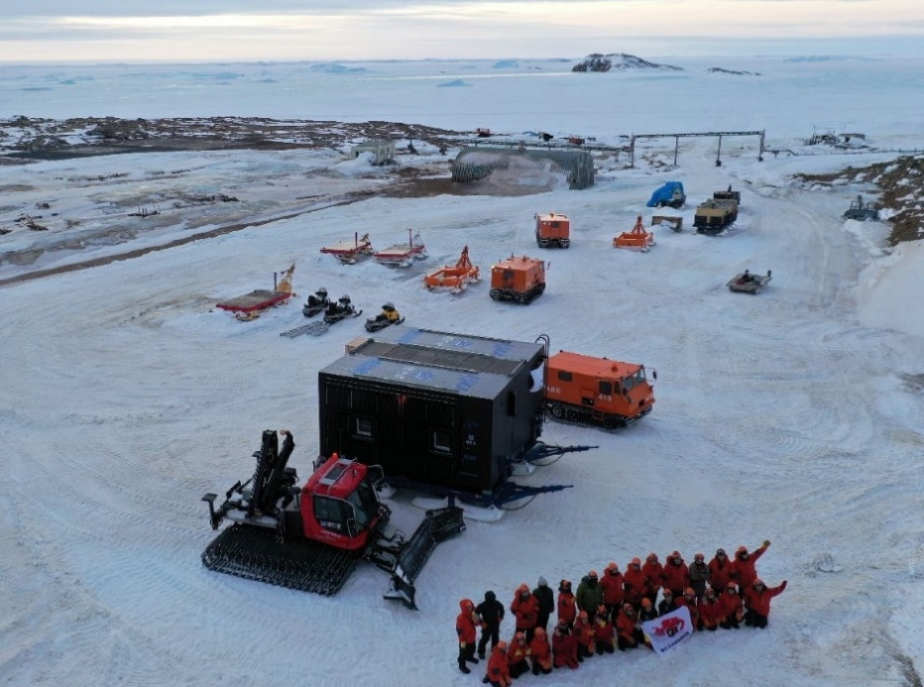

*Figure 4. Two covered AMSU residential units on a sledge.*

