PROANTAR Education & Outreach Activities

PROANTAR Education & Outreach Activities

During the 2020/2021 season, the COVID-19 pandemic has caused many PROANTAR events to be cancelled or postponed due to the restrictions on large eventsand gatherings.

In addition to the specific actions listed below, PROANTAR developed virtual meetings and conference presentations, webinars and other events to promote the dialogue among the scientific community, Antarctic colleagues, teachers and students, general public and decision makers.

The public outreach program of PROANTAR is supported by the Ministry of Science, Technology and Innovation (MCTI), the Brazilian Navy, the National Council for Scientific and Technological Development (CNPq), the Ministry of Environment, APECS-Brasil (Association of Polar Researchers) and several universities that are committed to educational and public outreach efforts related to PROANTAR objectives and Antarctic issues.

The **Ministry** of **Science**, **Technology** and Innovation (MCTI) and the Brazilian Navy co-hosted the “Antarctic Science Symposium 2020”on October 16, 2020. That event was a great opportunity to present the *Antarctic Science Program* and to discuss the results of the scientific activities that were conducted during the XXXVIII Antarctic Operation (2019/2020). The symposium presentations are available at <http://bit.ly/cienciaantartica>

The MCTI *Antarctic Science Program* aims at developing excellent research on the Antarctic region and its connections with the Atlantic Ocean and South America; produce and manage knowledge; help scientific knowledge support public-policy decisions; promote the spread of scientific knowledge; and establish national and international partnerships for the development of science. ([www.cienciaantartica.gov.br](http://www.cienciaantartica.gov.br))

The Federal University of Minas Gerais (UFMG) held its “Antarctic Week – UFMG Symposium” from April 26 to 29, 2020.The main objectives of the event were to contribute to the discussion and spread of scientific advances in the areas of Antarctic medicine/physiology, microbiology and archaeology and their importance to Brazil.

All symposium materials are available at: <https://www.youtube.com/channel/UC8L_cCtQzHgbhgYFicpjk0w>

**“*Antártica ou Antártida*?” is a free online course designed for elementary school teachers who speak Portuguese.** Produced by the Federal University of ABC (UFABC), the 60-hour course was designed to help teachers who wish to include Antarctica in their teaching programs. The course is divided into 4 modules - Ice, Convergence, Environment and Life – and each module includes lectures, discussion forums, video lessons and didactic material production. The event provides opportunities for teachers to improve their teaching, outreach, and collaboration.

For more information on the program, registration, prerequisites and certification, please visit [ufabc.net.br/antarticaouantartida2021](http://ufabc.net.br/antarticaouantartida2021)

|  |  |
| --- | --- |
| IMG_2326.jpg |  |

The Brazilian National Committee of the Association of Polar Early Career Scientists (APECS-Brazil) celebrated in February 2021 the “VI APECS-Brazil Symposium”. The event discussed the importance of the polar regions for the global climate and the relevance of research in Antarctica for everyday life. The virtual symposium had simultaneous interpretation – English, Spanish, Portuguese, and sign language.

From the May 10th to 14th 2021, during the “XXVIInternational Polar Week”, a series of activities to raise awareness of the polar areas and educating the public about Antarctic activities were carried out: mini-courses, webinars, lectures, cinema and presentations.

Students from all over the country, at all levels, were able to learn facts and curiosities about polar regions, how they affect our daily lives, the research that Brazil conducts in Antarctica and the importance of the conservation of these environments.

All the APECS-Brazil material is available on YouTube: <https://m.youtube.com/c/APECSBRASIL/featured>

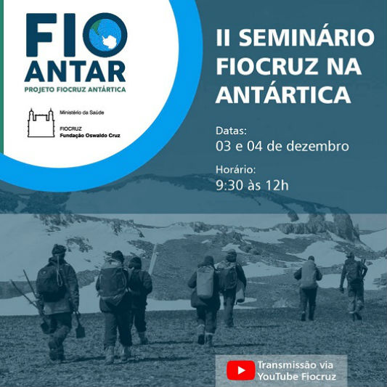

The Brazilian Oswaldo Cruz Foundation (Fiocruz) held its virtual “II Seminar Fiocruz in Antarctica” on December 3rd and 4th 2020. The event discussed the background and challenges of doing science in the region from the experience of the first year of the FioAntar project. The project investigates risks and opportunities that microorganisms present in the region can offer to human health, in an epidemiological surveillance perspective that seeks to benefit the Unified Health System (SUS, the acronym in Portuguese for the Brazilian public health system).

The seminar presentation is available at <https://youtu.be/jvrQm4M4RD8>