The Value of Long-term Ecological Datasets to Evaluate Ecosystem Response to Environmental Change along the Antarctic Peninsula

**The Value of Long-Term Ecological Datasets to Evaluate Ecosystem Response to Environmental Change along the Antarctic Peninsula**

***Information paper submitted by the United States***

**Summary**

The Western Antarctic Peninsula (WAP) represents a boundary region between the polar and sub-polar climates. This region is one of the most rapidly warming regions on Earth, with increases in air and water temperatures over the last half century leading to substantial reductions in sea-ice coverage. The variability and change in the physical environment and documented biological and biogeochemical responses make this a model system for how climate and sea ice changes might restructure high-latitude ecosystems. Although the WAP shelf region is arguably one of the better studied areas around Antarctica, significant gaps remain in needed spatial and temporal data to resolve the atmosphere-ice-ocean-ecosystem feedbacks that control the ecosystem dynamics and evolution of this complex polar system. The US has funded a program a Long-Term Ecological Research (LTER) Program for over 30 years to capture regional environmental change. The resulting datasets constitute a major advancement understanding of how the ecosystem is changing. The value of long-term research programs like the Palmer LTER are helping us to anticipate how global change might evolve over the next few decades and to build a scientific foundation to guide action plans toward sustainability of ecosystems and their life supporting functions.

**Background**

The Long-Term Ecological Research program at Palmer Station Antarctica (PAL LTER) studies a polar marine biome with research focused on the Antarctic Peninsula pelagic marine ecosystem, including sea ice habitats, regional oceanography and terrestrial nesting sites of seabird predators. The program has allowed scientists to consistently track environmental changes taking place over 30+ years along the Antarctic Peninsula, one of the fastest-warming regions on Earth. Multiple teams of U.S. and associated international scientists have been gaining new mechanistic and predictive understanding of ecosystem changes in response to disturbances spanning long-term, decadal, and higher-frequency “pulse” changes driven by a range of processes, including natural climate variability, long-term climate warming, transformed spatial landscapes, and food-web alterations. Scientists in this program are using traditional ecological monitoring paired with autonomous vehicles, floats, moorings, satellite data, and modelling to expand and bridge time and space scales not covered by shorter sampling periods. These observations are complemented with process studies that include lab and ship-based manipulative experiments. They have documented how changes have affected all parts of the food web, affecting everything from microscopic ocean plants and crustaceans and fish to penguins and other seabirds and marine mammals. Data collected over multiple time and space scales in the region (Fig. 1; Henley *et al.* 2019) helps researchers understand not only how climate change is disturbing the marine ecosystem of the Antarctic Peninsula, but also provides an indication of what this region might look like in the coming decades.

**Figure 1**: Map showing the major sustained research efforts in the WAP discussed here, including northern (N), central (C) and southern (S) sub-regions (white dashed lines), and the major circulation and bathymetric features of the shelf system.

**Key Outcomes**

Bringing together physical, biological and chemical oceanographers and a variety of animal ecologists has allowed the PAL LTER network scientists to track many components of the Antarctic Peninsula marine ecosystem simultaneously over longer time periods. Results of the PAL LTER program have shown that over time, sea ice has declined, glaciers have retreated, and the weather has overall become warmer, wetter, and stormier in the region. Summer precipitation has in many areas switched from snow to rain, and the sea ice, which historically lasted around six months long, now only lasts three to four months, with less predictability from season to season. The sea ice changes have had major impacts to the food web in the peninsula area (reviewed by Henley et al., 2019).

This briefer highlights two representative examples of how the PAL LTER program ecosystem datasets are tracking environmental influences on ecosystem structure:

*1. Antarctic research links warming to fish decline: Drop in sea ice linked with decline in larvae of key forage fish*.

Analysis of 25 years of data (1993–2017) from the WAP region reveals the first significant relationship reported between warming waters, decreased sea ice, and reduced abundance of larval Antarctic silverfish, Pleuragramma antarctica (Fig. 2; Corso et al. 2022).

**Figure 2**: Positive (red; warmer temperatures) and negative (blue; cooler temperatures) anomalies in the standardized mean sea surface temperature for the Palmer LTER study region during austral summer (Dec, Jan, Feb). Standardized anomalies in mean annual larval Antarctic Silverfish abundance (larvae/1,000 m3) that were captured during Jan and Feb are overlaid (black dotted line) (Corso et al. 2022; Photo credit: Andrew Corso).

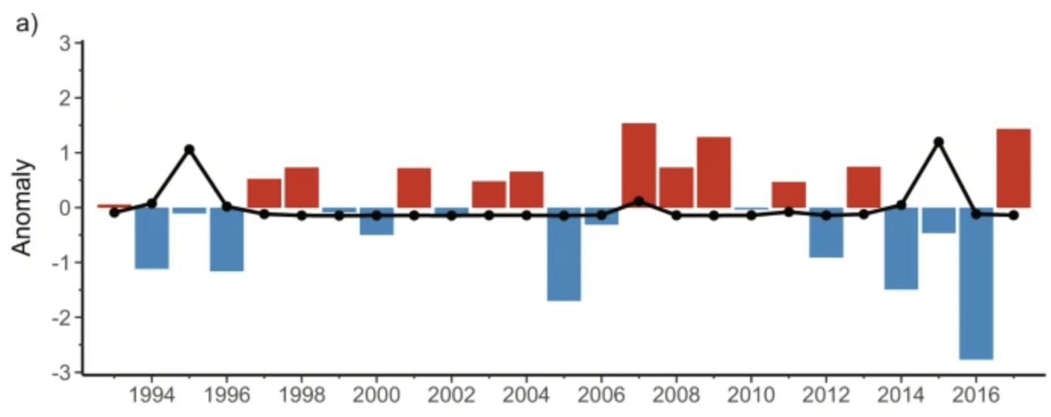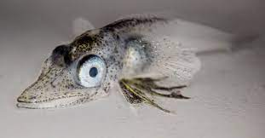

Antarctic Silverfish are the only fish in the Southern Ocean that have been shown to use sea ice as spawning habitat, and they are important prey for penguins, seals, and other predators. The authors showed that warmer sea surface temperature and decreased sea ice are associated with reduced larval abundance. Further regional warming predicted to occur during the 21st century could displace additional populations of Antarctic Silverfish, further altering this pelagic ecosystem (Fig. 3).

**Figure 3**: Timeline with optimal and suboptimal conditions for Antarctic Silverfish reproduction near the Western Antarctic Peninsula (Corso et al., 2022).

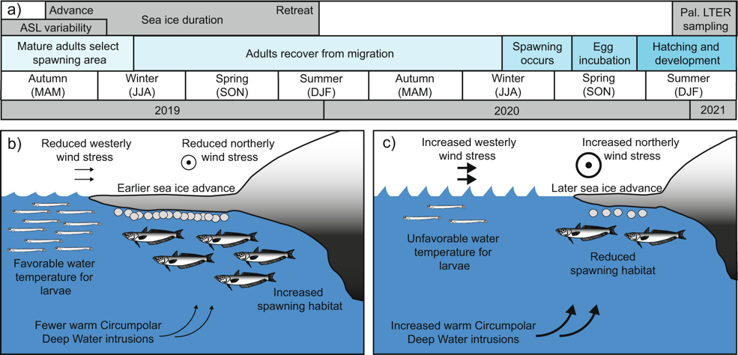

*2. Ecosystem changes result in Penguin colony shifts:*

The LTER program research has also provided clear examples of how species are shifting ranges as the WAP warms.For example,penguin species that used to be endemic throughout the WAP region are giving way to ones that are more adapted to warmer, wetter conditions *(Henley et al. 2019)*. Adélie penguins (*Pygoscelis adeliae)* thrive in colder, drier regions with ample sea ice. Their populations used to dominate breeding grounds adjacent to Palmer Station with about 15,000 breeding pairs in 1975. Now there are less than 2,000 – a decrease by approximately 90% in the region (Fig. 4). Gentoo (*Pygoscelis papua*) and chinstrap (*Pygoscelis antarcticus*) penguins prefer ice-free nesting areas and have historically been found in more sub-polar, lower latitude regions. Warmer and wetter conditions in the region around Anvers Island has decreased sea ice coverage and resulted in the long-term change from the once dominant Adélie penguins to the more sub-polar, ice-intolerant species. The Adélie penguin population has decreased by ~90% near Palmer, with no declines seen at colder, higher latitude southern colonies. Since 1993, sub-Antarctic species like Chinstrap and Gentoo penguins have migrated into the region. In 1975, there were almost no Chinstrap or Gentoo penguins in the Palmer area; now, there are more than 3,500 breeding pairs of Gentoos and several hundred pairs of Chinstraps. This change is one of many occurring within the ecosystem.

**Figure 4**: Percent change in penguin populations in the Palmer study region between 1975-2020. The ice-dependent Adelie penguins have declined by 90% while ice-intolerant Chinstrap and Gentoo penguin populations have increased Graph: Bill Fraser, Polar Oceans.

**About the Palmer Long-Term Ecological Research Program**

The National Science Foundation established the U.S. National LTER program in 1980 to support research on long-term ecological phenomena. The PAL LTER program is a collaborative effort involving a large group of scientists and students investigating ecological processes over long temporal and broad spatial scales in the Western Antarctic Peninsula region. The Program promotes synthesis and comparative research across sites and ecosystems and among other related national and international research programs. Since inception, the program has demonstrated outstanding productivity, amassing > 600 peer-reviewed publications. Many of the publications are a result of leveraged international collaboration and cooperation from many teams of researchers (available here <https://pallter.marine.rutgers.edu/>), numerous graduate student theses, and leveraged external and international funding. All program data is freely available through the PAL LTER homepage or the United States Antarctic Program-Data Center (USAP-DC) portal; <https://www.usap-dc.org/>.

**References**

LTER related publications: <https://pallter.marine.rutgers.edu/>

Corso, A. D., Steinberg, D. K., Stammerjohn, S. E., & Hilton, E. J. (2022). Climate drives long-term change in Antarctic Silverfish along the western Antarctic Peninsula. *Communications Biology*, *5*(1), 1-10.  <https://doi.org/10.1038/s42003-022-03042-3>.

Henley, S.F., Schofield, O.M., Hendry, K.R., Schloss, I.R., Steinberg, D.K., et al., 2019. Variability and change in the west Antarctic Peninsula marine system: Research priorities and opportunities. Progress in Oceanography. 173:208-237. <https://doi.org/10.1016/j.pocean.2019.03.003>.