Australian Antarctic Science Program 2021-22

Australian Antarctic Science Program 2021-22

Summary

Australia operated a successful science program in 2021-22. Nearly 50 projects were supported, across multiple disciplines and through strong collaboration with Australian and international research programs and institutions. Research highlights include the arrival of Australia’s new icebreaker RSV Nuyina and the testing and commissioning of science systems; fieldwork to support projects on climate processes and change, Southern Ocean ecosystems and environment protection and management; and the publication of a number of significant papers. Australia has commenced the development of a decadal plan for Antarctic science that will set out priority science questions and research priorities. The Australian Antarctic Science Program continues to benefit enormously from national and international research and operational collaborations.

Overview

The Australian Antarctic Science Program (the program) is made up of Australian Government agencies and Australian and international universities and research institutions. In 2021/22 the program undertook 49 science projects across multiple disciplines. More than 50 per cent of these projects included international collaborations across 22 countries. The science program continues to benefit enormously from national and international research and operational collaborations.

The program has a strong focus on research designed to inform the protection and management of Antarctica. This includes research that contributes to understanding and addressing regional and global issues through international organisations such as the Committee for Environmental Protection (CEP) and Antarctic Treaty Consultative Meeting (ATCM), the Commission for the Conservation of Antarctic Marine Living Resources (CCAMLR), the Intergovernmental Panel on Climate Change (IPCC), International Whaling Commission (IWC), and Agreement on the Conservation of Albatrosses and Petrels (ACAP).

The Australian Antarctic Division (AAD) of the Department of Agriculture, Water and the Environment, leads, manages and coordinates the Australian Antarctic Science Program. Public summaries of all science projects, past and present, are available on the [AAD website](https://secure3.aad.gov.au/public/projects/).

Research Highlights 2021 - 2022

In the 2021-22 season, the AAD took receipt of the new icebreaker RSV *Nuyina*, and undertook commissioning trials that included Antarctic resupply and marine science operations. *Nuyina* demonstrated the effectiveness of its acoustic instrumentation for seafloor mapping, successfully caught live krill in its ‘wet well’ facility and deployed conductivity, temperature and depth (CTD) sensors through its ‘moon pool’. Through the use of the ship’s acoustic facilities, seafloor mapping in Vincennes Bay revealed a significant and previously undiscovered canyon at the front of the Vanderford Glacier in East Antarctica. The science capabilities of RSV Nuyina will allow the program to support a greatly enhanced marine science research effort over the life of the vessel.

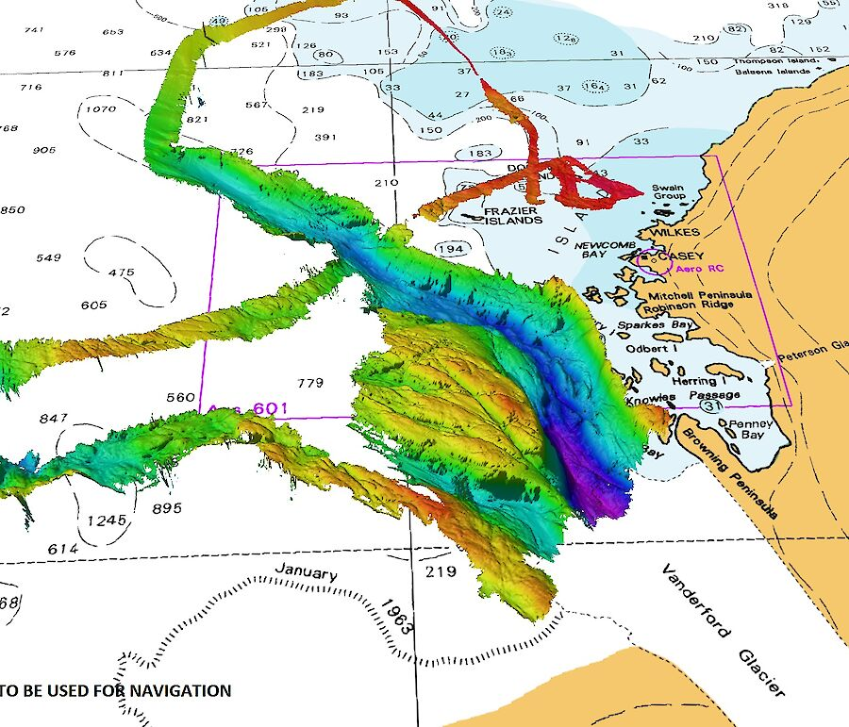

*The AAD acoustics team used Nuyina’s multibeam echosounders to map more than 840 square kilometres of the seafloor in front of the Vanderford Glacier, following a canyon more than 55 kilometres long, and 2200 metres deep at the deepest point mapped (in purple). Hydrographic Material reproduced with permission of The Australian Hydrographic Office © Commonwealth of Australia 2022.*

Significant field programs included the multi-national collaborative project *Old-growth mosses as proxies for past Antarctic climates*, which utilised ‘moss cores’ as proxies for climate change. Researchers from Australia, New Zealand, Chile and the Czech Republic are collaborating on this project, which included field-work from Casey research station in the 2021-22 season utilising drone technologies for data collection. The first fieldwork for the *Securing Antarctica’s Environmental Future* (SAEF) project, led by Monash University was also commenced, with the collection of rock samples at Haupt Nunataks and Browning Peninsula, lake samples throughout the Windmill Islands and soil samples at Browning Peninsula to inform studies of climate processes and change and biodiversity status and trends. Field activities also included an episodic retrieval of ice core material from Law Dome, providing for ongoing updates of this climate record now stretching more than 30 years from recovery of the original core.

Marine science projects throughout the period included the retrieval of a Krill Observation Mooring for Benthic Investigations (KOMBI) in support of an ongoing sustainable krill fishery management project and the retrieval and redeployment of passive whale acoustic recorders (in support of the *Conservation and management of Australian and Antarctic whales* project). These underwater moorings are deployed for many months at a time, and collect data that provides important insights into the distribution and abundance of krill and whales. These data and associated insights are used in the preparation of submissions to CCAMLR on krill biomass and krill predators and the IWC on the status of Southern Ocean whales.

A number of significant manuscripts were published during the period, with highlights including:

* the seminal work of Australian Bureau of Meteorology and Australian Antarctic Division scientists to document changes in Antarctic coastal exposure over the past four decades [1]
* insights into Eastern Australian Climate risk, from analysis of the Interdecadal Pacific Oscillation over the last 2000 years - a collaboration between researchers from the University of Tasmania’s Institute for Marine and Antarctic Studies, University of Newcastle and Australian Antarctic Division [2]
* population modelling of emperor penguins led by the Woods Hole Oceanographic Institute in the United States with contributions from the Australian Antarctic Division, that suggest the species will become “quasi-extinct” by 2100 if sea ice declines as projected [3]
* a paper co-authored by the Australian Antarctic Division, with contributions from further collaborators in Australia, New Zealand and the United States on observations of the Antarctic ozone hole through 2020 to 2021. Their research showed a significantly larger daily hole area than the previous year, with the findings linked to low temperatures in the Antarctic lower stratosphere [4]
* a study led by scientists from the Institute for Antarctic and Marine Studies at the University of Tasmania and the Australian Antarctic Division assessed climate change impacts on habitats that are known to be important for krill growth. The study found that there were shifts in seasonal timing of habitat quality, and that regions likely to experience declines in habitat quality were concentrated near the northern limits of krill distribution [5].

Australian Antarctic Strategy and 20 Year Action Plan Update

Australia has reviewed and updated its *Australian Antarctic Strategy and 20 Year Action Plan* (the Strategy and Action Plan), first released in 2016. The Strategy and Action Plan sets out Australia’s Antarctic interests and vision for future engagement in Antarctica and the update further strengthens Australia’s scientific capabilities in the region.

New measures in the Strategy and Action Plan expand Australia’s scientific capability, including for:

* research focused on Antarctic ice sheet science to build global understanding of climate change impacts;
* marine science in the Southern Ocean and a new state-of-the-art krill aquarium in Hobart;
* Australia’s new icebreaker, RSV Nuyina, to focus on extended scientific voyages by providing logistical shipping support; and
* new research to improve our understanding of Antarctica and the Southern Ocean’s role in the global climate system by expanding Australia’s logistical capability, including new long‑range helicopters and autonomous vehicles.

Antarctic Science Strategic and Decadal Plans

Australia has commenced the development of a decadal plan for Antarctic science that will set out priority science questions and research priorities. The decadal plan will deliver on the Australian Antarctic Strategy and 20 Year Action Plan and builds on the Antarctic Science Strategic Plan (Attachment 1). The decadal plan for Antarctic science is expected to be completed by the end of 2022.

Major Ongoing Research Partnerships

In addition to the Antarctic research led by the Australian Antarctic Division, Australia has three major Antarctic research partnerships to deliver integrated and collaborative science under the Australian Antarctic Science Strategic Plan:

* **Australian Antarctic Program Partnership** – includes the University of Tasmania with partners from the Australian Antarctic Division and agencies with Antarctic research interests. This program focusses on improving the understanding of the role of Antarctica and the Southern Ocean within the global climate system and its implication for marine ecosystems. It has a strong focus on teaching and early career researcher development.

**Excellence in Antarctic Science Special Research Initiative** (Australian Research Council):

* **Securing Antarctica’s Environmental Future** (led by Monash University) – this is an international research program with interdisciplinary science focussed on climate processes and change, biodiversity status and trends, and supporting environmental stewardship.
* **Australian Centre for Excellence in Antarctic Science** (led by University of Tasmania): this program conducts research into changes that are happening in the Antarctic and Southern Ocean and the impact those changes are having on the global climate system.

Australian Antarctic Science Program Research Priorities

The Australian Antarctic Science Strategic Plan guides the development and operations of the program in alignment with the plan’s research priorities. These include four thematic areas:

* Environmental protection and management
* Ice, ocean, atmosphere and earth systems
* Human presence and activities in Antarctica
* Digital integration

There are two major ongoing projects within these theme areas.

* **Million Year Ice Core:** Australia continues its progress towards drilling a deep ice core at Little Dome C (some 30 km south of Dome C and Concordia Station (Italy/France)). During December 2021, coordinates for the million-year drill site were finalised, with analysis of the location indicating undisturbed ice that will provide a record likely to extend back 1.4 million years in age. In December 2021, Australia conducted the first operational testing of the million-year ice core drill in Antarctica.
* **Krill Research:** Analysis of krill biomass resulting from the TEMPO expedition in March 2021 has continued, including observations resulting from the KOMBI moorings in support of an ongoing sustainable krill fishery management project. Research on krill reproduction, development and physiology, and the response of krill to the effects of climate change remain a high priority for the Australian Antarctic Science Program and the Australian Antarctic Division. This research contributes to Australia’s engagement in CCAMLR and in particular the work of its Scientific Committee**.**

References

1. Reid, P. A., & Massom, R. A. (2022). Change and variability in Antarctic coastal exposure, 1979–2020. *Nature Communications*, 13(1), 1-11.
2. Vance, T. R., Kiem, A. S., Jong, L. M., Roberts, J. L., Plummer, C. T., Moy, A. D., ... & van Ommen, T. D. (2022). Pacific decadal variability over the last 2000 years and implications for climatic risk. *Communications Earth & Environment*, 3(1), 1-9.
3. Jenouvrier, S., Che-Castaldo, J., Wolf, S., Holland, M., Labrousse, S., LaRue, M., Wienecke, B., Fretwell, P., Barbraud, C., Greenwald, N., Stroeve, J., & Trathan, P.N. (2021). The call of the emperor penguin: Legal responses to species threatened by climate change. *Global Change Biology, 27*(20), 5008-5029
4. Stone, K. A., Klekociuk, A. R., & Schofield, R. (2021). Future changes in stratospheric quasi-stationary wave-1 in the extratropical southern hemisphere spring and summer as simulated by ACCESS-CCM. *Journal of Southern Hemisphere Earth Systems Science*, 71(2), 181-193.
5. Veytia, D., Corney, S., Meiners, K. M., Kawaguchi, S., Murphy, E. J., & Bestley, S. (2020). Circumpolar projections of Antarctic krill growth potential. *Nature Climate Change*, 10(6), 568-575.