Conclusions of the UN Ocean Conference 2022 in Lisbon, Portugal

Conclusions of the UN Ocean Conference 2022 in Lisbon, Portugal

Information Paper submitted by Portugal, France, Sweden and WMO

Summary

In 2022, Portugal co-hosted – alongside Kenya – the second UN Ocean Conference in support of the implementation of UN Sustainable Development Goal 14 (Conserve and sustainably use the oceans, seas and marine resources for sustainable development). At least 4 events related to the Antarctic and Southern Ocean were carried out during the UN Oceans Conference. The declaration “Our ocean, our future, our responsibility” was adopted, by consensus, by the conference. France and Costa Rica declared their availability to host the third UN Oceans Conference. The information on the relevance of the Antarctic region and the work of the Antarctic Treaty System in future UN Oceans conferences will surely be welcomed.

Background

The Antarctic Treaty has an important role in sharing and promoting Antarctic research with the World community, in accordance with Art. III of the Antarctic Treaty (ATCM XLII/IP68). The United Nations 2030 Agenda for Sustainable Developments and its 17 Sustainable Development Goals (SDGs) aim to address global challenges facing humankind, including issues that overlap with some of the provisions of the Antarctic Treaty (Ex. Art. I, II and III), such as climate change, ocean threats and gender equality. The aim of this paper is to provide the conclusions of the UN Ocean Conference, that took place in Lisbon 2022 (ATCM XLIV/IP3).

**Conclusions of the 2022 UN Oceans Conference (UNOC)**

Organized by Portugal and Kenya, the UN Ocean Conference took place in Lisbon, between the 27th June and the 1st July 2022 (https://www.un.org/en/conferences/ocean2022). The Conference held eight interactive dialogues addressing themes related to the different targets under SDG 14, thus exploring the key role and the potential partnerships can bring to the full implementation of SDG 14 and other Ocean-related SDGs. Another key outcome of the Conference was the adoption of an action-oriented political declaration, focused on essential areas where solutions based on science and innovation can play a transformative role in addressing Ocean challenges.

UNOC gathered approximately 6 500 people from 159 countries, including 181 personalities of political level (I.e. 13 Heads of State, 3 Deputy-heads of State, 9 Heads of government, 124 other members of government, 17 heads of the system of the United Nations and 12 leaders of intergovernmental organizations) and 1178 non-governmental organizations and various entities such as businesses, foundations, Universities and research institutes (Figure 1).

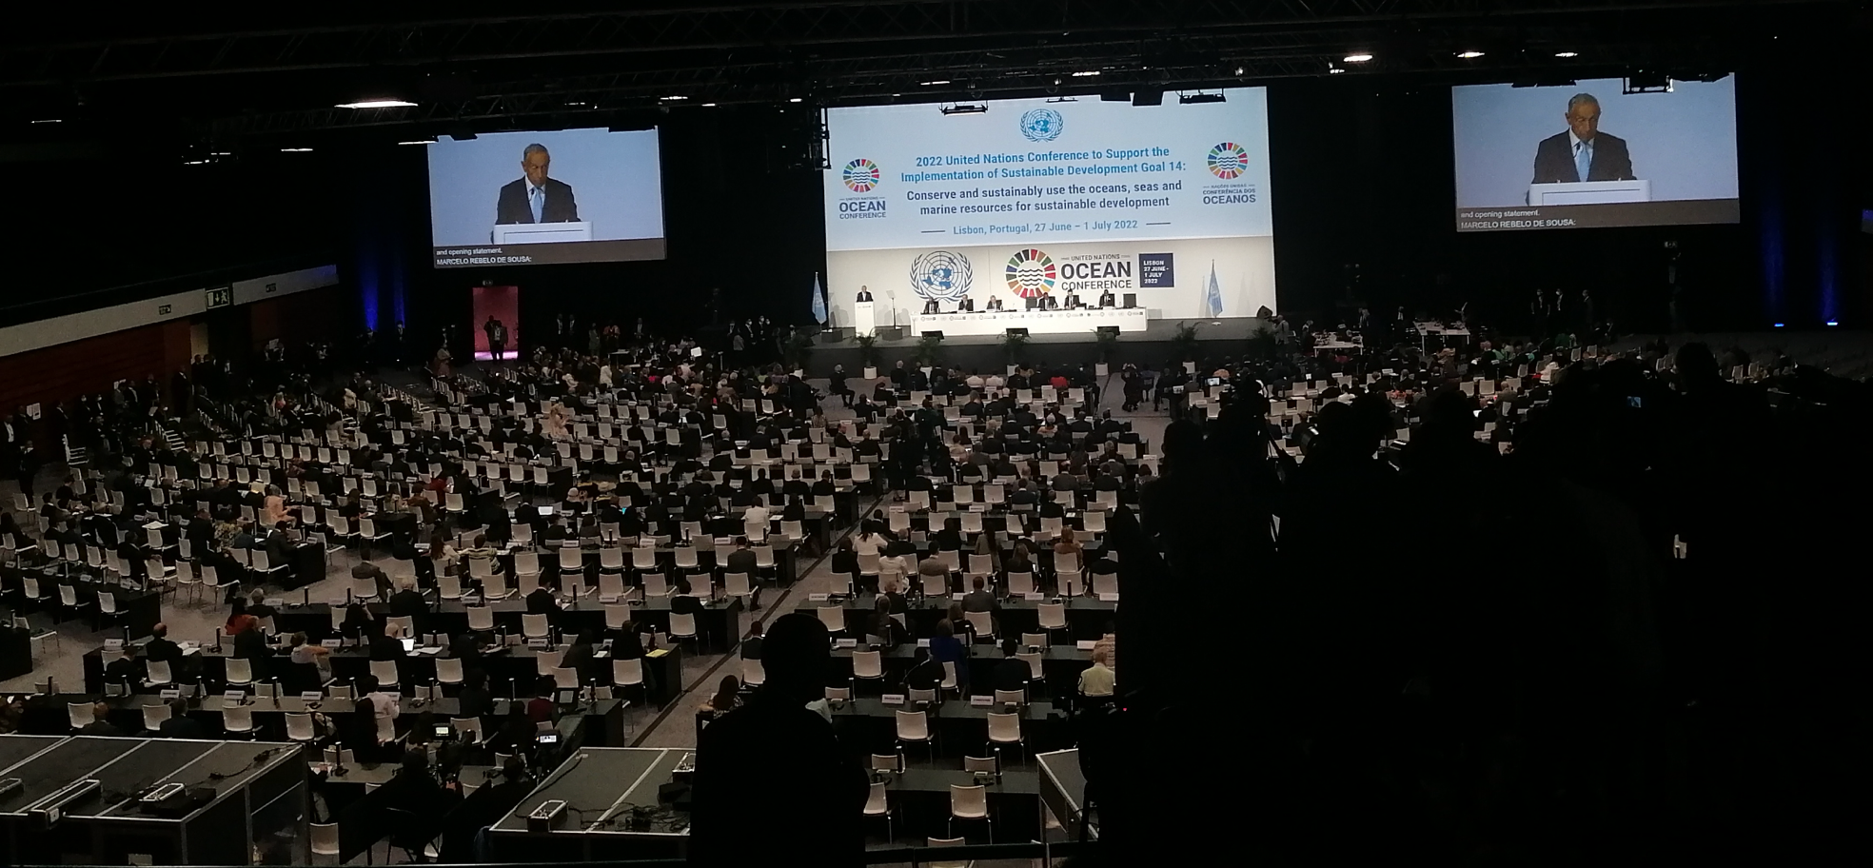***Figure 1.*** *President of Portugal, Prof. Marcelo Rebelo de Sousa, at the opening ceremony of the UN Ocean Conference (Lisbon, 2022).*

At least five events linked to the Antarctic took place, namely:

* “From the Southern Ocean to the Arctic – a call to action via the UN Ocean Decade” to bring together polar ocean initiatives and leading polar experts and discuss cross-cutting issues at the poles and provide insights for actions to the UN Decade of Ocean Science for Sustainable Development. It was organized by the European Polar Board, Royal Belgium Institute of Natural Sciences, Scientific Committee on Antarctic Research (SCAR), Southern Ocean Observing System, Scientific Committee on Oceanic Research, World Climate Research Programme (WCRP), the Climate and Ocean – Variability, Predictability, and Change (CLIVAR) of WCRP, Integrating Climate and Ecosystem Dynamics in the Southern Ocean and Prince Albert II of Monaco Foundation,
* “Polar oceans: Engine to the global ocean-Messages and Messengers” to raise awareness to the role of the Southern and Arctic Oceans in driving ocean and climate change. It was organized by Prince Albert II of Monaco Foundation, Oceanographic Institute - Prince Albert I of Monaco Foundation, Oceano Azul Foundation, SCAR, International Arctic Science Committee (IASC), International Cryosphere Climate Initiative (ICCI) and European Polar Board,
* “Antarctica, microplastics and conservation photography: How Portuguese researchers are leading international marine research and public engagement in ocean protection” to address three societal challenges to promote ocean conservation and potential solutions to them. It was organized by the Marine and Environment Sciences Centre (MARE),
* “Ocean Research: the future for science collaboration” to discuss science, data collection, mobility and capacity building issues in which the Antarctic was provided as an example. It was coordinated by the British Embassy in Portugal.
* “Polar regions in a changing climate: ocean solutions through science to services” to raise discussion about the Arctic and Antarctic, including identification of gaps and needs in ocean and ice observations, improved methods for assimilating these data into Earth prediction models, and recommendations for how best this can be achieved through a coordinated approach to services. It was coordinated by the World Meteorological Organization (WMO) in collaboration with University of Lapland (Finland); Environment and Climate Change Canada; US National Ocean and Atmospheric Administration (NOAA), Ministerie de Defensa Republica Argentina; and UNESCO Intergovernmental Oceanographic Commission (IOC). See https://public.wmo.int/en/events/events-of-interest/wmo-side-event-un-ocean-conference-polar-regions-changing-climate-ocean

The declaration “Our ocean, our future, our responsibility” was adopted by the Conference[1]. Its following nine objectives should be highlighted:

* Adoption of urgent measures to accelerate the achievement of SDG14 targets, thus contributing significantly to the delivery of the 2030 Agenda.
* Recognition of the Climate-Ocean links and the need of more actions to tackle climate change
* Need to increase decisions and solutions based on science and technological innovation
* Develop a sustainable Blue Economy, compatible with the protection of biodiversity and value of the natural marine resources, including the commitment to protect 30% of marine areas by 2030. More than 100 member states agreed to goal.
* Address plastic and litter pollution via the negotiation of a global agreement, with the commitment to prevent, reduce and control marine pollution, including single use plastics.
* Swift conclusion of the treaty on the conservation and sustainable use of marine biodiversity in areas beyond national jurisdiction (BBNJ)
* Clear directives towards fisheries, with the objective of restoring and maintaining populations at levels that produce, at least, the maximum sustainable yield in the least possible time, through plans of management, fighting illegal/not declared/not regulated fishing, and the end of harmful subsidies, in line of the target 14.6, protecting therefore, the contribution of healthy oceans for the resilience of feeding systems
* Strengthen the connections between SDG6 and SDG14
* Reinforce private-public partnerships, with the objective of promoting solutions of innovative finances, raising the viability of projects and reinforce the support of developing countries, especially in relation to capacity building, funding and transfer of technology.

In addition to these objectives, nearly 700 new voluntary commitments were noted, addressing issues such as the global number of marine protected areas (goal 30 x 30: protect 30% of marine habitats by 2030), obtaining a global agreement to fight plastic pollution and the support of the establishment of a legal international framework for BBNJ.

France and Costa Rica declared their availability to co-host the third UN Oceans Conference in 2025. The Antarctic Treaty System has the capacity and expertise and will certainly be a contributor to the success of this event.

1. https://sdgs.un.org/sites/default/files/2022-06/UNOC_political_declaration_final.pdf