Addressing critical knowledge gaps identified by the IPCC in Antarctica’s future contribution to sea level rise by international collaboration

In support of WP39

Addressing critical knowledge gaps identified by the IPCC in Antarctica’s future contribution to sea level rise by international collaboration

Summary

ATCM XXL WP0039 *DML-RINGS and Enderby Land RINGS – opening extensive international collaboration to close critical data gaps for sea-level projections* (Norway, Germany, Australia, Belgium, China, Finland, India, Japan, Sweden, United States) suggests that Parties lend their support to the pan-Antarctic RINGS initiative and encourage coordinated regional efforts to close data gaps, using the DML and Enderby Land effort as a useful example and test case for the broader Antarctic needs. This Information Paper provides further information about the societal and scientific rationale of the RINGS initiative, as well as information about the regional efforts initiated to contribute to RINGS and points to further published information related to this.

The bed topography at the Antarctic margins and its link to sea level rise

The Antarctic Ice Sheet is the largest freshwater mass on Earth, holding a volume of water equivalent to 58 meters of global sea level rise. Accurate projections of the future evolution of the ice sheet are essential for mitigating potential risks to people and infrastructure along continental coastlines and on low-lying islands.

The bed topography around Antarctica’s margins fundamentally affects the dynamics of ice flow and the vulnerability of glaciers and ice shelves. Warm ocean water is routed under the ice shelves and melts the base of the ice shelf near the grounding line (see the illustration). It may trigger the retreat of the grounding line and acceleration of the ice discharge. These processes largely depend on the bed topography under the ice. For example, seabed valleys under the ice shelves may act as a highway to deliver warm ocean water to the grounding line. Small bed bumps near the grounding line may act as a stopper of initial retreat. Mapping such features is fundamentally important to predict the future of the Antarctic Ice Sheet in the coming centuries. Despite its importance, the bed topography around Antarctica’s margins remains poorly known.

Nearly three quarters of the ice-sheet margin comprises floating ice shelves. When ice is discharged across the grounding line to the ice shelf, it contributes directly to sea level rise. Quantifying the ice discharge from the ice sheet to the ice shelf therefore requires accurate measurements of ice thickness and flow speed at the grounding line.

Whereas ice thickness can change relatively rapidly, the elevation of the bed does not change significantly over decadal timescales. So once the bed topography is measured, future thickness changes of the grounded ice as well as flow speed can be monitored with ice sheet surface elevations measured by satellites.

The emerging SCAR initiative RINGS aims to measure bed topography using airborne radar and gravimeter and to collect other key data to characterize the coastal regions all around Antarctica. It is multi-disciplinary science that can be made as an integrated effort of science and logistics and has a direct and immediate impact for the society.

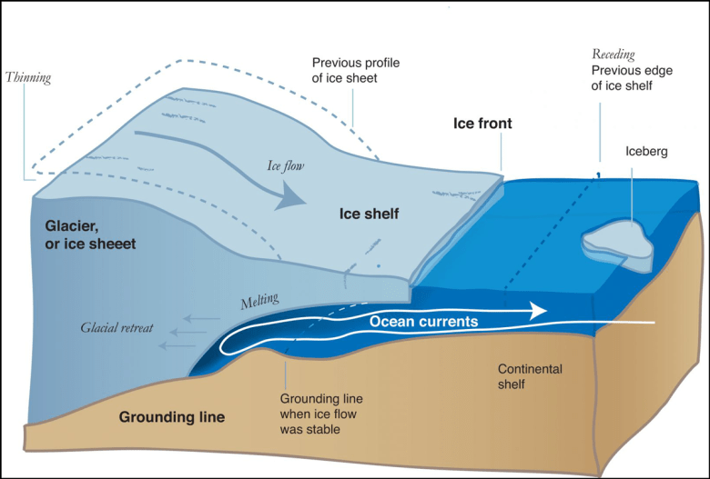

*Fig. 1. The grounding line, where ice on land meets the ocean and begins to float, is retreating or will retreat in many regions of Antarctic Ice Sheet, primarily because of ocean-induced melting under floating ice shelves. Grounding line retreat is governed by the interplay among ocean circulation, ice dynamics, and bed topography; areas where ice recedes over a retrograde slope, as depicted here, may be especially vulnerable. Credit:*[*National Snow and Ice Data Center*](https://nsidc.org/about/monthlyhighlights/2015/09/paving-runway-runaway)*, NASA*

Collecting bed topography data from airplane

We are not yet capable of measuring ice thickness and bed topography with satellite-based instruments, so large-scale bed topography under the ice is still measured by airborne radar. Local features are also measured by ground-based radar surveys. However, radar does not always detect the bed clearly in challenging cases, such as when the ice surface is highly crevassed or when the ice lies in deep and steep valleys. In such cases, gravity data measured from airplanes can be inverted to estimate bed elevation and ice thickness.

Analysis done in context of the RINGS initiative has revealed poor data coverage in coastal regions. Only 12% of the grounding line is within 1 kilometer of a radar data point; nearly 50% of the grounding line is not within 6 kilometers of a data point, and about 28% of the grounding line is not within 20 kilometers of a data point. Data coverage is better for fast-flowing glaciers than for slow-moving ice in many regions, but even for glaciers that are well studied, data are not always available continuously along the margin. The reason is that radar data are often collected along ice flow lines, rather than across the glacier, for ice flow modeling purposes.

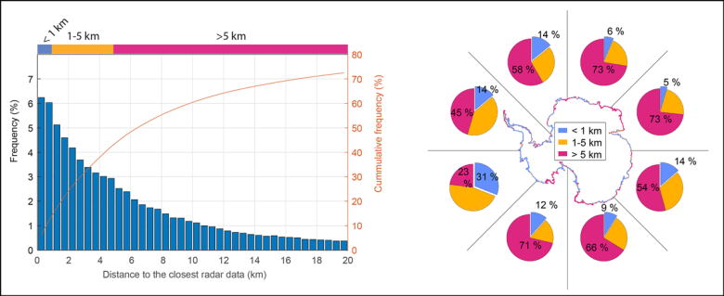

*Fig. 2. Plotting proportions of the Antarctic Ice Sheet margin (i.e., at the grounding line) according to the proximity of the nearest radar-measured bed elevation data point shows that only 12% of the margin currently has at least one data point within 1 kilometer and nearly 28% of the margin has no data points within 20 kilometers (left). Data availability varies considerably by region (right), with some East Antarctic regions standing out for their sparsity of data (e.g., at one o’clock and two o’clock in the diagram). Even in the region including the relatively data rich Amundsen Embayment (eight o’clock), nearly a quarter of the margin has no data within 5 kilometers. Source: Matsuoka et al. (2022)*

Closing the gap through RINGS

SCAR RINGS is an international initiative that aims to collect a comprehensive airborne data set from the Antarctic Ice Sheet margin to better estimate ice discharge and sea level contributions today and in the future. RINGS aims to organize individual efforts to carry out three vital rings of pan-Antarctic surveying. The primary survey will follow the grounding line around the perimeter of Antarctica, and the other two will cover the seaward and landward sides of the grounding line. Completing the RINGS surveys will require an international, pan-Antarctic collaboration that integrates existing and novel technical and logistical capabilities of numerous countries.

There is an ongoing effort to carry out regional surveys in Dronning Maud Land and Enderby Land. These two regions are adjacent to each other but serve as distinct examples from which lessons can be taken to plan RINGS surveys in other regions. Many nations actively work in Dronning Maud Land and already have strong collaborative relationships. Also, there is ample of data in this region, which can be used to guide our further study to develop a comprehensive dataset. On the other hand, Endebry Land is the largest data gap in the context of RINGS (see the histogram and map above), and there has been very little survey efforts historically speaking. It requires to develop new collaboration between nations and starts the RINGS effort with reconnaissance surveys that lead to more comprehensive surveys in later seasons. These efforts are coordinated between scientists and logistics specialists based on lessons from previous regional surveys.

Further information

For further information about the societal and scientific rationale of the RINGS initiative, as well as information about regional efforts initiated to contribute to RINGS see:

* Matsuoka, K., R. Forsberg, F. Ferraccioli, G. Moholdt, and M. Morlighem (2022), *Circling Antarctica to unveil the bed below its icy edge*, Eos, 103, https://doi.org/10.1029/2022EO220276. Published on 15 June 2022.
* RINGS whitepaper *RINGS: Collaborative international effort to map all Antarctic ice-sheet margins*: <https://www.scar.org/library/science-4/physical-sciences/rings/5768-white-paper-2022>or https://zenodo.org/record/6638327#.ZBwf43bMK70
* Enderby Land RINGS whitepaper *International collaboration is urgently needed for airborne surveys in Enderby Land to fill the largest RINGS data gap:* <https://www.scar.org/library/science-4/physical-sciences/rings/5919-white-paper-2023/> or /<https://doi.org/10.5281/zenodo.7818281>