MSI BROADCASTING OF NAVAREA VI through the World Wide Navigational Warning System (WWNWS)

*English version provided by the author*

**MSI BROADCASTING OF NAVAREA VI through the World Wide Navigational Warning System (WWNWS)**

**Summary**

This report has been drafted with the aim of informing Consultative, non-Consultative Parties and the whole Antarctic community about the broadcasting of NAVAREA VI Navigational Warnings and inviting them to collaborate by providing information of interest to their Coordinator.

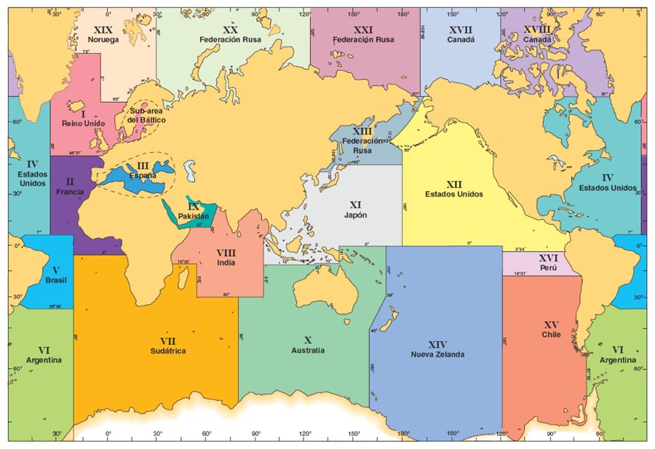

**INTRODUCTION**

The World Wide Navigational Warning System has been successfully used since 1979, which currently comprises twenty-one fully operational NAVAREAS.

If we have a look at the NAVAREAS picture we can see that NAVAREAS XV, XIV, X, VII, and VI cover the Antarctic region, being the Argentine Republic the coordinator of NAVAREA VI and the *Servicio de Hidrografía Naval* the authority in which the coordination vests.

**GLOSSARY**

For a better understanding, it is necessary to set forth some of the definitions governing this service:

***NAVIGATIONAL WARNING:***

a broadcast message containing urgent information relevant to safety in navigation

***NAVAREA Zone:***

Geographical sea area established for the purpose of coordinating the broadcast of navigational warnings. The term NAVAREA followed by a roman numeral may be used to identify a particular sea area. The delimitation of such areas is not related to and shall not prejudice the delimitation of any boundaries between States.

***NAVAREA Coordinator:***

Authority charged with coordinating, collating and issuing NAVAREA warnings for a designated NAVAREA.

***NAVAREA WARNING***

Navigational warning issued by a NAVAREA Coordinator for its zone.

In general terms, NAVAREA WARNINGs provide reliable information for mariners to navigate safely, safeguarding human life at sea and protecting the marine environment.

In particular, they include information about the following subjects, namely:

1. Casualties to lights, fog signals, buoys and other aids to navigation affecting main shipping lanes;
2. The presence of dangerous wrecks in or near main shipping lanes and, if relevant, their marking;
3. Establishment of major new aids to navigation or significant changes to existing ones, when such establishment or change might be misleading to shipping;
4. The presence of large unwieldy tows in congested waters;
5. Areas where search and rescue (SAR) and anti-pollution operations are being carried out (for avoidance of such areas);
6. The presence of newly discovered rocks, shoals, reefs and wrecks likely to constitute a danger to shipping, and, if relevant, their marking;
7. Unexpected alteration or suspension of established routes;
8. Cable or pipe-laying activities, seismic surveys, the towing of large   
   submerged objects for research or exploration purposes, the employment of manned or unmanned submersibles, or other underwater operations constituting potential dangers in or near shipping lanes;
9. The establishment of research or scientific instruments in or near shipping lanes;
10. Significant malfunctioning of radio-navigation services and shore-based maritime safety information radio or satellite services;

Notices to mariners NAVAREA:

List of the series numbers of the NAVAREA WARNINGS in force issued and broadcasted by the NAVAREA Coordinator during a period covering at least the last six weeks.

**PROPOSAL:**

1. Take note of the importance of informing NAVAREA VI Coordinator about the news related to safety of navigation, some of them listed in the Glossary under the NAVAREA WARNING title, aimed at enhancing safety of navigation for the benefit of safeguarding human life at sea and the protection of the marine environment.
2. Advice Member States to inform mariners and tourist operators (IAATO) that organize cruises to the Antarctic about the availability of forms to report news affecting safety of navigation in NAVAREA VI.
3. Request mariners to inform NAVAREA VI Coordinator about anomalies and failures of these signals or any other information that they may consider relevant for the broadcasting of a NAVAREA WARNING.
4. In order to enable the communication, an online form in Spanish and English languages has been uploaded on www.hidro.gov.ar. Conversely you can also send an e-mail to snautica@hidro.gov.ar or through postal mail to the following address:

Servicio de Hidrografía Naval

Avda. Montes de Oca 2124 (C1270ABV)

Ciudad Autónoma de Buenos Aires

República Argentina