Finalizing the construction of the gravel runway in the area of Mario Zucchelli Station, Terra Nova Bay, Victoria Land, Antarctica

**Finalizing the construction of the gravel runway in the area of Mario Zucchelli Station, Terra Nova Bay, Victoria Land,**

**Antarctica**

**Information Paper submitted by Italy**

1. ***Summary***

To increase the reliability of the transport system of the Italian National Antarctic Programme (PNRA), Italy proposed, several years ago, the construction and operation of a gravel runway in the area of Mario Zucchelli Station (MZS), Terra Nova Bay, Victoria Land, Antarctica.

A Draft of Comprehensive Environmental Evaluation (CEE) was prepared by ENEA-UTA, which is in charge of the implementation of the PNRA, logistics and maintenance of the stations, and by CNR for the scientific contributions related to the initial state of the environment. During ATCM XL, the Final CEE was proposed and approved. The Italian Ministry of Research provided funding for this infrastructure, whose realization was carried on by ENEA-UTA, in cooperation with the Italian Air Force and Fire Department.

A first update on ongoing works was presented to Parties in 2019, with IP109 (ATCM XLII). In 2020 and 2021 the runway construction experienced a forced slowdown due to the pandemic and some financing issues. Maintenance works were in any case performed, in order to maintain the surface operational for Basler aircraft landing, when the sea ice runway was no longer available.

In 2022, during the 38th Italian expedition, the main works were finalized and a first landing attempt of the C-130J of the Italian Air Force was successfully performed.

A total length of 1700 m has been realized together with an apron of 130x134 m. The runway has a double slope of 1% from the centre of the runway lengthwise, to allow an easier drainage of water from melted snow.

When fully operational, this runway will allow a more flexible turnover in Antarctica for Italian and other Antarctic Programs personnel, so contributing to develop international and multidisciplinary agreements and research activities.

1. ***Technical works performed***

The Boulder Clay runway will be the first runway constructed on a moraine. Several studies indicated the place as suitable being on an almost stagnant glacier ice. The embankment, whose function is also to protect the underneath ice from ablation or melting, has been realised as an open aggregate, to ensure a high air permeability, and was constructed using the material available in the nearby areas. The first sub-base layer is composed of crushed rock poorly graded and gravel put in place as it is. The final surface layer is composed of meshed material from coarse to fine gravel compacted with a steamroller.

Constructions works started in 2017.

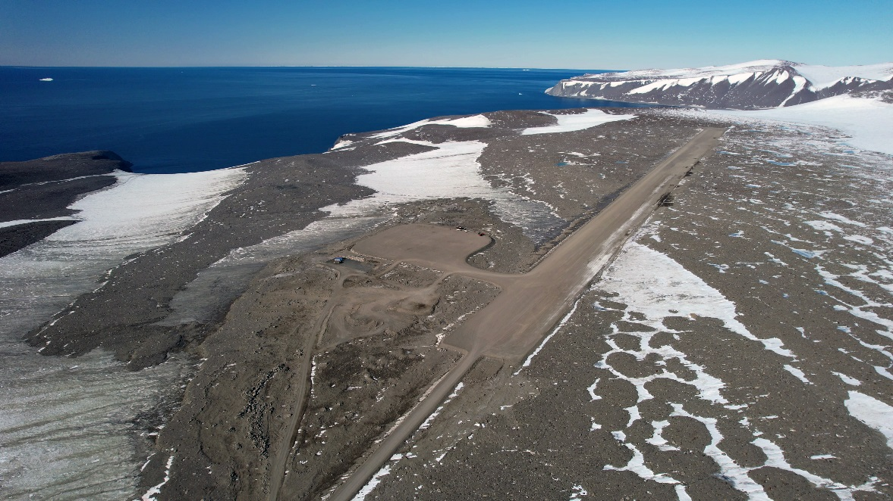

*Fig.1 overview of Boulder Clay site with the realized gravel runway and apron*

The following facilities were realized (Figure 1):

* an access road from MZS re-using the pre-existing road from MZS to Enigma lake;
* a gravel embankment 1700 m long and 60 m wide, adequate for landing with C130. The first 700 m of the runway have a slope of 1%, between 700 and 800 m the slope is 0%, and from 800 forwards it is -0.8%;
* an apron (130x134 m) and a small taxiway (70 m long, 25 m wide) to connect the runway with the apron;
* a service area (70x22 m).

Some unplanned works originated from on-site experience. Uncontrolled flow of melted water from the moraine could determine future deterioration of the infrastructure caused by the creation of underground holes. Therefore, along the runway, a contour ditch needed to be digged and two drainage pipes were placed under the runway, at 1480 m and 1600 m, to allow a controlled crossing of the embankment from a collecting drain point.

Differential GPS measurements were performed as well as drone surveys to produce a 3D model of the surface allowing rapid evaluation of planarity and corrections needed.

a)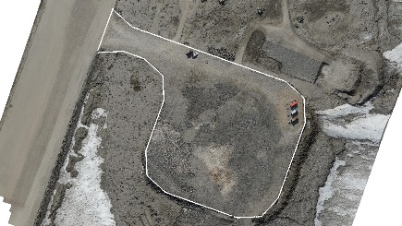 b) 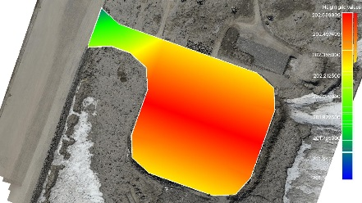 c) 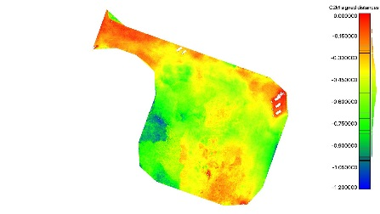

*Fig. 2 drone survey of the apron surface: a) apron surface in Nov 22; b) desired final heights in order to minimize filling material; c) indications of zones of intervention.*

These data were useful to limit the amount of material to excavate from the quarries.

1. ***First landing of C130-J***

On November 21st, the C130-J of the 46th Air Brigade of the Italian Air Force landed successfully for the first time on the runway (Fig. 3). Prior to the landing, inspections and CBR measurements were made according to the ASTM E2583-07 protocol and the runway was classified according to NATO ATP-3.3.4.4 procedure. No refuelling was needed because operations of the C130-J aircraft had been diverted to McMurdo because of unprecedented low thickness of sea ice in Terra Nova Bay. Support from the American Program USAP was essential for intercontinental operation in the 2022-2023 summer season.

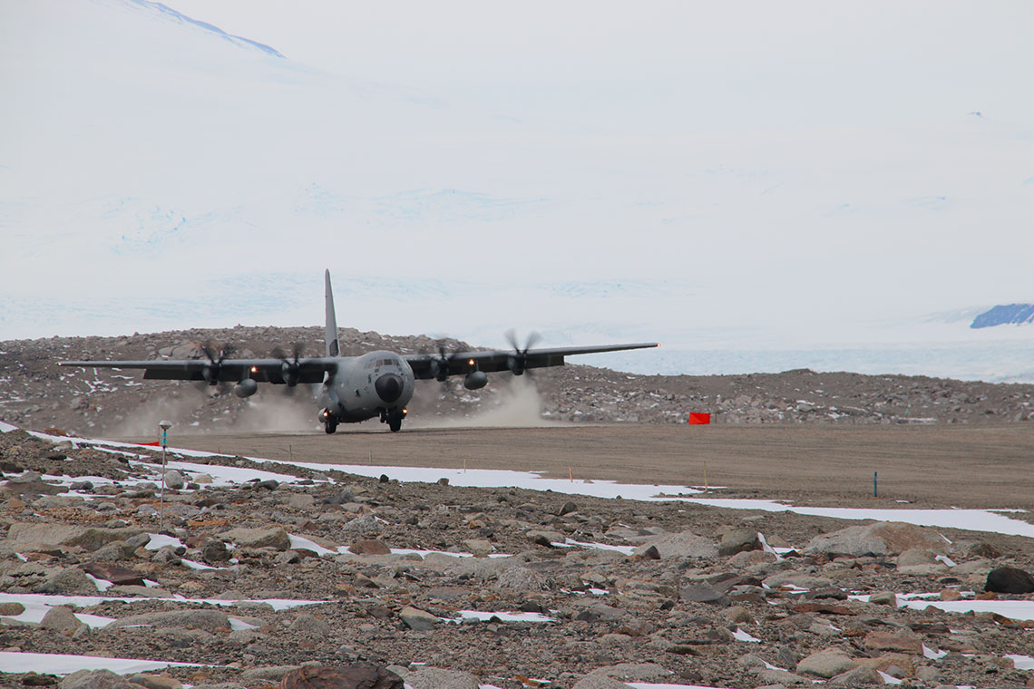

*Fig. 3. C130-J of Italian Air Force successfully landing at Boulder Clay*

Formation of dust was observed upon landing, also as a result of the non-completed finishing of the final layer. In the next season, finishing works will be performed. Some laboratory tests will also be carried out this year to identify possible solutions to limit dust formation, including at the aircraft operational level.

1. ***Environmental impact***

In the Final CEE the conclusion was that proposed construction and operation of a gravel runway in the area of Mario Zucchelli Station would likely have a “more than a minor or transitory” impact on the environment. In the construction phase, there have been an unavoidable release of exhaust gases and particulate matter (PM10) from the operation of trucks, vehicles and generators, and of dust produced by scraping of the surface, rock crushing and screening using heavy equipment.

The total excavated material, up to now, has been around 320,000 m3 (roads, apron and runway). The total fuel consumption, up to now, has been 447,536 L of JET-A1 with additive.

An Environmental Monitoring Plan (EMOP) has been proposed by ENEA and CNR in order to evaluate the impacts of the proposed infrastructure. The mainly interested environmental compartments are permafrost, fauna, vegetation and air quality. Once the construction works are completed, a full report of the construction phase will be elaborated.

Air quality has been monitored at 5 sampling points, for SO2, NO2 and organic compounds by passive sampling and for PM10 and PM10 composition (heavy metals and polycyclic aromatic hydrocarbons PAHs), only in one point, with a high-volume sampler when electrical power was available. PM was also monitored occasionally with an optical particle counter. Campo Icaro, a location at around 3 km from MZS and 600 m from the road leading to the runway, served for the last 25 years as clean baseline reference for the activities at MZS. Campo Icaro historical data set will also be used as a baseline reference for evaluating changes on air quality related to the operations at the runway.

Concerning heavy metals (As, Cd, Ni, Pb) in PM10, results indicate an increase of As, Pb and Ni compared to the baseline levels of Campo Icaro, while for Cd no increase was observed. Data are well below the threshold values of the Italian legislation (D.L.155/2010), which are 20 times higher for Nickel, 60 times higher for Arsenic and 3 orders of magnitude for Cadmium and Lead.

Concerning gaseous contaminants revealed by passive sampling (SO2, NO2) concentrations resulted always below the detection limit of 1g/m3 and around 2 orders of magnitude lower than the threshold values of the Italian legislation. No particulate contamination seems to reach sampling point P5 that corresponds to the farther limit of the construction site. Wind conditions may have an effect on measures.

Concerning flora and fauna, as previously reported (IP109 ATCM XLII), a pilot project within the EMOP has carried out actions for the transplantation of vegetation patches. No apparent changes in behaviour were recorded in the penguin colony of Adelie Cove, located approximately 2000 m meters from the closest point of the runway, as a result of construction works.

Microorganism presence in brine samples collected near the ice blisters of two adjacent lakes at Boulder Clay are currently analysed in the frame of a PNRA research project, in relation to the biodegradation capabilities on contaminants.

Concerning moraine and permafrost, since the beginning of activities, in collaboration with the personnel from the geodetic observatory of MZS, the moraine of Boulder Clay was subject to annual geodetic measurement to check its deformation. No major displacement has been observed until now. The moraine and permafrost were inevitably impacted by construction works, as there was the need to avoid excessive snow accumulation and to create a controlled drain for melted waters in January. The CALM grid for monitoring of the active permafrost layer has been updated, and is currently part of a PNRA research project.

Concerning dust formation, in 2023-2024 season, some deposimeters will be deployed on site to measure dust deposition.

1. ***Future works***

Next year works will be devoted to the refining and compaction of the final layer, with particular attention to the grading curve. A mechanical sieve and a rock crusher will be used to increase the yield of material. A steam roller will be used for compaction. Preliminary tests showed that addition of a small amount of water to the mixture allows a better compaction and an increased resistance.

Concerning the future fuel deposit, since the beginning it was chosen to store onsite a limited amount of fuel. An empty double walled stainless steel tank (total capacity 30,000 L) has been placed onsite. A specific basement will be prepared. Refuelling of the tank will be provided by a specific truck tank from MZS.

The service area will be equipped with a little parking area for vehicles, a reception structure (MZS terminal) and a shed for maintenance and shelter for vehicles, as for approved project. The design of such structure has been completed and its realization is expected in 2024/2025.