Update on the Australian Antarctic Strategy and 20 Year Action Plan and major initiatives

Update on the Australian Antarctic Strategy and 20 Year Action Plan and major initiatives

**Information Paper submitted by Australia**

Summary

The *Australian Antarctic Strategy and 20 Year Action Plan* update of 2022 affirms Australia’s commitment to the Antarctic Treaty system and to Antarctic science, protection and environmental stewardship. This paper highlights new measures and reports on the progress of major initiatives, including: the state-of-the-art icebreaker, RSV *Nuyina,* Australia’s traverse capability to support drilling for a million-year ice core, and krill research. Looking forward over the next five years, the updated Strategy and Action Plan identifies a number of activities to further strengthen opportunities for Antarctic science.

The Australian Antarctic Strategy and 20 Year Action Plan update of 2022

In 2022, Australia reviewed and updated the *Australian Antarctic Strategy and 20 Year Action Plan* (the Strategy and Action Plan), which was first released in 2016. The Strategy and Action Plan sets out Australia’s Antarctic interests and vision for future engagement in Antarctica. The 2022 update further strengthens Australia’s logistic and scientific capabilities in the region, and reaffirms Australia’s strong commitment to the Antarctic Treaty system to ensure Antarctica remains valued, protected and understood.

New measures in the 2022 update to the Strategy and Action Plan include:

* an expansion of Australia’s scientific capabilities, including:
* research focused on Antarctic ice sheet science to build global understanding of climate change impacts
* new research to improve our understanding of Antarctica and the Southern Ocean’s role in the global climate system supported by logistical capability, including new long‑range helicopters
* logistical shipping support to allow Australia’s new icebreaker, RSV *Nuyina*, to focus on extended scientific voyages, and
* marine science in the Southern Ocean and a new krill aquarium in Hobart.
* greater support for Australia’s environmental management including a ‘Cleaner Antarctica Strategy’, and
* support for Hobart as a gateway to East Antarctica.

The updated Strategy and Action Plancan be found on the [Australian Antarctic Division’s website](https://www.antarctica.gov.au/about-us/antarctic-strategy-and-action-plan/).

Updates on major initiatives

Consistent with the updated Strategy and Action Plan, Australia is continuing with major initiatives announced in 2016, including: making use of Australia’s new, state-of-the-art icebreaker, RSV *Nuyina,* long-term planning for infrastructure upgrades to our Antarctic research stations, contributing to the international efforts to retrieve a million-year ice core, and development of a state-of-the-art krill research facility in Hobart. Information Paper 71 outlines highlights from the Australian Antarctic Science Program in 2022-23.

RSV *Nuyina*

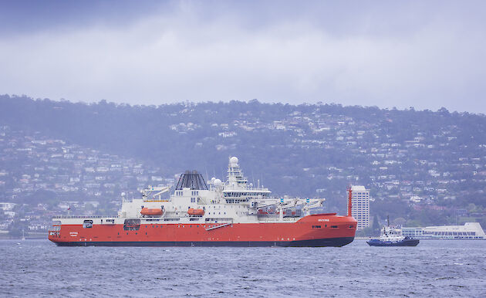

*Figure 1: RSV Nuyina on the Derwent River, Hobart*

Australia’s Antarctic research and resupply vessel, RSV *Nuyina*, was delivered to Hobart in October 2021. *Nuyina’s* maiden voyage to Antarctica departed Hobart in December 2021 to deliver helicopters to Davis research station, refuel Casey research station and commission marine science systems. The vessel’s second voyage saw it retrievehelicopters from Davis research station and conduct a resupply of Macquarie Island research station in March 2022.

Following these two successful voyages, *Nuyina* travelled to Singapore in April 2022 for scheduled warranty work and maintenance. While in Singapore, an unexpected fault was discovered in the large couplings that connect the propulsion shafts with the clutches. Rectification works have been completed and *Nuyina* returned to Hobart in April 2023.

This delay meant the *Nuyina* was unavailable to support Antarctic resupply and continue marine science commissioning over the course of the 2022-23 Antarctic season. Two additional vessels, the icebreaker [*Aiviq*](https://www.antarctica.gov.au/about-antarctica/history/transportation/shipping/mpov-aiviq/)*,* and an ice-strengthened cargo ship [*Happy Diamond*](https://www.antarctica.gov.au/about-antarctica/history/transportation/shipping/happy-d-ships/), were secured to resupply Australian continental stations and transport expeditioners.

TheRSV *Nuyina* is scheduled to depart Hobart in early May 2023 to conduct a resupply and project support voyage to Macquarie Island research station.

Further information about RSV *Nuyina* is available from the Australian Antarctic Division’s dedicated [RSV *Nuyina* website](https://www.antarctica.gov.au/nuyina/stories/2022/nuyina-maintenance-shifts-plans-for-antarctic-season/).

Enhanced traverse capability and million-year ice core

The Traverse and Inland Station Project supports Australia’s involvement in the collaborative Million-Year Ice Core project to recover a million-year ice core to aid climate research.

The first traverse was successfully completed in early 2023. The team departed Casey station on 23 December 2022 traversing a distance of approximately 1200 kilometres arriving at Little Dome C on 10 January 2023. The route from Casey rises to Law Dome, at an elevation of 1500 metres, and then drops down towards the Totten Glacier before ascending to the project site at Little Dome C, at more than 3200 metres above sea level.

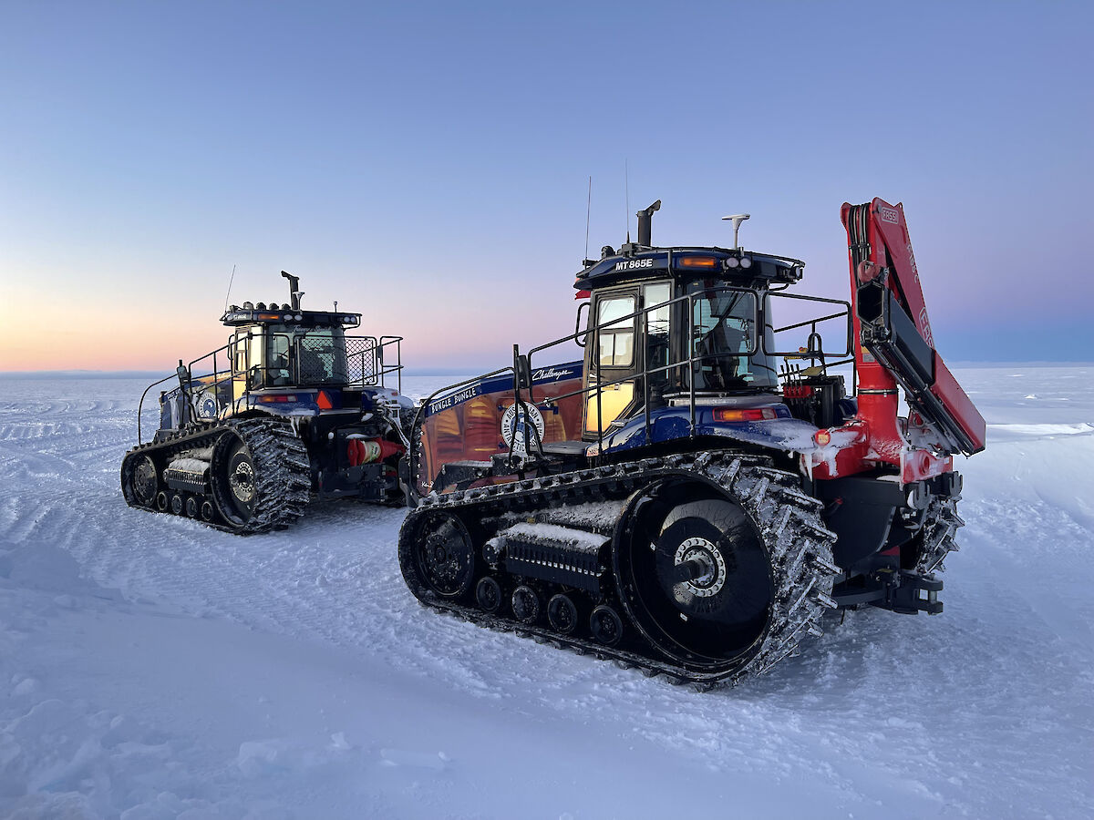

*Figure 2: Traverse tractors*

The traverse team included five bespoke tractors, two snow groomers, sleds, fuel, food and the infrastructure to support 10 people at Little Dome C mobile inland research station and drilling camp for the Million-Year Ice Core project.

Ice core test drilling was completed at Little Dome C in early 2023. Ice cores were successfully transported to gas analysis laboratories in Hobart, thereby proving the cold supply chain for the Million Year Ice Core project. The first full drilling season is expected to commence in the 2023-24 Antarctic summer.

Further information about the [Traverse and Inland Station Project](https://www.antarctica.gov.au/science/climate-processes-and-change/antarctic-palaeoclimate/million-year-ice-core/inland-traverse/) and [Million-Year Ice Core Project](https://www.antarctica.gov.au/science/climate-processes-and-change/antarctic-palaeoclimate/million-year-ice-core/) is available from the Australian Antarctic Division’s website.

Modernising Antarctic research stations

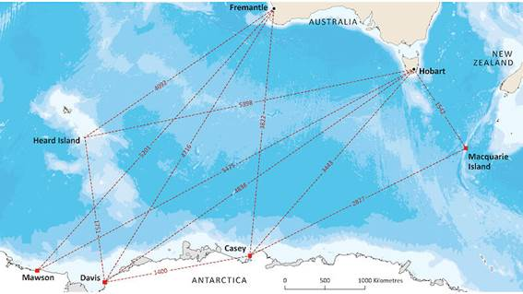

*Figure 3: Australia’s Antarctic research stations*

Long-term planning work is underway to modernise Australia’s Antarctic research stations, including summer facilities at Wilkins Aerodrome. Modernisation works aim to improve operations, revitalise our science programs, and improve environmental sustainability, including:

* Modernise fuel storage, water supplies, energy provision, and communication technology
* Upgrade the heavy vehicles and mobile equipment that maintain our daily operations
* Provide Antarctic doctors with access to cutting-edge medical technology
* Enhance the environmental sustainability of Australia’s research stations, including pathways to lower greenhouse gas emissions
* Improve operational assets such as boats, field huts, and aerodromes
* Provide new science equipment to support leading-edge research and development.

Masterplans are being developed to deliver sustainable world-class facilities to support Antarctic science and operations, as well as addressing the challenges of living and working in Antarctica and supporting diversity, equity and inclusion in the Australian Antarctic program.

Southern Ocean research aquarium (SOra)

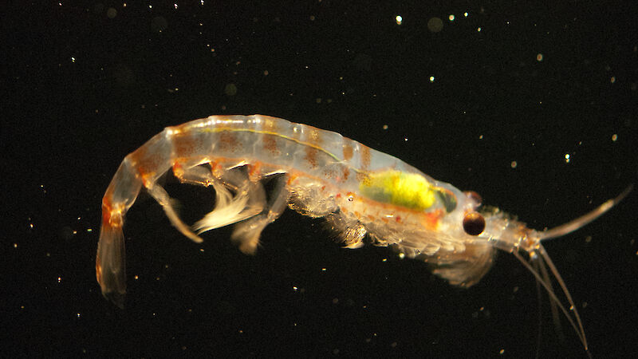

*Figure 2: Close up of krill swimming in laboratory tank. Photo: Robert (Rob) King*

In 2022, the Australian Antarctic Division launched a 10-year Flagship ‘Krill and Krill Ecosystem (KaKE)’ Project to inform the sustainable and ecosystem-based management in the Southern Ocean and to quantify impacts of climate change on krill and the krill ecosystem.

The updated Strategy and Action Plan commits to ensuring the sustainable management of the Southern Ocean krill fishery, and building research infrastructure in Hobart to establish Australia as the world’s leader in krill research. Our current krill research aquarium, the only one of its kind, has long been recognised as an international hub for experimental krill biology.

The new Southern Ocean research aquarium (SOra) will be located at the University of Tasmania’s Taroona site in Hobart and will provide a fivefold increase in capacity from the existing facility. The aquarium is designed to interface with RSV *Nuyina*’s 20-foot aquarium containers to seamlessly transfer live specimens collected in Antarctica to this new state-of-the-art research aquarium facility in Hobart. All approvals to build SOra have been successfully obtained with construction expected to commence in 2023.

In addition, the ‘wet well’ system in RSV *Nuyina* allows the collection and maintenance of live krill and plankton in perfect condition without the need to trawl or stop the vessel. This new concept in sampling is a step change that allows major advances in experimental research.

More information on krill research is available from the [Australian Antarctic Division website](https://www.antarctica.gov.au/news/2022/new-aquarium-under-development-for-antarctic-krill-research/).

Forward activities

The 2022 Update to the Strategy and Action Plan outlines Australia’s commitment to Antarctic science and stewardship. Future activities include to:

* Strengthen Australia’s collaborative relationships with Antarctic nations to capitalise on the capabilities of the RSV *Nuyina* and the new traverse infrastructure, such as:
* collaborative large-scale Southern Ocean marine science research programs with key partners, and
* new opportunities for Antarctic science with Australia’s space and medical sectors, as well as safety, environmental monitoring and communications.
* Implement an enhanced program of mapping and charting of areas in East Antarctica including seabed mapping.
* Establish a regular forum called the *Risk of East Antarctic Collapse & Tipping-points (REACT) Initiative* to cultivate a coordinated international approach to science activities focussed on regions thought to be vulnerable to rapid ice sheet retreat in East Antarctica. A website will be established to foster coordination, collaboration, and relevant announcements, including facilitation of meetings.
* Investigate opportunities for a greater scientific presence in Antarctica with minimal environmental impact including establishing autonomous monitoring stations and remote controlled and autonomous drones.
* Develop future capabilities to deliver a safe Antarctic program, including the addition of four new medium-lift multi-engine helicopters by 2023-24 with flow on benefits for increased logistical capability and range, and exploration of future intracontinental aviation options between stations and access across East Antarctica.
* Develop Digital Earth Antarctica, a world leading management of satellite imagery, aerial photography, radar and hyperspectral data for near real-time detection of changes in the landscape including monitoring of iceberg and ice calving, marine biology, nutrient observations and other Antarctic activity.