SARS-CoV-2 in Antarctic Species by way of Reverse Zoonosis

SARS-CoV-2 in Antarctic Species by way of Reverse Zoonosis

Background

1.1 The SARS-CoV-2 virus that causes COVID-19 in humans, shows the potential for “reverse zoonosis”.

1.2 Reverse zoonosis is the process by which a human virus is spread to other species when particular conditions and other factors align for infection and disease to occur.

1.3 This paper explores, from an operational perspective, the issues related to reverse zoonosis of SARS-CoV-19 from humans to Antarctic fauna species.

1.4 Detection of SARS-CoV-2 is the first crucial step for effective infection control (Barbosa et al., 2020) and national Antarctic programs have put in place rigorous pre-screening, testing and isolation criteria for all their expeditioners to ensure pre-deployment early detection (COMNAP 2021).

1.5 Antarctica remained the only continent to be free of a COVID-19 case through 10 December 2020, a full nine months into the global pandemic and almost a year from the initial report of the novel coronavirus.

1.6 Since that time, no further suspected or confirmed cases of COVID-19 in Antarctica have been reported, eliminating a direct source for human to Antarctic species spread.

1.7 Given the evolving global pandemic situation and the current limited availability of vaccine, there is recognition that this largely COVID-19 free situation may change for Antarctica and, also that indirect sources of infection for migratory Antarctic species are widespread and substantial (Annex 1 Figure 1).

Risk Assessment: Binding Propensity

2.1 A challenging aspect of viral transmission is gaining entry to a new host’s cells (Geoghegan, 2020). This involves a virus latching on to a molecule that binds the outside of a cell, analogous to a key clicking into a lock. The better the fit, the more likely the pathogen is to access the cell’s interior.

2.2 In humans, SARS-CoV-2, fits with the protein ACE2 to enter airway cells.

2.3 How would SARS-CoV-2 “fit” with Antarctic species? Damas et al. (2020) looked at 410 vertebrate species to predict SARS-CoV-2 “fit” or binding propensity in those species, ranking each according to their potential to be infected by SARS-CoV-2 via their ACE2 proteins. The research used *in silico* analysis (computer modelling) and urged caution not to over-interpret the research predictions.

2.4 Of the 410 species considered by Damas et al. (2020), five Antarctic species were included: 1. Antarctic minke whale (*Balaenoptera bonaerensis*); 2. Killer whale (*Orcinus orca*); 3. Sperm whale (*Physeter catodon*); 4. Emperor penguin (*Aptenodytes forsteri*); and 5. Adelie penguin (*Pygoscelis adeliae*). Using a five-stage scale (very high, high, medium, low, very low), the two penguin species showed a “very low” binding propensity. For the three cetaceans, the first two showed a “high” binding propensity of the ACE2 receptor to SARS-CoV-2, the third a “medium”. None of the Antarctic species in the study received the highest designation of “very high” binding propensity.

2.5 Referring to Damas et al. (2020), Barbosa et al. (2020) provided “early insight” on the “susceptibility of Antarctic wildlife to infection by the SARS-CoV-2”, as follows:

* Antarctic birds (including penguins) – likely to have low susceptibility to SARS-CoV-2 infection;
* Antarctic pinnipeds – very low to low susceptibility to SARS-CoV-2 infection; and
* Cetaceans – appear to have the highest risk of SARS-CoV-2 infection amongst Antarctic wildlife.

2.6 Binding propensity in itself is not enough to predict whether reverse zoonosis will occur and other factors must also be considered.

Risk Assessment: Transmission Pathways

3.1 SARS-CoV-2 is a respiratory virus transmitted between people through direct, indirect, or close contact with infected people’s saliva and respiratory secretions and droplets, expelled when an infected person coughs, sneezes, talks or sings. The US Centers for Disease Control (CDC) notes that airborne particles are not considered the primary route of transmission, therefore social distancing and good hygiene play a key role in preventing human-to-human transmission.

3.1.1 Direct or close contact with infected people

3.1.2 A small number of studies have shown that SARS-CoV-2 can infect other animals (domestic cats, dogs, zoo gorillas and farmed mink) that are in **direct contact** with infected people (CDC 2021).

3.1.3 National Antarctic programs generally endorse a wildlife “no approach” distance of 5 metres. If following this protocol, it is highly unlikely people will come into direct contact with wildlife. Under usual circumstances, only Antarctic scientists and related science support personnel, with national authorization through the EIA process, will come in to direct or close contact with wildlife. This is always under strict protocols for carrying out proposed investigations. Following SCAR and COMNAP recommendations for scientific equipment to be cleaned prior to packing greatly reduces the likelihood of contaminated equipment surfaces in the field.

3.1.4 A reduction in personnel numbers for the 2020/21 Antarctic research season reduced the risk of contact with wildlife. The COMNAP COVID-19 prevention protocols contain recommendations for pre-deployment testing, with only those returning negative results for SARS-CoV-2 immediately before deployment to Antarctica being deployed.

3.1.5 This means that “contact” with wildlife in the true sense of that word (physical touching) by operational and logistical personnel within national Antarctic programs is rare and therefore does not provide a direct transmission pathway.

3.1.6 Indirect through virus shedding

3.1.7 Environmental stability of coronavirus may provide indirect transmission pathways by way of human faeces, and sewage-derived transmission routes may be of importance to prevent unprecedented human-to-human spread of disease. The plausibility of this indirect pathway relies upon the assumption that SARS-CoV-2 can be shed in the faeces of infected humans (Franklin & Bevins, 2020) and that the virus remains infectious in faeces.

3.1.8 Studies report detection of virus RNA copies in faeces specimens and in urban wastewater. However, only a limited number of studies detected infectious SARS-CoV-2 in human faeces (CDC 2020). Viral load kinetics and duration of viral shedding are important determinants for disease transmission. Most studies detected the SARS-CoV-2 viral load peak within the first week of illness (CDC 2020) and no study to date has detected live virus beyond day 9 of illness, despite persistently high viral loads. Elsamadony et al. (2020) showed that despite evidence of prolonged SARS-CoV-2 RNA shedding in respiratory and stool samples, viable virus appeared to be short-lived. Therefore, RNA detection alone cannot be used to infer infectiousness. Uncertainty remains as to the possibility of this human-to-human transmission pathway regardless of sewage treatment employed, viability in seawater, and little work has been published on this transmission pathway from humans to other species. The role of faecal shedding in viral transmission remains unclear (Cevik et al., 2020) and further investigation is warranted before this indirect transmission route can be proven (Elsamadony et al., 2020).

3.1.9 Conceptual model studies indicate that this indirect transmission pathway would likely require faecal virus shedding that is “substantial” in terms of number of infected persons at a focal location (Franklin & Bevins, 2020).

3.1.10 The Antarctic situation, with an extremely low human population and COMNAP guidelines which recommend evacuation of any programme expeditioner testing positive in Antarctica for COVID-19, mean that the “substantial” threshold will likely never be met.

3.1.10 Indirect through migratory Antarctic species

3.1.11 Globally, over 150 million people are infected. Reverse zoonosis to migratory Antarctic species is a possibility via humans external to Antarctica.

3.1.12 Damas et al. (2020) identified the Antarctic minke whale and the Killer whale as two Antarctic species that had a “high” score for binding propensity. The Antarctic minke whale is the most abundant baleen whale in the world and has a habitat range of the whole of the southern hemisphere (IWC 2012). The Killer whale is found in all oceans, tends to inhabit coastal areas (Annex 1 Figure 2) and are considered "common" in the eastern Pacific coasts.

3.1.13 Under most circumstances, no Antarctic staff would come into contact with these or any other cetaceans. Scientists, whose research specifically focuses on understanding cetaceans, usually carry out their data collection by remote sensing or distanced biological sampling methodology. Ships may come close to such species, this is not a common occurrence and, ship sewage handling and discharge is regulated including under MARPOL.

3.1.14 There is no risk of reverse zoonosis to these whales from the people currently present in Antarctica. There may be risk of infection when these animals travel outside the Antarctic region, into coastal areas near highly-infected human populations.

Summary

4.1 At the time of writing, the risk of reverse zoonosis of SARS-CoV-2 from direct contact with humans in Antarctica and Antarctic wildlife is very low to nil as there are no confirmed or suspected cases of COVID-19 in Antarctica. As we continue to employ prevention protocols, we prevent reverse zoonosis via three of the four principle transmission pathways identified in the Barbosa et al. (2020) paper (summarised as: 1. Contact; 2. Faecal and sewage transmission pathways; and 3. Human to animal to animal transmission).

4.2 Given that the highest score for binding propensity in the Damas et al. (2020) study was for Antarctic minke whales and Killer whales, both of which are migratory species, the greatest risk to Antarctic species will likely come from external, indirect, transmission pathways.

COMNAP recommended measures

Based on the information presented above, COMNAP proposes the following recommended measures for ATCM consideration:

1. Antarctic Treaty Parties to continue to support the proactive protocols related to management and outbreak prevention of COVID-19, such as those found in the COMNAP COVID-19 *Prevention and Outbreak Management Guidelines*.
2. Antarctic Treaty Parties to work with their competent authorities and national non-Antarctic agencies to educate those agencies on the migratory nature of Antarctic marine species and of the risks related to reverse zoonosis to Antarctic species, especially to cetaceans.
3. Through the EIA process, ensure Antarctic researchers and related research support personnel with national authorization to come into direct or close contact with wildlife for research purposes are doing so under the strict protocols for carrying out their proposed investigations including following their national Antarctic programme procedures, and any applicable SCAR and COMNAP guidelines.
4. Ensure all Antarctic personnel receive regular training that includes education on their programme’s protocols in regards to wildlife “no approach” distances.
5. Educate all expeditioners on the importance of continuing to employ robust cleaning and basic hygiene practices while in all Antarctic situations (on station, in the field, on a vessel or aircraft) and especially if in close or direct contact with Antarctic wildlife.
6. Researchers or research support staff who suspect they have COVID-19, should follow their programme protocols which may include self-isolation and testing, and should not come into contact with Antarctic wildlife even if permitted to do so.
7. Support research into reverse zoonosis studies involving Antarctic species, and share information and data from these studies.

Annex 1: Figures

Figure 1. Map showing total reported cases of COVID-19 by country on 8 December 2020. With global total reported as 67.9 million cases with more than 500,000 new cases reported each day on average. Source: The New York Times Coronavirus World Map, Updated December 8, 2020, 2:07 P.M. E.T., <https://www.nytimes.com/interactive/2020/world/coronavirus-maps.html>.

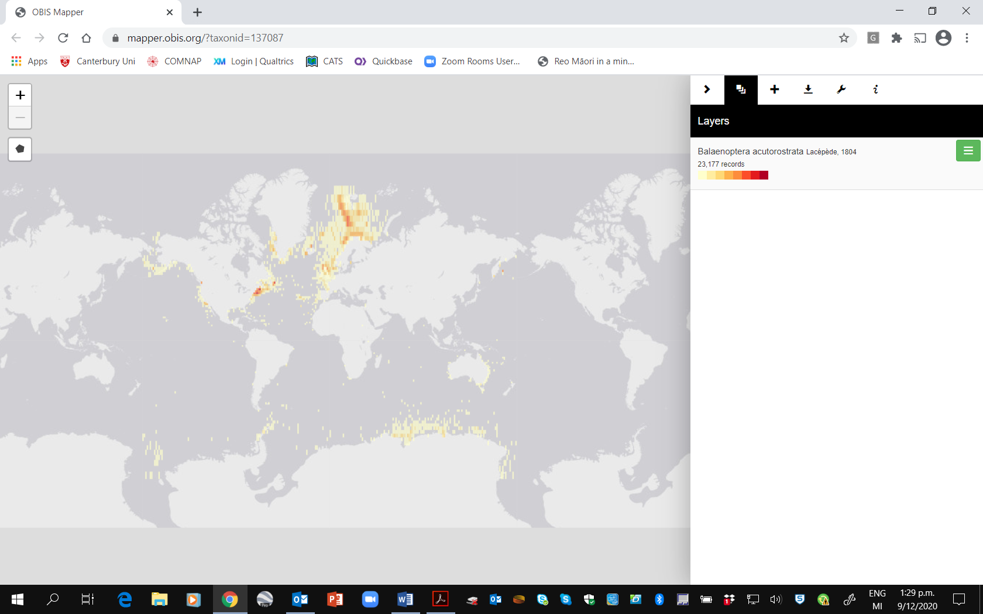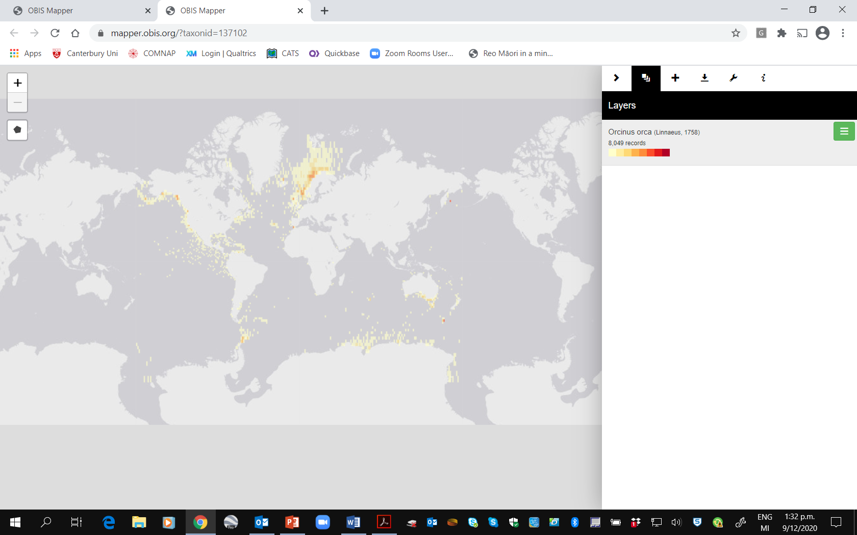

Figure 2. Graphic showing presence or observation data for Minke whales (on left) and Killer whales (on right) giving the overall feel for the distribution and migratory patterns of these cetaceans. Source: <https://mapper.obis.org/?taxonid=137087> and <https://mapper.obis.org/?taxonid=137102>.

Annex 2: References

Barbosa, A., Varsani, A., Marandini, V., et al., Risk assessment of SARS-CoV-2 in Antarctic wildlife, *Science of the Total Environment,* <https://doi.org/10.1016/j.scitotenv.2020.143352>.

Centers for Disease Control and Prevention (CDC), COVID-19 and Animals, updated February 10, 2021, <https://www.cdc.gov/coronavirus/2019-ncov/daily-life-coping/animals.html>.

Centers for Disease Control and Prevention (CDC), COVID-19 Science Update, edition 20-09-08, September 8, 2020.

Cevik, M., Tate, M., Lloyd, O., Maraolo, A.E., Schafers, J., and Ho, A., SARS-CoV-2, SARS-CoV, and MERS-CoV viral load dynamics, duration of viral shedding, and infectiousness: a systematic review and meta-analysis, *Lancet Microbe*, 2021 Jan;2(1):e13-e22. doi: 10.1016/S2666-5247(20)30172-5. Epub 2020 Nov 19.

Council of Managers of National Antarctic Programs (COMNAP), *COVID-19 Prevention and Outbreak Management Guidelines*, version 6, 13 January 2021.

Damas, J., Hughes, G.M., Keough, K.C., et al.., Broad host range of SARS-CoV-2 predicted by comparative and structural analysis of ACE2 in vertebrates, *PNAS* September 8, 2020, 117 (36) 22311-22322; first published August 21, 2020; <https://doi.org/10.1073/pnas.2010146117>.

Elsamadony, M., Fujii, M., Miura, T., and Watanabe, T., Possible transmission of viruses from contaminated human feces and sewage: Implications for SARS-CoV-2, *Science of the Total Environment*, 2021 Feb 10; 755: 142575; Published online 2020 Sep 29. doi: [10.1016/j.scitotenv.2020.142575](https://dx.doi.org/10.1016%2Fj.scitotenv.2020.142575).

Franklin, A.B. and Bevins, S.N., Spillover of SARS-CoV-2 into novel wild hosts in North America: A conceptual model for perpetuation of the pathogen, *Science of the Total Environment* 733 (2020) 139358.

Geoghegan, J., as quoted in Wu, K.J., in *National Geographic*, Science, Coronavirus Coverage, “There are more viruses than stars in the universe. Why do only some infect us?”, 15 April 2020.

International Whaling Commission (IWC), Report of the Scientific Committee. J Cetacean Res Manag 14 (Suppl):1–468, 2012.

Quammen, D.,“And Then the Gorillas Started Coughing: Humans are spreading the coronavirus to other animals. What does that mean for all of us?”, *The New York Times,* February 19, 2021, <https://www.nytimes.com/2021/02/19/opinion/covid-symptoms-gorillas.html?smid=em-share>.

Scientific Committee on Antarctic Research (SCAR) *Environmental Code of Conduct for Terrestrial Scientific Field Research in Antarctica* (2018).

SCAR & COMNAP *Inter-continental Checklists For supply chain managers of the National Antarctic Programmes for the reduction in risk of transfer of non-native species* (May 2019).

Wageningen University & Research News, “COVID-19 detected on multiple Dutch mink farms, October 25, 2020, <https://www.wur.nl/en/Research-Results/Research-Institutes/Bioveterinary-Research/show-bvr/COVID-19-detected-on-two-mink-farms.htm>.